Small Group Activity: Evaluation of three versions of a project proposal

Which version best convinces the reader to fund the project? Why? Why are the others less effective?
Version A:
LearnTech Ltd is an incubator aiming to bridge the technological gap between Aalto and surrounding local schools, which have been largely left behind in the technological developments. This has resulted in the younger generations not being able to familiarize themselves with software and equipment to the extent that would allow them to develop essential working life skills already at school. We offer a variety of programs that serve the local education institutions by supplying a broad range of technology-related services that allow young people to take advantage of the educational opportunities created by information technologies.
This proposal seeks funding for our computer education program. This program is the cornerstone of our strategy to bring technology to children and teenagers, and relies on the following classroom principles: low student-to-teacher ratio and problem-based learning. These methodologies facilitate student familiarity with authentic, real-life cases, contrary to traditional textbook examples. To reach our mission, LearnTech Ltd seeks to launch a partnership with the Innovatum Group.
LearnTech Ltd respectfully submits its proposal to the Aalto Foundation for €30,000 to support its computer education program for young people.
Version B:
This proposal seeks funding for our computer education program. This program is the cornerstone of our strategy to bring technology to children and teenagers, and relies on the following classroom principles: low student-to-teacher ratio and problem-based learning. These methodologies facilitate student familiarity with authentic, real-life cases, contrary to traditional textbook examples. To reach our mission, LearnTech Ltd seeks to launch a partnership with the Innovatum Group.
LearnTech Ltd respectfully submits its proposal to the Aalto Foundation for €30,000 to support its computer education program for young people.
LearnTech Ltd is an incubator aiming to bridge the technological gap between Aalto and surrounding local schools, which have been largely left behind in the technological developments. This has resulted in the younger generations not being able to familiarize themselves with software and equipment to the extent that would allow them to develop essential working life skills already at school. We offer a variety of programs that serve the local education institutions by supplying a broad range of technology-related services that allow young people to take advantage of the educational opportunities created by information technologies.
Version C:
LearnTech Ltd respectfully submits its proposal to the Aalto Foundation for €30,000 to support its computer education program for young people.
LearnTech Ltd is an incubator aiming to bridge the technological gap between Aalto and surrounding local schools, which have been largely left behind in the technological developments. This has resulted in the younger generations not being able to familiarize themselves with software and equipment to the extent that would allow them to develop essential working life skills already at school. We offer a variety of programs that serve the local education institutions by supplying a broad range of technology-related services that allow young people to take advantage of the educational opportunities created by information technologies.
This proposal seeks funding for our computer education program. This program is the cornerstone of our strategy to bring technology to children and teenagers, and relies on the following classroom principles: low student-to-teacher ratio and problem-based learning. These methodologies facilitate student familiarity with authentic, real-life cases, contrary to traditional textbook examples. To reach our mission, LearnTech Ltd seeks to launch a partnership with the Innovatum Group.
Writing Problem-Solution Texts
The Problem-Solution pattern is one of the most important organizational structures in scientific and engineering texts, but is also found in newspaper and magazine articles. The problem-solution pattern reflects a form of critical thinking that tends to be more argumentative and evaluative. You may find this pattern useful in writing introductions, research reports, proposals, and essay answers to examination questions. In its simplest form, the Problem-Solution pattern consists of two parts: a problem and a solution. However, most problem-solution texts involve four steps.

SITUATION  The first sentence in a paragraph, often referred to as the Situation, provides background information and the setting for the problem. In this step, the writer attempts to orient the writer by showing the importance or relevance of the current situation to the reader’s world. The words below are frequently used to emphasize the relevance of the topic:  major, important, popular, common, and many  PROBLEM  The second or topic sentence states the problem. In science texts, the problem is commonly signaled using the following types of words:  contrast (However, despite, unfortunately, although, but),  negative connotation (limited, few, little, no, not, none),  synonyms for “problem”(danger, drawback, disadvantage, weakness, need, shortcoming, obstacle).  Sometimes, the present situation may be presented as the problem, or these first two steps can even be presented in reverse order. Describing a problem also entails commenting on the history, possible causes and effects of the problem, the limitations of any current/previous solutions, as well as the criteria for a good solution. | SITUATION
Importance?
Relevance?

 | PROBLEM
Causes?
Consequences?
Past solutions?
Criteria for a good solution?
 | SOLUTION
Features of solution?
How does it work?

 | EVALUATION
How effective is it?
Does it meet criteria?

SOLUTION
Once the reader understands the importance/relevance of this topic and the problems arising from it, the next step introduces a solution to the problem. This step is often signaled using the words below:
Nouns (solution, answer, approach, strategy, improvement)
verbs (solve, address a problem, work out and develop)
causative connectors (therefore, as a result, thus).

EVALUATION
When presented with a possible solution, readers naturally wonder whether this solution is effective in light of the criteria described in the problem step. Therefore, the final step should evaluate the solution. If the evaluation is negative (i.e., the solution is ineffective), then your reader will expect an explanation as to why it will not work. Alternatively, a positive evaluation supports a successful solution, and the positive features of the solution would be signaled by positive language:
Nouns (benefit or advantage)
verbs (provide, offer, enable, allow)
Adjectives (effective, efficient, reliable, safe, useful)

Creating an outline for a problem-solution text
Use this chart below (figure 1) or the simpler diagram (figure 2) to begin planning what your problem-solution text could be.
Problem-Solution Outline
What is the overall situation?
What is the problem?
What caused this problem?
What have been the effects of this problem?
What are the criteria for a good solution?
What solutions have already been tried or are possible?
Limitations of these other solutions? (evaluation)

What is your solution?

What features make your solution better? (evaluation)

What makes you the right person for the job? (Credibility)

Figure 1: Problem-Solution Outline Chart

Overall structure of your problem-solution paper

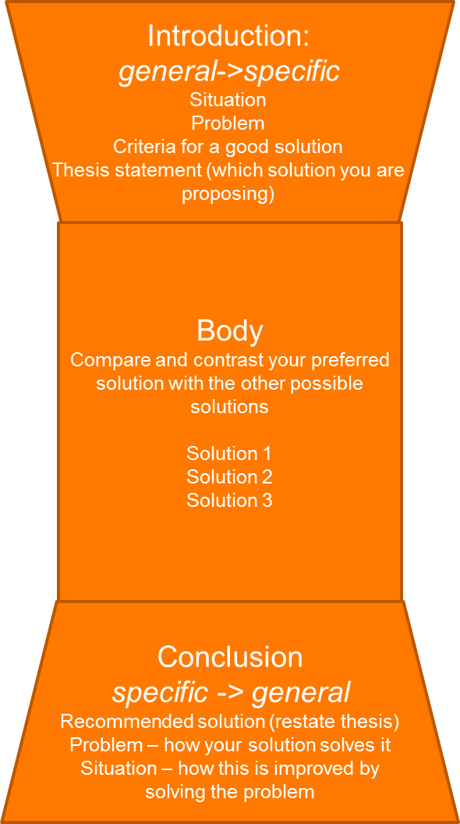

Figure 2: Problem-Solution structure

Title

I Introduction

Situation:

Problem:

II Body

Solution 1

Solution 2

Solution 3

III Conclusion

