**Simscape Fluids exercise**

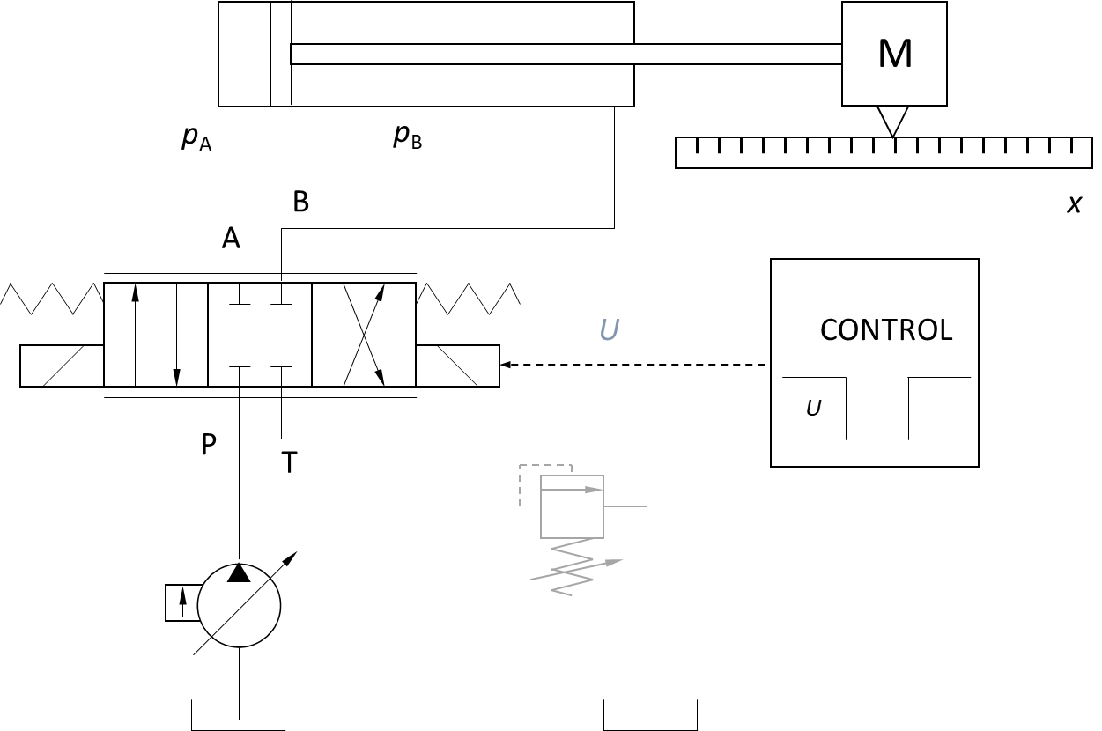

Simscape is an environment for modeling and simulating multidomain physical systems within Matlab/Simulink. More than 10 physical domains, including mechanical, electrical and hydraulic (Simscape Fluids) are covered. In this assignment both the **Simscape Fluids** and **Simulink** domains are mostly utilized.

With Simscape physical component models can be generated based on physical connections by using physical units for both parameters and variables. All unit conversions are handled automatically.

Cylinder piston’s position can be controlled in open and closed loop by using directional proportional control valve. System includes

• Differential cylinder with inertia load (mass)

• Directional proportional control valve

• Pressure compensated pump (constant pressure)

• Control system for position control

• (Presure relief valve)

Hydraulic actuator force needed only for mass acceleration and deceleration since there is no mechanical friction in this system.

In the assignment the cylinder piston is moved

a) into **–** direction and b) into **+** direction

both by using **a) open loop** and **b)** **closed loop control**.

The hydraulic system to be modeled

Open **Matlab.**

Open the **Simscape** model template for your Simscape Fluids models.

For opening give Matlab command

ssc_new

This will open the

* **Model template** with
  + [**Solver Configuration**](https://se.mathworks.com/help/physmod/simscape/ref/solverconfiguration.html) block to specify the solver parameters for your model
  + [**Simulink-PS Converter**](https://se.mathworks.com/help/physmod/simscape/ref/simulinkpsconverter.html) and [**PS-Simulink Converter**](https://se.mathworks.com/help/physmod/simscape/ref/pssimulinkconverter.html) blocks for data transfer between Simscape and Simulink domains
* **Foundation library**

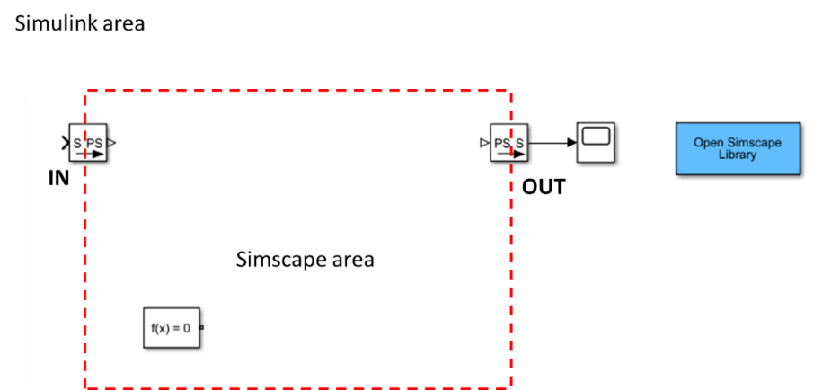

You can enter **Matlab** command SimscapeFluids_lib for Simscape Fluids block library.

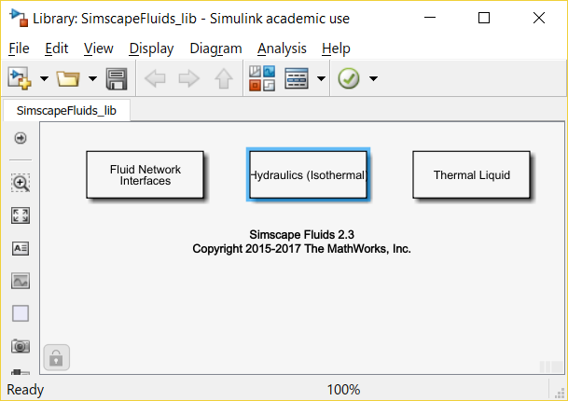 Library: SimscapeFluids_lib

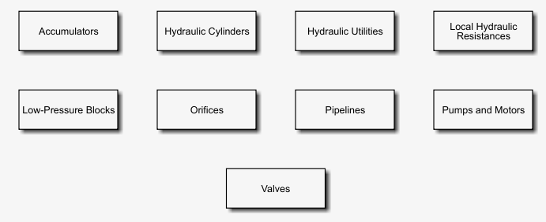

Library: SimscapeFluids_lib > Hydraulics (Isothermal)

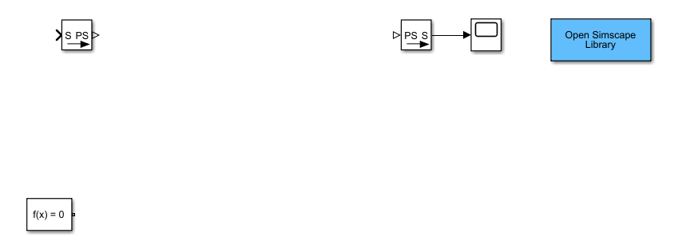

Model canvas

**Open loop control – assignment phase 1**

Find **Hydraulics (Isothermal)** > **Hydraulic Utilities** library, open it (double clicking) and use the mouse to drag a [**Hydraulic Fluid**](https://se.mathworks.com/help/physmod/hydro/ref/hydraulicfluid.html) block to your new model canvas.

With this block you can determine the physical properties of the hydraulic fluid.

* density,
* viscosity, and
* bulk modulus.

1. Open [**Hydraulic Fluid**](https://se.mathworks.com/help/physmod/hydro/ref/hydraulicfluid.html)block by double clicking it.
2. Change the **Hydraulic Fluid** from Skydrol LD-4 to ISO VG 32 (ESSO UNIVIS N 32).
3. Keep the other fluid parameters the same.

Skydrol is fire-resistant aviation hydraulic fluid: <http://skydrol-ld4.com/technical_bulletin_skydrol_4.pdf>.

•  Connect the [**Solver Configuration**](https://se.mathworks.com/help/physmod/simscape/ref/solverconfiguration.html) (f(x)=0) and **Hydraulic Fluid** blocks.

* With left mouse button draw a wire between blocks’ terminals.
* **OR**
* Click on the first block with the left button of your mouse
* Press **Ctrl** button of your keyboard
* Click on the second block
* Connection (Wire) will be formed automatically.

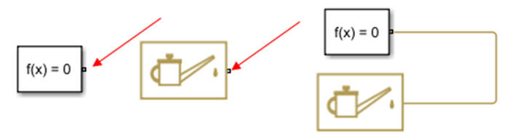

Solver Configuration Hydraulic Fluid

The Solver Configuration block defines solver settings for your model.

**Attention!** You can rotate blocks by using Crtl-R keyboard command.

In your canvas window click **Library Browser** button to open **Simulink Library Browser**.

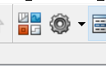

From the **Simulink** **Library Browser’s** **Simscape** > **Foundation** library

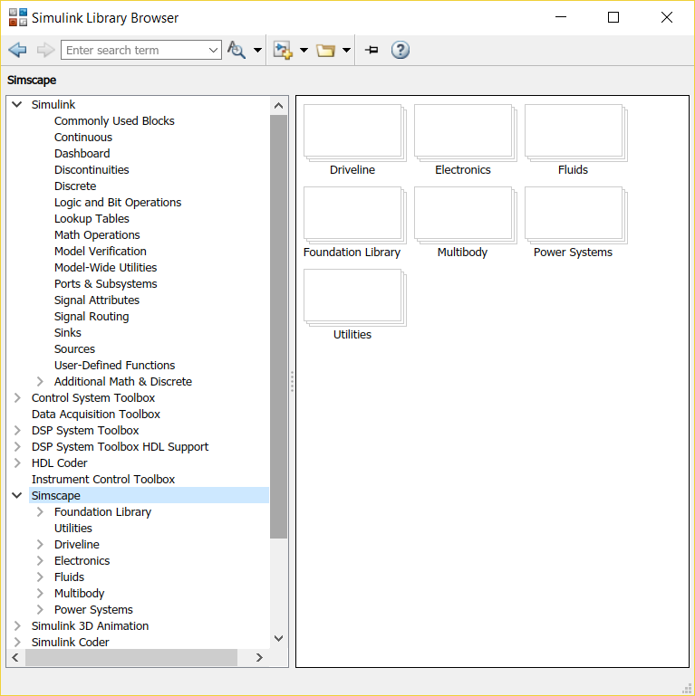

**Pick the next two blocks and drag them to the model canvas.**

**Block                                                         From Sublibrary**

|  |  |
| --- | --- |
| Hydraulic Constant Pressure Source | **Foundation Library > Hydraulic** > **Hydraulic Sources** |
| Hydraulic Reference | **Foundation Library > Hydraulic** > **Hydraulic Elements** |
| cid:image004.png@01D454CB.47CF9DF0 | **Hydraulic Constant Pressure Source** and  **Hydraulic Reference** |
|  |  |

The Hydraulic Reference block represents a connection to atmospheric pressure.

Connect these elements on the canvas. To make the branch use mouse’s right button.

|  |  |  |
| --- | --- | --- |
|  | **Simscape Fluids** | **Hydraulics (Isothermal)**  cid:image012.png@01D454CB.47CF9DF0 |

From the **Simscape** > **Fluids** library, pick and drag two blocks to the model canvas.

| **Block** | **From Sublibrary** |
| --- | --- |
| Double-Acting  Hydraulic Cylinder  (Simple) | **Hydraulics (Isothermal)** > **Hydraulic Cylinders** |
| 4-Way Directional Valve | **Hydraulics (Isothermal)** > **Valves** > **Directional Valves** |
|  |  |

•  The block connections represent the physical connections between the actual components. The cylinder connects to the valve, which connects to the pump, which in turn connects to the fluid reservoir.

•  From the **Simscape** > **Foundation** > **Mechanical** > **Translational** library, add a **Mechanical Translational Reference** block

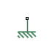

and connect it as shown in the figure below.

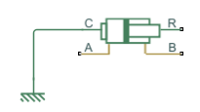

* Connect the **4-way Directional Valve** to the **Double-Acting Hydraulic Cylinder** as follows.

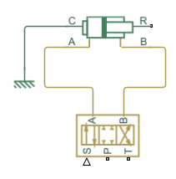

* From the **Simscape** > **Foundation** > **Mechanical** > **Translational Elements** library, add a **Mass** block and connect it as shown in the figure below.

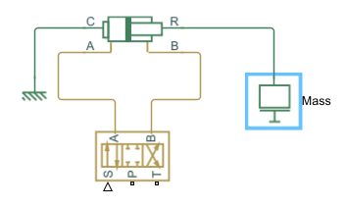

* From the **Simscape** > **Foundation** > **Mechanical** > **Mechanical Sensors** library bring an **Ideal Translational Motion Sensor** block and connect it as in the figure below (both **C** and **R** terminals).

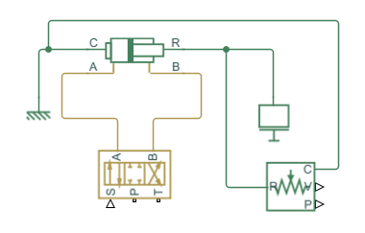

* Connect the **Ideal Translational Motion Sensor** block to **PS-Simulink Converter** and **Scope** as follows.

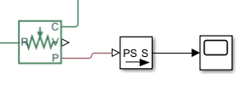

Velocity

Position

Velocity

Position

* From the **Hydraulics (Isothermal)** > **Valves** > **Valve Actuators** library bring a **Valve Actuator** block and connect it to **Simulink-PS Converter** and **4-Way Directional Valve** as in the figure below.

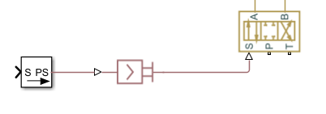

Valve Actuator Block

* Connect the **4-Way Directional Valve** to **Hydraulic Constant Pressure Source block** and to **the Hydraulic Reference block** as in the figure below.

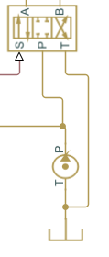

**Pressure sensors**

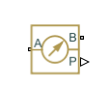for measuring cylinder chamber pressures.

* From the **Simscape > Foundation** library bring **Hydraulic** > **Hydraulic Sensors** > **Hydraulic Pressure Sensor** block. Make a copy of it (Ctrl-C and Ctrl-V) and connect those
* between **Hydraulic Cylinder’s** A interface and **Hydraulic Reference (B interface)**
* between **Hydraulic Cylinder’s** B interface and **Hydraulic Reference (B interface)**

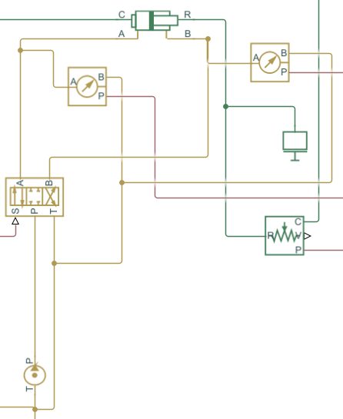

* Connect both of the **Hydraulic Pressure Sensor(s)** to **Scope(s)** by using a **PS-Simulink Converter** as follows. You can use the existing converter and make a copy of it.

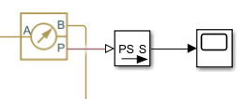

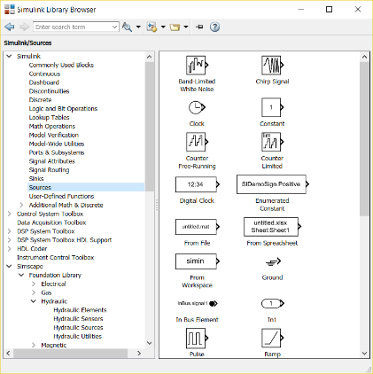**Signal inputs**

From the **Simulink Library Browser > Sources** bring

**Step** block ⇒ clone it (Ctrl-C and Ctrl-V) to get **4 blocks** together.

**Constant** block

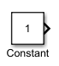

From the **Simulink Library Browser > Math Operations** bring

**Add** block

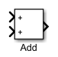

Connect the blocks with **Simulink-PS Converter** block as follows.

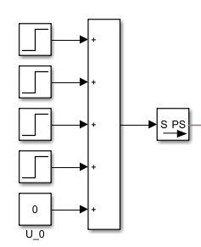

**Constant** (named U_0) block represents the valve’s zero point parameter. At first set the **Constant value** to **0**.

Adjust that parameter later to keep cylinder still during zero input signal.

The **Step** blocks are used for step input commands for the proportional control valve. These parameters values will also be set later.

**Pipes**

From the Library: **Simscape > Fluids > Hydraulics (Isothermal) > Pipelines** bring **Hydraulic Pipeline** block.



Make a copy of it and connect those two to **Hydraulic Cylinder’s** A and B interfaces and corresponding A and B interfaces of **4-Way Directional Valve** as in the figure below.

**Attention!** Remember that you can rotate blocks by using Crtl-R keyboard command.

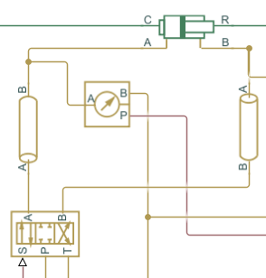

**System Parameters**

Double click blocks to open

Set system parameters as follows.

**Step blocks** for timing of the valve commands (usable voltage area: -10 V … 0 … +10 V).

|  |  |
| --- | --- |
| *U* [V] |  |

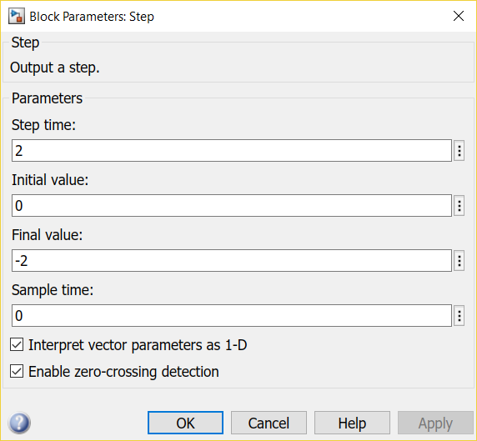Set **Time** and **Final value**

*t* [s]

**Step block 1** parameters

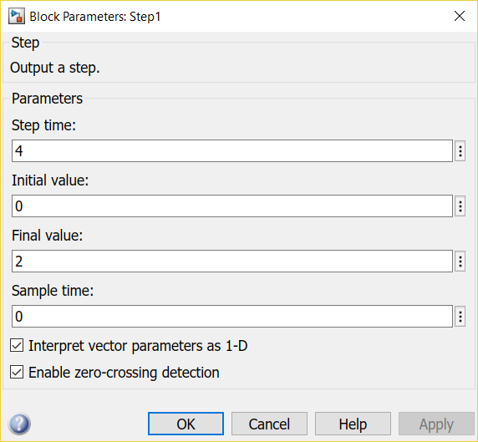 Set **Time** and **Final value**

**Step block 2** parameters

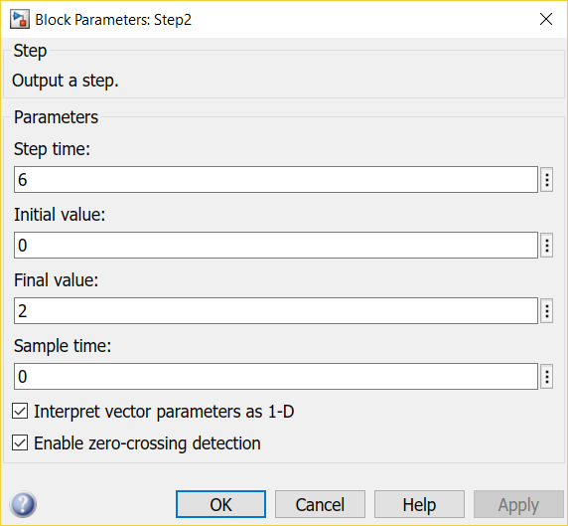 Set **Time** and **Final value**

**Step block 3** parameters

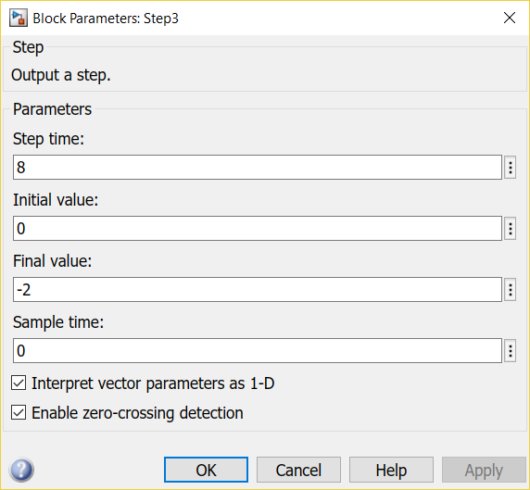 Set **Time** and **Final value**

**Step block 4** parameters

**Constant** (named U_0) block represents the valve’s zero point parameter. Run the simulation (after setting other parameters) and adjust that parameter to keep cylinder still during zero input.

**Valve Actuator**

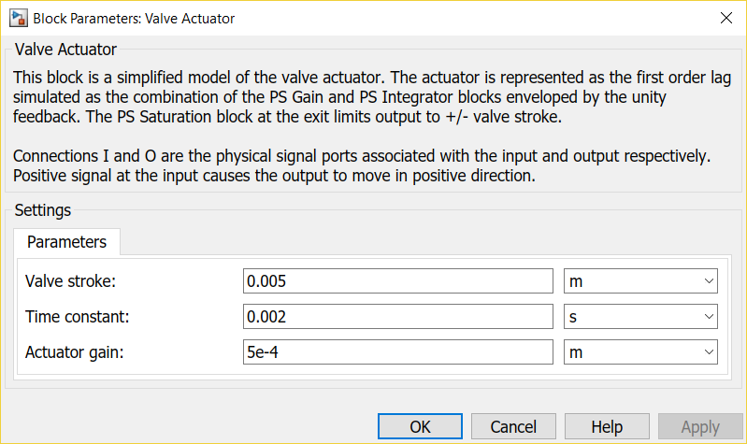

* maximum **Valve stroke** 0.005 m (5 mm)
  + by applying 10 V input the Actuator reaches full 5 mm stroke
* therefore the **Actuator gain** is 0.005/10 [m or in theory m/V]
* the value for the **Time constant** can be 0.002 s (2 ms)

**Hydraulic Constant Pressure Source** (ideal constant pressure pump)

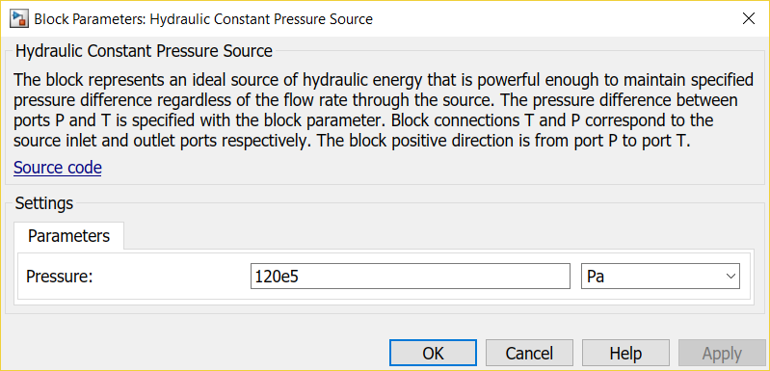

* ideal pump with constant pressure of 120 bar (120⋅105 [Pa] in Matlab: 120e5 [Pa])

**4-Way Directional Valve** (proportional valve)

For a narrow (mainly turbulent flow) orifice the flow rate is

If we know

* nominal flow rate (*q*v),
* nominal pressure drop (Δ*p*),
* fluid density (*ρ*) and
* flow coefficient (*C*q)

the corresponding flow area can be calculated as follows

**For leakage of a certain proportional control valve**

*q*v 0.45 l/min ⇒ 0.45/60000 m3/s

Δ*p* 50 bar ⇒ 50⋅105 Pa

*ρ* 844.4 kg/m3 (from **Hydraulic fluid** block for ISO VG 32 hydraulic fluid at 60°C)

*C*q 0.7 (for turbulent region)

Open the **4-Way Directional Valve** block dialog box by double clicking.

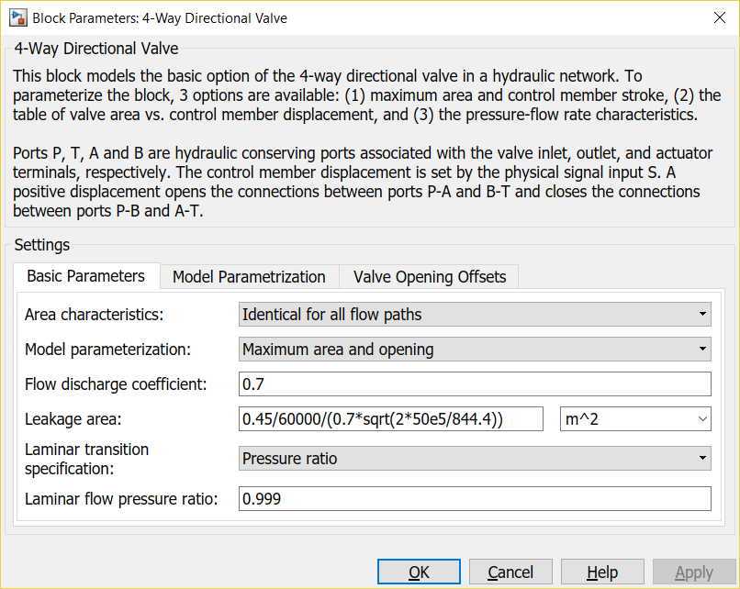

Set the **Leakage area** parameter as follows.

**Leakage area** parameter (0.45 l/min @ Δ*p*= 50 bar over each control edge), use Copy+Paste.

0.45/60000/(0.7*sqrt(2*50e5/844.4))

In **Model Parametrization** page

**Maximum opening** parameter 0.005 m

**Maximum opening area** parameter, use Copy+Paste

Actual flow area (40 l/min @ 35 bar) + Leakage area +

40/60000/(0.7*sqrt(2*35e5/844.4))+0.45/60000/(0.7*sqrt(2*50e5/844.4))

|  |  |
| --- | --- |
|  | Simscape’s way of modeling orifice area  *h*  orifice opening [m]  *h*maximummaximum orifice opening [m]  *A*maximummaximum orifice area [m2]  *A*leakageleakage orifice area [m2]  Leakage orifice area is for a “closed orifice”. |

**Double-Acting Hydraulic Cylinder (Simple)**

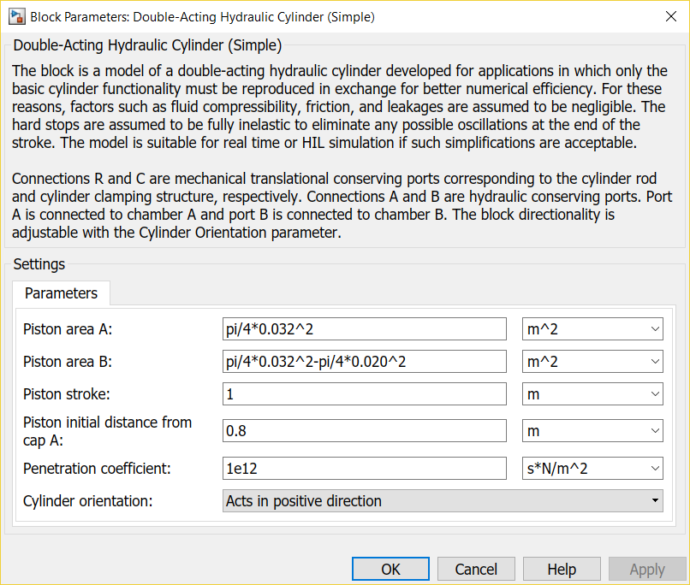

* *D* cylinder diameter 32 mm
* *d* rod diameter 20 mm
* Piston area A: pi/4*0.032^2(*A*A= π/4*D*2)
* Piston area B: pi/4*0.032^2- pi/4*0.020^2(*A*B= *A*A -π/4*d*2)
* Piston stroke: 1 m (maximum stroke)
* Piston initial distance from cap A: 0.8 m (initial position of piston)

**Mass**

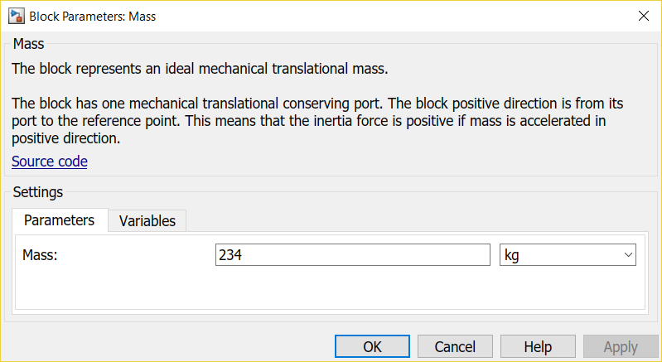

**Pipe parameters**

Update parameters

* Pipe internal diameter ⇒ 0.012 m
* Pipe length ⇒ 0.75 m

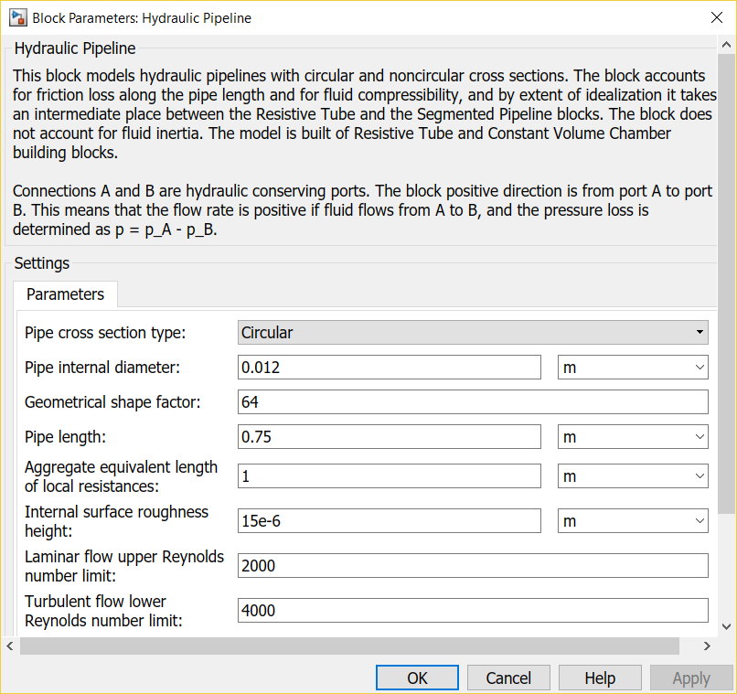

**Ideal Translational Motion Sensor**

Update parameter **Initial position** ⇒ 0.8 m

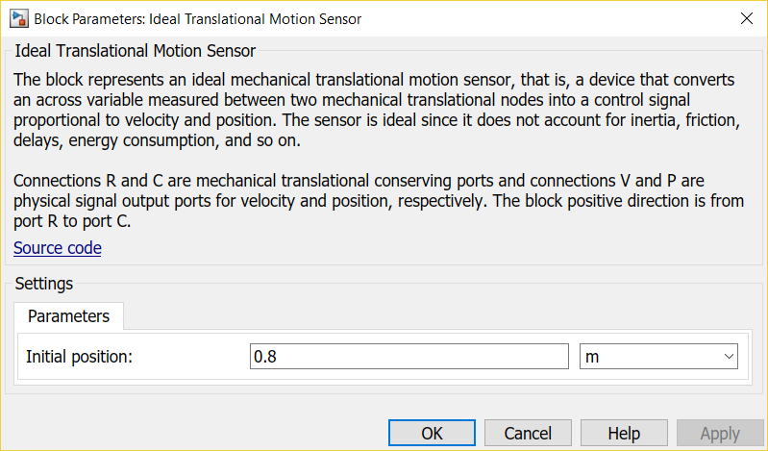

Your system should look like this. **Start simulation**

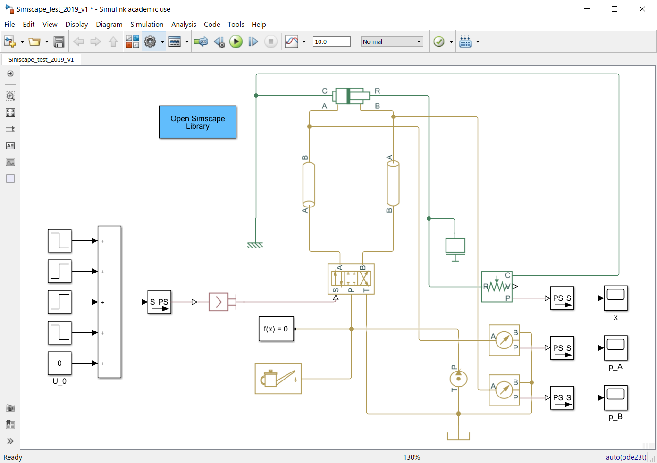

Your model should be ready for 10 s simulation.

Use scopes

* x
* p_A
* p_B

for piston position [m], A chamber pressure [Pa] and B chamber pressure [Pa].

You can also test if the input commands are correct by placing a **Scope** between **Add** block and [**Simulink-PS Converter**](https://se.mathworks.com/help/physmod/simscape/ref/simulinkpsconverter.html)**.**

**Assignment for phase 1 – Open loop control**

**Make a short document (Word- > pdf)**

Documentation Format:

**Your name**

**Assignments**

1. Finalize the simulation model
   1. Document **part 1**
      1. Paste a **Figure of the System Model** to your document
      2. **Edit > Copy Current View to Clipboard > Metafile or Bitmap**
2. Tune the system with valve’s zero point parameter (U_0). Adjust that parameter to keep cylinder still during zero input.
   1. Document **part 2**
      1. Give the proper parameter value for U_0
3. Plot the **Piston Displacement** signal
   1. Document **part 3**
      1. Copy the Scope plot and paste it into your document
      2. **File > Copy to Clipboard (Ctrl-C) OR**
      3. (File > Print to Figure) OR
      4. Configuration Properties > Logging > Log data to Workspace
         1. Variable name x
         2. Save format: Array
         3. In Matlab workspace
            1. figure
            2. plot(x(:,1),x(:,2));
4. Plot the **Cylinder Pressure A** signal
   1. Document **part 4**
      1. Copy the Scope plot and paste it into your document
      2. **File > Copy to Clipboard (Ctrl-C)** OR the options presented above
5. Plot the **Cylinder Pressure B** signal
   1. Document **part 5**
      1. Copy the Scope plot and paste it into your document
      2. **File > Copy to Clipboard (Ctrl-C)** OR the options presented above
6. Improvement suggestions to this Tutorial document
   1. Actual errors or misprints (page and location)
   2. Missing information
   3. Actual improvements

**Additional material**

Getting started

<https://se.mathworks.com/help/physmod/hydro/getting-started-with-simhydraulics.html>

Simple actuator model tutorial

<https://se.mathworks.com/help/physmod/hydro/ug/creating-a-simple-model.html>

**Closed loop control – assignment phase 2**

Remove blocks **Step 2** and **U_0**.

Open block **Add** block change the **List of signs** to **+-**.

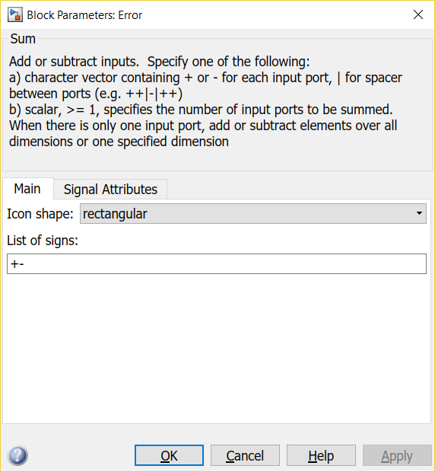

Rename the block to **Error**. Delete **Step** blocks **2, 3, and 4**. Delete **Constant** block (U_0).

Open **Step 1** block. Rename it as **Step** and update the parameter values as in the figure below.

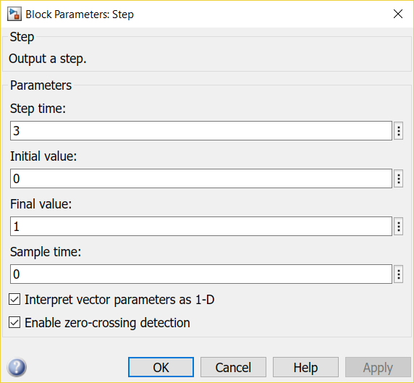

Update **cylinder parameters**

Double click **Double-Acting Hydraulic Cylinder (Simple)** to open it.

Update **Piston stroke** and **Piston distance from cap A** as follows. Click **OK**.

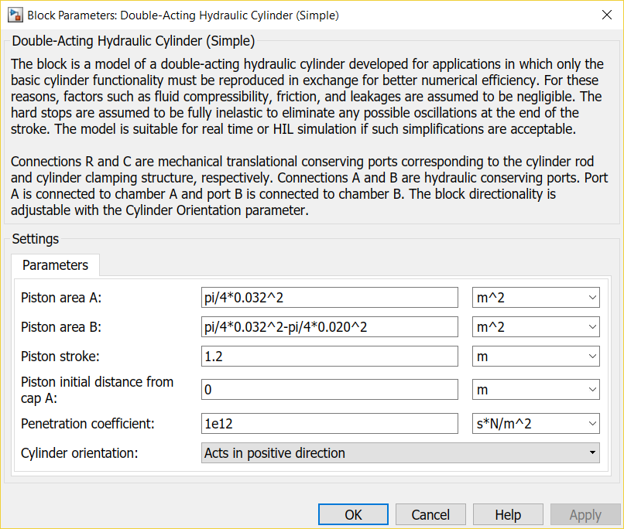

Update also **Ideal Translational Motion Sensor**.Set **Initial position** to **0.**

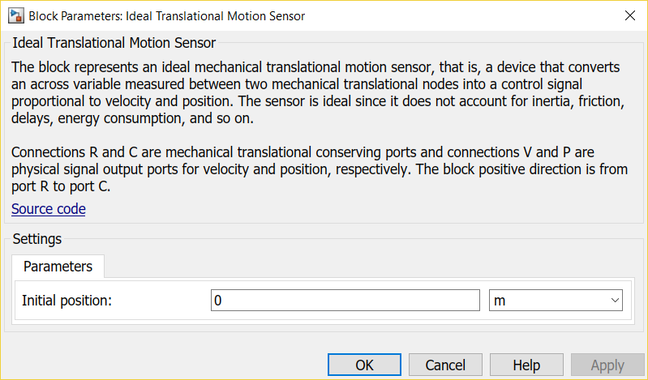

From the **Simulink > Math operations** bring **Gain** block. Place it between **Error** and **Simulink-PS Converter** as in the figure below. Name it as **P gain**. This is the system’s P controller (**P**ID).

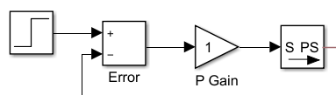

Branch (mouse right button) and connect **Piston displacement signal** wire from block **PS-Simulink Converter ….**

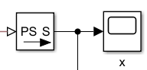

to **Error block’s** second interface. The difference between the values tells you how far the actual position is from the target position.

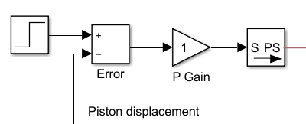

From **Simulink > Signal routing** library bring **Mux** (multiplexer) block. 

Connect **Scope** block to it and name it for example as **Piston Displacement - Command and Position**.

Connect wire from **Step** block to the first interface and **Piston displacement** signal to the second interface.

|  |  |
| --- | --- |
| From: Step |  |
| From: Piston displacement (x) |

From **Simulink > Sinks** library bring **To Workspace** block.

Connect wire from **Mux** signal(s) to its interface.

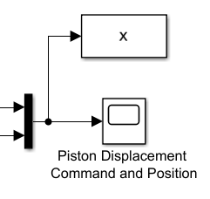

Double click to open **To Workspace** block.

Adjust the parameter(s) as follows **> Variable name > x**. Click **OK**.

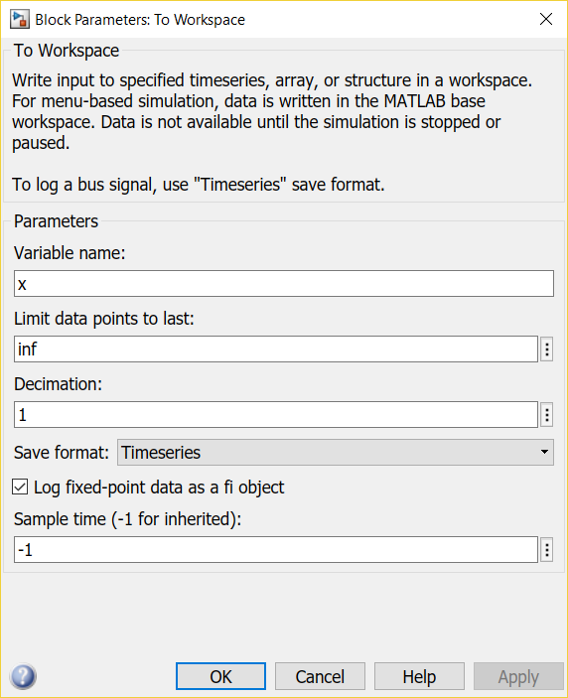

Add also a **Scope** for valve command voltage U between **P Gain** and **Simulink-PS Converter**. 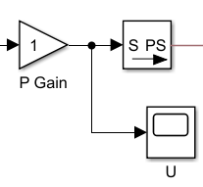

Your system should look (something like) this.



**Plotting** of variables

**File > Model properties > Model properties > Callbacks > StopFcn**

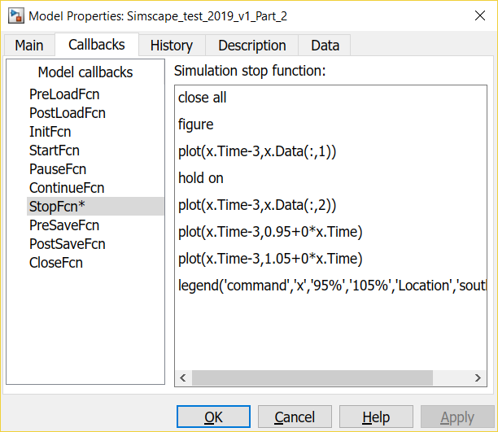

Add the following **code** to **StopFcn**

close all

figure

plot(x.Time-3,x.Data(:,1))

hold on

plot(x.Time-3,x.Data(:,2))

%plot(x.Time-3,1+0*x.Time)

plot(x.Time-3,0.95+0*x.Time)

plot(x.Time-3,1.05+0*x.Time)

legend('command','x','95%','105%','Location','southeast')

Click **OK** to confirm the changes.

**Run** the model.

You should get also a **Figure** like this.

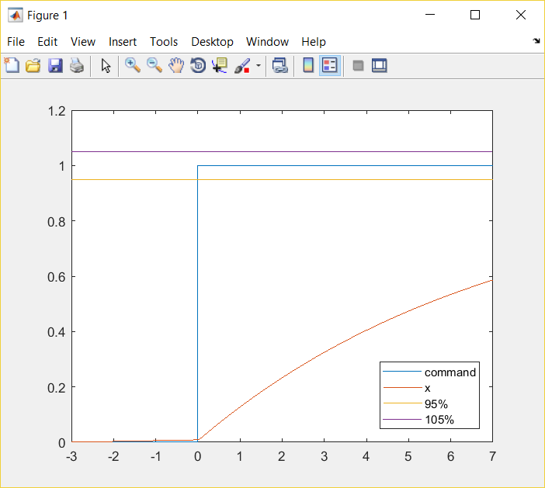

Can be also here (depending on Matlab version)

Zoom

Data Cursor

Use **Zoom** (In or Out) and **Data Cursor** tools for finding detailed information.

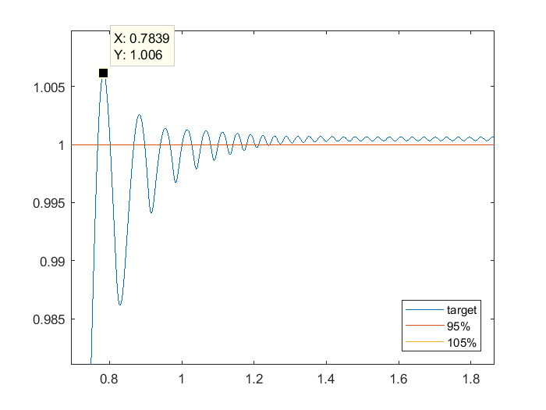

Check from the **Figure** or from **Scope Piston Displacement - Command and Position** how well the actuator follows the command.

If the performance is poor increase the **P Gain** value. Raise the value boldly (decades). This is only a simulator!

Notice that the **Piston displacement** signal starts to oscillate if the **P Gain** value is too high.

More specified servo tuning instructions below (**Tuning the P controller according to Ziegler-Nichols**).

**Tuning the P controller according to Ziegler-Nichols**

* Increase **P Gain** parameter value until the system starts to **oscillate continuously**. Use **zooming**!
* This **minimum** value of **P Gain** (parameter **KP**) is so called critical gain **KP, crit**. **Store this value!**
* (To implement controllers as PI or PID you should also estimate the time period of oscillation **Tcrit** corresponding this gain. This can be identified from the response ⇒ time between two successive peaks).
* P controller’s gain according to Ziegler-Nichols tuning rules is now simply **0.5⋅KP, crit.**

**Assignment for phase 2**

**Continue with your short document (Word -> pdf) for Phase 1**

Documentation Format:

**Assigments**

* Finalize the simulation model
  + - Paste a **Figure of the** updated **simulation model** to your document
    - **Edit > Copy Current View to Clipboard > Metafile or Bitmap**
* Test the system with **critical gain** and two different values for the **P gain**
  + Pgain, 0= **KP, crit** (critical gain according to Ziegler-Nichols tuning rule)
  + Pgain, 1= **0.5⋅KP, crit** (tuned according to Ziegler-Nichols tuning rule)
  + Pgain, 2= **0.25⋅KP, crit** (smaller gain for comparison)

* Plot the **Piston Displacement** signals for
  + - **Pgain, 0 (critical)**
      1. overall displacement Figure
      2. zoomed Figure to see the performance near the target position
    - **Pgain, 1**
      1. overall displacement Figure
      2. zoomed Figure to see the performance near the target position
    - **Pgain, 2**
      1. overall displacement Figure
      2. zoomed Figure to see the performance near the target position

Analyze the plots and add information to these tables. Check the following page for **Performance** analysis.

**P controller parameters**

|  |  |  |
| --- | --- | --- |
| **KP, crit** |  | V/m |
| **0.5⋅KP, crit** |  | V/m |
| **0.25⋅KP, crit** |  | V/m |

**Performance of P control for Pgain, 1 parameter value (0.5⋅KP, crit)**

|  |  |  |
| --- | --- | --- |
| Overshoot |  | % |
| Rise time 95% |  | s |
| Settling time 5% |  | s |
| Steady state error |  | m |

**Performance of P control Pgain, 2****for parameter value (0.25⋅KP, crit)**

|  |  |  |
| --- | --- | --- |
| Overshoot |  | % |
| Rise time 95% |  | s |
| Settling time 5% |  | s |
| Steady state error |  | m |

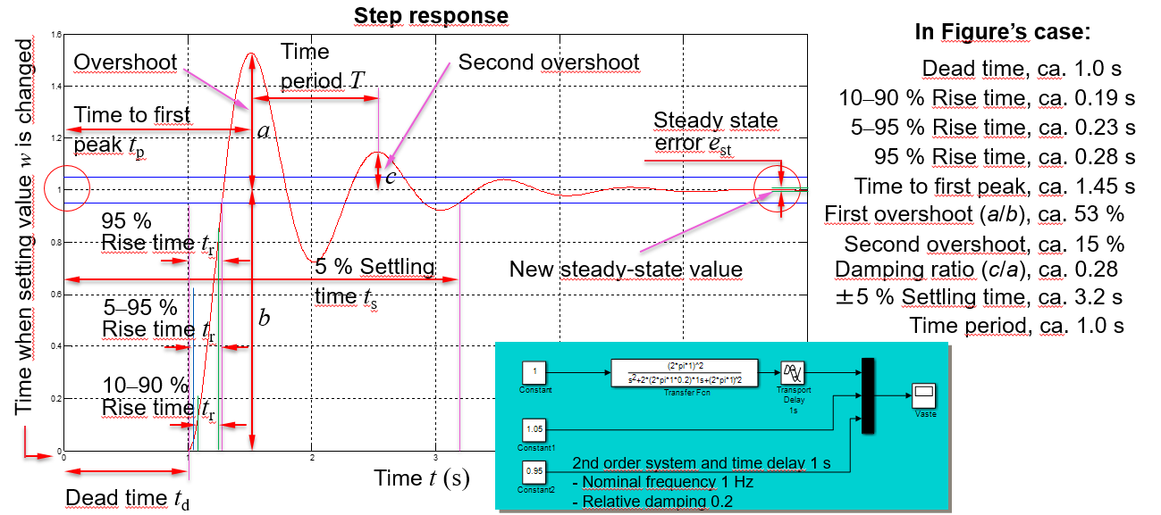

**Overshoot**

The ratio of difference between output *y*’s first maximum and its new steady-state value to its new steady-state value (= *a*/*b* in Figure above). Sometimes this characteristic is marked with *M*p, maximum percentual overshoot.

**Rise time (95%)**

Time it takes for the response to rise from zero to 95% of the steady-state response.

**Damping ratio**

The ratio of difference between output *y*’s first maximum and its new steady-state value to the difference between output *y*’s second maximum and its new steady-state value (= *c*/*a* in Figure above).

**Settling time *t*s**

The time that after a stepwise change in system’s setting value *w* is required for the process output *y* to reach and remain inside a band whose width is equal to ±5 % of the total change in *y* (sometimes also other bandwidths are used, e.g., ±1 %, ±2 %).

**Time period *T***

The time between output *y*’s two successive peaks (e.g., first and second maximum) or valleys.

**Oscillation frequency *f***

The frequency that the system oscillated with (= **1/*T***).

**Steady state error *e*st**

The constant deviation between system’s setting value *w* and actual output value *y*.