Small groups & group assignments

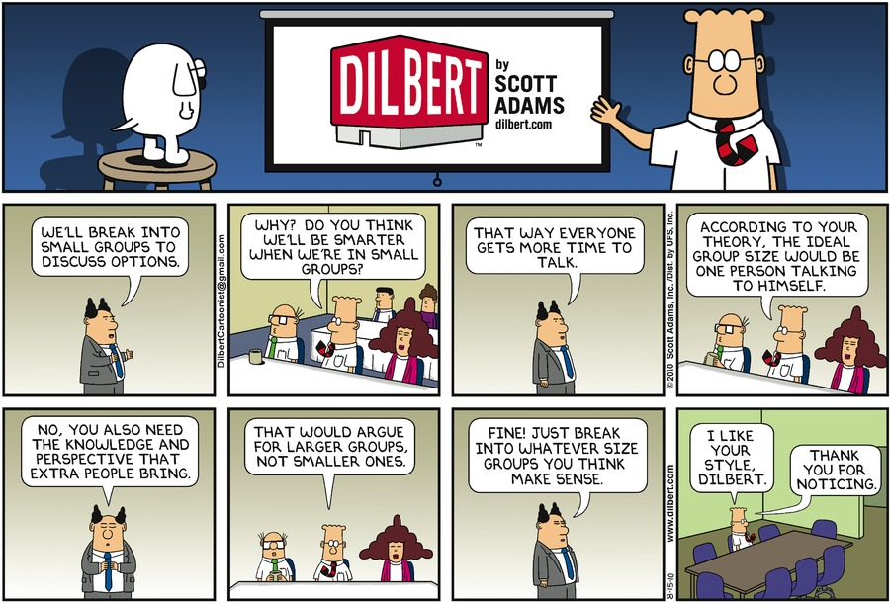

Contents

1 General framework for small group activities 2

1.1 Selecting a teaching strategy 2

1.2 Group Projects 3

1.3 Group Discussion 4

1.4 Interactivity during lectures 4

2 Project-based learning 5

2.1 Advantages 5

2.1.1 Teachers point of view 5

2.2 Challenges 5

2.2.1 Teachers point of view 5

2.3 Group size 6

2.4 Group selection 6

2.5 Topic 7

2.6 Guidance 7

2.7 Motivation 8

3 References 8

# General framework for small group activities

# 

## Selecting a teaching strategy

A teaching strategy involves **combining and sequencing a number of different instructional activities** to help students accomplish learning goals of the class.

To determine an effective teaching strategy, think about what you want **students to be able to do when they leave the course**.

Having identified the broad learning objectives, work backwards, asking yourself:

* What particular skills and knowledge will students need in order to accomplish these objectives? Then address the following questions:
  + **What kinds of activities** will students need to engage in to acquire the necessary skills and knowledge?
  + How can you organize these activities to provide sufficient practice?
  + How can you sequence them so that skills build upon one another?

🡪 **How and what kind of a group work activity fits in to your teaching?**

A lot of methods described, most of then applicable to small group working: Independent work, Stimulating writing assignments, Exercises, Learning diary , Collaborative learning, Cross-over groups, Learning café, Cumulative group – snowball, Presentation walk, Teaching walk, Step-by-step discussion, Inquiry teaching, Teaching discussion, Brainstorming, Discussion group, Reading circle, Presentations (lecturing), Panel discussion, Debate with argumentation, Problem-based learning (PBL), Case teaching, Project work, Learning by doing, Roleplaying, Games, Dialogue with oneself, Participants teach, Interview, Web-based learning…

## Group Projects

If structured well, group projects can promote important intellectual and social skills and help to prepare students for a work world in which teamwork and collaboration are increasingly the norm.

Employing group projects, consider the following questions:

* What are the benefits of group work?
* What are the challenges of group work, and how can I address them?
* What are best practices for designing group projects?
* How can I compose groups?
* How can I monitor groups?
* How can I assess group work?
* Sample group project tools

Possible Roles on Teams

* **Facilitator**: Moderates team discussion, keeps the group on task, and distributes work.
* **Recorder**: Takes notes summarizing team discussions and decisions, and keeps all necessary records.
* **Reporter** Serves as group spokesperson to the class or instructor, summarizing the group’s activities and/or conclusions.
* **Timekeeper** Keeps the group aware of time constraints and deadlines and makes sure meetings start on time.
* **Devil’s Advocate** Raises counter-arguments and (constructive) objections, introduces alternative explanations and solutions.
* **Harmonizer** Strives to create a harmonious and positive team atmosphere and reach consensus (while allowing a full expression of ideas.)
* **Prioritizer** Makes sure group focuses on most important issues and does not get caught up in details.
* **Explorer** Seeks to uncover new potential in situations and people (fellow team members but also clients) and explore new areas of inquiry.
* **Innovator** Encourages imagination and contributes new and alternative perspectives and ideas.
* **Checker** Checks to make sure all group members understand the concepts and the group’s conclusions.
* **Runner** Gets needed materials and is the liaison between groups and between their group and the instructor.
* **Wildcard** Assumes the role of any missing member and fills in wherever needed.

Most effective group learning & group productivity: **rotate roles**!

## Group Discussion

Discusses some alternatives to meeting as a complete group and having open discussions. Help your students recognise which structuring technique might be appropriate to move a group project or particular task forward.

Teacher-supervised activity: Cross over groups

Student-run activities: Individual reading and reflection, Working in pairs or sub-groups, Rounds, Circular interviewing

Encouraging creativity in groups: Brainstorming, Project pictures, Wishful thinking

## Interactivity during lectures

Beyond the obvious ways of making students active, such as posing or taking questions, research has identified several activities that productively break the unidirectional flow of the lecture

* **Pause to pose a "thought problem“:** Give students sufficient time to reflect and write a   
  response (1-2 minutes). You might call on students to discuss the answers or collect the   
  anonymous responses to get an indication of the range of levels of understanding.
* **Assign short tasks to pairs or trios**: Students can work together to define a term, generate examples of a concept, solve (or set up) a problem, or answer a "why" or "how" question. You can call on a few students randomly to report for their groups after about 5 minutes.
* **Reserve brief segments of class time for students to meet with group members**: In courses involving group projects you can be available for short consultations and can identify groups which may be having difficulties.
* **Ask students to brainstorm or generate lists**: This method is especially effective when you can draw on common knowledge, current events, or recently discussed course concepts.
* **Solicit specific questions from students**: In very large classes you might ask students to write their questions and pass them forward near the end of class. Depending on the number and type of questions, you can answer them immediately, in the next class, or on the course b-board or web page.
* **Periodically reserve a portion of class for discussion** (15-30 minutes).
* **Consider including discussion of a case study**: A good case is based on real events, has elements of conflict, promotes empathy with central characters in the events, requires a decision or plan of action, and encourages students to think and take a position. You can incorporate short cases into a lecture without prior student preparation.
* **Allow time for students to write a summary of the key points of a lecture**: These summaries can be reviewed without grading to assess students' understanding and you can use them to diagnose and then respond to student misconceptions.
* **Use Classroom Response Systems, or “Clickers.”:** This technology displays students’ answers on screen to questions that you pose, allowing you to monitor students’ understanding as a whole.

# Project-based learning

## Advantages

* Social, interaction and teamwork skills
* Interaction contributes to learning
* Project management and taking responsibility
* Sharing of ideas, experiences and information, brainstorming
* Social facilitation
* Synergy (a group can achieve more than an individual)

### Teachers point of view

* Possibly decreased workload
* Observing the groups can provide feedback
* Project work may attract students interested in the subject
* Can encourage student to attend to lectures
* Unexpected approaches or views on the topic

## Challenges

* Coordination and getting started with the group, dividing the tasks
* Free riding, social loafing
* Different motivation/knowledge of the group members
* Pressure to conform to the majority opinion
* An individual may dominate the discussion
* Badly prepared topic/schedule etc. may lead to frustration (the task should be worth doing!)

### Teachers point of view

* Difficulty of creating group work that aims deep learning (opposite views also)
* Possible requirements of experience from teacher and skills from the students
* Keeping up student motivation
* Preparing group work topics can take time
* Shy students
* Learning from the process should be at least as important as “getting good results”!

## Group size

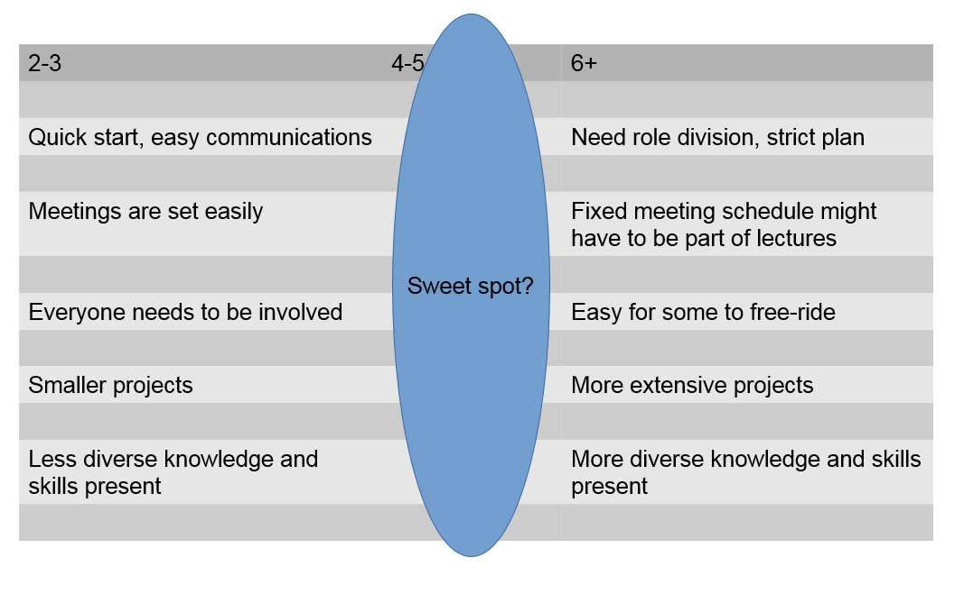

## Group selection

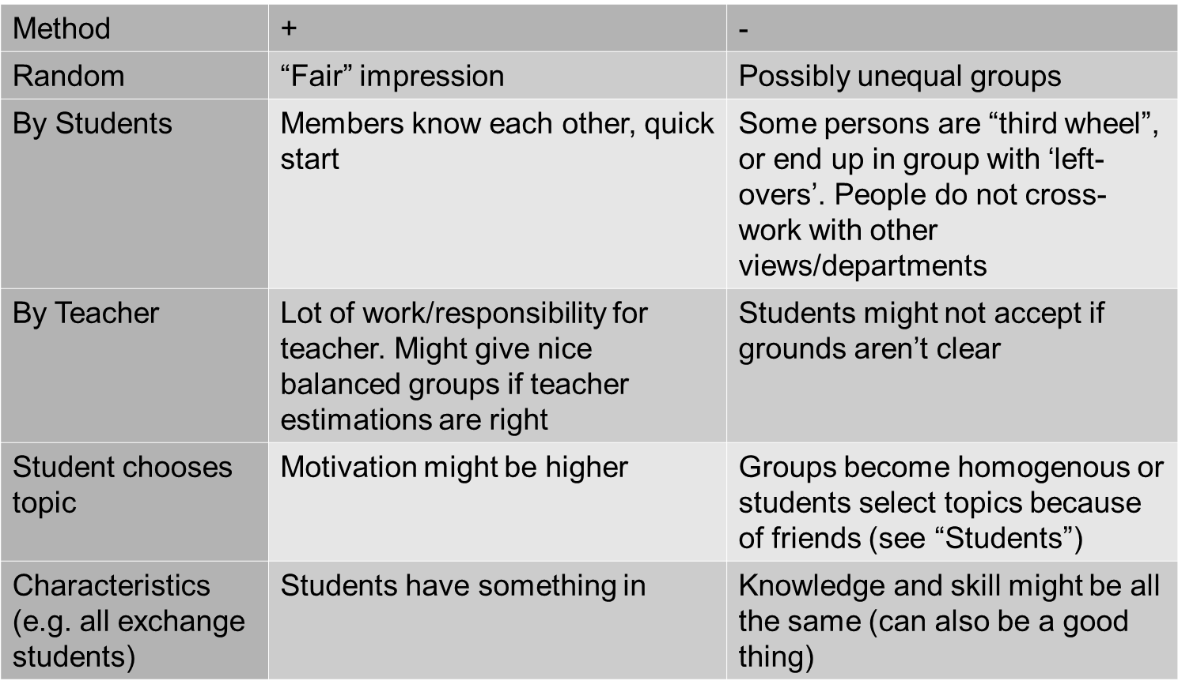

## Topic

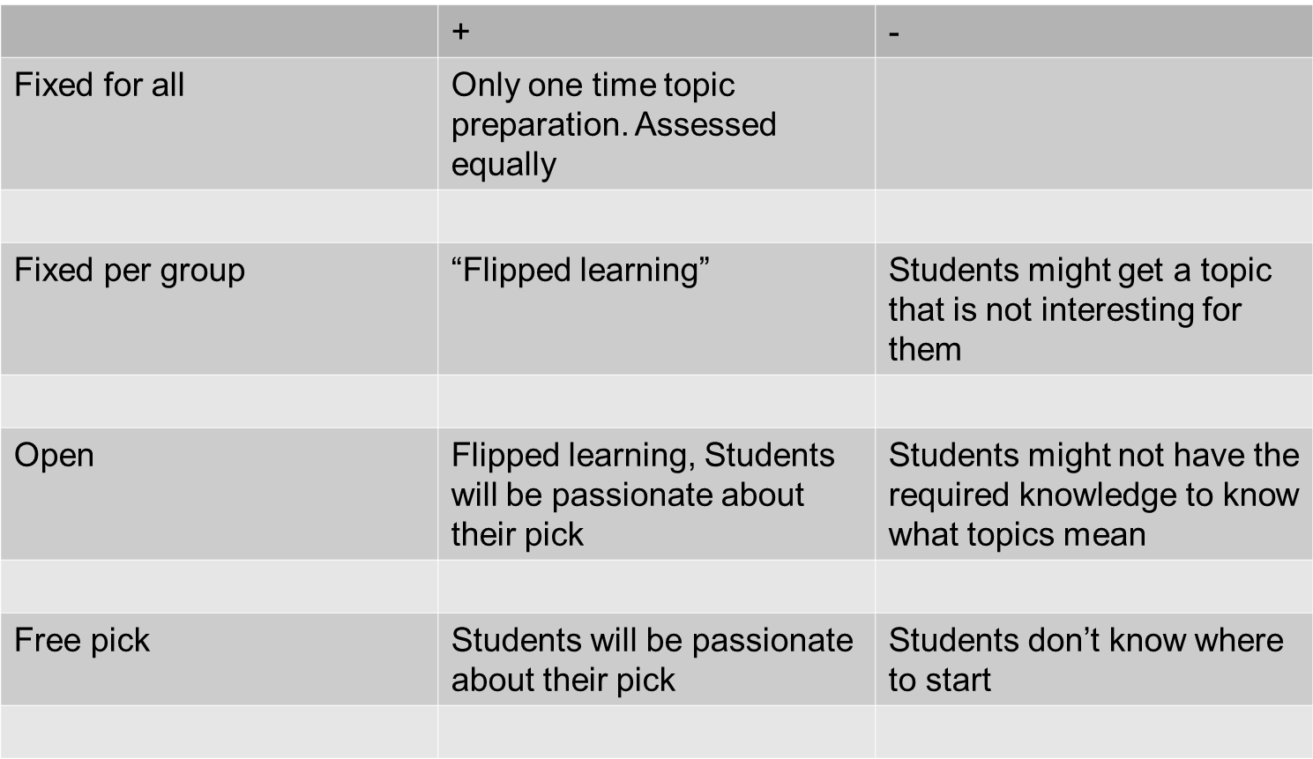

## Guidance

The objective of this activities is to **ensure to compliance of the objectives.** The following activities can help to guide and supervise the proper development of the project:

**Design a Plan for the Project**

* Stablish learning outcomes (conceptual knowledge and the ability to use that knowledge in decision making)
* “Think backward”—backward because they are planned around what they want students to be able to do when they have finished the course; only then do instructors think about what students need to know.
* Work load estimation.

**Monitor the Student’s learning and the Progress of the Project**

* Help students build deep knowledge and learn with understanding.
* Expand individual capabilities by using collaboration and technology tools in ways that enhance learning.
* Feedback is essential to content learning and immediate feedback also has tremendous impact on group development.

**Structured collaboration**

* Team-building activities designed to produce a sense of group identity and social cohesiveness. Such activities would include ice breakers or warm-up activities when groups are first; taking team photos; creating team names; providing explicit suggestions and concrete recommendations for promoting cooperation and teamwork .
* Roles and change them for each assignment: A sense of individual responsibility to the group may be increased if each group member has a specific and essential role to play in achieving the group's final goal or product.
* Provision of individual rewards as an incentive for promoting group interdependence. For example, if an individual student improves her score from one exam to the next, then all group members are rewarded by gaining extra (bonus) points toward their individual course grades.
* Report the evolution and the contribution of the members.

**Assess the Outcome**

* Team Test or other grades.
* Individual accountability. Individual grades.
* Grades given by the team members.

## Motivation

The objective of this activities is to **keep student’s interest in line with the project.**

**Engage students’ interests and prior understandings**

* Link important concepts to real-world applications.
* Think about what they already know about the topic and see how new learning fits.
* Assignments: When assignments emphasize making decisions, most students choose to complete the task by engaging each other in a give-and-take content-related discussion. By contrast, assignments hat involve producing complex output such as a lengthy document often limit both learning and team development because they typically inhibit intra team discussions in two ways.
* Individual interests.

**Student’s voice and choice**

* Ensure students do not feel obligated or constrained in a variety of preferred learning and comprehension styles for individuals finding the best medium for their subject area.
* Teacher, acting as a facilitator, may choose standardized elements, background research….

**Give the student reasons for getting involve in the work**

* Applicability of the concepts.
* Public exposition.
* Publication of the results.
* Contest.

# References

Teaching methods & group work:

* Hyppönen, O. & Lindén, S. Handbook for teachers - course structures, Teaching methods and assessment. - https://aaltodoc.aalto.fi/handle/123456789/4755 - available in Finnish, too
* Get inspired! A guide for successful teaching. -https://aaltodoc.aalto.fi/handle/123456789/11990 - especially in Chapter 5, pages 45-46.
* <https://teaching.unsw.edu.au/teaching-approaches-and-strategies>
* <https://www.cmu.edu/teaching/designteach/index.html>

Group projects:

* Barkley, E.F., Cross, K.P., & Major, C.H. (2005). Collaborative learning techniques. San Francisco: Jossey-Bass.
* Johnson, D. W., Johnson, R. T., and Smith, K. (1991). Cooperative learning: Increasing college faculty instructional productivity (ASHE-ERIC Higher Education Report No. 4). Washington, DC: The George Washington University, School of Education and Human Development.
* Millis, B. J., and Cottell, P. G., Jr. (1998). Cooperative learning for higher education faculty. American Council on Education, Series on Higher Education. The Oryx Press, Phoenix, AZ.
* Smith, K. A. (1996). "Cooperative Learning: Making 'Group work' Work" In Sutherland, T. E., and Bonwell, C. C. (Eds.), Using active learning in college classes: A range of options for faculty, New Directions for Teaching and Learning No. 67.

Group size and group selection

* Get inspired- Aalto University

Guidance and motivation

* Karen Sunday Cockrell, Julie A. Hughes Caplow, Joe F. Donaldson. A Context for Learning: Collaborative Groups in the Problem-Based Learning Environment. The Review of Higher Education, Volume 23, Number 3, Spring 2000, pp. 347-363.
* Joseph Cuseo. Cooperative Learning Vs. Small-Group Discussions and Group Projects: The Critical Difference. Cooperative Learning and College Teaching 2.3 (1992): 5-10-
* Barbara Gross Davis. Cooperative Learning: Students Working in Small Groups. Stanford university newsletter on teaching, 1999 Vol.10, No. 2.
* Doug Jacobson, James Davis and Barb Licklider, Ten Myths of Cooperative Learning in Engineering Education, 1998 FIE Conference pp. 790
* Larry K. Michaelsen and Michael Sweet. The Essential Elements of Team-Based Learning. NEW DIRECTIONS FOR TEACHING AND LEARNING , no. 116, Winter 2008
* [http://www.bie.org/object/video/john_mergendoller_keynote_pbl_world_2014](http://www.innovationunit.org/sites/default/files/Teacher's%20Guide%20to%20Project-based%20Learning.pdf)
* <http://www.innovationunit.org/sites/default/files/Teacher's%20Guide%20to%20Project-based%20Learning.pdf>
* [http://www4.ncsu.edu/unity/lockers/users/f/felder/public/Papers/Oakley-paper%28JSCL%29.pdf](http://www4.ncsu.edu/unity/lockers/users/f/felder/public/Papers/Oakley-paper(JSCL).pdf)
* https://www.edutopia.org/project-based-learning-guide-implementation
* https://www.youtube.com/watch?v=hnzCGNnU_WM