**MAIN OUTLINES OF FINNISH HISTORY**

* 5000 BCE  
  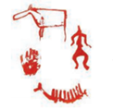

*THE SWEDISH REIGN*

* beginning in the 12th century
* 1548
* Who is Mikael Agricola?

*FINLAND AS A GRAN DUCHY OF RUSSIA*

* 1809
* 1812
* 1849
* 1866

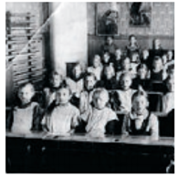

* 1906
* 1917
* Who is Elias Lönnrot?

*THE INDEPENDENT REPUBLIC*

* 1917
* 1918
* 1939-40
* 1941-44
* 1952  
  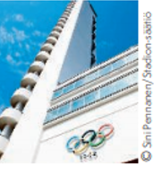
* 1991
* 1995
* Who is Martti Ahtisaari?
* Who is the Prime Minister of Finland now?