**Lab work 3: Measurement of size and isoelectric point of colloidal particles**

* **Objective**

The main objective of this lab work is to measure the size and isoelectric point of different colloidal particles: nanoparticles of silicon dioxide (silica) and aluminum oxide (alumina).

* **Introduction**

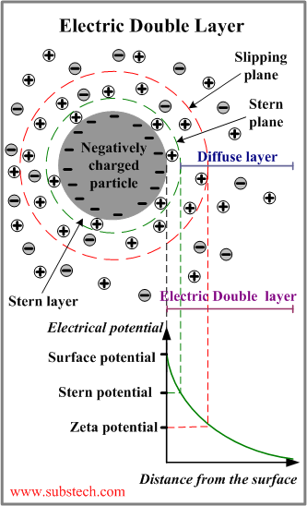

Colloidal particles are particles with dimensions in the range between 1 nm and 1 μm, approximately. The dispersion of colloidal particles in water is called colloidal dispersion.

The colloidal particles usually acquire a surface charge through different mechanisms when they are dispersed in aqueous solutions. That surface charge affects the distribution of ions around the particles, increasing the amount of counterions (ions of opposite charge) and decreasing the amount of coions (ions of the same charge). The space around the particles where the distribution of ions is affected by the surface charge of the particles is called electric double layer.

Due to their surface charge, the particles (and their adjacent layer of solvent and ions delimited by the slipping plane) move with a velocity when an electric field *E* is applied, according to the equation:

, where is the electrophoretic mobility.

The electrophoretic mobility is related to the potential at the slipping plane, called zeta potential *Z*:

(Smoluchowski, valid for particles with radius much larger than the thickness of the electric double layer)

(Hückel, valid for particles with radius smaller than the thickness of the electric double layer)

where and are the viscosity and dielectric constant of the medium, respectively.

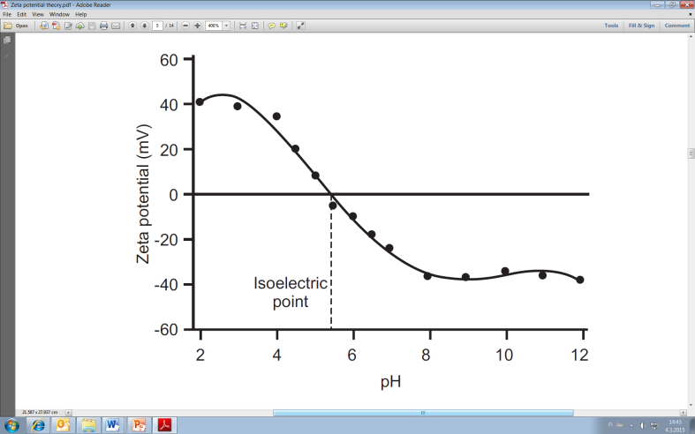

The isoelectric point (i.e.p.) is defined as the pH at which the electrophoretic mobility and, therefore, the zeta potential are zero. In general, the i.e.p. is not exactly the same as the point of zero charge of the particles because the ions trapped between the surface of the particles and the slipping planes also contribute to the electrophoretic mobility of the particles.

* **Experimental methods**

In this lab work the size and i.e.p. of silica and alumina nanoparticles will be measured using a Malvern Zetasizer instrument. The principle of operation of the instrument is based on the analysis of the light scattered by the particles moving either freely in solution (Brownian motion, for size measurements) or under the influence of an applied electric field (for zeta potential measurements). Please carry out the lab work according to the following instructions:

* Prepare 500 ml of 10 mM NaCl solution (MWNaCl = 58.44 g/mol).
* Add 0.025 g of silica powder to 200 ml of 10 mM NaCl solution. Agitate the mixture using ultrasound for 10 min.
* Transfer 20 ml of the silica suspension to 9 plastic bottles. Adjust the pH of the suspension in each bottle to values ranging from 2 to 10 using HCl and NaOH solutions (0.1 M or 1 M). Try to add small volumes of HCl and NaOH solutions for not altering the particle concentration considerably. Check the pH with a pH-meter.
* Transfer 1 ml of each sample to a cuvette with electrodes and measure the zeta potential of the particles following the instructions of the Malvern Zetasizer manual (at least 3 measurements per sample).
* Transfer 1 ml of each sample to a plastic cuvette and measure the size of the particles following the instructions of the Malvern Zetasizer manual. Write the values of size and polydispersity index PDI (PDI takes values between 0 and 1; closer PDI to zero more monodisperse the colloidal system is, that is, all the particles have similar size).
* Repeat all the previous steps using alumina instead of silica nanoparticles.
* **Homework**

- Compare the size values of the nanoparticles obtained at different conditions. Discuss the results.

- Plot the experimental data of zeta potential *versus* pH for silica and alumina nanoparticles. Determine the i.e.p. of the nanoparticles from the graphs.

- Compare the obtained i.e.p. values with those found in the literature. Discuss the results.

* **Additional information**

- This lab work is carried out in a group of 3 people. The answers to the homework should be submitted in a common report within one week.

- Up to 3 points can be obtained for this lab work: up to 1 point for the work in the lab, and up to 2 points for the report with the answers to the homework.

- Safety in the lab is a very important issue. You must always wear lab coat, gloves and goggles when you work in the lab.