Mandatory readings for critical reading assignment #1.

Pick 5 out of 8 in this list

Brown, T. (2008). Design Thinking. Harvard Business Review.

https://web-p-ebscohost-com.libproxy.aalto.fi/ehost/pdfviewer/pdfviewer?vid=5&sid=7b45c7cc-e3a7-4507-bc7f-1961257fee07%40redis

Björklund, T. (2019). The changing role of design. In: Design +: Organizational renewal and innovation through design. Aalto University

2019_DesignPlus_book_ONLINE_version.pdf (aalto.fi)

Björklund, T. (2019). The foundations of design thinking. In: Design +: Organizational renewal and innovation through design. Aalto University
2019_DesignPlus_book_ONLINE_version.pdf (aalto.fi)

Design Council: What is the framework for innovation? Design Council’s evolved Double Diamond https://www.designcouncil.org.uk/news-opinion/what-framework-innovation-design-councils-evolved-double-diamond

Dorst, K. (2015) Chapter 3: Lessons from design. In: Frame innovation: Create new thinking by design. MIT Press.

https://primo.aalto.fi/permalink/358AALTO_INST/1g8mond/alma997849334406526

Dziobczenski, P.R.N. (2023). Strategic design – A viewpoint about to change. In Soini-Salomaa. LAB Design Annual Review 2023. Lahti: LAB University of Applied Sciences. 14 - 22 https://www.theseus.fi/bitstream/handle/10024/817070/LAB_2023_73.pdf?sequence=2#page=14

Stickdorn, Marc, Adam Lawrence, Markus Edgar Hormess, and Jakob Schneider. Chapter 01: Why Service Design? In: This Is Service Design Doing : Applying Service Design Thinking in the Real World : a Practitioners’ Handbook Sebastopol, CA: O’Reilly Media, Inc., 2018.

ProQuest Ebook Central - Detail page

Stickdorn, Marc, Adam Lawrence, Markus Edgar Hormess, and Jakob Schneider. Chapter 02: What is Service Design? In: This Is Service Design Doing : Applying Service Design Thinking in the Real World : a Practitioners’ Handbook Sebastopol, CA: O’Reilly Media, Inc., 2018.

ProQuest Ebook Central - Detail page

Critical reading #2 assignment list of readings
Pick one chapter from Part 01 of the book ‘The Handbook of Design Management’(see image below). Editorial Introduction is not a chapter.
Cooper, R., Junginger, S., & Lockwood, T. (2013). The handbook of design management. A&C Black.
https://primo.aalto.fi/permalink/358AALTO_INST/1g8mond/alma999516116806526
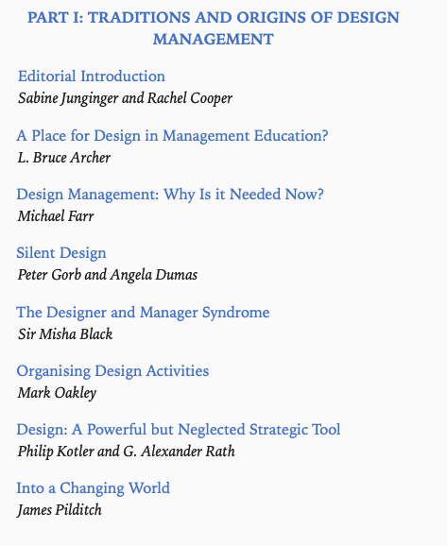
Pick from Design Bits online course - https://designbits.aalto.fi/ - Chapters 01, 02 and 07. Plus, you need to select at least one of the pillars (chapters 03, 04, 05 and 06).
These two texts
Dziobczenski, P., Keinonen, T., Sekar, B. ‘MY PREVIOUS VIEW OF DESIGN WAS LIMITED’ – TEACHING DESIGN TO NON-DESIGNERS AT [UNIVERSITY]’. (2024) Accepted for the NordDesign Conference 2024.
Uploaded to MyCourses

Micheli, P., Wilner, S. J., Bhatti, S. H., Mura, M., & Beverland, M. B. (2019). Doing design thinking: Conceptual review, synthesis, and research agenda. Journal of Product Innovation Management, 36(2), 124-148.

https://primo.aalto.fi/permalink/358AALTO_INST/cis3s6/cdi_crossref_primary_10_1111_jpim_12466

