

**cuñados**



**“Ham should not be cut like that. Let me show you how it’s done.”**

**“I would have got that at half the price.”**

**What do you think of these sentences? Why could they be considered a piece of brother-in-law talk?**



1. You can live in Spain like nowhere else.
2. Crisis… What crisis? The terraces are full!
3. I don’t want any male chauvinism nor any feminism. Just equality.
4. Right… They say they are communists, but they own an iPhone.
5. And when will a Straight Pride parade be organised?
6. All politicians are the same. Thieves and liars!
7. I’m not a racist, but we should take our nationals into account first.
8. I would give a pick and a shovel to that bunch of slackers!
9. The state workers are lazy because they can’t be fired.
10. They can go on strike if they want, but the rest of us shouldn’t have to suffer it.

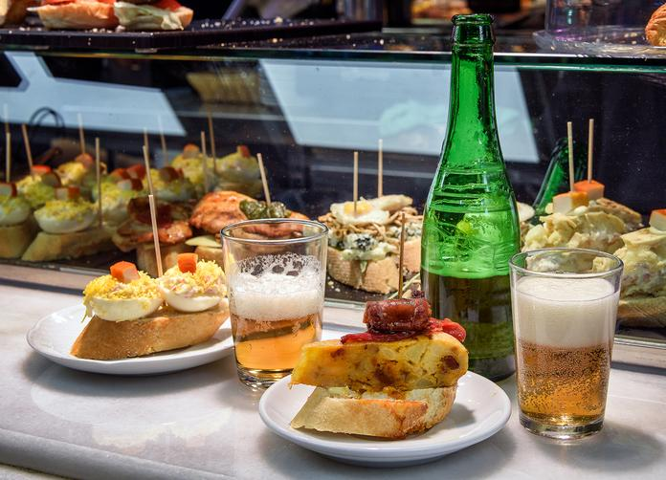

**Here we are, just suffering…**