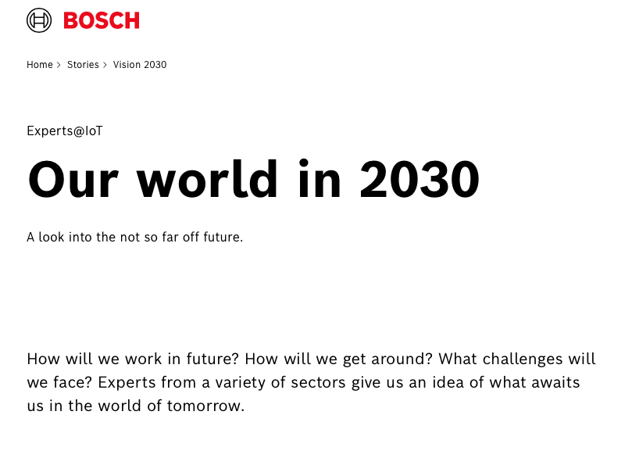

https://www.bosch.com/stories/vision-2030/

https://www.bosch.com/stories/future-of-robotics/

https://www.bosch.com/stories/industry-4-0-merging-man-and-machine/

https://www.bosch.com/stories/air-taxis/

https://www.bosch.com/stories/thought-leader-annemike-unterschuetz/

https://www.bosch.com/stories/open-manufacturing-platform/

https://www.bosch.com/stories/artificial-intelligence-in-industry/

https://www.bosch.com/stories/thought-leader-frank-appel/

https://www.bosch.com/stories/thought-leader-johann-jungwirth/

https://www.bosch.com/stories/digital-mall-future-of-retail/

https://www.bosch.com/stories/future-of-farming/

https://www.bosch.com/stories/motorsport-formula-e/

https://www.bosch.com/stories/thought-leader-michael-chui/

https://www.bosch.com/stories/future-of-the-internet/

https://www.bosch.com/stories/thought-leader-kala-fleming/

https://www.bosch.com/stories/future-transportation-in-urban-infrastructure/

https://www.bosch.com/stories/artificial-intelligence-progress/

https://www.bosch.com/stories/future-of-quantum-computing/

https://www.bosch.com/stories/innovation-culture/

https://www.bosch.com/stories/impact-of-self-driving-cars-on-society/

https://www.bosch.com/stories/artificial-intelligence-in-business/

https://www.bosch.com/stories/agile-innovation-management/

https://www.bosch.com/stories/thought-leader-guenther-schuh/

https://www.bosch.com/stories/digital-business-transformation/

https://www.bosch.com/stories/didi-new-mobility-services/

https://www.bosch.com/stories/thought-leader-tobias-menne/

https://www.bosch.com/stories/economic-impact-of-self-driving-cars/

https://www.bosch.com/stories/green-energy/

https://www.bosch.com/stories/green-tech/

https://www.bosch.com/stories/digital-future-daily-life/

https://www.bosch.com/stories/smart-grids-renewable-energy/

