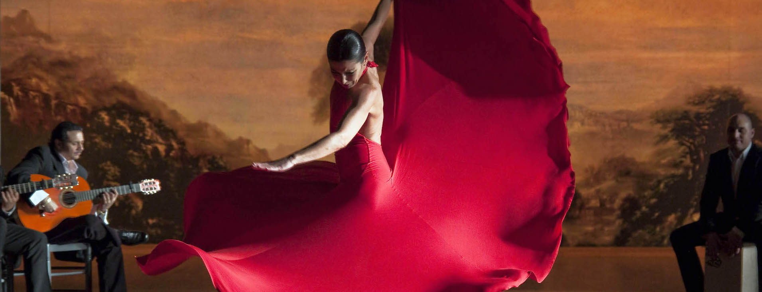
- It is almost impossible to fire the civil servants, and it is very difficult to bribe them.
In Spain…
True or false?
- A policemen can fine anyone they want with 600 € without any evidence of a crime.
- It is difficult to be invited to have a coffee at somebody’s home.
- The Catalans want to be independent. They also force everybody living there to speak Catalan.
- The Basque terrorist organization ETA existed between 1959 and 2018. During its almost 60-year-long history it killed roughly 80 000 people.
- The Madrid region is very rich and managed to save thousands of lives in its nursing homes during the COVID-19 pandemic.
- The national anthem has no lyrics, and the flag makes many people uneasy.
- According to the official statistics ―carried out by the CIS, which is the Centre for Sociological Research―, most Spaniards are now in favor of setting up a republic.
- The state has donated a world heritage site and thousands of monuments and real estate properties to another state and does not want them back.
- A paella can have meat, fish, or even squid ink, but never any chorizo.
- The mortality in traffic accidents is not high, and the national transplant system is the world’s best.
- The southern region of Andalusia has a remarkably good network of public daycare centers, partially thanks to the EU funds.

