Swedish for international students 1A
Lektion 1
Lärare: Isabella Fröjdman, isabella.frojdman@aalto.fi
Presentation
1) Jag heter … [ja heettär]
1) Vad heter du? [va heettär dy]
2) Jag kommer från …
[ja kommär froon]
2) Varifrån kommer du? [varifroon kommär dy] 3) Jag talar … [ja taalar]
3) Vad talar du för språk? [va taalar dy föör sprook]

https://tt.se/tt-spraket/ord-och-begrepp/internationellt/stat-och- nationalitet/

2
Today´s lesson
1) Presentation in small groups 2) Information about the course 3) How do you learn languages?
4) About Swedish in Finland
5) Text: Här är vi s. 6 - 7 + exercise

3
Time and place
- Course: 5.9.2022-12.10.2022
- On Tuesdays 10.15-11.45 in Y-228b
- On Thursdays 10.15-11.45 in Y-346

- Written exam and oral exam
- Isabella informs you about the dates

Learning outcomes
After the course, you can:
• introduce yourself or someone else
• use simple greeting or parting phrases
• understand numbers, prices and times
• talk about where you live or describe your normal day using simple
language
• know the language needed to buy basic things or order something
at a restaurant or café

= basic Swedish skills for the simple everyday communication

Assessment methods and criteria
• Regular attendance (80%)

• Grading scale for the course:
0-5
• Written exam 30%
• Oral exam 30%
• Active participation and written and oral assignments
during the course (40%)

Study material: Vi ses! (2018)
by Marit Keränen, Camilla Lindroos, Katja Peltola

Chapters 1-3: pages 6 - 57
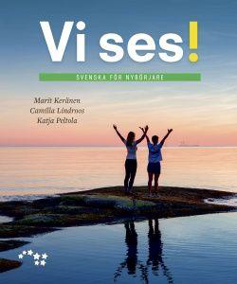

- WE ALSO LISTEN TO SWEDISH MUSIC AND DISCUSS SWEDISH TRADITIONS, HABITS ,,,

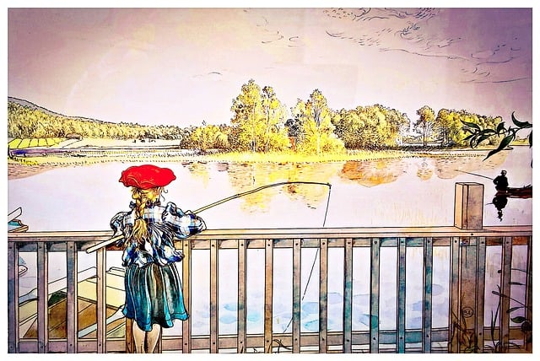

How do you learn languages?
- Discuss the questions rooms:
1) What is the best way of learning? for you?
2) What do you like or hate about learning languages?
3) Expectations/wishes for this course?

Your best tips for learning a new
language
- Different kinds of applications: Duolingo, Drops,
Quizlet
- Swedish music from Spotify
- Spotify: Learn Swedish
- Tv-programs in Swedish
- Att äta på Täffä (Otakaari 22) (Täffä =
Teknologföreningen)

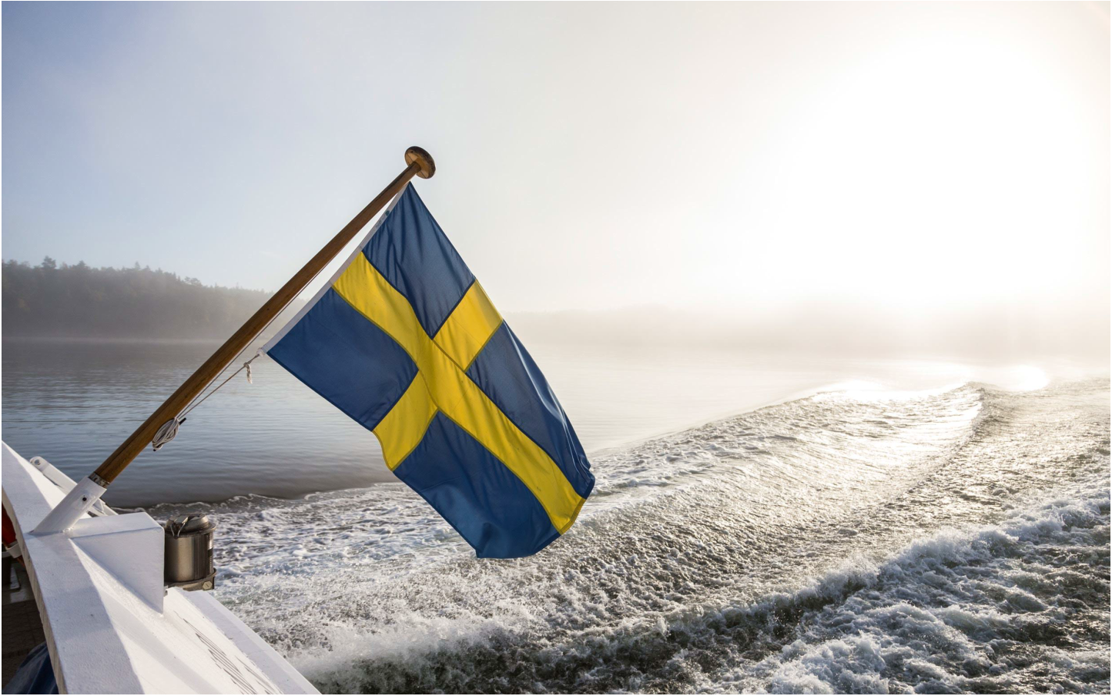
About Swedish in Finland
Finland is a bilingual country
• Finland has two official languages: Finnish and Swedish
• 90 % of Finns speak Finnish as their first language - roughly 5 % speak Swedish
• You can use either language when dealing with government officials
• Swedish is spoken the most on Finland’s western and southern coast - in a few
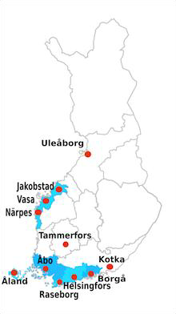
places, Swedish is spoken more commonly than Finnish
• Some jobs require both Finnish and Swedish skills
• In Finnish schools, both Finnish and Swedish are studied

Swedish
• Swedish is an Indo-European language and belongs to the group of
North Germanic languages.
• In Swedish, verbs inflect for different tenses. Nouns are divided into two
genders. Adjectives inflect by these genders.
• Swedish uses a large number of prepositions and its word order is very
regular.
• The Swedish spoken in Finland is called Finland Swedish. It is
pronounced differently from the Swedish spoken in Sweden.

Här är vi! s. 6-7
- Lyssna på texten
- Gå igenom fraserna på sidan 7

Gå igenom fraserna s.7
- Jag heter…
- Jag är…
- Mitt namn är…
- Jag studerar…
- Jag har…
- Jag jobbar…
- Jag arbetar…

- Jag kommer från…
- Jag bor i…

Presentera dig själv/ Introduce yourself
- Make a presentation where you answer the following questions:
1) Vem är du? – Jag heter … [ja heettär…]
2) Varifrån kommer du? – Jag kommer från… [ ja kommär froon]
3) Vad talar du för språk? – Jag talar… [ja taalar…]
4) Var bor du? – Jag bor i… [jag buur i…]

(It can also be a short video)

Hemuppgifter
1) Läs, översätt och lyssna på texten: Här är vi! s. 6 - 7 Read, translate into English and listen to to text. Do the exercise on page 7.
2) Make your presentation. It can also be a video
3) Läs texten: (just read it)
https://www.sayitinswedish.com/blog/language/swedish-has- a-sister-in-finland/

