Hello Designers!
General rules for getting your yarn
- You resource the materials you need yourself. You can buy for eg. from Finnish yarn suppliers, yarn shops or online stores (see last page list of suppliers – university has the shade cards for most suppliers)
- University will make a shared order to the agents & suppliers of industrial yarns. These yarns are only available for companies with VAT number (some exceptions apply). Please note that if you have a company of your own and a valid VAT number, you can also order the yarn yourself. In this case, please ask the staff for more information (contact person, agent etc).
Shade cards for the shared orders are in the weaving workshop side table at the moment, generally you will find them in the weaving workshop cupboard. If you can’t find what you are looking for, please ask for help.
- You buy the whole cone you order and you pay when you collect. Delivery time for these industrial yarns is 4-8 weeks (Finnish suppliers deliver within a week depending on the stock).
Cone sizes vary between suppliers and even within the same quality (0,5 – 1,4 kg). If we have ordered the same yarn before, you can find the previous price per kg from the workshop’s pricelist. The price you will pay consists of the price per kg, +freight costs, +10% university costs and VAT (arvonlisävero) 24%.
Those of you who are interested in the shared order for industrial yarns,
please find the list via the link below (deadline is 29.01.2019)
https://aaltofi-my.sharepoint.com/:x:/g/personal/tiina_saivo_aalto_fi/EWN-zXyiigNBhYovcPZM7T4BUG5fMgb9balF8Qvq_1OwQQ?e=Gi8SiA
- Choose Edit workbook Edit in Browser
- Fill in all the columns, ask for help if needed
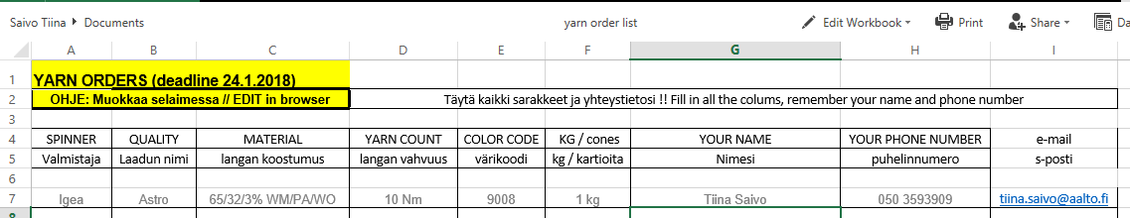
- File is automatically saved

Please note that the yarn stored in the workshops is course material and only for sampling!
University will order more of the most popular qualities for sampling and shared use – if you know you will need a full cone please order it for yourself
Anna-Mari and Maija are available for tutoring when you need help in choosing your yarn, calculating the amounts etc.

We will make a shared order to the following companies

Sesia *yarns that are in stock service*

Igea *Astro + Astro 50, Nm 10*

Filmar *Fine cotton yarns Nm 50/3 – Nm 100/2*

Baruffa *Cashwool Nm 2/30, cone sizes 1,1 – 1,4 kg*

Venne Colcoton *minispools 50-100g, eurocones 1,0 kg*
Check yarns: www.vennecolcoton.com

Lurex *minimum order per color is 1 kg*

Corneta *minimum order 1 cone per color*

Elastan *Baktron 1300 (90 % PES 10% Lycra)*

Luigi Boldrini *Techno, sample colors available in 1 kg, minimum order per color 10kg*

Avia *Fancy yarn*

From these companies you can buy yarn yourself
Yarn shops to visit in Helsinki (most of them also sell yarn online)
Snurre in Kamppi https://www.snurre.fi/
Fiinaneule in Kamppi (Simonkatu 12) http://www.fiinaneule.fi/
Menita shop in Korkeavuorenkatu 20 http://www.menita.fi/myymalat/
Vihreä Vyyhti is in Hakaniemi (Street: Toinen Linja 1) https://www.vihreavyyhti.fi/
Lankamaailma in Oulunkylä shopping Centre ”Ogeli” http://www.lankamaailma.fi/myymalat/lankamaailma-helsinki/
Online shops
www.titityy.fi
http://www.lankatalo.net/
https://novitaknits.com
BC Garn http://www.bcgarn.dk/
Venne Colcoton www.vennecolcoton.com
…and many more
Finnish Yarn Suppliers (with Online shops)
Wetterhoff Oy, www.wetterhoff.fi
Lankava, https://lankava.fi
Toika, https://kauppa.toika.com
Tekstiiliteollisuus, https://teeteeshop.fi
Lappajärven Värjäämö https://lappajarvenvarjaamo.fi
Pirtin Kehräämö http://www.pirtinkehraamo.fi/verkkokauppa
Pirkanmaan kotityö www.taitopirkanmaa.fi

