Tu-E4031 Startup Finance
5 ects

Course Brochure – Spring 2024
Period IV (Thursdays 09.15 – 12.00)

U9-U271 Kandidaattikeskus (Otakaari 1)

Peter Kelly
Connector & Senior Lecturer, High Growth Entrepreneurship, Aalto University

Office: Tuas Talo (2168) Maarintie 8 (2nd floor)
Mobile: +358 41 503 4508
Email: peter.kelly@aalto.fi
Skype: theideastudio

Learning Objectives:

This course has been designed to enhance students' understanding of the dynamic challenges faced by entrepreneurial ventures in securing financial backing to support future growth and development. We shall examine these challenges in a variety of industry settings and stages of venture development both from the capital seeker (entrepreneur) and capital provider (investor) perspectives.

After this course, participants can:

- Identify and assess various sources of finance to support entrepreneurial ventures
- Interpret information presented in historical financial statements and forecasts
- Evaluate the “value” of a venture
- Understand the dynamics of negotiation and structuring deals, and importantly
- Gain perspective on navigating the X-factor, timing

Target Audience:

There are three distinct groups to which this course has been targeted:

- Entrepreneurs who are intent on raising financial support for their ventures;
- Individuals who wish to pursue careers in venture capital or private equity; and
- Those wishing to pursue careers professionally supporting entrepreneurial ventures (banking, consulting, legal, etc)

Pre-Requisites:

My starting assumption in the course is that students have limited practical knowledge of finance and financial statements. And my assumption is well grounded from my own experience as an MBA graduate specializing in finance. I was a highly capable reader of financial information but a much less developed interpreter of the nuances of what the numbers were telling me. A major objective of this course is for participants to become more astute consumers of accounting information. It is essential for entrepreneurs to have financial literacy (an ability to read financial statements) even though they are not editors (auditors) of the books. Sound financial information is absolutely vital to make informed decisions about pricing, scaling and financing a business. It is absolutely lethal not to have a feel for how a venture is doing financially!

You will discover that entrepreneurial finance is more ART than science. In the murky world of startups, you are dealing with incomplete and in many instances, non-existent financial data (and no projections don’t qualify as data!). A lot of intuition and common sense underpins investment decisions in startups. Is there an opportunity here? (does it make sense?) Is the proponent credible? (do I believe what they are saying and in their ability to deliver?) Is the opportunity big enough to scale up and thereby open up exit possibilities? (can I see some capital gain potential?)

And in this edition of the course, we will be grappling with a very real and contemporary challenge … are the finance markets even open for business for startups?

Teaching Method:

Traditionally this course has been an immersive face-to-face experience mirroring the approach of entrepreneurs raising support for their ventures – which involves meeting people and making presentations, in person. Social distancing has opened up possibilities to connect but the ever present challenge of building bases of trust with strangers at a “digital distance” is an open issue. Can you really get a level of comfort investing in someone who you typically do not know and have never met in person?

The subject matter of the course lends itself to lively discussion that will take place in regularly scheduled “meet ups” (not lectures); an ideal forum for exchanging views and learning. Deeper background information is provided in the “Materials” and “Online Resources” sections of MyCourses. We will also use practical case studies and insights from practitioners.

Before each “meet up”, I expect all participants to read the assigned material and cases studies thoroughly and provided question(s) to consider beforehand. For topical questions, I expect you to seek out and integrate contemporary insights from the business press. The case studies lend themselves to both qualitative and quantitative analysis. In my experience, group discussions are an excellent way for individuals to prepare for class and I strongly encourage you in this course to "talk through the issues" with others. Having said this, the task of writing up reports is an individual endeavor.

Reference Material:

There is no formal textbook for the course, but you will find a wealth of material and online resources on the MyCourses page. As you navigate your journey in the course and uncover other materials or resources that you consider insightful, please reach out to me and I will upload them onto the MyCourses page.

Many students use this course as a springboard for their Masters’ thesis work. By putting so much material “out there”, you get a better sense of what work has been done and what questions need to be explored further. In my opinion, your negotiating power is a direct function of your perceived and credible awareness and understanding of the audience’s domain, be they investors, bankers, lawyers, public financiers, and other founders.

Course Material:

A number of cases will be used throughout the course. Arrangements for distribution will be discussed during the first scheduled meet up. In a fast moving, dynamic domain like entrepreneurial finance, it is also advisable to keep on top of developments by developing a habit and appetite for reading the contemporary business press.

Grading Scheme:

Your final grade in the course will be determined by two components:

Individual Components 60%
Group Project 40%

Individual Components (60%):

- Meetup Activities (10%)

We will have various activities during our meetups – to participate you need to be there.

- Meetup Assignments (15% - 3 write ups x 5% each)

Question related to specific issues/cases to be discussed during our meet up sessions. As we have 5 meetup sessions (excluding the first session) scheduled, you can freely choose any 3 to be submitted in MyCourses by the beginning of the respective session.

To practice the discipline of “getting to the point”, aim for impactful 1 page executive summary submissions (bullet points acceptable) that are supported by exhibits & citations as appropriate (no page limitations).

- Entrepreneurial Finance Market Personal Forecast (10%)

During 2021, the market for entrepreneurial finance could be described as white-hot in terms of investment. The number of companies completing Initial Public Offerings in 2021 was more than 2,5x higher than the dot.com bubble of 2000 according to Stock Analysis:

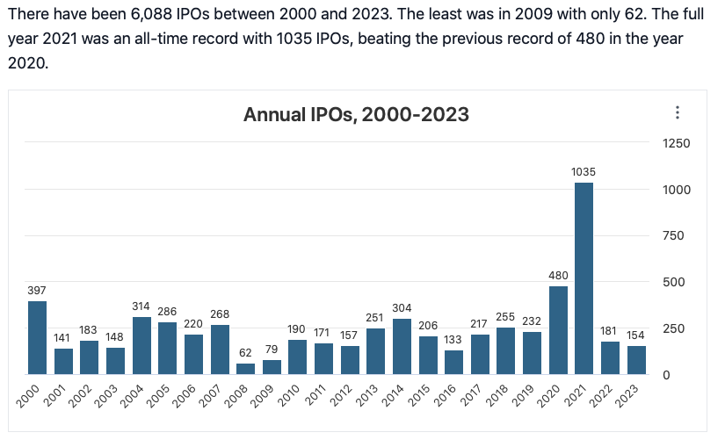

IPO activity fell off by 83% in 2022 and by a further 15% in 2023. Venture capitalists often look to receptive IPO markets to achieve exit, so any downturn of conditions and reduced appetite for risk impacts both their ability to generate returns for and raise new funds from their limited partners. And even if an exit is achieved by way of IPO, the returns to investors post IPO have been less than stellar. For companies that went public in 2023, 60% are trading at prices less than the listing price at the time of the IPO and more striking, 70% of those are trading more than 50% less than listing price! More than one in five companies that went public in 2021 are trading at more than 50% less than the price set when they originally went public! Government budget deficits are growing. Destructive conflicts are happening in Ukraine and Gaza. Inflation and interest rates are abating but still uncomfortably high.

What is your personal outlook for entrepreneurial finance markets in 2024? Put another way, if you were an entrepreneur seeking to raise funding, is this the right time to do so? 3 page maximum (excluding exhibits and citations) and you are strongly encouraged to support your arguments – trust me there is LOTS of business press coverage on this!

- Take Home Exam (25%)

I will also distribute early in the course a case study that will require a more detailed (3 pages maximum excluding exhibits) write-up from each student. This individual case assignment will be due at a date to be determined at the beginning of the course and it will count for 25% of the total course grade.

Course Project:

The major course assignment will be a project to be undertaken by groups of no more than 4 students. Regardless of option selected, the report submitted must not exceed 20 pages (excluding exhibits). There are five options available to satisfy the course project requirement:

- The entrepreneurial venture activation option is targeted those who have a specific project in mind to launch in the future. Activating a venture is a lot like putting on a play. The entrepreneur takes on the role of director. To stage a play needs a script (business plan), a cast (founding team), a venue (business domain), and sponsorship (investors back plays that hold out the prospect of attracting big audiences). You will have an opportunity in our first class to pitch your idea and seek out assistance. The scope and focus of the project will be negotiated with the course instructor.

- The valuation option is targeted at those who wish to "benchmark" the valuation placed on an entrepreneurial company that has recently been listed on a public exchange. You will need to obtain a copy of the offering prospectus and will be expected to establish and critically evaluate the basis for valuation. I expect you to comb through information available across different markets. You can search the SEC Edgar database (https://www.sec.gov/edgar/searchedgar/companysearch.html) for prospectuses lodged in the US. Another search strategy is to navigate to a company’s investor relations site or search with the company name + prospectus. You do not have to restrict your search to US based companies!

- The technical note option is targeted at those who wish to explore a specific aspect of entrepreneurial finance in detail, such as management issues related to the management of cash flow in high growth firms, the role of corporate venture capital, exit mechanisms, business models, challenges associated with raising money in family business settings, crowdfunding and basically anything of interest to your team and acceptable to the instructor. You may also choose to take on a fast-moving development. Rumor has it there has been an implosion in the cryptocurrency “market” unfolding as we speak. There is lots of debate around the central point of practical utility.

- The unicorn/decacorn/hectacorn option – a growing number of private companies have achieved valuations exceeding $1 billion (unicorn), $10 billion (decacorn) or $100 billion (hectacorn). According to CBI Insights (2023) there are currently 1173 unicorns (as of January 2024 – 1129) 49 decacorns and 2 hectacorns (Bytedance and SpaceX). More than 60% of the decacorns are US based. The cumulative estimated valuation is $3.775 trillion. You can access the updated list here: (https://www.cbinsights.com/research-unicorn-companies) Choosing any company you like from that list, I would like you dig into the reasons why such a high valuation is warranted relying on company provided and secondary sources of information as well as personal insights for perspective. And incidentally, 4 Finnish companies made the list Relex ($5,7b), Aiven ($3,2b), Oura ($2,6b) and HMD Global ($1b)

- The freelance option of your creation – the focus and scope of which is proposed to and negotiated with the course instructor.

Regardless of option selected, the topic must have prior clearance from the instructor to ensure the scope will satisfy course requirements and the project can be completed in a timely manner. There are some particularly useful "compendium" web sites that can help spearhead the process of identifying relevant background literature that you may find to be invaluable:

- www.entrepreneurship.org
- http://www.babson.edu/Academics/centers/blank-center/bcerc/Pages/frontiers-of-entrepreneurship-research.aspx

Preliminary Schedule of Coming Attractions:

29 February Getting Into Business (Entrepreneurial Project Pitchs)
Market Context and Timing

Case: Rowing Machines (seeking £100,000 equity)

7 March Bootstrap Mindest Founders Family Friends & Fools (FFFFs)
Raising Support from the Crowd (Crowdfunding) and Customers

Exercise: Creating a Campaign
Case: Emmy Clothing (equity)

14 March Raising Support from Business Angels

Cases: Unique Slimming Programme
Mobile Productivity
Compact Pyrloysis
Guest: Miikka Miettinen, Deal Flow Manager, FIBAN

21 March Raising Support from the Bank (Debt)

Case: Advanced Business Computers
Exercise: A First Look at the Art of Valuation
Guest: Petri Laine, Partner Innovestor

4 April Raising Support from Venture Capitalists / Working Capital

Case: Waterstone & Company
Exercise: The Self-Financing Growth Rate
Guest: tba

11 April Building and Leveraging Networks

Case: R&R Games
Exercise: Networking With Confidence
Guest: Toni Mikkonen, CEO, The Finnish Climate Fund

Submissions & Deadlines:

Due to the large number of participants, the following guidelines will be strictly enforced:

- While I encourage you to discuss issues in groups, individual assignments must be completed on your own in your own words …
- Individual assignment instructions will be provided one week in advance and submissions are to be made through MyCourses by 09.30 on the meetup date where the respective topic/case will be discussed. There will be no makeups.
- The take home exam must be submitted through MyCourses by (9 April)
- The final project must be submitted through MyCourses by (22 April)

