How to type Pinyin:
www.mdbg.net click “三” on the left top of the page -> Type pinyin
Type 1, 2, 3,4 after each word: Fen1lan2

How to type characters with Google word-processing function:
HOW TO GET THE “TYPE BAR” READY
- Go to web-page: https://translate.google.com
- Choose first language as Chinese/kiina(on the left side), and choose second language as English (on the right side)
- Click the arrow on the right side of “拼” and choose “Chinese (simplified han, Chinese - Pinyin)” and you will get a “Type Bar” on the right low side of your page: 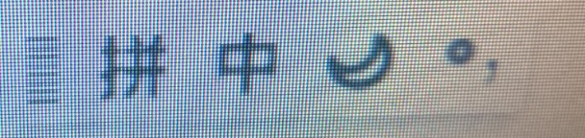
- When you have the “Type Bar”, you are ready to type characters. You can make the bar appear and disappear by clicking the 拼 symbol.

HOW TO TYPE CHARACTERS
- Type the whole sentence without capital letter, space or tone marks, for example, type: woshifenlanren and choose 1 我是芬兰人
- You will see the pinyin of this sentence under Ä and 拼: Wǒ shì fēnlán rén
(If you cannot see the pinyin, just click the Ä to show and disappear the pinyin)
- Type “v” to get “ü”
- When you have “r”(like in “nar”), type “er” instead of “r”: “naer” 哪儿
- To check you result, you can 1. check the pinyin (the best) 2. check the translation on the right side of the page

