Zoom instructions
Before the class:
- Please download and install the Zoom app before the course starts, and use the app whenever possible.
Participants usually have audio problems when joining the meeting from a browser without downloading plug-in or software, thus using browsers for Zoom meetings is possible but not recommended.
- Please test your devices (microphone, camera, and speaker) and your connection in advance and join the class at least 5 minutes early to make sure things work properly.
How to join the class:
- A link and a meeting ID will be posted on the course homepage. Click on the link or use the meeting ID to join.
- Please use your full name when joining the class
During the class:
- Mute your microphone, unless you’re instructed to do otherwise
- The participant controls can be found at the bottom of the Zoom window:
- Click on “Participants” to see the list of participants and more non-verbal icons, which will be used during the class.
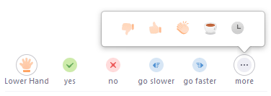

- If you have audio problems, first check the audio settings by clicking on the small arrow next to “mute/unmute” icon
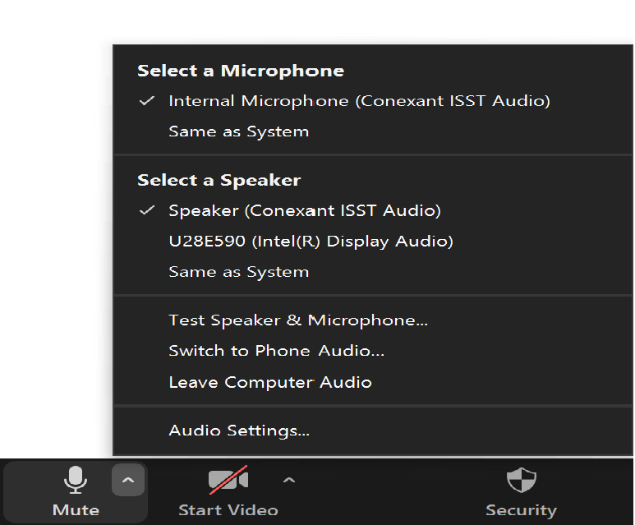

Open audio settings and check the speaker/microphone:

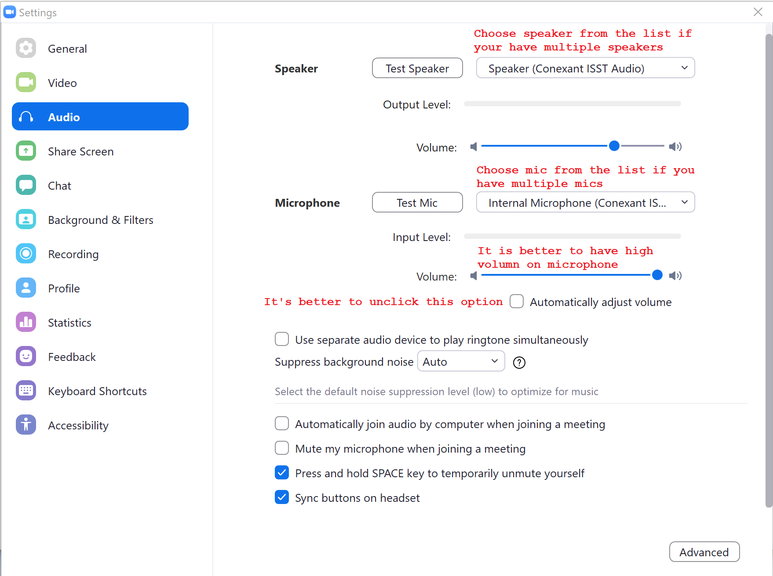
If it still doesn’t work, try to leave and join the meeting again, or restart your computer. Still, it is recommended to test your devices well in advance.
Finally, you can find all detailed instructions in Zoom website:
https://support.zoom.us/hc/en-us/categories/200101697-Getting-Started

