Bachelor’s Thesis

Aalto University School of Business

Author Name Surname
Title of thesis Title of thesis
Degree Bachelor’s degree
Degree programme Information and Service Management
Thesis advisor(s) Advisors
Year of approval yyyy | Number of pages xx | Language Language
Abstract
Georgia Regular, 11pt/14pt. Lorem ipsum dolor sit amet, consectetuer adipiscing elit. Sed posuere interdum sem. Quisque ligula eros ullamcorper quis, lacinia quis facilisis sed sapien. Mauris varius diam vitae arcu. Sed arcu lectus auctor vitae, consectetuer et venenatis eget velit. Sed augue orci, lacinia eu tincidunt et eleifend nec lacus. Donec ultricies nisl ut felis, suspendisse potenti. Lorem ipsum ligula ut hendrerit mollis, ipsum erat vehicula risus, eu suscipit sem libero nec erat. Aliquam erat volutpat. Sed congue augue vitae neque. Nulla consectetuer porttitor pede. Fusce purus morbi tortor magna condimentum vel, placerat id blandit sit amet tortor.
Sisennetty kappale, sisennys 3mm. Mauris sed libero. Suspendisse facilisis nulla in lacinia laoreet, lorem velit accumsan velit vel mattis libero nisl et sem. Proin interdum maecenas massa turpis sagittis in, non lobortis vitae massa. Quisque purus lectus, posuere eget imperdiet nec id arcu. Vestibulum elit pede dictum eu, viverra non tincidunt eu ligula.
Mauris sed libero. Suspndisse facilisis nulla in lacinia laoreet, lorem velit accumsan velit vel mattis libero nisl et sem. Proin interdum maecenas massa turpis sagittis in, interdum non lobortis vitae massa. Quisque purus lectus, posuere eget imperdiet nec sodales id arcu. Vestibulum elit pede dictum eu, viverra non tincidunt eu ligula.
Sisennetty kappale, sisennys 3mm. Mauris sed libero. Suspendisse facilisis nulla in lacinia laoreet, lorem velit accumsan velit vel mattis libero nisl et sem. Proin interdum maecenas massa turpis sagittis in, interdum non lobortis vitae massa. Quisque purus lectus, posuere eget imperdiet nec id arcu. Vestibulum elit pede dictum eu, viverra non tincidunt eu ligula.
Sisennetty kappale, sisennys 3mm. Mauris sed libero. Suspendisse facilisis nulla in lacinia laoreet, lorem velit accumsan velit vel mattis libero nisl et sem. Proin interdum maecenas massa turpis sagittis in, non lobortis vitae massa. Quisque purus lectus, posuere eget imperdiet nec id arcu. Vestibulum elit pede dictum eu, viverra non tincidunt eu ligula.
Sisennetty kappale, sisennys 3mm. Mauris sed libero. Suspendisse facilisis nulla in lacinia laoreet, lorem velit accumsan velit vel mattis libero nisl et sem. Proin interdum maecenas massa turpis sagittis in, non lobortis vitae massa. Quisque purus lectus, posuere eget imperdiet nec id arcu. Vestibulum elit pede dictum eu, viverra non tincidunt eu ligula
Sisennetty kappale, sisennys 3mm. Mauris sed libero. Suspendisse facilisis nulla in lacinia laoreet, lorem velit accumsan velit vel mattis libero nisl et sem. Proin interdum maecenas massa turpis sagittis in, non lobortis vitae massa. Quisque purus lectus, posuere eget imperdiet nec id arcu. Vestibulum elit pede dictum eu, viverra non tincidunt eu ligula.

Keywords keyword, keyword, keyword

Table of Contents
Abstract
1 Introduction 3
1.1 Research objectives and research questions 3
1.2 Scope of research 3
1.3 Structure of the research 4
2 Theoretical background 5
2.1 Structure of this chapter 5
2.2 Citations and references 5
3 Methodology 8
4 Results 9
5 Discussions and conclusions 10
5.1 Implications to research 10
5.2 Implications to practice 10
5.3 Limitations and future research 10
References 12
Appendices 13

List of Figures
Figure 1. Mendeley reference management software 7

List of Tables
Table 1. Title of the table (source: Authors 2018, p. 34) 9

Introduction
This example document introduces the basic structure of scientific thesis and journal articles. You can use this same structure to organise your thesis or use a variation of this that best suits your work. Your topic, approach and content determine the best way to organise your content. This example structure suits especially well for empirical studies, e.g. based on quantitative surveys. For literature analyses, you may consider another type of structure. In addition to helping with your work, the structure presented here is useful when you read scientific articles. You can observe variations of this structure throughout your academic reference literature and it gives you a view on how scientific research is typically organized and presented. It will also help you to quickly find and focus on the sections you will need in your reference literature.
In academic writing, the introduction section introduces your topic to the reader and typically includes a short background description of the topic and the latest development in the discussed area. This section also includes motivation for your work: why is it important to do research on your topic? How is the topic new, current or important, etc.? Another aspect to include here is the explanation of key new terms and abbreviations used in your work. If there are a lot of these in your work, you can add a glossary as an appendix. The introduction section in a Bachelor’s thesis is typically 2-4 pages long. The length will depend on your topic and approach.

Research objectives and research questions
This section describes the research objectives and purpose of your work. What are your research goals, what do you intend to find out with your work? You can also list your specific research questions here.
As a note on style, you should have minimum two paragraphs under each heading. If you have material for one paragraph only you probably do not need a separate heading for it.

Scope of research
This section defines the scope of your research: what will and will not be covered in your thesis. The scope will set the reader’s expectations on what is included in your work.

Methodology
You may describe your research methods either here or more lengthier in its own chapter (see details in Chapter 3).

Structure of the research
In this section, you will describe how your work is structured and what is coming up in each of the chapters of your work. For example:
“The rest of the thesis is structured as follows. Chapter 2 reviews previous literature on X and provides the theoretical framework for this study. Chapter 3 presents the methodological approach for…. . Chapter 4… . In Chapter 5 I will… .“
A note on the writing process: While you structure your thesis linearly from start to end, remember that in reality you will write it as a process. It is good to start with the high-level structure and add (bullet point level) notes to key sections. You may then alter between writing different sections, for example, start with the motivation and literature review, do some data analysis and write some of your results, then change something in e.g., your literature review or in the motivation section in the introduction, etc. You will typically finalise the writing process by reading the whole work through (several times) and ensuring it is consistent throughout and then writing the abstract last.

Theoretical background
In this chapter, you will typically describe previous relevant research and discuss the previous findings – especially if you have collected your own empirical data for your thesis (which you will then introduce and discuss in the following chapters).
This is where you introduce the main theoretical concepts, constructs and framework you may be using in your work and discuss their origin.
If you are doing a pure literature review, you can write a bit longer introduction with more structure, then skip this section, and go straight to explaining the method of your literature selection and review (described in Chapter 3). In that case, most of the previous literature is your “data” and you will discuss that in your Results section in chapter four. If you use some framework to structure and analyse the literature, you will introduce it here.

Structure of this chapter
How you will structure the description of previous research in detail depends on the breadth, depth and content of the included literature and can vary in each thesis. Regarding what literature to include and what not, you can start with the research that is most essential for your work and then broaden the literature review with additional chapter(s) to provide more background later during the writing process if needed.

Citations and references
Use citations always when you discuss someone else’s work. Direct word-on-word quotes should be marked with quotation marks ”…”. You should always refer back to the original work if possible, not on so-called second-hand sources. However, if you use second-hand sources, you should add reference “cited in first-hand source”.There are several different reference systems, which you can observe in scientific papers. The recommended system for ISM Bachelor’s thesis is the Harvard system, i.e. the name-year system (as presented during your first thesis seminar lectures). In that system, in-text citations include the author's surname, the publication year, and page numbers if needed (i.e., quoting literally, or when the source is very long such as a book). Examples of the Harvard notation are included below:
<text here>... (Mattila 2006, p. 32).
Meikäläinen (2006, p. 22) found that...
<text here>... (Lahtinen & Järvinen 2007). When there are two authors, both should be noted.
<text here>... (Meikäläinen et al. 2003). When there are several authors (three or more), only the first author should be noted, followed by "et al."
<text here>... (Huovinen 2003a). If there are several works published by the same author in the same year, they should be differentiated by adding a lower case letter.
<text here>... (Huovinen 2003a; Mattila 2006, p. 40). There can be references to several sources in one citation, separated by a semicolon.
Recent research (Meikäläinen 2006, p. 22; Virtanen 2017) has found that...
For more detailed instructions, please visit the citation guide website of Aalto university learning centre – particularly the subsections of “Reference systems” and “Making a bibliography”, available here: http://libguides.aalto.fi/citation_guide
You can use specific reference management software to organise your reference literature and easily add and change citations and bibliography in your thesis. One of them is RefWorks, which is provided for you by Aalto University Learning Centre:
http://libguides.aalto.fi/c.php?g=410674&p=2797646
Another option is Mendeley (https://www.mendeley.com), and you can get started with it by watching the tutorial video provided at the Bachelor’s thesis seminar pages: https://aalto.cloud.panopto.eu/Panopto/Pages/Viewer.aspx?id=97deb772-a3c2-4fd7-ba9c-aa3800a11297

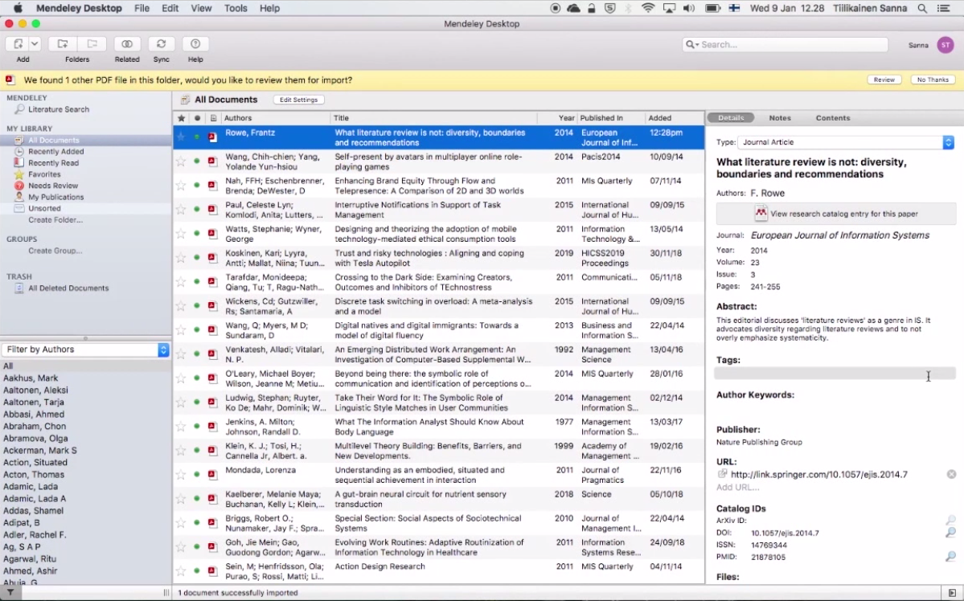
Figure 1. Mendeley reference management software
Note that figure captions are placed under the figures, and table captions are placed above the tables.

Methodology
This is the chapter where you describe what data you will collect and how, and justify the reliability and validity of the data and the collection method you are using. Here you will also describe how you will analyse your data. Do use references here (e.g., research papers and/or books) that talk about the data collection and analysis methods you are using to show that you are following proven methods and thus add credibility to your work. If you are doing a literature review, the literature is your “data” and the way you search, select and analyse the literature is your method and will be described here. Literature reviews may employ for example bibliometric method s or rigorous Systematic Literature Review (SLR), or Evidence-Based Management (EBM) research protocols, although these are more common in Master’s or Doctoral theses.
Depending on your work and content in this section, you can add more structure here by including subsections as needed. You should not yet describe your results and findings here in the methodology section. Those will follow in the next section.

Results
In this chapter, you will describe the results of your data analysis, i.e., what the data revealed or (if you are doing a literature review) what the review of previous literature covered and suggested. The detailed structure of this chapter depends again on the content and needs to be tailored separately for each thesis. Here you can also refer back to your research objectives and research questions to discuss your findings in light of those. It is helpful to illustrate your findings with figures, tables and diagrams where possible. Again, add subsections as needed to improve the clarity and readability of this section.
In some quantitative research papers, where the results are quickly presented and the focus is on the discussion of the findings, you may see that the results are included as a subsection in the “Methodology” chapter and the next main chapter is “Discussion”.
Table 1. Title of the table (source: Authors 2018, p. 34)

Discussion and conclusions
Here you will summarize and conclude your key findings. You can refer back to the research motivation you presented in the introduction and describe what your results will add to the current discussion of your topic area. If you have collected your own empirical data, you can also refer back to your literature review and discuss how your findings compare to the findings in previous literature. What was similar, what was different, what was new or unexpected, etc.?

Implications to research
This section is dedicated to assessing your findings regarding their implications to previous research in more detail. What do your results indicate? Did they corroborate previous findings or theories or did you find some contradictions or something interestingly new? What does that mean to the existing theories or knowledge? Why might the results be similar or different? Would you suggest making some additions or changes to previous theories or knowledge, or can you say the previous research seems useful as-is in explaining the phenomena you were focusing on? Please note: writing implications to research may be a stretch target for bachelor’s thesis work, as you are not expected to make new contributions to existing research or knowledge yet. If you think that it is difficult to include this section in your own work you can leave it out.

Implications to practice
Here you will focus on what your results mean in practice. Consider companies, public sector organizations and other actors operating in the field and topic area you were studying. What recommendations or advice can you give to them based on your findings?

Limitations and future research
No single study is perfect or fully comprehensive. Typically, the results you got could be different, for example, if your study was repeated in different cultural contexts (e.g., in different countries), with different case companies, with different user groups, multiple times during a longer time-period, etc. The purpose of acknowledging the limitations is not to diminish the value of your findings but to show that you are aware of the most important of the limitations and guide readers also to consider them. The limitations also build a bridge to your final point, future research on your topic.
It is good to end your work with propositions to future research rather than the limitations because it gives a positive ending to your research. In here, you will give recommendations to follow-up research on the same topic. What would be interesting and important to research next on your topic? Did you find any gaps in the current knowledge or any new, interesting aspects that require further research to provide more evidence? Propositions for future research may also include addressing some of the most important limitations you mentioned: for example, repeating your study in different countries, with more data, etc.
An alternative ending to a research report is to keep the “Conclusions” section separate and add it as a final main chapter in the report. You can do that also but please avoid copying content between sections, instead make sure you have something new and interesting to discuss in each section you add to your work.

References
Add your bibliography here. Use instructions and examples in Aalto citation guide to help you: http://libguides.aalto.fi/c.php?g=410674&p=2797572
Examples - Journal article:
Al-Jabari, M. 2004. Dynamics of chelation-supercritical fluid extraction from wood fibers. Journal of separation science. Vol. 27:9. P. 686-690.
Examples - Books, series and reports:
Wilson, S. 1984. Electron correlation in molecules. 2nd ed. Oxford, United Kingdom: Clarendon Press. 281 p. (International series of monographs on chemistry 11).
Examples - Thesis:
Teikari, P. 2006. Biological effects of light. Master's thesis. Aalto University, School of Electrical Engineering, Department of Communications and Networking. Espoo. 134 p.
Examples - Conference papers:
Graefe, G & Shapiro, L D. 1991. Data compression and database performance. In: Kumar, Vijay & Unger, E. A. Proceedings of the 1991 Symposium on applied computing. Kansas City, Missouri, USA. 3-5.4.1991. Los Alamitos, California, USA: IEEE Computer Society Press. P. 2227.
Examples – Websites:
The Purdue Online Writing Lab (OWL). Purdue University. [Last accessed April 7, 2019]. Available at: https://owl.english.purdue.edu/.
Note: If the text on the website includes author name and publishing date you should add these in the reference as well.

Appendices

Appendix 1: About layout and style
This appendix will give you tips about the layout and style of your work.
Table of contents
The table of content is systematic and presents all your chapters, headings and page numbers. You should avoid adding heading levels beyond level three, e.g., not 1.3.1.1 (level 4). After table of contents you can add List of figures, List of tables, and the Appendices. Page numbering will start on the first page of the first main chapter, after the table of contents. The cover page, abstract, table of contents, etc. will not have page numbers.
Fonts and formatting
The thesis report needs to be well written and professional. The length of the core text is approximately 20-25 pages. Cover page, abstract, the table of contents, references or any appendices are not part of the core text. The thesis may be printed on on A4 paper using, for example, the following page lay-out (margins): top 15 mm, bottom 20 mm, left 35 mm, right 25 mm. (If you plan to have your thesis bound into a book, you should leave a broader left margin).
In the core text you can use the font types preferred in Aalto publication series (i.e. main text with Georgia 11 pt. and headings Arial) – similar to this example document. Other font options are also possible. The basic rule is that texts printed in paper should have main text with serif fonts, e.g., Georgia (11 pt.), Palatino (12 pt.) or Times New Roman (12 pt.). Line spacing should be 1,5. The alignment of the right side, use of headers and footers, and format of page numbering can vary. Sans serif font types (such as Arial and Helvetica) should be used in headings and typically also in pure electronic publications (which are viewed on screen only, not printed on paper).
On headings the font can be larger and formatted – such as bold or italics. Headings at the same level should be formatted similarly throughout the text. Chapters on the highest level will always start on a new page (as in this example document).
For appendices, tables, and figures you can choose an appropriate font but in captions (text besides figures and tables) you should use the same font and formatting as in the main text. The table caption is placed above the table, whereas the caption of a figure is placed under the figure. In principle, you should not copy figures or tables as such from other publications as there is a risk of breaking the copyright laws. If you must use one, you need to check the copyrights and always add appropriate captions and references to the original work very carefully. Figures, tables and formulas are numbered separately for each group with a running number and can be listed, each group separately, immediately after the table of contents.
About subtitles
Add minimum two subheadings in each level, i.e., if you add 1.1 under Chapter 1 you should also have 1.2 before moving on to chapter 2.
Avoid adding subheadings beyond three decimal points, e.g., not 1.3.1.1 (level 4). This is usually not necessary and additional levels add complexity to the overall structure of your work.
References
All references are listed at the end of your thesis according to the chosen reference notation. You should use only one notation throughout the work. Note that the References and Appendices headings are unnumbered headings.
Appendices
All appendices are numbered and placed at the end of your work, after the references. You need to consider carefully what you will add as an appendix to avoid adding unnecessary length and information in your thesis. Examples of appendices include survey or interview questions, detailed results, detailed method descriptions, large figures, maps, etc. Appendices are not usually necessary in Bachelor’s theses.

