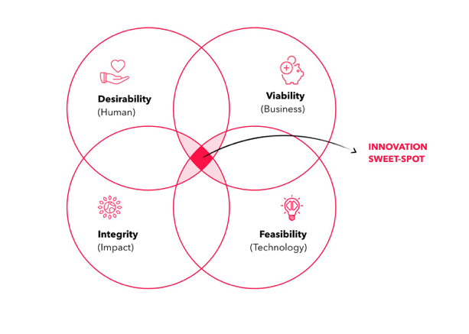

tu-e4060

design & innovation in context

fall 2022 (thursdays 14.00 – 16.00) @ aalto design factory STAGE

6 ects

your mentor dr peter kelly
connector @ aalto

my habitat tuas 2168 (next to avp space)
my handles +358 41 503 4508 (mobile)
theideastudio (skype)
peter.kelly@aalto.fi

course objectives

By the end of this course, students will:

- Develop a deep appreciation for and exposure to design thinking principles

- Apply these principles to address “customer experience challenges”

- Develop an ability to craft persuasive and engaging messages

- Appreciate that entrepreneurship is a design infused discipline by its very nature

- Be confident and able to apply insights from this course to guide innovation in their own fields of interest

The learning objectives of the course:

- To develop your design and entrepreneurial acumen guided by Vision In Product (VIP) design framework and Effectuation theory

- To hone your sensemaking ability through observation, rigorous research, and discussion

- To identify relevant and meaningful starting points to guide new product development

We are working from the premise that exploring future possibilities is more important than solving present day problems. Opportunity is “placed” in a future context that is constructed on the back of research insights, personal perspectives and conscious choices.

the design perspective

In the rush to innovate, too often our focus is short term in nature and based on superficial understanding of the underlying structure of the present domain where perceived problems lie. We need to deconstruct the present to design for the future.

We will rely on the Vision in Product (VIP) design framework developed at Delft University by Paul Hekkert and Matthijs van Dijk. Their work is part of a broader movement called speculative design. Phil Bagatas, formerly an Experience Design Partner at McKinsey considers speculative design as: “…a way to manifest possibilities, to prepare us for inconvenient challenges and facilitate a more desirable, responsible path in the future.”

The VIP process is displayed below and moves from bottom left to bottom right. Note that designing new products is the LAST not the FIRST stage of the process!

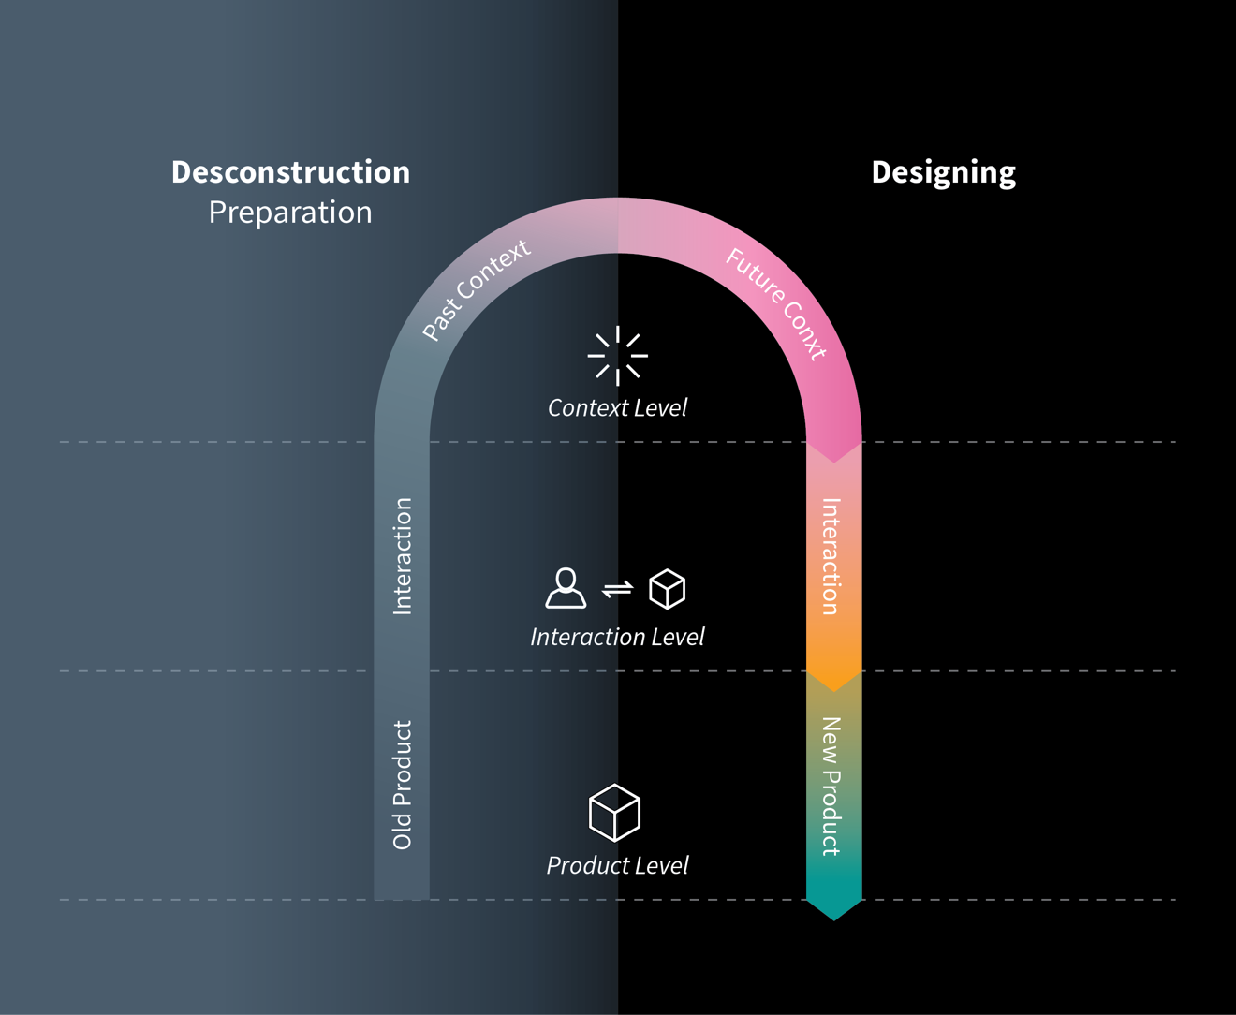

the innovation perspective

Taking the time to deconstruct a domain highlights some of the assumptions and driving forces that underpin existing products. On reflection, many of these existing products are well past their sell by date. VIP encourages you to identify relevant driving forces in a domain (called factors) and to speculate how these might play out in the future. In designing a future context, you imagine how people will interact and what they need in that world.

We know that successful entrepreneurs (and entrepreneurial individuals):

- Spot patterns where others see chaos
- Are grounded in a deep and empathetic understanding of the context within which customers operate
- Prototype potential solutions quickly and cheaply to garner feedback and guide future action
- Trust their instincts and intuition in knowing what customers want even if they are unable to articulate it, read Apple!

What we don’t appreciate nearly enough is the process they rely on to know opportunity when they see it and to act upon it. But if I had to speculate, look no farther than the work of Pierre Azoulay from MIT who looked at ALL the new businesses founded in the USA from 2007-2014. The average age of the founder of the top 1 in 1000 (,01%) growth ventures was 45 years. Ask yourself what does a 45-year old bring to the table? Deep networks for sure but an even deeper perspective on how a domain ticks, the driving forces at work, and perhaps experience bringing new products to life.

Once you have decided on what to do, that is when Effectuation theory kicks in.
Saras Sarasvathy identified a set of decision-making principles that expert
entrepreneurs use in situations of high uncertainty:

- Action is initiated based on means available and not pre-set goals
- Limits of investment both in terms of time and money are set up front
- Opportunities are explored and developed in co-creation with outside parties
- Surprise opens up new possibilities if you are open to reshape the opportunity
- The future is shaped by the actions you take

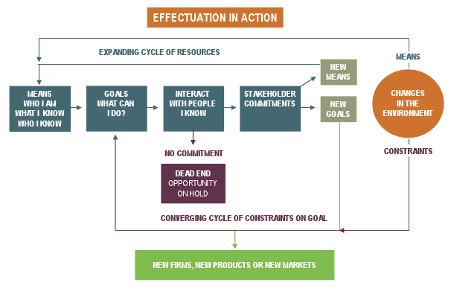

deliverables & evaluation

Course deliverables involves both individual tasks (50%) and group project (50%)
Each participant will need to complete the following:
- Coffee Experience Challenge (20%) (Week 3):

As you may be aware, Starbucks had established two outlets at Helsinki-Vantaa airport; one was closely permanently and the other still remains open airside. Their flagship store is located at the iconic Aalto designed Academic Bookstore in central Helsinki. An additional outlet operates in Kamppi shopping center. Starbucks had been in partnership with Kesko (K Market) to open more outlets (12 at a peak) but this initiative was put on hold in late 2020 because “there was insufficient demand”. How can a global coffee giant have such a small presence in a coffee fueled country like Finland? Each participant is to put their creative hats on and propose some ideas that Starbucks should consider adopting.

For background, download a copy of “The Coffee Experience” where you will find a candid and critical email written by Howard Schultz, Chairman of the Board at Starbucks. Notice the date (Valentine’s Day) and the tough love message. Starbucks was founded in 1971, operates almost 34000 outlets in 80 countries, generating sales of $30 billion annually. Investors currently value the company at around $100 billion.

Howard is always open for innovative ideas. Clearly some aspects of the current operation appear ill suited to the Finnish market or well past their sell by (or serve by!) date. I want you to take VIP on a test drive. Deconstruct the existing domain, identify the driving forces that may impact the future context. What will that context look like, what types of interaction and products do customers int that world need? As we are dealing with a public company, assume the time frame is one year from now.

Assuming you have an opportunity to pitch to Howard (5 minutes max), prepare a presentation. Include the storyboard (what you intend to say) as presentation notes or attach a separate summary.

- Coffee Experience Presentation/Critiques (10%):

On a voluntary, first come, first served basis, you will have an opportunity to take the “stage” and make a presentation to the class. A strict 5 minute time limit will be imposed and there will be an additional 5 minutes allocated for questions from the audience.

OR

If you do not present, you will be required to submit detailed and thoughtful critiques on any TWO (2) of the presentations.

- Reflective Essay (20%)

Download a copy of the article “What Makes Entrepreneurs Entrepreneurial?” by Saras Sarasvathy from:

http://www.effectuation.org/sites/default/files/documents/what-makes-entrepreneurs-entrepreneurial-sarasvathy.pdf

Based on insights from reading through the substantial resources that I have provided you on the course web, I want each of you to write a reflective piece to support the answer “because they embrace design thinking” to the question posed by Saras.

WORD LIMIT: 2000 (PDF)

Urban Mobility in 2030 (Group Task 50%)

The group task will be discussed at length in the introductory session. It will provide you with an opportunity to engage with the VIP approach on a domain the is rapidly transforming before our very eyes, Urban Mobility. Your group will deconstruct the present (and past) as a basis for visualizing a future context of Urban Mobility that envisions new forms of interaction and products. There is an abundance of experimentation going on around us as we cope with the challenges of climate change, congestion, noise, safe navigation, budget and time constraints, among many other considerations. I have set the time frame as 2030.

There is an enormous amount of insights, perspective, opinions to tap into. As an amuse bouche, consider the following:

According to the IEA in their recently released Global EV Outlook (2022), we appear to be approaching a tipping point:

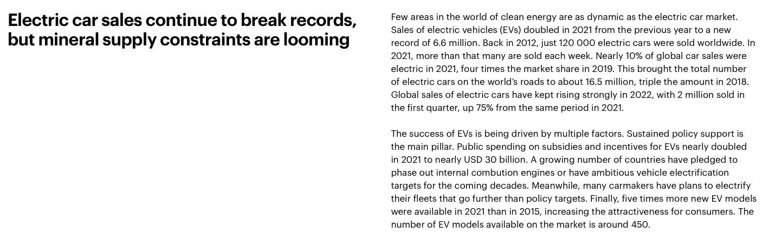
Looking out to 2030, Oliver Wyman Forum and the Institute of Transportation Studies (2022) at UC Berkeley speculated about:

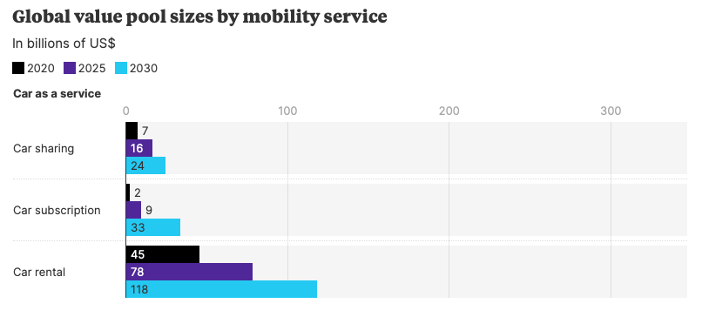
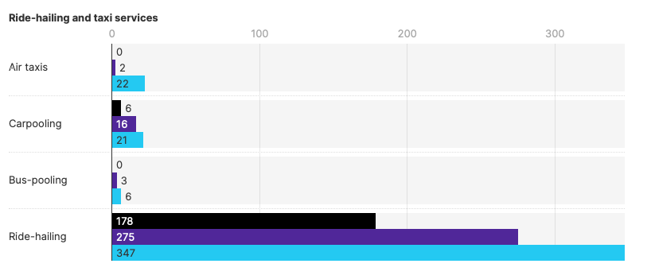

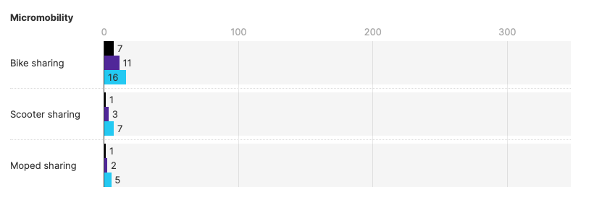

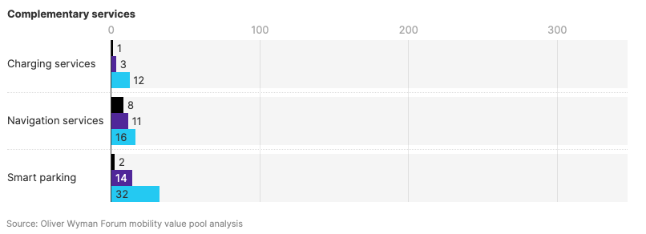

- An Aalto Master’s thesis completed in 2014 by Sonja Heikkilä (Mobility as a Service) garnered global media attention at the time and spurred the early development of Maas Global Oy in 2016. Maas has raised €75 million in equity investment from venture capitalists and transportation companies.

- The Aalto University Centre for Autonomous Systems has been doing groundbreaking research throughout the years on “driverless” technologies. Sensible4 was spun out of that work (https://sensible4.fi/company/).

- Not to mention the robots you see navigating the Aalto campus

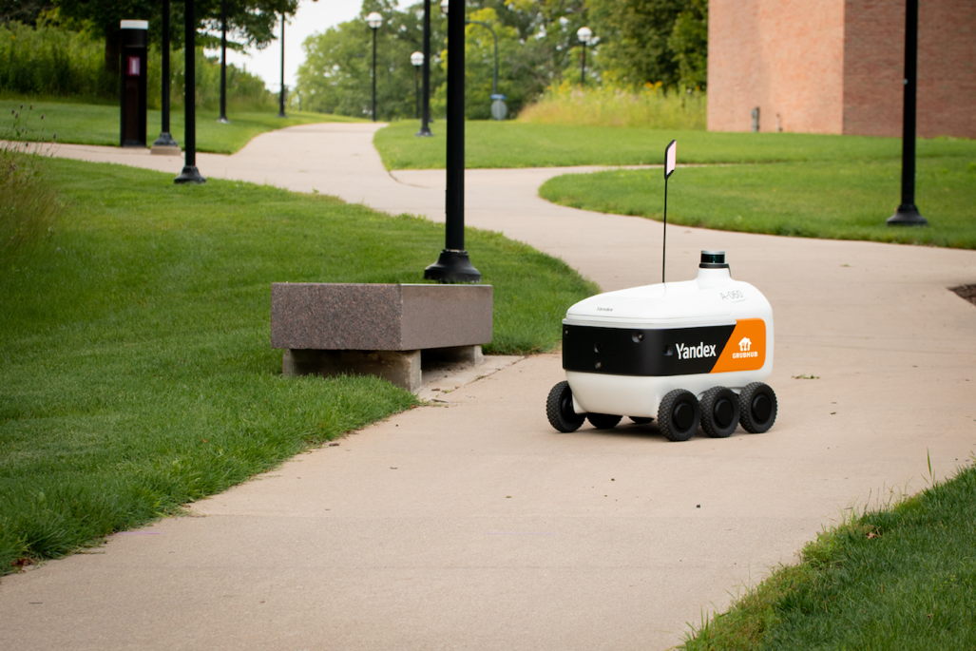

YOU WILL BE WORKING IN GROUPS OF 6. I JOIN EACH TEAM AS A MENTOR.

The Presentation

- You have complete freedom as a group to determine the domain of interest to you – there is plenty of scope for choice! Your group will determine what the relevant and meaningful factors that need to be considered in designing a future context, envisioning interaction and developing new offering(s). Your team takes agency in the project, I am here to mentor and help as needed.

- Each group will be allocated private time with me “in camera” where I will provide you with detailed and thoughtful critique. This method proved to be the most valuable and impactful learning experience for course participants in previous years and addresses a very real need for students to develop the ability to create and deliver high impact messages.

- Final presentations will be in the form of Pecha Kucha – a highly visual story telling format that requires you to communicate messages in 20 second sound bites. Some examples and guidelines of this format can be found at: www.pechakucha.org.

- ABOVE ALL ELSE HAVE FUN WITH THIS AND DON’T CONSIDER IT A “TASK”!

Schedule of Coming Attractions (subject to revision)

27 October Course Introduction
From Design Thinking to Design Doing

3 November Empathetic Research Methods

10 November Coffee Experience Challenge

17 November Rapid Opportunity Prototyping

24 November Team Consultations

1 December Final Presentations

