Learning Finnish vocabulary through sanahaaste (word challenge)

During the course collect two Finnish words a day and write them down!
Words can be from anywhere: supermarkets, shopping centers, bus or metro stations, movies, TV-series, university, from you Finnish friends etc….
They can be collected on a word document, PowerPoint, padlet, paper or even in pictures.
You can also organize your words under different topics if you want.
By the end of the course, you should have more than 140 new words in Finnish!

February 8th we will have a midway checking of your collected words. You will have the possibility to share them and your collecting methods/places with other students.
March 19th you have to upload your sanahaaste into MyCourses or give it to the teacher if you have your words on paper.

Esimerkki = example

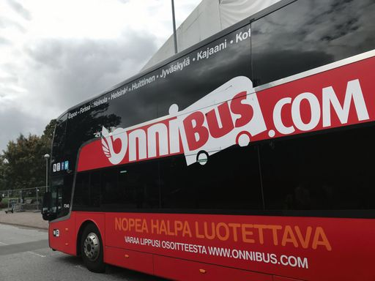
nopea = fast
halpa= cheap
luotettava = reliable

