AXM-E3002 Story Ecologies in Theory Practice & Everyday Life Spring 2023

NB to be combined with AXM E031 (Art + Media Studio) 1.3.2023-2.6.2023 see below
"We live in capitalism, its power seems inescapable — but then, so did the divine right of kings. Any human power can be resisted and changed by human beings. Resistance and change often begin in art" Ursula K. Le Guin, recipient speech at the US National Book Foundation Medal November 19, 2014

Story Ecologies is equally about the stories to be found/sensed in complex urban ecologies and then different kinds of ecologies of story; methods for you to work through and eventually present these experiences in your own practice.
You will be encouraged to think critically about how and why stories matter. You will reflect upon the stories we tell, the stories that have been told to you and the stories you tell yourself about human relationships to non-human worlds, as well as the ways in which we such stories are performed in everyday life. In this critique, the course takes starting point in a critique of the key dualisms that have constructed our modern orders, political economies. However, the main emphasis of this course is to go further than critique and explore what art research does best, which is to ask “what if?” and explore ecological contexts and techniques which allow us to speculatively suggest other ways of being in the world.
An ecological approach to storytelling through art might concern itself with (among other things):
Situating a narrative in/with more than human places and temporalities;
Revealing existing human-more than human interdependencies and interconnectivities;
Speculating about future political ecologies;
Suggesting how these might manifest in multi-sensorial multi-species experiences.

Practicalities
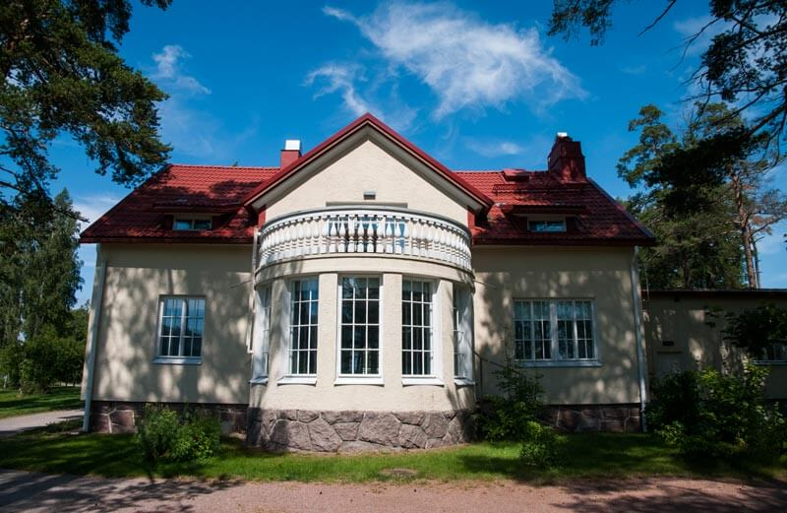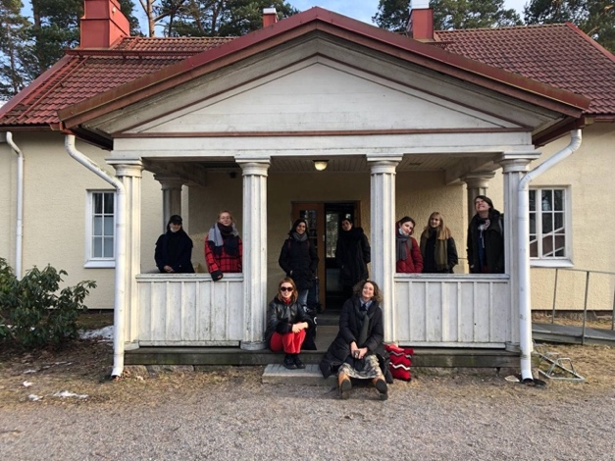
https://www.taiteilijatalo.fi/villa-lill-kallvik
This part of a two section course runs each Thursday in April and May in the lovely Villa Lil Kalvik (Vuosaari metro).The choice of Vuosaari is both as this area of the city gives you access to the early springtime forests, beaches and waters of Kallahti and Uutela, but also the contested urban dynamics and incessant construction in this fastest growing area of Helsinki.

Pre-requisites and Recommendations.
This Story Ecologies course is for everyone and anyone in ViCCA and beyond who are interested in engaging multisensorial and multispecies or more than human forms of storytelling in their practice and/or thesis work.
As the content of this course has been reduced in this curriculum from a previous 2 period course to a 1 period course, it is now strongly recommended that you combine this course with AXM E031 (Art + Media Studio) which runs 1.3.2023-2.6.2023 on Wednesdays and Fridays and has one of the studio groups under my name, also called story ecologies.

Most of the site specific inputs and content will be given on the Thursdays in this course AXM-E3002 Story Ecologies. But the time to apply this in a practical project as well as the studio based guidance from me as to skills and techniques as to how you might do this, would occur on Thursdays and Fridays AXM E031 (Art + Media Studio).

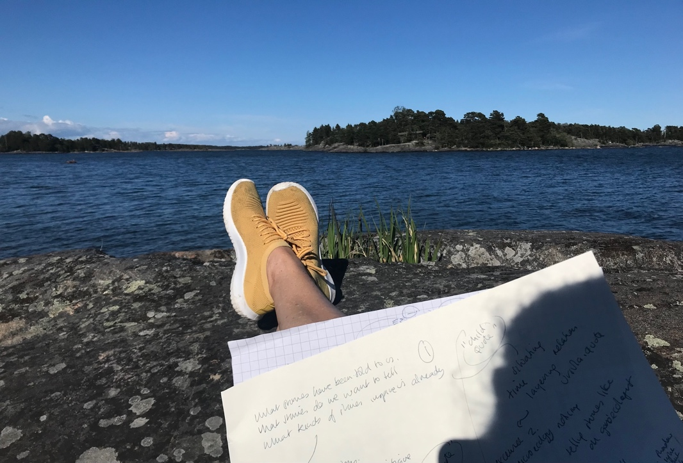

Course Content
The (AXM-E3002) Story Ecology Thursdays at Vuosaari will focus upon developing your own, group or individual story-ecological process and expanded senses of storytelling via guest inputs, experiential exercises, scores, field tours, readings films and podcasts (theory and fiction). Story Ecological themesexplored in Vuosaari may include: Site specificity, Non linear and alternative narrative structures, Embodied Storytelling, Multiple temporalities, Non linguistic storytelling, Walking & Story, Everyday Animisms, Collaborative Methods and More than Human Actors. Critical explorations may include: Multi-Species Collaborations, Biomimicry, Voices and Reception (Audiences, Viewers, Listeners--be these human or non human).
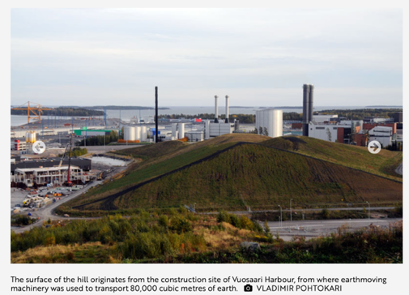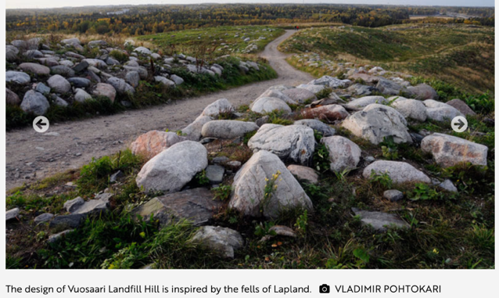

Vuosaari Landfill Jukka Toivonen, 1980s–1990s From: https://vihreatsylit.fi/en/vuosaarenhuippu/from
The Wednesday and Friday AXM E031 (Art + Media Studio) components will focus mostly upon the application of Thursday's contents and methods in the development of ecologies of storytelling in your group, individual or thesis work. These sessions will be mostly held in Otaniemi, with certain dates reserved for extra field trips around Vuosaari.
Some of these Wednesday and Friday sessions may be conducted together with Pia Euro’s Material Situations and Spatial Arrangements as our studio rooms will be side by side. Pia and I would like to keep open the possibility for ViCCA Art & Media Studio students to benefit from both of our studios. However, if you sign up for Story Ecologies, you will be expected to commit to completing the Story Ecologies course outputs (below)
Course Outputs
For combined courses AXM E031 (Art + Media Studio) 9 credits and AXM-E3002 (Story Ecologies) 5 credits
1. A working weekly journal/sketchbook (individual)
2. A story ecological work that resonates with the themes, methods and questions of the course (group or individual)
3. A critical reflection of this work that takes into consideration key methodological, material and multi species questions that have arisen during the course (individual max 2500 words)
Very Tentative Weekly Themes
I will update this closer to the time but here are some tentative themes which will again emerge from the content in the Thursday AXM-E3002 (Story Ecologies course)
*Pre reading (if you have not read it already) Ursula Le Guin A Carrier Bag Theory of Fiction
27 April Week 1 Situating/Placemaking:
What is in your carrier bag? Vuosaari walking stories & troubled grounds

4 May Week 2 Deepening:
Guest input Aliya Syed Meta Incognita 2
More-than-human temporalities and rhythms. More than human narrative forms

11 May Week 3 Complexifying:
Coding & Cosmic Collage (Guest input Kiran Kumār). Who is your audience? Are They Human? (May Adadol’s Animistic Apparatus)

18 May Week 4 Listening:
Allowing Oneself to be Drawn Outside, (film screening & sound led exercises)
On the naming of names

25 May Week 5 Refracting:
Storytelling Like Shadows Through Leaves (Lucy artist talk)

1 June Week 6 Presentations
NB A Presentation/exhibition of story ecology works is possible together with Pia Euro’s AXM E031 (Art + Media Studio) course in REDI in June

