Understanding the Spanish Speakers

The Origins
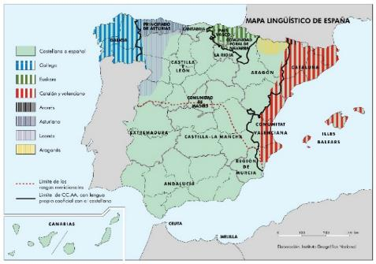
Today, the Iberian Peninsula is home to two EU countries: Spain and Portugal. However, many centuries ago it was only a province in the Roman Empire. The romans had come in the 3rd century BC and had swept all the local languages away, except for the Basque, that remained ignored in the Biscay gulf area. Long after that, in 701 AC, north African Muslims conquered the peninsula, and the isolated Christian kingdoms that were stablished on the north coast shortly after that developed different dialects of Latin.
Many languages developed form Latin in Northern Spain during the Middle Ages and are spoken today, but only a few became official.
These dialects evolved into languages of their own, and today the four official languages in Spain in order of importance are:
- Español: Spanish is official across the country.
- Catalán (in Spanish) / Català (in Catalan): Catalan is official along with Spanish in the Catalan-speaking areas, although in some areas it can bear a different local name such as valenciano/valencià or mallorquín/mallorquí.
- Euskera (In Basque): Basque is official along with Spanish in its own area of influence, namely the Basque country and Navarra. The word vasco means Basque in Spanish but should be avoided when speaking about the Euskera language, since this use is too closely associated to General Franco’s dictatorship in the 20th century.
- Gallego (in Spanish) / Galego (in Galician): Galician is official along with Spanish in Galicia and shares an origin with Portuguese.
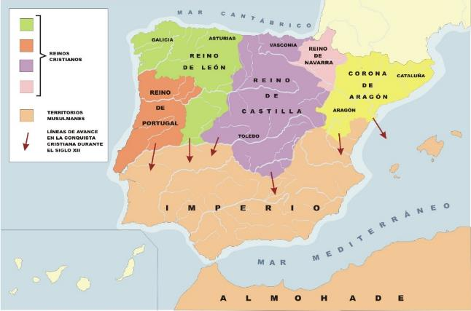
Number of phonemes
Spanish 24
Portuguese: 37
Catalan 36
Basque: 30
Galician: 26
Finnish: 34
English: 36
French: 39
German: 45
https://www.eupedia.com/linguistics/number_of_phonemes_in_european_languages.shtml
Here's a sample:
- English: I want to talk to you. What is your name?
- Spanish: Quiero hablar contigo. ¿Cómo te llamas?
- Catalan: Vull parlar amb tu. Com et dius?
- Basque: Zurekin hitz egin nahi dut. Zein da zure izena?
- Galician: Quero falar contigo. Como te chamas?
While Basque existed long before the Romans and is not related to anything, the other three are Latin-based sibling languages. And more specifically, Spanish was born as a pidgin when the Basques tried to do business with their Latin-speaking neighbors in the Christian Kingdom of Castile. It was, so to speak, bad Latin with a Basque accent.
For this reason, Spanish has a phonetical similarity with Basque, although both languages are completely unrelated otherwise. This is best seen in the fact there are only five vowels in Spanish and all of them are short: a, e, i, o and u. Most monolingual Spanish speakers find it extremely difficult to speak any foreign language decently, since nearly every language is phonetically more complex, but Spanish is in turn a very easy language for students to start with. The language only becomes more difficult when you start learning the nuances of the numerous verbal tenses and some object pronouns.
Since the Spanish language was born in the Kingdom of Castile (stemming from the word castillo or “castle”), the language is known either as español or castellano. Although they are synonyms, the word español is preferred in most of Spain while castellano is clearly the choice in the territories with a local co-official language. So, you will probably want use español while visiting Madrid and castellano when visiting Barcelona. In Latin America, the difference is not that important, but español is more common in Central America and castellano tends to be preferred in South America.
During the Middle Ages, Castile conquered most of the land as the Christian kingdoms were expanding towards the south, and so their Basque-sounding dialect of Latin became the leading language in the risings new state. Although the founding Christian kingdoms are considered the seed of the Spanish nation, the fact remains their conquests were not any sort of “national crusade” ⎯ The concept of nation was not born until the late 18th century ⎯ but a few noble families’ expansion plan. These families became a very powerful elite and still are in the present day.
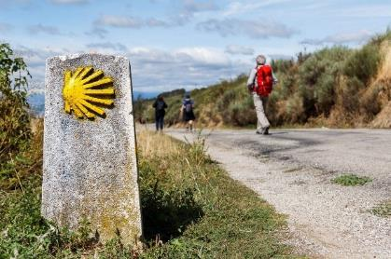
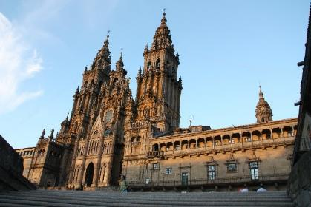
In the 9th century, the Catholic Church in the northwestern Iberian Peninsula claimed to have found the tomb of St. James the Apostle and took this alleged discovery as a divine sign. The priests in the peninsula made the expansionist policy of the noble families out to be some kind of holy crusade of Christendom to “recover their land”, so they established the term reconquista (reconquest) to describe that historical period and used the myth of Santiago to both have the starving commoners join the “holy common cause” and guarantee themselves a position of dominance since the very birth of the Spanish state.
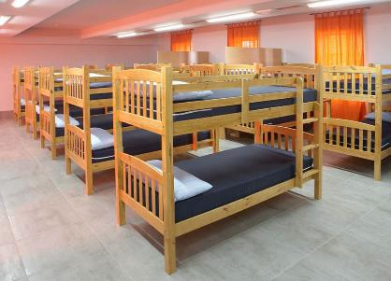
Today, Santiago de Compostela is considered the third most important pilgrimage destination for Christians after the Vatican and Jerusalem. The Camino the Santiago starts in many places across Europe, but it always ends at the Santiago’s cathedral, which became a founding symbol of the Spanish state and hence appears in the Spanish one, two, and five cent coins. The final section of the Camino crosses northern Spain and offers free accommodation to the pilgrims in designated hostels, so non-religious people come by the hundreds of thousands every summer to enjoy the local nature, art, and gastronomy. In a few words, it is a healthy and cheap holiday plan where you can meet people of all ages and nationalities.
The Catholic Church, though, is an extremely powerful lobby still today. It owns many schools, universities, hospitals, valuable historical sites, and media outlets. The Spaniards are not particularly religious, but the Catholic Church continues to play an active role in Spanish politics, usually trying to secure their fiscal and administrative privileges or lobbing against people’s rights like divorce, abortion, same-sex marriage, or euthanasia.

Land and Power in Spain
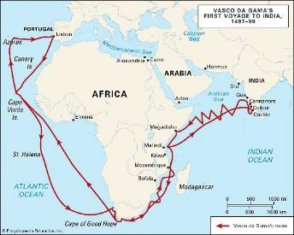
The expansion of the Northern Iberian Christian Kingdoms was officially called Reconquista to support this whole Christendom-recovering-their-land propaganda construct, but eventually most of the land was held by the noble families and the Catholic Church.
By the end of the Middle Ages, the different European elites founded the first set of modern states long before such concepts as “a people” or “nation” even existed. These European elites wanted to escape the power of the Pope as much as they wanted to put up a transnational commercial infrastructure, so they built both their first state armies and police forces, approved some commerce laws, and stabilized their monetary systems. They did not put up a schooling or health care system for their fellow “nationals”, though, because these states were born mainly to protect private property as the foundations of international commerce were being laid.
Throughout the Middle Ages, the different European elites were eager to trade with the far East, but commerce only flourished when the Portuguese sailor Vasco da Gama found the ocean route to India in 1498. This put a strong pressure on the European elites to quickly build a commercial infrastructure that would support this trade and, at the same time, exploit the vast natural resources of the recently discovered American continent.
While most European modern states were the result of an alliance between the kings and the rising bourgeoisie against the noble landowners, Spain took a different path. The eight-century long reconquista process had led to the rise of an unusually strong land-owning elite of ranchers and had crippled the development of the local bourgeoisie. But, at the same time, the ecclesiastical hierarchy had managed to cleverly turn the noble families’ conquests into an alleged common cause for the sake of Christendom, so the Catholic Church emerged as the very embodiment of the Spanish soul.
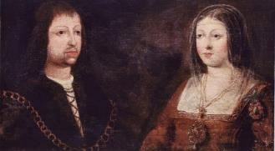
As the only institution that was present in virtually every corner of the Iberian Peninsula, the Catholic Church formed an alliance with the Spanish monarchy to build the Spanish state. This is why the Spanish Inquisition was stablished by the end of the 15th century as the first administrative authority of Spain. Officially the inquisition was created to find the undercover Muslims and Jews that somehow threatened Christianity, but in fact it was the instrument to have the land-owning elite finally obey their king.
In 1469, the Spanish state was officially born with the wedding of Isabella I of Castile and Ferdinand II of Aragon. Since the bride and the groom were cousins, they needed the Pope’s approval, but the Pope vetoed the marriage in the hope of hampering the rise of any strong European state. Finally, the couple had the Pope’s approval forged since they could count on the support of the Spanish Catholic Church and got married anyway. The Catholic Monarchs of Spain as they came to be known fostered the Spanish expansion and are therefore considered a symbol of Spanish grandeur. Under their rule, the Spanish armies conquered the last Muslim Kingdom in the Iberian Peninsula, exterminated the native population in the Canary Islands and set for new lands in the Americas.
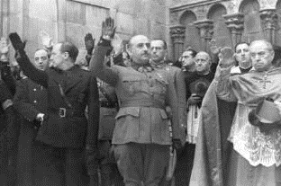
In 1505, the Catholic Monarchs approved the mayorazgo, a law allowing the nobility to make their estate non-severable for life. This strengthened the high nobility by preventing the fragmentation of real estate property but forced the younger children of noble families to look for either a profitable marriage or a good position in the Church or the army as they didn’t inherit anything, and wage labor was not an option either. Since the nobility in southern Spain had not had much time to divide their land before this law, the land concentration remained particularly high in that part of the country. And, if someone died without any children, their property would most often be transferred to the Church.
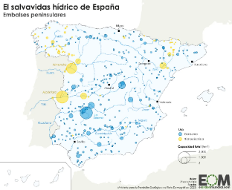
Approximately in the first half on the 19th century, the powerful nobles had the state expropriate the Catholic Church’s lands and hand it over to them almost for free. The Church was compensated with the financing of the first Spanish school system, which was small but important for indoctrination, and the nobility started concentrating an extremely disproportionate power. In 1936, a recently founded Second Spanish Republic was preparing to expropriate some of this land, and the so-called Spanish Civil War was unleashed. The result was a roughly 40-year-long dictatorship which practiced social engineering with the help of the Catholic Church.
Dams in Spain (2024)
The Francoist dictatorship developed the dam-building plans laid out by the Second Republic partly with the forced labor of political prisoners. The new dams multiplied manyfold the value of the lands and boosted the position of an already powerful elite. In exchange the benefiting landowners were required to set apart 10 % of their lands (usually the worst lots) for poor peasants. The jobless children of these poor peasants provided the rich landowners with a source of cheap labor, and the families paid for the water infrastructure with overpriced irrigation water bills.
The president of Real Madrid Florentino Pérez made his fortune through his connec-tions to the Spanish adminis-tration. Since then, the Real Madrid’s VIP area has become the place where the business with the public administration is conducted. After the 2008 credit crunch, his construction firm ACS sought some public works in other countries, and his dam building plans in Honduras have led to accusations of human rights violations. ACS also invested heavily in privatized public services, such as the old people’s homes where thousands died unattended during the 2020 pandemic in Madrid. In his essay El director, former newspaper editor David Jiménez explained Florentino alone had 60 journalists on his payroll.
Although made and paid by the poor people, these dams were enjoyed by the landowners and used by Francoist regime to advertise the agricultural delopment of the country. In 1946, Franco allowed the Catholic Church to register as their own every real estate property not specifically owned by anyone. This privileged lasted until 2015 and allowed a foreign state (the Vatican) to appropriate thousands of properties for free including some valuable monuments or World Heritage sites. Last, in 1956 Franco passed a “Law of Land” that had municipalities declare the land “developable” before expropriating it, which made the landowners even richer thanks to real-estate speculation and made housing very expensive.
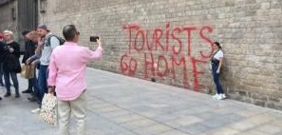
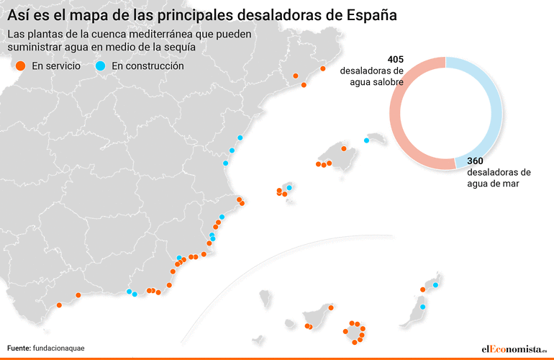
When Spain forfeited its monetary sovereignty to the European Central Bank in 1998, the interest rates felled sharply, and the cheap credit made the whole building sector go crazy until the 2008 global credit crunch. The most important speculators redirect then their investments towards the privatized public services, and new investment funds took over the real estate market, turning the housing bubble into a housing rent bubble that insanely raised the rents. In the meantime, agriculture and livestock were still profitable enough for the big farms thanks to a combination of good climate, modern fertilizers, water from the dams and desalination plants, and since 1986, the European aid money. Over time, the Common Agricultural Policy funds have been allocated proportionally to the amount of land, the overall production, or most recently according to some environmental criteria, so in practice these funds have disproportionally benefitted the big landowners.
The “hostility” towards tourists is a rection to the current rent bubble that turns the long-term rentals into touristic flats.
Desalination plants in Spain (2024)
Today, this landowning elite can be made up either of the heirs of the “reconquista” or of international investment funds ⎯ It makes no difference ⎯ but key is that the vast majority of the Spanish people still does not benefit from the uses of their land. Apart from some small proprietors (mainly in the northern half of the country), the primary sector offers only low-paying jobs that draw poor foreign workers from North Africa and encourage employers to abuse undocumented immigrants. And this is not even a good source of tax revenue, because the big users of Spain’s natural resources resort to fiscal engineering to hide a big chunk of their profits.
As we will see, the Spanish-speaking countries are in general subject to the so-called resource course, which establishes that countries with a wealth of natural resources usually have less economic growth, less democracy, and tend to score poorly in social development rankings. This happens because wherever the land is valuable, there always are powerful elites who are interested in monopolizing it whatever the cost. The concentration of real-estate property hampers the development of a land-owning middle class with purchasing power and cripples the nations’ economic development, but at least Spain has been able to compensate this partially thanks to having a modest industrial development, an access to the European markets, and a thriving touristic sector.

What Do the Names Have to Do with the Land?
The Spanish-speaking people have one first name and two surnames. Traditionally, the first surname comes from the father, and the second comes from the mother. Nevertheless Spain (2017) and Chile (2022) approved new laws allowing the parents to choose their order. People do not usually change their surnames when getting married, but in some Latin American countries, women can choose to replace their mother’s surname with her husband’s surname, preceded by the preposition “de”. This means many Latin American women who marry a wealthy man often sport both their father’s and their husband’s surnames with no trace of the maternal line.
This contrasts with the Portuguese-speaking countries: in Portugal, parents can decide whether they give their children one or two surnames, while in Brazil they always give both, the mother’s being the first. In these countries, the last surname is considered to be the most important though.
Interestingly, the structure of people’s names in these countries is tightly connected to the ownership of land. In medieval Spain, the nobles always tried to use as many surnames as possible, since each surname was supposed to have come with a real estate property, and hence, power. Even the landless rabble started using several surnames too in an attempt to improve their social position. In 1870, Spain approved a law defining everybody would have “only” two surnames, although a few “compound surnames with a strong tradition” were allowed. Nowadays, compound surnames are rare and thought to be a sign of noble origin, so some politicians use this in order to address “The regular folk, with no compound surnames.”
Regarding the first names, the Spanish-speaking people usually have one. Two-part first names are considered compound names and are pronounced as such although they are not usually hyphened. For instance, José María is a boy’s name, and it is pronounced “Josemaría”. María José is in turn a girl’s name, and it is pronounced “Mariajosé”. Many first names run in families as a tradition. Since the variety of names is not that large, many names are considered timeless, and do not end up being identified with one particular generation as it happens in Finland or used as an insult.
The habit of giving children their parent’s or their grandparent’s first names in some families can also be considered a sign of how important family, and also “passing something on” to their children is for the Spanish-speaking people. This role of parents as providers for their children has some political consequences, as many Spaniards are very hostile to having an inheritance tax, and therefore many regions tax wealthy inheritors with a close-to-zero rate if anything.
Last, it is worth noting that the most usual first-names have a biblical origin (without prejudice to the local names in regions with other languages), but lately some foreign names have also been popularized by the media. Usually wealthy people prefer traditional or two-part names (for instance María del Carmen for women and Francisco José or Pelayo for men) while poor people go for such names as Jennifer of Jonathan.
Two Dynasties
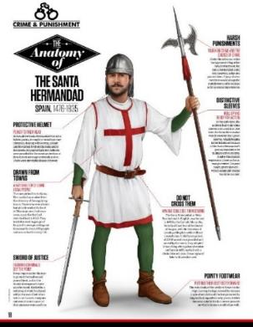
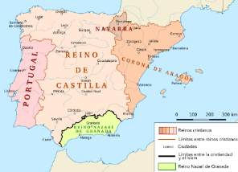
As previously stated, the Spanish state was born in 1469 with the wedding of Isabella I of Castille and Ferdinand II of Aragon. The Catholic Monarchs of Spain, as they were known, conquered the Emirate of Granada, which was the last Muslim kingdom in the Iberian Peninsula, conquered the Canary Islands, and financed the trips of Cristopher Columbus, so they are considered the cornerstone of both the Spanish state and the Spanish empire. They created the empire’s currency unit, known as peso, founded the Spanish inquisition, and established both the first state army and the first state police force.
The first police force’s uniform included a light-colored jerkin (a sort of shirt with no sleeves) on top of a green shirt. Although very effective in the beginning, this police force earned a bad reputation over the years as the empire entered a series of economic crisis and crime skyrocketed. People started saying ¡A buenas hora mangas verdes! (“It is rather mustard after dinner” or, more literally, “About time green sleeves!”) whenever the solution to a problem came too late as it often happened with the police, and that idiom has made it to the present time, usually shortened as ¡A buenas horas!
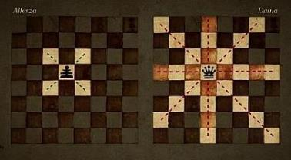
It is interesting to note Isabella, a powerful queen who could ride on her horses to some distant parts of the country, also inspired a fundamental change in modern chess. While the old chess included a piece that represented “the advisor” of the king and could only move one square diagonally, the new chess included a far-reaching queen. The Jews spread this upgraded chess across Europe after they were expelled from Spain in 1492, and that is nowadays the standard chess world-wide. Although these Catholic Monarchs had six children, both death and political intrigue caused the crown to be finally inherited at the beginning of the 16th century by Charles of Habsburg, a Flemish prince who would give his last name to four subsequent Spanish kings.
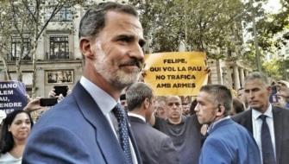
The Habsburgs, as they were called, enlarged their domains and were avid art collectors, but also plunged the empire into a series of catastrophic economic crisis. They also had the habit of marrying within their family for the purpose of building up their own fortune and power, and they finally died out in 1700, unable to have an offspring. After that, the European powers tried to influence the succession process in order secure access to the Spanish markets in the Americas. A 14-year long War of the Spanish Succession broke out mainly between France on one side and the UK, the Austrian Empire, Holland, and Portugal on the other. Eventually, France’s victory brought a new dynasty, the Bourbons, to power.
Filip VI in Barcelona in 2017
Since the old kingdom of Aragon had supported the loser candidate, the Bourbons stripped this “traitor” region of its institutions, its laws, and the power to collect taxes, while the loyal regions of the Basque Country and Navarra got to keep all that. After the current “democratic” Spain was born in 1978, Catalonia got most of its self-government rights back as a small-sized heir to the old Kingdom of Aragon, but it could never fully recover the tax-collection rights both the Basque Country and Navarra enjoy to this day. For this reason, the Bourbons are very unpopular in Catalonia and are booed loudly whenever they dare to set foot in Barcelona.
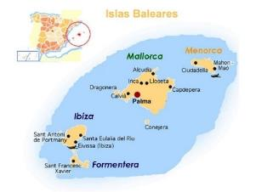
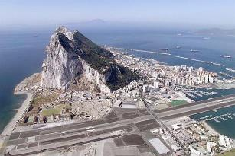
But back to the Spanish Succession, the war had other consequences. The British crown got both Gibraltar and the Balearic island of Menorca as a compensation for its defeat. Spain would eventually get Menorca back, but it never managed to conquer Gibraltar, which basically was a big rock on the Andalusian coast. During the Spanish civil war, Gibraltarians even seized the occasion to grab an extra chunk of Spanish land to build their airport. Today, Gibraltar remains as a British territory to the chagrin of many Spaniards, particularly conservative ones. The Spanish land blockade has left Gibraltar with only a few options to develop economically beyond tourism and bunkering, and the place has also become a tax haven, and a smuggling hub.
A tapa of patatas alioli
Gibraltar
With regard to Menorca, its sovereignty shifted among the UK, France, and Spain until the latter got it permanently in 1802. During the seven-year long French rule, the French people discovered there a thick sauce made of olive oil, eggs, and garlic. The sauce’s name was mahonesa after Menorca’s capital Mahón, but the French made a garlicless version and called it mayonnaise. Today, this sauce is world-wide known. In Spanish it is known as either mahonesa or, more commonly, mayonesa, since it became popular in mainland Spain through the French influence. Also, the traditional version with garlic is very popular in Spain, and it is known as alioli, after the Catalan words for oil and garlic.

A Monarchy or a Republic? Rather a Dictatorship
At the beginning of the 19th century, the French dictator Napoleon Bonaparte sent an army to occupy Spain and replaced the king Ferdinand VII with his own brother Joseph Bonaparte. According to an anecdote, one of the many laws Joseph Bonaparte signed required sailors to shave their hair for hygiene, but many protested since ―so the argument went― they always risked falling to the water, and their long hair made it easier for rescuers to spot and grab any drowning man. The law was withdrawn, but the saying Salvarse por los pelos (literally “To be saved by your hair”) has been used ever since whenever someone is saved by the skin of their teeth. People also say simply ¡Por los pelos! when something happens by the narrowest of margins.
Napoleon’s army had entered Spain without any opposition under an agreement with the Spanish authorities to invade Portugal, but this army also occupied Spain and abused the locals at will, so a four-year long war broke out. The Spanish rabble, who had nothing to lose, fought alongside British troops that were sent in an attempt to weaken Napoleon. Despite the fact the French controlled most of the country, many representatives of different Spanish regions managed to gather in the southern city of Cádiz to make the first Spanish Constitution in 1812. It was the first time the word liberal was ever used in history before spreading to other languages. However, when the French were finally expelled, the Spanish king returned and imprisoned all the liberals that had fought for him.
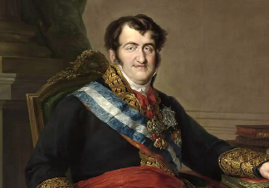
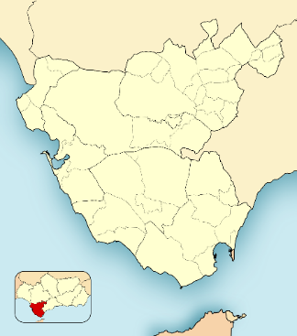
On a separate note, it must also be noted the word liberal can nowadays mean very different things. Although the term first labelled those in favor of individual liberties and equal rights, at length it became clear such equality of rights was not possible under dramatic income differences. For this reason, the left-wing revolutionaries made equal access to capital their top priority, while the old liberals thought the equal rights could be best provided by a market economy. However, in the US the abundance of land muffled these rivalries greatly, and the liberals were not portrayed as opposites to the left-wing revolutionaries. This is why currently liberal labels the “free-market supporters” in Europe while it is used as a synonym for “leftist” in the US.
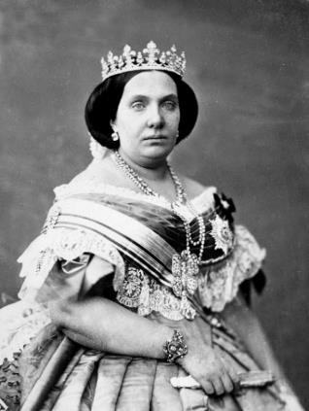
In Spain, king Ferdinand’s come back in 1814 and subsequent crackdown on liberals marks the beginning of the republican sentiment. The liberals championed the rule of law, but Ferdinand VII wanted to be the law. Because the Spanish army was full of liberals who had fought the French alongside the regular folk, they usually won. However, given other European monarchies always threatened to send troops (as the French did in 1823) if a republic was proclaimed, the liberals were usually led to accept the king, who was in turn forced to accept a liberal Constitution. Predictably, the king accepted this with great reluctancy and then conspired against the liberals as much as he could.
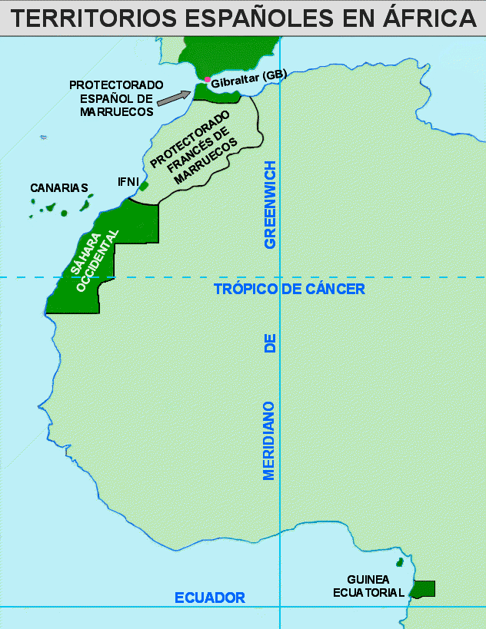
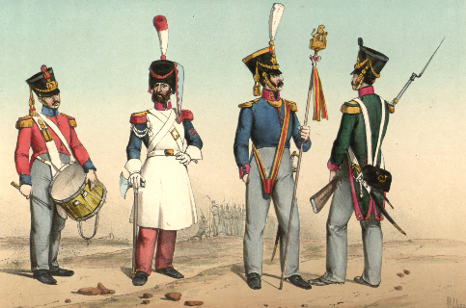
With Ferdinand VII, and after him his daughter Isabella II, corruption became rampant. The conservative elites usually complained the army was full of liberals and tried to promote monarchic officials to the top positions, while plundering the public finances and stifling any protest. It was common to say Se le ve el plumero (His feather duster is showing) when accusing someone of being a liberal since the soldier uniforms included a cap with a feather. For this reason, today you can say Se te ve el plumero (Your feather duster is showing) whenever you want to make clear you know what someone is up to. This idiom has hence lost its original political meaning.
In 1873, the Spaniards got rid of queen Isabella II, and a short-lived republic was proclaimed. Nevertheless, the poor people revolted in many regions against a regime that, in their view, would simply replace the king and the nobles with a new rising bourgeoisie. The republic thus sank under the combined attacks of the starving poor and the wealthy conservatives, and the Bourbons were finally able to make their come back. The role of the parliament strengthened, but the system was corrupt, and the big parties simply took turns in the Government regardless the result of the elections just as the poor people had feared.
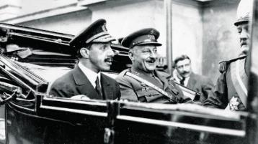
When the European powers divided Africa 1884, Spain was granted some land (North Morocco, Western Sahara, and Equatorial Guinea in addition to the Canary Islands). The successive Spanish governments used their military occupation of the colonies to promote the most conservative officials to top positions in the army. Then in 1923, a catastrophic defeat of the Spanish army led to a scandal where the contempt of the Spanish authorities ― including the king Alfonso XIII ― for their soldiers was exposed. A captain named Miguel Primo de Rivera staged a coup to save these authorities from a parliamentary inquiry, much in the spirit of Mussolini’s takeover in Italy. The king did not realize at the time, but by joining forces with a dictator, he linked his future to the dictatorship’s popularity.
In 1931, the dictatorship was completely discredited, so the king had to go into exile, and a second republic was proclaimed. Women’s suffrage was granted, but income inequality was dramatic. According to historian Manuel Tuñón de Lara, 2 % of the population owned half of the agricultural land. After two unstable governments, a left-wing government was elected in 1936 and got set for an agrarian reform, but the army in Africa revolted with the aid of the rich and some conservative regions in northern Spain. After a 3-year long civil war, the dictator Francisco Franco ruled for several decades. When “democracy” returned in 1978, Spain was back to square one in the dilemma between a monarchy and a republic.
After Primo de Rivera’s (on the right) coup, the king Alfonso XIII (on the left) proclaimed “I finally have my Mussolini.”

Women and Civil Wars
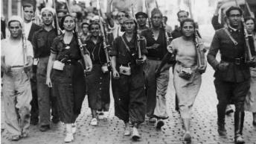
Given that princesses could very rarely inherit the Spanish crown, in 1830 the king Ferdinand VII approved a law officially allowing females to become head of state in the absence of a male heir. The king meant to pass his power on to his older daughter, but his brother Carlos lobbied very actively to succeed him too. The fact the new succession law had not been made public due to its implications for foreign policy became a problem three years after, when the king died and a series of three long civil wars broke out. These wars, called The Carlist Wars, spread to the whole Spanish empire and they accelerated its decadence so much that, at the beginning of the 20th century, all the Latin American countries had become independent.
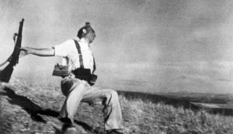
A century after, Spain had put the corrupt mockery of a government of Ferdinand’s daughter Isabella II behind and was a democratic republic. However, general Francisco Franco led in 1936 a military rebellion that was only successful in the most conservative regions, along with a few Spanish colonies that were left in Africa. The most important cities resisted, but Franco was helped by the Nazi Germany, Fascist Italy, Fascist Portugal, some big companies, and thousands of Moroccan mercenaries. On the other hand, the Spanish democracy was helped by the Soviet Union ⎯ Odd as this may sound in Finland ⎯ and thousands of volunteers from some European countries and the U.S., but this help was always way more limited. Finally, the rest of Europe tended to either ignore or sabotage the Spanish republic.
First Prime Minister after the dictatorship Adolfo Suárez admitting he sneaked the monarchy in the Spanish Constitution. The Madrid airport carries his name since 2014.
Robert Capa’s The Falling Soldier (1936) became an iconic picture of the Spanish “civil war”.
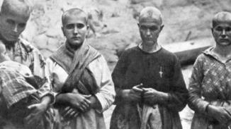
The fact France, Britain and the U.S. did not participate in this conflict led many historians to consider it an internal affair of Spain and therefore to use the name “Spanish Civil War”, although it was the first actual military clash between the Axis powers and the Soviet Union. This means this war could maybe more accurately be considered the first chapter of World War II and not just a Spanish thing. Funny enough, there have been three actual civil wars in Spain under the name of Carlists Wars and one international war under the paradoxical name of “civil war”. It all started with the Spanish extreme conservatives refusing to have a queen and it ended with their very heirs supporting a dictatorship that stripped women of any trace of freedom.
Women on the losing side of the “civil war” were head-shaved, given laxatives that caused them diarrhea, paraded, insulted and spitted at. They could not bury their dead, and their properties ⎯ sometimes even their babies ⎯ were transferred to the winning families. Under Franco, women needed a written permission of either their fathers or their husbands to work outside the house.

The Bourbons’ Comeback
During Franco’s dictatorship, the Bourbons were in exile around Europe. The dictator did not want to share his power with a king, but since he did not have a son of his own he accepted the little grandson of the last king in power could be raised in Spain under his supervision in order to become his successor eventually.
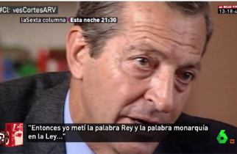
When the dictator died, the young heir became the king Juan Carlos I and confirmed the return of the monarchy. The new king had Franco’s dummy parliament approve a law to move towards a parliamentary system. Elections were held, and the new parliament drafted a Constitution. This Constitution stated Spain was a monarchy, but also promised many social rights and individual liberties. The people were given a choice between either accepting or rejecting the whole package.
Many years later, an old interview with the Spanish prime minister of the time was found to include some off-the-record declarations where he admitted the government never organized a separate referendum on the monarchy because their surveys said the republic was the most popular option. According to another survey carried out in 1970 ― That is, in the intimidating atmosphere of Franco’s dictatorship ―, roughly 20 % of the Spaniards preferred a monarchy, 30 % preferred the existing dictatorship, and 50 % would opt for a republic.
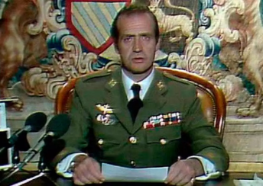
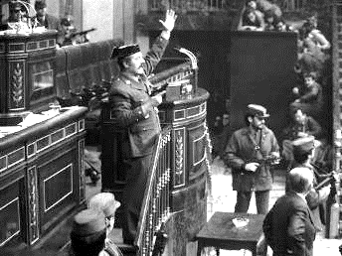
The Spanish elites wanted to get Spain into the EU and the NATO, so they decided to tolerate democracy as long as it would not work against their interest. They used their media to have a conservative government elected, but this first government needed to be somehow sensitive to the polls, so it legalized the communist party, which had been the main pro-democracy clandestine force under Franco’s regime and showed some reluctancy to join NATO. As a result, a group of far-right military officers staged a coup in 1981.
Having learned from the mistakes of his grandfather, king Juan Carlos I invalidated the coup in a tv broadcast. The failure of the coup made Juan Carlos’s popularity skyrocket, as he was “the savior of democracy”, but today we know he was very much aware of the coup, and he just made up his mind about it when he was sure most of the officers did not support it. At heart, Juan Carlos I was very fond of Franco, but he was shrewd enough to find an understanding with the social democratic party PSOE (who won a landslide victory after the failed coup) and become somehow a king for the whole country.
Officially the 1981 coup was a failure. In practice, it helped the pro-NATO, neoliberal-under-the-guise-of-social -democracy party PSOE to win the 1982 parliamentary elections by a landslide.
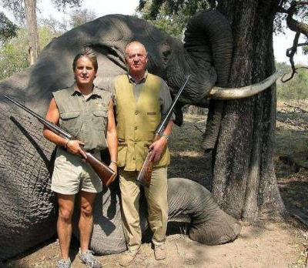
Juan Carlos I also developed a double life. In public, he was a respected symbol of consensus, an experienced sailor, and a facilitator of multimillion contracts for the Spanish construction firms. However, behind the curtain he was an unfaithful husband who made a fortune through arms trafficking, collection of fees and tax evasion. Insulting the king (calling him arms trafficker for instance) was punishable by law, but most media did not need a law to praise him continuously. Juan Carlos I became the beacon of a democratic Spain in which the Francoist elites had automatically found new top positions in the administration or the State-owned enterprises.
Given the Spanish Constitution demanded a completely new text to be drafted should the monarchy come to an end, these elites had every reason to protect the king to make sure nothing ever changes. The media presented Juan Carlos I as a hero. It was the same media that had made the first disobedient conservative government unpopular and had boosted the PSOE, which quickly became pro-NATO. The Spanish parliamentary system became stable again with a social democratic party and a conservative party (PP) that agreed on all the key questions such as the monarchy, the economic policy, or the foreign affairs.
However, in 2012 a news bomb was leaked to the press: the king had broken his hip in elephant-hunting safari in Botswana, and there even was a picture. Amidst one of the worst economic crises in recent history, the king not only appeared living a luxury life paid with public money, but also posing by a dead elephant he had just shot. The safari only added to a couple of corruptions scandals affecting some of the royal family members. As the public resentment grew, a left-wing, pro-republic political party called Podemos came third in the elections to the European parliament in 2014. The elites interpreted this as a serious threat, so the king abdicated in favor of his male son Felipe, who was not as tainted by corruption, and had the two big parties (PSOE and PP) approve hastily an immunity law for himself.
Despite the support of all the Spanish establishment, this immunity did not cover crimes committed after the king’s abdication, so the public prosecutor was forced at least to pretend he opened an investigation when new information about tax evasion leaked. Given Juan Carlos I’s relationship to his wife had long been non-existent, he exiled to Abu Dabi in order to avoid the attention of the media, and in 2023 sought to change his tax residence permanently to the United Arab Emirates. So much for the king as a “symbol of the nation”. Many of the media that had enthusiastically supported Juan Carlos now turned their backs on him and focused on showing how Felipe VI was a much better king than his father. But was he?

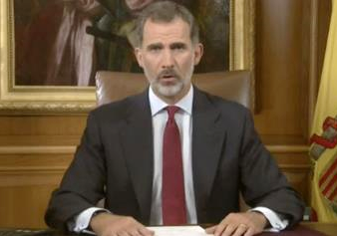
The Monarchy Now
When Felipe VI became king in 2014, the monarchy was at an all-time low. The Spanish Centre for Sociological Research (CIS) showed how Juan Carlos’s popularity had dropped from 7,48 out of 10 to 3,72 between 1995 and 2013. Felipe VI was a fresh face, but only could raise the crown’s popularity 4,34 in 2015. After that, the CIS stopped conducting surveys about the monarchy, officially because it was not any longer a “matter of concern” for the people. Despite this, 16 independent media joined forces to conduct their own wide-range survey in 2021. The results were 39,4 % of the people would vote for a republic in a referendum while 31 % would vote to keep the monarchy.
As a king, Felipe VI differed from his father in one essential way: he was clearly identified as a right-wing king. This became evident in 2017, when Catalonia held an unauthorized independence referendum heeding an overwhelming popular call of the local population. Thousands of policemen were sent to close the polling stations and beat pro-independence demonstrators, unleashing a bitter controversy across the country. Later that night, Felipe VI appeared on tv condemning both the demonstrations and the referendum itself and speaking about the prevalence of a united Spain. Since that moment, only the right-wing and far-right political parties defend the king publicly.
In 2022, Felipe VI attended the assumption of the President of Colombia Gustavo Petro. A highlight of the ceremony was the arrival of Simon Bolívar’s sword, a highly respected symbol that made almost all the attendants stand up. Felipe remained seated, showing maybe a similar contempt to the one his father had showed in 2007 when he told Hugo Chávez to shut up in a summit. Felipe VI has tied his destiny to the political right much in the fashion his great-grandfather Alfonso XIII tied his to the dictator Miguel Primo de Rivera. This is not a problem as long as that political option remains popular. However, should the ideological tide ever head clearly in the opposite direction in the Spanish society, a third republic would surely be on the table again.
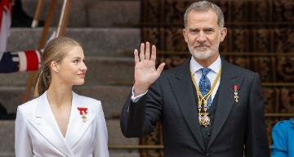
Whatever happens, the monarchy is already preparing a new succession. The 1978’s Constitution kept the priority of males as heirs to the crown (and Felipe VI was the little brother of two women indeed), but since the royal couple only has two daughters, a constitutional amendment has not been deemed necessary. In 2023 the Princess Leonor was officially designated future heir to the crown in a bombastic ceremony in Madrid. The media organized a propaganda campaign that tried to turn her into a pop icon and even to normalize the term Leonormania.
Now, with the political tide changing into a more conservative direction, there’s some speculation about her grandfather Juan Carlos finally moving back to Spain from the United Arab Emirates, but that is no surprise. If history is any guide, we must conclude the Bourbons are always likely to find their way back.

The Capital of Spain
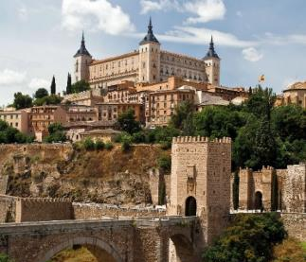
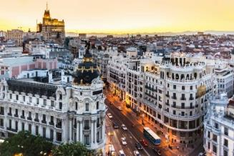
Before the beginning of parliamentarism, there was not such a thing as “capital of the state”. Countries were run by kings, and these kings could choose where to live with their court. During the Middle Ages, the Spanish court was mostly in Toledo, a beautiful city of medieval architecture in the center of Spain, although the headquarters of the Spanish inquisition were there too. However, the monarchs could sometimes decide to spend a season with their court elsewhere, as when they went to Seville to enjoy its mild winters and maybe put some pressure on raising the local taxes. In 1563 though, the king decided to move the court more or less permanently to Madrid, a little village in the middle of nowhere.
While other European capitals have been established in historically, strategically, or commercially important cities, Madrid was chosen because it was a quiet place with good hunting grounds. The king did not want to be continuously bothered with nobles or bishops who asked for his favors, so he fled to the countryside in order to better spot these favor-seekers as they moved closer to the royal palace. The king had several palaces built in the area. However, the first Bourbon to rule Spain did not like the main palace in downtown Madrid and, allegedly, set it on fire. The current Royal Palace doubles de size of those in Buckingham or Versailles and was built on the ruins of the old one.
Despite the palaces though, it was not until the late 18th century that Madrid became a true capital by the European standards, with several large avenues, a sewage system, and some scientific institutions and academies.

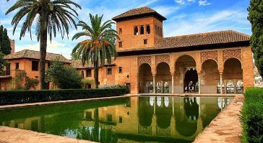
The Architectural Legacy of Different Cultures
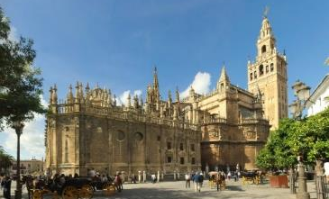
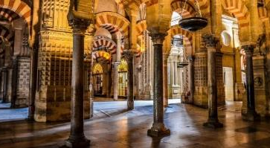
Both the romans and the Muslims left some important buildings and infrastructure in Spain. The romans built for instance A Coruña’s Tower of Hercules, which is the world’s oldest existent lighthouse, or the Aqueduct of Segovia with its characteristic roman arches. The Muslims had their most important buildings in Granada, Seville, Córdoba, and Zaragoza. Córdoba’s case is unique since the Christians decided to build a cathedral on top of the great mosque after they conquered the city in 1236. The site is nowadays a one-of-a-kind combination on mosque and cathedral, but it doesn’t officially belong to the Spanish state since the Catholic Church registered as its own in 2006 for 30 euros.
The Muslims took their famous horseshoe-shaped arch from the medieval architecture of the Iberian Peninsula. They built palaces and mosques which were richly decorated inside but scarcely decorated outside. Their decoration included some sentences from the Quran and geometrical figures. This decoration can be interpreted as a token of the development of geometry in the Muslim civilizations as well as a consequence of the ban on portraits of the living beings. The Muslims also paid great attention to gardening and the use of water, and the outside of some buildings give evidence of this.
A residential building in The Alhambra fortress, Cordoba’s mosque, and Seville’s cathedral.
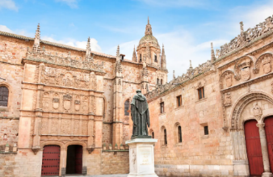
Meanwhile, the Christians started building humble churches in North Spain, but developed their architecture as they were moving south. This is why the Spanish churches are larger and more impressive the closer we get to Andalusia in spite some important exceptions in Burgos or Barcelona. The world’s largest gothic cathedral is in Seville, and that is also the resting place of Christopher Columbus’ remnants. The building process took several centuries, and the successive crisis of the Spanish economy forced its makers to draw on remarkable handcraft skills to have everyday stones or plaster look like the finest marble, wood, and gold.
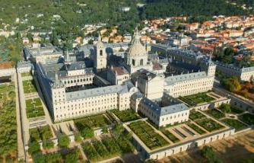
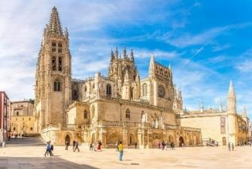
Throughout the centuries, Spain adapted to the European architectural trends. There are outstanding examples of the Romanesque, the Gothic (especially Burgos), the Renaissance, the Baroque (Santiago de Compostela or, in a more ascetic version, Madrid among others), and the Neoclassical art. During the first two centuries of the Spanish empire, a richly decorated kind of Renaissance style called plateresque developed in Spain. This in best seen in Salamanca, but the style was replicated in other parts of the country and the Northern half of the Spanish territories in the Americas. However, by the end of the Renaissance, the Reformation and the economic crisis forced both the crown and Catholic church to seek a purer, more stripped-down style.
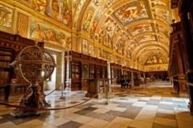
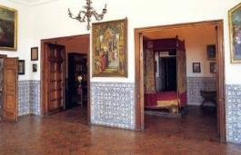
This was the Herrerian style, which is best seen in the monastery-palace of El Escorial. El Escorial is a village close to Madrid, where this building officially known as the Royal Site of San Lorenzo de El Escorial is located. Its grill shape commemorates a Spanish military victory against France occurred in Saint Lawrence’s day, because this martyr had been grilled to death. The Herrerian style and this building in particular conveys order through its predominance of horizontal shapes, authority through its gigantic proportions, and austerity through its lack of ornament. All the Spanish kings and queens are buried in its underground mausoleum, and it is interesting to note that the decorations recover some predominance as we approach this “spiritual” area of the dead monarchs.
Burgos’s cathedral, the University of Salamanca’s façade, and El Escorial.
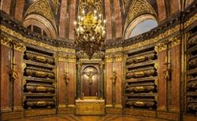
The ideology behind this transition from plateresque to Herrerian was earthly life was meant to cause strain, suffering, and submission, while spiritual world symbolized by the El Escorial’s library gallery and its royal mausoleum is the place where all the awards are granted. But this is only an example of how architecture has been used as a propaganda tool through history. The romans used their infrastructure and monuments to extend their power just as much as the Spanish royalty did. The Herrerian style was obviously useful to have people accept their harsh reality, and as the crowds became more conscious with industrialization, more symbols would be needed to prevent the rabble from threatening the established order.
El Escorial: the empe-ror’s bedroom, the library and the crypt.
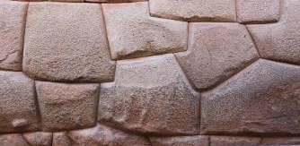
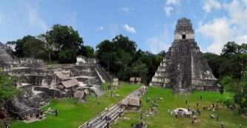
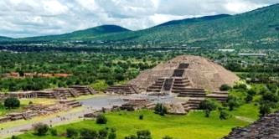
In Latin America, the Incas, the Aztecs, and the Maya people built some palaces, fortresses, and temples that dwarfed everything else in the continent. The Aztecan and Mayan pyramids in such places like Teotihuacán or Tikal respectively are very famous while the Incan architecture stood out for building solid walls made out of tight chunks of sculpted stone that imitated corn on the cob. Again, their massive buildings were symbols of authority in some of the most hierarchical societies the Americas had. The Spanish in turn either abandoned or destroyed these buildings and built their own symbols of authority: palaces, cathedrals, and so on.
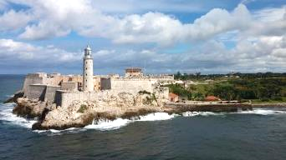
In 1740 the Spanish king ordered that all cargo ships carrying silver and other goods for Spain would leave at the same time once a year from Havana in Cuba, heavily guarded by warships to prevent piracy. Havana thus monopolized the American trade with the mother country and filled with palaces, churches, and fortresses. Today, it has some of the finest examples of colonial architecture along with other cities such as Bogotá or Santo Domingo.
Teotihuacan, Tikal, an Inca wall, and Havanna.

The Role of Urbanism in Class Conflict
During the second half of the 19th century, Paris and many other European cities underwent a remarkable transformation by turning many of their former narrow medieval streets into great bombastic boulevards. The aim was to make room for traffic, but also a propaganda strategy designed to advertise industrialism’s modernity, as well as a means of social control. The elites realized the old narrow streets were too easy for the growing urban proletariat to barricade, so they planned some big avenues where the key governmental buildings could be best protected. Should the people riot, the newest cannons were very well suited for dispersing any mob threatening these centers of power.
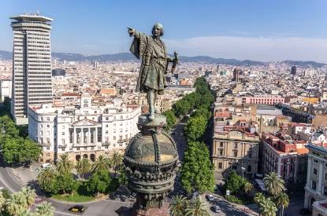
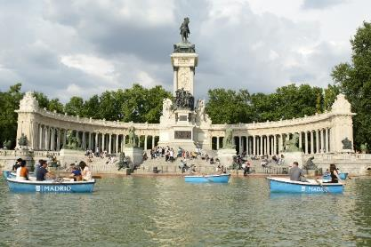
Spain followed suit after Paris. In Madrid, a distinction is made between the Habsburg’s Madrid prior to 1714 and the Bourbon’s Madrid, with its boulevards and its grandiose royal palace. In Barcelona, the architect Ildefons Cerdà created the concept of urbanism, and he managed to have his enlargement plans approved partly because they included wider streets for the police cavalry.
Regarding the symbols, the king’s supporters filled the country with monuments to imperialism after a brief republican experiment in Spain (e. g. Barcelona’s statue of Christopher Columbus or Madrid’s statue of Alfonso XII at the Retiro Park). They wanted to advertise their idea of Spain as a timeless reality standing above its people’s circumstantial will.
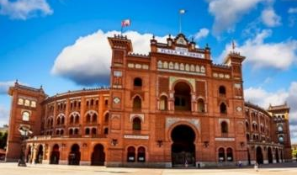
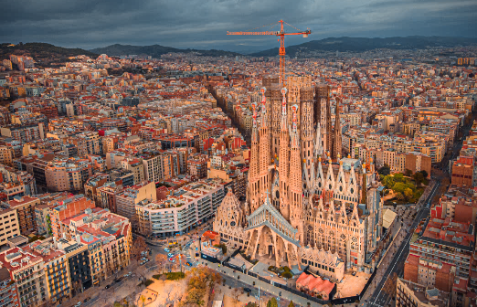
Many Spanish traditional symbols at that time either opposed the ordinary folk’s right to political power or glorified some symbols of an imperial, authoritarian past. Many buildings were made in Neo-Mudéjar art, imitating ―ironic as it is― those Muslims who lived in the Iberian old Christian kingdoms and produced beautiful abstract ornamentations with a set of humble materials such as brick, wood, and tiles. Madrid’s bullfighting arena, Barcelona’s triumphal arch or Seville’s old railway station are outstanding examples. The aim was not to showcase the skills of the working poor, but to draw an uninterrupted umbilical cord between “present” Spain and the medieval symbols of power.
La Sagrada Familia dwarfs almost everything in Barcelona.
Las Ventas is Madrid’s bull-fighting arena, but bullfighting is not very popular nowadays.
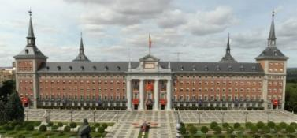
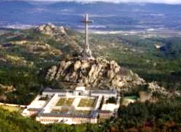
In Catalonia, the revivalist architecture was nevertheless most effective when drawing on local elements. The Catalan elites financed the construction / refurbishment of several buildings in a Gothic-like style, since the Middle Ages where considered the time Catalonia was at the height of its political power. These rich people also supported the modernist architecture since it was fashionable, and they wanted to present themselves as the key to European modernity. Modernism resorted to some simple, organic, solid structures with an abundance of nature-like ornamentation. Its chief masterpiece is Antoni Gaudí’s Sagrada Familia in Barcelona. It is Europe’s most visited church after Saint Peter in the Vatican, and it will be the world’s tallest when it is finished.
During the Francoist dictatorship, some National Catholic buildings were made, particularly in Madrid. They can be recognized by their overwhelming, hostile proportions. Their use of red brick walls in stone frames represented the chaotic mobs submitting to the authority of the “eternal Spain”. Quite often, they would use pointed shale rooftops in reference both to the Habsburgs and to some imaginary Germanic origins. In such a sunny, dry country as Spain, pointed rooftops have a clear ideological component, but not as ideological as the Valley of the Fallen, a gargantuan mausoleum close to Madrid where the remnants of general Franco remained buried until 2019.
Left: former “Ministry of the Air”. General Franco had the Ministry of War split into different branches to prevent other military leaders from concentrating more power than him. After World War II, ministries of war were renamed to Ministry of Defense in many countries. Right, the Valley of the Fallen, which is a pilgrimage site for Spanish fascists.

Housing and Ideology
Since Franco’s approval of the Law of Land in 1956, Spanish landowners got enormous capital gains every time a municipality declared a real estate property fit for construction. This system obviously created some powerful incentives for landowners to bribe and corrupt the local authorities, and it is in place still today. As a result, the Spanish real estate properties are unnaturally expensive, and a high building density is needed to make housing construction profitable. Many apartments built during the dictatorship are thus small with three tiny bedrooms connected through a corridor, and with a number of windows facing an inner courtyard. After gentrification, many apartments were refurbished into lofts, which are better suited for tourism.
The three-tiny-bedroom apartment was thought to be fit for any family. One was for the married couple, while the others were distributed according to sex. Naturally the high birth rate during the dictatorship usually meant these bedrooms were stuffed with bunk beds, but the priority was to cultivate a good reputation. The “public space” of the house was made of a small living room and a larger showcase dining room for social life. This meant many people spent most of their time in the least comfortable areas of their home, particularly women. The kitchens for instance were so narrow that the first refrigerators in the 60’s often had to be placed in the dining room, which also served as a sign of status.
Franco managed to make his regime accepted by other countries despite its fascist origins. In the 60’s, the Spanish economy boomed based on three pillars: tourism, foreign investment, and developmentalism. This meant many coastland areas were filled with tall touristic buildings, and also, that the young generations fled the countryside to the big cities and the coastline. Many new districts appeared overnight. In 1978, a law was passed to allow for self-sufficient housing developments and many people started living in areas that were poorly connected to the city, had no common areas, and only got their basic social needs (e. g. outpatients clinics or schools) covered many years after they had settled in.
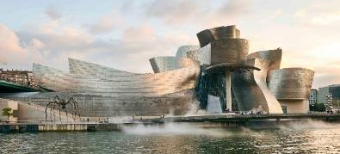
Over the years this influenced the ideological structure of society. The inhabitants of housing developments didn’t come into contact with other strata of society since each development targeted a specific income group. This people paid taxes but didn’t receive any public services in return, so they became hostile to the very idea of politics. The most appreciated buildings were designed as closed communities with a swimming pool for their use only. People could use an elevator to get directly from an underground parking lot to their apartments without seeing other neighbors. Many people didn’t know who lived next door, so maybe the only thing that united them was cheering at football games and the use of flags and other nationalistic symbols.
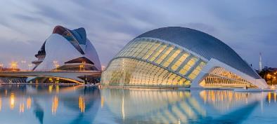
After Franco’s death, Spain put up a parliamentary system and then joined the EU in 1986. In 1992, both the Barcelona Olympic Games and the Seville Expo ’92 were the calling card of the “new modern Spain”. Amid a new golden age for tourism, Bilbao reached a tremendous economical and propagandistic success with the opening of its architecturally impressive Guggenheim Museum. After that, many regions joined in a populistic, landmark-building race encouraged by European cheap financing. For instance, Valencia’s City of Arts and Sciences was a futuristic cultural complex that turned into a money drain, and Spain built the best high-speed train network in Europe, but half of the seats were empty due to an insufficient demand.
Bilbao’s Guggenheim Museum and Valencia’s City of Arts and Sciences
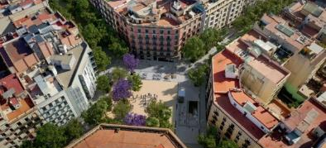
In 2008, the credit crunch showed Spain had been pouring money into roads, high speed trains, and spaceship-like buildings while forgetting the regular suburban train network or the social services. The roundabouts had conquered the cities as the country had adapted to drivers, not citizens. The ensuing social and political unrest was mostly buffered by the media and only in Barcelona there has been a long-lasting transformation project. In 2016 Barcelona started the Superilles project, which has turned some streets and squares formerly open to road traffic into parks and green areas. Today, Barcelona builds more subsidized housing than Catalonia and the Madrid region combined.

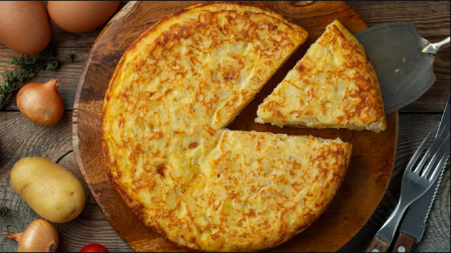
The Spanish cuisine
The romans brough the techniques of both cheese and wine making to the Iberian peninsula. That’s one of the reasons why some former areas of the Roman Empire have nowadays a strong cheese and wine tradition. The romans also made extensive use of wheat products, and you can see that today in the fact that most Spaniards usually eat holding a fork and a piece of bread instead of a knife. And they also brought olives and olive oil, which became the basis for so many dishes. The mayonnaise, for instance, was born in the Balearic Islands. It is a heavy mixture of olive oil and eggs, but people just love it. Today, Spain produces roughly a third of all the olive oil made in the World.
The Muslims on their part brought the rice, the legumes, the dried fruits, and the citric fruits. For instance, there are many different rice paellas, meat stews come usually with legumes, and the typical Spanish bakery uses more lemon and dried fruits than in other western European countries. Also, since the Muslims or the Jews didn’t eat pork, it became a proof of Christianity to eat it. The old Christian kingdoms specialized in its production, and today jamón serrano is a well-known kind of ham. This ham had to be buried is salt for a few days and then hung to dry for 1-3 years in a cool, dry place. Because this ham had to be made in the cool top of mountains, it was called serrano, which means “from the mountains”.
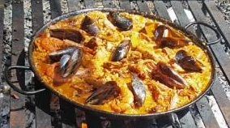
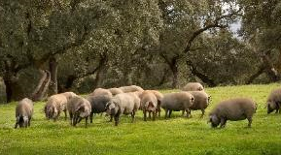
White pigs are the ones used for serrano ham and other meat products such as chorizo, which is a pork sausage with paprika. However, the more appreciated dark Iberian pig is used for top quality hams such as jamón de pata negra (black leg ham) or jamón de bellota (acorn ham), which is considered by many the world’s finest and it is made with Iberian pigs that roamed freely eating nothing but acorns for four months before the slaughter. Cured hams have only unsaturated fat, so you are not supposed to withdraw the tasty white fat that is intertwined with the meat. On the other hand, the Finnish uunikinkku (jamón asado) is not very known in Spain. You can find the basic boiled ham (jamón de York), but it is not nearly as appreciated.
After Columbus’ journey, the Americas became the third basis for Spanish cuisine along with the Roman and the Muslim tradition. In the Middle Ages, most people used honey to sweeten their bakery, but after the first sugar canes were brought from Asia to the South American colonies a very profitable import frenzy was unleashed in Europe. The Spaniards brought cocoa among other things, added some sugar, and made hot chocolate their national drink for centuries, although nowadays, this traditional, thick chocolate drink is mainly used to dip churros. The conquistadores also brought tomatoes, and gazpacho became a popular cold soup in hot Southern Spain.
The most important American ingredient, however, was the potato. It produced as much as two to four times the amount of food a cereal crop would. The Spaniards used them along with beans ―Another import from the Americas― in their meat stews and invented the Spanish omelet, which has become a national symbol ever since. It is interesting to note that Spaniards rarely use the oven, and many local specialties are stews where the meat, the fat and even the bones of an animal are supposed to flavor the rest of the ingredients including potatoes. The fact that in Finland the diners are supposed to peel their own potatoes might be related to a more egalitarian conception of the cooking chores.
Being a mountainous country, Spain developed a varied cuisine. It had three common roots (Roman, Muslim, and American), but many local differences. For instance, many different cheeses in north Spain are mild flavored, but we find much stronger varieties in the dryer inland areas. The Atlantic coast offers excellent seafood in the Cantabrian area and small fried fish in the Andalusian West coast, but the Spanish Mediterranean coast is not that fruitful. Andalusian vegetables allow for delicious gazpacho and salads with olive oil, salt, and vinegar while Valencia is clearly more specialized in rice meals, and inland Spain likes meats, beans, and heavy dishes.
On the minus side, Spain produces way more meat than it needs. That means stuffing animals in macro-farms. The animals need a high dose of antibiotics in order to prevent diseases and consume a large amount of soy. Some of this soy is imported from Brazil and partially explains the pressure to burn some patches of the Amazon rainforest every year to grow more soy. Spain’s patisserie is very varied in turn, but not nearly as good as the Portuguese. Portuguese coffee, as well as Italian, is also better. And Spaniards are not especially good with pasta or ice-cream, but every region has many unknown specialties that are shockingly delicious.

Latin American Cuisine
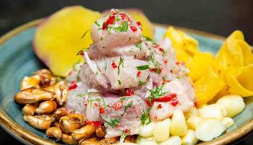
Every Latin American country has its own specialties based both on their local ingredients and on the role they played as colonies. For instance, corn has been grown in Mexico for thousands of years. The Spaniards didn’t want any competitors in wheat production, so they made Mexico stick to corn and a whole cuisine around corn-based dough, beans, chicken, and local vegetables developed. The closer the colonies were to Spain, the more they had to adapt to the market necessities of the mother country. That’s why many Latin American countries are not known for their wine (the Spanish producers did not want any competitors), but Argentina and Chile could become large producer thanks to being peripheral.
Enchiladas. The cultural prevalence of the U.S.A. has made Mexican food globally famous, but it has also created a fast-food image. However, UNESCO designated the Mexican gastronomy Intan-gible Cultural Heritage in 2010.
In South America, we see a clear distinction between the South-Atlantic and the Pacific coast countries. The Atlantic colonies had the best grazing lands, so they specialized heavily on beef production. Argentina is for instance one of the world’s top four per capita consumers of meat. On the Pacific coast, the Andes made it more difficult for a competitive cattle industry, so people relied heavily on fishing. The delicious Peruvian ceviche is a good example of this. Peru has, for its part, the most admired cuisine in the Pacific area not only because it was the heartland of the Inca Empire, but because it enjoys three different ecosystems: the coastlands, the mountains, and the rain forest, which allows for a wide variety of ingredients to be used.
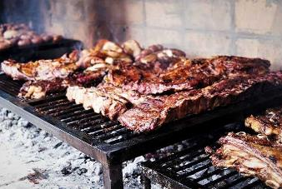
The Southern Cone is also known for mate, a caffeine-rich infused drink that is much more popular than coffee or tea. And maybe it is also best known for dulce de leche, a caramelized milk that is used in countless desserts. It is interesting to note that Spanish language is quite homogeneous even in areas as far apart as Argentina and Spain, but there are some local differences. For instance, although papa is the default word for “potato”, Spaniards are used to saying patata since early conquistadores mistook some potato varieties for sweet potatoes (which in turn are batata in Spanish). Another example is the word limón: Latin Americans use it for “lime”, but Spaniards use it for “lemon”.
Argentinean asado and mate

The Social Dimension of Food
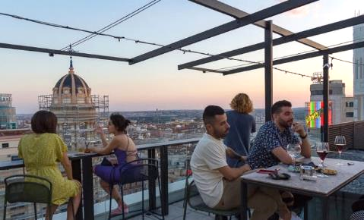
Consideration is a defining trait of the Finnish social gatherings as shown in the popular sentence Ei minua varten tarvii keittää. When inviting people over, it often happens the host does not promise any food in order dampen down any expectations, but still they will want to have something to offer out of consideration. Since the guests do not usually want to cause any trouble either, they also make sure they are not too hungry at the visit. In some cases, this can even lead to guests being offered a full-fledged meal when they have already eaten and having to eat again out of courtesy. In the Spanish-speaking countries such misunderstandings would be very difficult though. People usually set their dates around meals, saying for instance “Let’s get together for dinner” or “We’ll meet after lunch”. And, when they are not eating, they often talk about what the best foods are.
Do not judge the living standard in a country by how full the terraces are. Many people can’t move out from their parent’s house or have as many children as they would want, but they definitely can afford a beer in any of the numerous Spanish bars.
The Spanish-speakers as a whole do not usually thank after their meals since that is what a recipient of charity would be required to do. You do thank however when you are offered something, so if you are offered a coffee, you should probably say Sí, gracias or No, gracias. If you said Sí, por favor as in English (Yes please), you would sound again as begging some charity. Instead of thanking for charity and begging for food, politeness requires you compliment the food. If you don’t actually like what you are eating, you can say it’s good (“Está bueno”) without any particular enthusiasm, and nobody will take it literally (especially if you don’t have a second helping!). Last, when you enter a room where someone is having a meal and make eye contact with them, you are supposed to say Que aproveche (“Enjoy!”) to make clear you do not mean to disturb a peaceful meal.
People usually have only a small breakfast at home before leaving for work, then they stop around 10.00 a. m. to have another breakfast in a bar. In Spain, there are many bars that offer a variety of affordable breakfasts, and some people think it actually is a matter of national pride and identity to have a bar in every corner, but in practice the abundance of such places is partly due to the lack of cuisines/cantinas in many workplaces. In physically demanding jobs, people might stop around 12.00 p.m. to have a sandwich and a beer, but proper lunch comes at 14.30 p.m. or so. Those who can, go home to have lunch with their families after returning the workplace, but the long distances in large cities make it very difficult for many people. Children might have an afternoon snack, but adults usually wait for dinner, that takes place around 22.00 p.m.
Many people think the Spanish people a split shift workday because they want to take a siesta or “nap”, but the truth is more complex. Just as many other countries, Spain achieved the 8-hour workday at the beginning of the 20th century, namely in 1919. However, as general Franco conquered the country in 1936-1939 inflation crushed salaries and forced men (women were excluded from the labor market) to look for some extra sources of income. Franco’s “solution” was to place Spain in Nazi Germany’s time zone in 1942. Most people used to have lunch at 1 p. m., as they still do in most of Latin America, but all of a sudden it was 2 p. m. so early-rising men could do their 8-hour shift, then go home for lunch and a power nap, and then hit the streets again to get more money.
The split shift workday is not then the result of laziness, but of the need to work more. Spain is still today in the wrong time zone, and most workers have split shifts. That often means toiling for a longer time than the official 8-hour day for a salary below the European average. Many people watch the main news broadcasts starting at 3 p. m., but usually only retired people have the time to take a siesta (nap).
While some people find “lively” that Latino cities as a whole seem active till late, it is a fact that parents with bad working conditions can hardly see their children during the week. Despite the help of grandparents, the lack of family time often weighs heavily on both their school performance and their screen addiction. When the Spanish women massively joined the workforce in the 80’s after general Franco’s death, men did not automatically take their share in the household chores, particularly in the first two decades, so the families’ nutrition started to depend more on fried stuff and pre-cooked food. Spaniards do take much pride in their local gastronomic specialties, but in a hectic, everyday life such treats can sometimes be more of a symbol than a reality.
Another trait that is worth noticing is that the Spanish-speaking people resort to bars and public places more often than people in many Western countries. Finns are often disappointed when they realize they are seldomly invited to other people’s houses and might feel they are failing in their integration, but this happens for a reason. In stratified societies, people are not comfortable letting others know how they live. They don’t want to be automatically categorized according to income, and the pressure to give a good impression might be high. During the Francoist dictatorship, the bars were men-only spaces, and women’s limited social life mostly took place either during grocery shopping or in their showcase dining rooms, but bars are now open to everybody and make it possible to meet others on a more egalitarian basis.
A good share of Spaniards takes the abundance of bars as a sign of their ability to enjoy life, although it is usually more connected to social inequality. Many people (mostly men) put up their own bar to make up for the lack of decent job opportunities, so the fierce competition in this sector does not usually allow for high profits. The positive side naturally is that customers have many affordable bars to pick from. This is a bliss both for young people and tourists alike. Under Franco’s regime, divorce was not permitted, and bars were the hiding place of many unhappy husbands. Today, youngsters find it difficult to leave their parent’s home given the sky-high housing prices, but this does not cause much of a problem since the bars still offer them an easy way to conduct their social life outside the house.
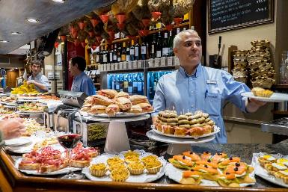
And, as regards to the famous Spanish tapas, many Andalusian bars offer these little snacks for free with their drinks in order to attract more customers, but these snacks usually have to be separately ordered and paid for elsewhere in Spain. The word tapa (cover) was probably chosen because the first tapas were little dishes that “topped” wine glasses and protected them from any annoying little fly. A tapa is always free of charge if not ordered, but most bars offer at least a list of paying tapas. And, if you want to share a larger dish, you can also order a ración (portion). Also, in the Basque country, there are pintxos instead of tapas. These are pieces of bread topped with some delicious food and held together with a stick. They are displayed on the bar top, and they can be a bit pricey. In traditional bars you can pick them at will and pay at once for all the sticks you have collected before leaving, but nowadays it is becoming more normal to order the pintxos and pay on the spot.
The Lack of an Oral Culture of Popular Origin in Spain
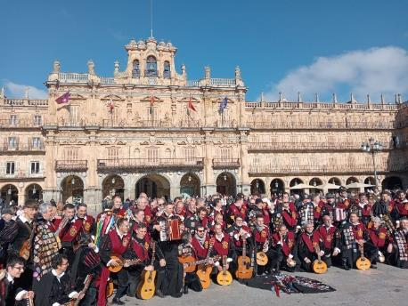
Salamanca is a beautiful Spanish Renaissance city north-west of Madrid. It is home to the First Spanish-speaking university ever. The Universidad de Salamanca was founded in 1218 as Europe’s fourth after Bologna, Oxford, and Cambridge, and today its wide offer of Spanish courses makes the city a top destination for people looking to improve their language skills. The first students in the University were of course boys of noble origin though. Some of them, called tunos, usually gave public concerts for food and money, and their songs were as conservative as could be expected since they usually portrayed love stories from the point of view of male aristocracy.
A century after the birth of this university, a Castilian king nicknamed the Wise was seeking to develop a cultural hub in Toledo that was not subject to the Catholic church. He had many fundamental Greek literary works translated from Arab or Hebrew to Latin and Spanish. In 1348 he approved the first Castilian book of laws (Las siete partidas, as the book is known today in Spanish), a legal code dealing mainly with the obligations of kings, subjects to the crown, people buying or selling land or married couples. In its last part, though, this legal code already forbade street musicians under the pretext it was “a degrading show”.
As a matter of fact, the “wise king” never actually intended to spread culture, but to control it in his fierce competition with the Catholic church. The Castilian book of laws allowed musicians to play “for their lords”, but not in public places since that would have had an enormous propagandistic potential. This meant the songs had to please only an aristocratic audience as the tunos’ songs did. The written ban of street musicians was only another milestone in a censorship system that has worked throughout history in the Spanish-speaking countries. That is why only some conservative cultural phenomena have been allowed to thrive.
Today, la tuna is a constellation of men-only clubs for university students in Spain, Portugal, and some Latin American countries. They dress in Middle-Age student clothes and play their traditional songs in weddings and local festivities. They have some public funding to support their travels, but opinions about them are very divided. This is the beginning of the tunos’ most famous song:

Clavelitos
Little carnations
Young girl, give me the carnation.
Give me the carnation in your mouth,
Since that doesn’t require
much nor little insolence.
I will give you the bell,
That is a promise young girl,
if you give me that honey
you carry in your little mouth.

Chorus
Little carnations, little carnations,
little carnations of my heart.
I bring you little carnations,
and they are red like a big strawberry.
If someday the little carnations
I couldn’t manage to bring,
don’t you think I don’t love you anymore.
It’s just a couldn’t pick ‘em.

Mocita, dame el clavel.
Dame el clavel de tu boca,
que pa’ eso no hay que tener
mucha vergüenza ni poca.
Yo daré el cascabel,
te lo prometo, mocita,
si tú me das esa miel
que llevas en la boquita.

Estribillo
Clavelitos, clavelitos,
clavelitos de mi corazón.
Yo te traigo clavelitos
colorados igual que un fresón.
Si algún día clavelitos
no lograra poderte traer,
no te creas que ya no te quiero.
Es que no te los pude coger.

The Finnish language has a well-developed oral tradition. This is due to a number of factors, such as the geographic spread of the population in a harsh land, the fact of being a latecomer in written production or the pursuit of national unity before Finland’s independence. On the other hand, the Spanish popular culture has traditionally been suppressed, and for instance there a are not many children’s songs. A telling example of how most of the cultural production has usually sprung from either the gentry or the church is Christmas songs, since all of them are centered around the birth of baby Jesus. Here is a small sample of what you might expect:

Los peces en el río
The Fish in the River
The Virgin is combing her hair
between a curtain and the other.
Her hair is made of gold.
Her comb is of silver.
Chorus
Just look at how the fish in the river drink.
Just look at how they drink in order to see the newborn God.
They drink, and drink, and drink time and again.
The fish in the river in order to see how God is born.

La virgen se está peinando
entre cortina y cortina.
Los cabellos son de oro.
El peine, de plata fina.
Estribillo
Pero mira como beben los peces en el río.
Pero mira como beben por ver a Dios nacido.
Beben y beben y vuelven a beber
los peces en el río por ver a Dios nacer.

Did you notice the snobbism in portraying an imaginary blonde Palestinian woman who combs her hair with a silver comb? Today, the Spanish people’s relation to their own cultural heritage runs pretty much along political lines. If you are a conservative catholic Spaniard, you will most probably love the tunos, the local Christmas songs, and other traditional symbols. If you are a progressive secular Spaniard, you are somehow bound to either ignore them or outright to despise them all. There still are some neutral children’s songs of course, but the numbers are nowhere close to those you would find in some other cultures.

What Do the States and Nations Have to Do with the Popular Culture?
The history of mankind is usually divided in four time periods: the Classical Age, the Middle Ages, the Early Modern era, and the Late Modern era. In the Middle Ages, the nobility used to control politics across Europe and kings were forced to request their help before declaring a war. However, in the Early Modern era, new modern European states were born as the kings allied with a rising bourgeoisie. Their aim was to set up a commercial infrastructure that would allow them to trade among them, and in the longer run with the Far East. That is why these modern states were defined by a legal system, a number of infrastructures (harbors, roads, and so on), and a centralized army that protected their commercial interests.
In Spain this alliance did not happen between the king and the too feeble bourgeoisie, but between the king and the Catholic church. This is why the Spanish inquisition became the first state-wide administrative authority. And along with this, came the first state-wide police force and the first state-funded regular army. The ensuing commercial development caused vast social inequalities to be sure, but it worked for the European states while they could offer jobs to the poor, or they could send their population surplus to their colonies. However, in the Late modern era everything changed.
Prior to the time of both the independence of the 13 colonies in North America and the French revolution, the starving, working poor developed a strong class consciousness. They all shared the same problems and therefore started feeling part of “a people”. When these working poor partially seized power, for instance in the US and France, they started granting themselves many rights on the basis of being a sovereign people. In other words, a nation. This means that although the creation of modern states was the project of a commercial elite, the concept of nation was developed long after that by the poor people who joined forces in a struggle for collective rights.
At first, the European kings usually tried to get rid of the very concept of nation. However, their bourgeoisie, and in Spain the Catholic church, understood soon enough they should rather try to reshape this concept. During the 19th century, many monuments were erected and a frantic quest for each country’s traditions and symbols started. Both the poor people and the elites tried to impose their own version of every nation’s history through the first-born newspapers, since controlling the past was the key to shape current policy. Since then, the current identity of every nation could be considered nothing but the outcome of a class struggle that took place mainly in the media.
For the working class, Spain was the home of a sovereign people trying to conquer their rights after centuries of oppression, silencing, and violent indoctrination. For the elites, Spain was a timeless reality whose identity was to be found in the Catholic legacy, the deeds of some historical figures (kings, saints, conquistadors, and the like), and the symbols of authority. The ensuing boom in the inauguration of monuments stressed quite openly that Spain was the product of a long tradition, not that of the rabble’s circumstantial whims at a given time. However, this implied a dreadful assumption: if the country was a timeless reality not subject to the people’s will, it meant Spain was something to be defended against Spaniards.
In this struggle, it was key to define the people’s true reference symbols, so the ruling authorities in Spain and some Latin American countries such as Mexico or Colombia, shaped and promoted bullfighting as we know it today. In their view, the national spirit was supposed to be represented in a defiant, brave, cold-blooded man who would skillfully use a red cape to repeatedly drive a raging bull away without giving up one inch of soil. The closest he would let the bull get, the more other men would admire his bravery, and the final blood bath represented superiority of a fearless man over the beast. As old hidalgos did, the bullfighter was supposed to constantly project a proud image of dignity and was admired for it, but today most people find the whole show cruel and ridiculous.
Another cultural phenomenon the Spanish authorities tried to use with a nationalistic agenda was flamenco, an Andalusian music and dance style that was inspired in old Muslim music and was a specialty of the local gypsy people. The rich advertised flamenco as a national symbol and usually tried to show how committed they were to the “national culture” by hiring some gypsy musicians to cheer up their parties. The uncouth, narrow-minded Spanish landowning elite had a way with the gypsy outcasts who were excluded from the educational system because both groups acknowledged their different social statuses, but the white working class never felt a part of this.
The Latin American elites tried to do exactly the same with all their local music styles. During the 19th and 20th centuries the following music styles were born.
19th century | Where | What
 | Dominican Republic | merengue
 | Brazil | samba
 | Colombia | cumbia & vallenato
 | Argentina | tango
20th century | The Caribbean | salsa
 | Panama | reggaeton
21st century | Puerto Rico | Latin trap
¨

All these styles were born spontaneously among the poor, but then used to create a an idea of national unity that overlooked the vast income disparities. Tango and salsa were the most successful due, among many other factors, to a lack of important racial barriers, but for instance capoeira, a Brazilian dance-like martial art, has always been limited by racial prejudice.
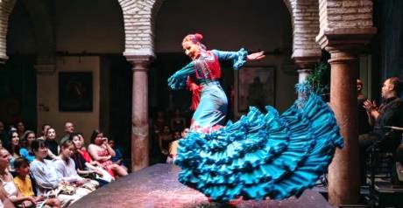
However, back to Spain, the fact a powerful minority has usually managed to impose a national vision that relies on both the symbols of authority and on some authorized cultural phenomena such as bullfighting or flamenco raises a few doubts now about what being Spanish really means. In other words, in a context where these symbols and cultural phenomena are not widely accepted any longer, what does it mean to be Spanish? Maybe the answers to that question could help explain why some people seem to be looking for a trace of a national identity in such things as gastronomy, a tendency to party, and the ever-present abundance of bars and restaurants.

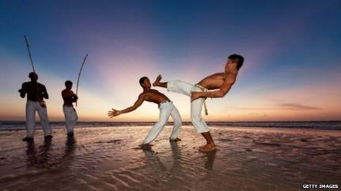
The role of music in Latin America
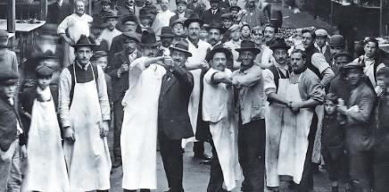
When considering the independence process in Latin America, it is important to bear in mind that the local elites were the actual drive behind it. Independence was not the project of “a people”, but of a set of local establishments who challenged the power of the Spanish ruling class. As the different areas became independent, these establishments saw the need to create a non-Spanish national identity from scratch in order to consolidate their own power, so they had to resort to their only original material available: the rabble’s cultural phenomena. This is why the 19th century gave birth to different low-class music styles that eventually spread to the whole population. Some examples are merengue in the Dominican Republic, samba in Brazil, cumbia and vallenato in Colombia, or tango in Argentina.
Interesting enough, Argentina had a massive influx of male immigrants at the time, so tango was danced between men who mourned the lands and families they had left behind. In Brazil, slavery had been abolished in 1888, and the old slaves did not have to hide in order to practice capoeira any longer. Capoeira was a dance-like martial art that slaves had brought with them from the African area of current Angola. While Angolan capoeira focusses on the fighting technique, the Brazilian capoeira stressed the dance because slaves had to hide they were training in fighting techniques. In spite of being initially despised as “slave-like”, the president-turned-dictator Getúlio Vargas declared capoeira a national symbol of Brazil in the first half of the 20th century to strengthen the cross-class national unity at a time Brazilians, not surprisingly, had lost some liberties to the local elites.
In Mexico, an old popular song genre called corrido became very popular during the national revolution in the 1910’s. The corridos use simple, repetitive rhythms that allow singers to easily improvise part of their lyrics. During the revolution, these songs were constantly used for propaganda, also in a positive sense. The best-known corrido probably is La cucaracha, a satirical song that criticizes the dictator Victoriano Huerta calling him cockroach. Although there are many versions of this song, this is the most famous verse.

La cucaracha, la cucaracha
The cockroach, the cockroach
can’t walk anymore
because it doesn’t have, because it’s lacking
marijuana to smoke
ya no puede caminar
porque no tiene, porque le falta
marihuana que fumar.

After that, a few other music styles have appeared. For instance, the 20th century saw the birth of salsa in the Caribbean and reggaeton (reguetón in Spanish) in Panamá, while Latin trap (trap latino in Spanish) is a creation of this century. Nowadays three large corporations control nearly all the music we listen to. These companies have made Spanish the most popular language of songs worldwide after English. Miami in the US is home to a powerful music industry that decides not only what artists should be publicized, but also what values. For instance, reggaeton always portraits women who are empowered exclusively through their sexuality while Latin trap spreads a set of outright male chauvinistic, materialistic behaviors.

The Americas Enter the Global Economy
A widely accepted assumption is that money was born millennia ago when people exchanging goods and services looked for a much simpler way to carry out their deals. This idea is completely wrong. More accurately, money was born as a means of ensuring supplies for an army: If everybody was required to pay taxes in money and soldiers were given a salary, there would always be people willing to feed the armies and provide them with the necessary supplies in return for some coins. The imperial armies in turn were created in order loot neighboring territories while getting rid of the jobless, landless, and indebted workers who could threaten the social order. It follows from this, money was a tool for sending problems far away, and it can be added the current economic is not far aways form that view.
In the empires of antiquity, money was also a way to store wealth as well as a tool for propaganda since the coins usually displayed the face of a king or some imperial symbol. However, the role of money in the Middle Ages was very limited. Peasants exchanged good and services mostly on credit (They would often try to settle their debts of gratitude on a yearly basis), and the nobles could take whatever they wanted from their servants without paying for it. It was 1497 when Spain created the peso in order to have its brand-new state army catered for. The peso became the first global currency, and today, eight countries still use that name for theirs.
Europe as a whole was shifting from feudalism to capitalism. The key concept under the new economic system was capital, which was the wealth whose main purpose was to reproduce itself. In other words, capital was NOT the land you lived in or the money you spent, but the land you lived off and the money you invested. Capitalism only worked if some people did not own any capital, because that way they could be forced to work for a salary. For this reason, the common lands were privatized in Europe before the industrialization. And also for this reason, Europe resorted to slavery in its colonies from the very beginning since the only alternative to that would have been to have all the Americas privatized in order to prevent people to fetch their own food from the nearest rainforest.
The American colonies developed their economies around the needs of the ruling class in the mother country. Mexico could not grow wheat for instance, since the Spanish landowners did not want any competitors, but the farther the colony was the less tight the mother country’s grip on its economy was. Buenos Aires, for instance was quite isolated until it was allowed to open its harbor to trade in 1778. That is why the Southern Cone could produce its own wine without bothering the mother country. Today, both Argentina and Chile are among the top global wine producers along with Spain, but other latino countries find serious difficulties to build a reputation in this sector.
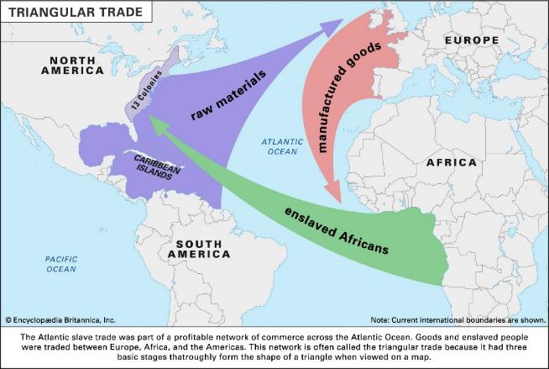
As the center of global trade shifted from the Muslim-dominated Indian Ocean to the Atlantic Ocean, a triangular trade route began to take shape. The Europeans bought kidnapped people from the African trade posts in the Gulf of Guinea. Then these people were brought to the Americas and used as slaves along with the Indians to extract the continent’s natural resources. Finally, these resources were carried to Europe to be transformed into manufactured goods (weapons, liqueurs, or different fabrics among others), and then the goods were carried back to the Gulf of Guinea where they could be traded for new slaves. This means the economic development of Europe relied either on the blood or the natural wealth of other continents.
As regards the Americas, many American colonies suffered the effects of developmentalism, an economic doctrine according to which a country devotes all its resources to the extraction of one single natural resource should it be silver, oil, sugar, or anything with a low aggregated value. This caused several problems such as the exclusion of large segments of the population that had no access to the land and had to run away either to the big cities or abroad. The birth of slums and many social problems related to poverty is closely connected to this process.
Another downside of developmentalism was that it creates a double dependance. A country devoting all its resources (natural, financial, human…) to the production of one single commodity is forced to import everything else, thus creating a dependence. And if that country’s economy depends entirely on the price of that one commodity, it becomes even more dependent and vulnerable. Also, when a country imports all its value-added products and pays for them with a cheap commodity, the asymmetry causes that no amount of that commodity will ever be enough to pay for the imports.
According to some estimations, there were about 70 million people when Columbus arrived at the Americas. A century and a half after that, there was only about 5 % of them. The diseases, the wars and slavery had perpetrated the greatest genocide in history. The Americas entered thus the global trade not as partners, but as an “empty” land that existed only to provide the industrial countries with cheap commodities. It is so much so, that still today many Latin American countries face accusations of forced sterilization of the poor even if the Continent is full of natural resources and has a much lower population density than Europe. The best documented case is Perú, where about 200.000 indigenous women were sterilized against their will in the 90’s.
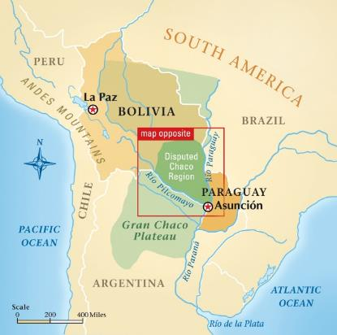
When the Americas got their independence from Spain and Portugal, the new territories figured out their borders under the pressure of rich countries and large corporations (mainly British and American). These powers incited several separatist movements in order to create a set of tiny feeble countries they could control more easily, and new nations such as Uruguay and the Central American countries were born. Brazil was harder to split because most of the population lived in the southern coast, and other parts were too “empty” to have them turn against the southern half, but the foreign powers got to influence the big countries as well.
Maybe the best example of border formation was the Chaco war in 1932 – 1935. Officially it was a border dispute between Paraguay and Bolivia, but it also was a clash between Standard Oil and Shell. Each company financed one side to get hold of the region’s oil. When Standard Oil ―I mean Paraguay― won, hostilities stopped and, according to Eduardo Galeano, soldiers of both sides ran to hug each other in a place called Puesto Merino. It was not their war.

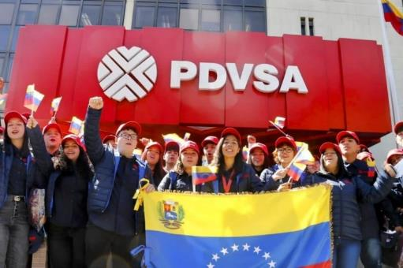
The North-South Divide
It is no coincidence the poorest countries on average in the Americas are those that once were affluent (with enormous income disparities of course), commodity-rich colonies. The United States were founded on less profitable land and its soil was not fit for high-demand export crops such as coffee, sugar, tobacco, cocoa, or bananas. For this reason, the British empire used this land to get rid of their poorest subjects and did not invest that much in the administration of the 13 colonies. Something similar happened to the South Cone, where there were no precious metals nor an especially rich arable land. These colonies could develop more independently than other Latin American areas since not everything revolved around the export of one single product.
The resource course means that countries that are rich in natural resources tend to have lower development rates. A reason for this is that other countries have an interest to promote political instability and asymmetric free trade to better plunder these natural resources, thus leading to lack of democracy and underdevelopment.
In the regions with no precious metal or natural resources, some land was allocated to poor farmers. These farmers acted as a buffer class between the rich landowners and the landless poor, and gained enough purchasing power to boost the national demand. After the Homestead Act was passed in the US in 1862, people who had tilled the land in some low-quality areas of the wild west could claim ownership of 160 acres. Likewise, the “Conquest of the Desert” carried out in Argentina between 1870 and 1864 led to selling some vast Indian territories to the rich and distributing the remnants among some poor soldiers and middle-sized businessmen from Buenos Aires.
However, in other parts of Latin America, both the profitability of the land and the closeness to the mother country (Spain or Portugal mainly) led to a tighter control on land ownership. This did not allow for a land-owning middle class to be born. This was not only a drag on the economic development of the whole region, but an injustice that caused some dramatic income disparities and, in the long run, the emergence of many revolutionary guerrillas. A telling example of this are the US themselves: the warm south was more suited for growing corn and cotton, and this made big landowners earn a lot of money while real industrial and economic development took place in the New York area.
Usually, the appearance of a middle class with purchasing power could have destabilized the trade balance through an import increase in the colonies, but the U.S. protected their industry by passing the Tariff Act in 1789.
In Latin America, foreign banks and powers managed to use both sovereign debt and diplomatic pressure to force the whole region to keep their borders open to imports, so it could hardly design a customs policy of their own. This policy caused some trade deficits but found a very receptive establishment in Latin America. There was a farming oligarchy that profited from exports under a free trade agreement and also a port city oligarchy that profited from trade itself. Both got richer at the cost of killing the industrial development of their nations, and big port cities such as Buenos Aires, Montevideo, or Sao Paulo (Puerto de Santos) grew at the expense of their respective countryside areas.
During the 20th century, foreign investment turned some big cities such as Rio de Janeiro, Santiago de Chile, Bogotá, or Mexico City into large industrial hubs, but Latin America as a whole was short on an industry of its own. The birth of this industry was continuously hampered both by the foreign powers and the national establishments, and the region was left with not only an economy dependent on low-paying jobs, but also huge income differences and a fierce rivalry between the big port cities or the industrial hubs on the one hand and the countryside on the other.
In a nutshell, the US managed to develop thanks both to the emergence of a land-owning middle class with some purchasing power and a protectionist policy that gave some room to the development of a national industry. When that industry was strong enough, the US started forcing free trade agreements on other countries by means of what was called gunboat diplomacy. On the other extreme though, Latin America only saw the emergence of a tiny middle class in the South Cone and could not protect their own industry in any case, making the whole region a big provider of raw materials with no added value. Over the years, many attempts have been made to change this in the Latin American countries, but the pressure of foreign powers to prevent change has been at least as fierce.

The Curse of Silver in Spain
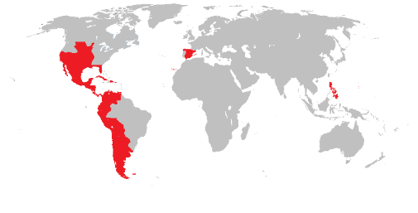
Weird as it sounds, the influx of precious materials had a catastrophic effect on the Spanish economy. Already during his first trip, Cristopher Columbus found the Indians on Hispaniola island wore golden earrings, so the Spaniards started looking for any precious metals they could find, and they found mostly silver over the years. In Spain, money is called dinero, which comes from the Latin word denarius (Also the South-Mediterranean dinar comes from it), but in Latin America the most common word for it is plata, which means silver. Coincidentally, China started basing its monetary system on silver, so the global demand of silver increased dramatically.
This only meant huge gains for a selected few. The rest of the population only saw a long hyperinflation cycle called the Spanish price revolution that crushed both the salaries and the empire’s manufacturing capacity. Everything was extremely expensive both in Spain and in the Americas, but imports were enough to solve the problems of those with access to silver. Even if in the section The Americas Enter the Global Economy it was claimed that the European economic developed at the expense of other continents, this was not true for Spain. The unhinged food prices led to general starvation and forced the poor to either join the imperial army if men or to engage in prostitution if women.
Another factor of underdevelopment was the arrival of the Habsburgs, a new ruling dynasty, to Spain at the beginning of the 16th century. The first “Spanish” Habsburg was Charles V, who had inherited large portions of Germany, Italy, the Nederlands or Switzerland as well. Such vast territories meant many enemies, so he was often at war with both other European countries and the Ottoman empire. Being a foreigner who arrived at Spain at the age of 19 with no previous notion of the Spanish language and a taste for high taxation, the Castilians met him with great hostility and rebelled. This is important because, by crushing this rebellion, the king won the power to make Castille go as much into debt as he wanted.
Regarding debt, it should be noted the Catholic Church did not allow any Christian to lend money with an interest. The reason was the Church was a great donee of real estate and did not want risk losing any future donations to creditors if people started mortgaging their lands. That is why the wealthy Christians usually lent their money through a Jewish family, and people of Jewish origin is overrepresented at the head of big banking even today. In 1492 the Jews were expelled from Spain and had their properties confiscated. The motivation was mainly economic, as proven by the fact that Muslims, who were much poorer on average, were not expelled until 1609-1613. As a result, Spain had to resort to foreign lenders in order to get its financing and had no power over its own debt.
But back to the Habsburgs, even if they raised taxes (unjust taxes based on the import and consumption of basic necessities, not income) everywhere across their empire, they only got authorization to go into limitless debt in post-rebellion Castille. This was particularly harmful since the financing of state debt was a much more profitable business than the financing of productive investment. As a result, the more the Habsburgs went into debt the more they drained money form the productive economy, causing the already inflation-ridden businesses to go into bankruptcy. It was a perfect storm of hyperinflation, skyrocketing taxation, and finance-guzzling sovereign debt that lasted for centuries.
Spain did plunder the American natural resources, but only a small minority profited from it. On the whole, the American silver brough nothing but serious economic turmoil to Spain, as proven by the fact the state went bankrupt seven times between the 16th and the 18th centuries (and seven times more, though only partially, during the 19th century). This never-ending economic crisis hit Castille the hardest, because the old kingdom of Aragon had not rebelled against the king and was exempted from limitless debt and some taxes. Southern Castille (current Andalusia) was particularly hard-hit since the American silver came directly to Seville and that was the area with the highest inflation.
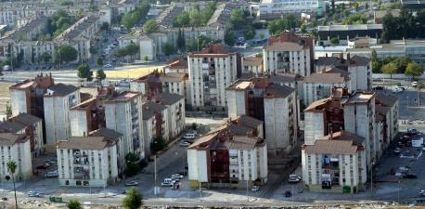
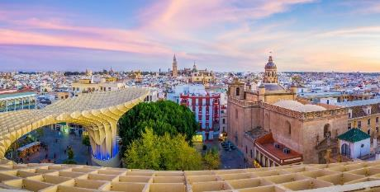
The arrival of the American silver is the turning point of the historical stagnation of Southern Spain. On the other hand, the Catalonian coastland in the old Kingdom of Aragon was relatively safe from the Habsburgs hyperinflation and overtaxation, and therefore could slowly take off even before the Barcelona harbor was open to the American trade in 1778. The Castilian soldiers had made a vast empire and had then forced their colonies to buy the products shipped from Barcelona. Meanwhile, Andalusia started a low decline. Although the topic obviously is more complex, the fact remains that present day’s Seville is a showcase example of inequality: the old city is extremely beautiful and vibrant, but the outskirts have 11 of the 15 poorest neighborhoods in Spain.
Downtown Seville versus its outskirts.

Ethnicity and Languages
History can explain a lot of the current ethnic composition in Latin America. American Indians are a large portion of society in all the areas where the Mayans, the Aztecs and the Incas lived, particularly in Guatemala, Ecuador, Perú, and above all Bolivia. The Indigenous people in these areas speak a wide variety of languages (420 different indigenous languages in Latin America according to UNICEF), but sometimes this is hard to estimate since some people might feel embarrassed to acknowledge what their mother tong actually is.
It is commonly believed the Spaniards imposed their language on the Indians, but this is not true. The Spaniards had no interest in having the Indians learn a language they could use to make their demands be heard. Hence, the conquerors did impose slavery and Christianity, but not their language. The Catholic Church was in turn very happy to learn the most important Indian languages since it allowed the priests to be the unavoidable interpreter and articulator in every aspect of people’s lives. After the American colonies became independent, the new oligarchic governments forced everybody to learn Spanish, because the local elites wanted their backward Indian folk to adapt to “modernity”.
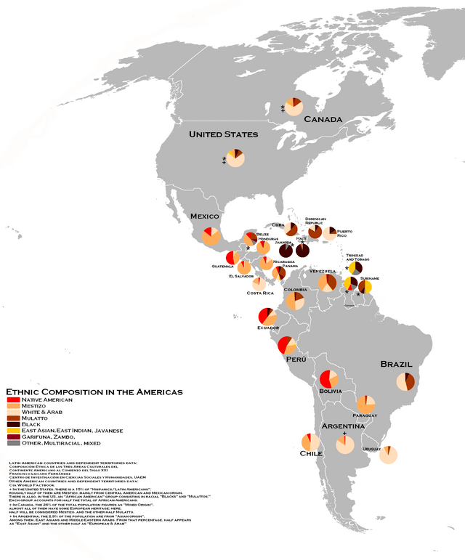
In Argentina, the local post-independence government fostered the conquest of the Southern lands between 1878 and 1885. It was called the “Conquest of the Desert”, but these lands were actually inhabited, and thousands of Indians were, killed, enslaved, or imprisoned. Also, similar processes took place in Chile and Uruguay. Since the new lands drew lots of European immigrants (especially from Sicily), white Europeans form a majority in the Southern Cone. This is interesting if we compare it with the case of the Philippines. Although the archipelago belonged to Spain between 1565 and 1898, the local oligarchy did not need the Spanish language ⎯ Known only to an elite ⎯ after the conquerors left, so they kept their own.
During the empire, the most profitable farmlands were in Northern Brazil and the Caribbean region. These were the areas where kidnapped Africans were taken to make up for the decreasing Indian population, while the Indians were in turn being dragged to the dreadful silver mines in Peru and Southern Mexico. Nowadays it is only logical African Americans are a majority in Northern Brazil (the poorest half of the country) and a large minority in the Caribbean countries.
Slavery was abolished in Brazil in 1888 because of the fear of slave revolts. The owners, not the enslaved workers, were compensated. A year after the ban, the Brazilian oligarchy expelled the king Pedro II and founded a republic where they could directly control the labor market. Today, Brazil is a de facto segregated country where people who are “at the wrong place” can get into trouble either with the gangs or the police.
On the whole, Latin America is an obvious melting pot where many people cannot be that easily placed in the racial continuum. Mexico is a good example of that since over half of the population are considered mestizos. However, it is interesting to note that maybe the Latin American people we might run into in Europe are not that representative of that Latin American continuum. On average, people who travel abroad are above average in wealth, educational level, “skin lightness”, and conservativism. This is why if you ask Latinos living in Europe about, say, Nicolás Maduro, they will probably say he is a dictator. However, if you ask poorer people living Latin America the same, some of the answers may go along the lines of “He’s one of us”.

The Aztecs and Mayans
The Aztec and Mayan civilizations flourished in the current areas of South Mexico and the northern half of Central America. Both were, to name a few things, skillful pyramid-builders, sculptors, and artisans, and both had their own writing system. However, while Mayans were in decay probably due to exhaustion of soil fertility, the Aztecs were a thriving, cruel empire that offered human sacrifices to a sun god.
According to their own legends, the Aztecs founded their main city Mexico-Tenochtitlan around the year 1325 allegedly following the instructions given by the sun god of war Huitzilopochtli. The instructions were to build a city on a little island in a lake. They would recognize the island, because they would see an eagle eating a snake on top of a prickly pear (a local cactus). The current Mexico City is located on the place that lake apparently was, although it has completely dried out, and also the Mexican flag portraits an eagle eating a snake on a cactus as a reminder of this legend.
A bit over a century after that, a group of 600 Spaniards managed to conquer the Aztecs due to many factors. Some factors have to do with the material advantages the Aztecs did not enjoy, namely horses, iron, and powder. Horses had become extinct in the Americas thousands of years before the invasion, so there was no need to invent the wheel, and this in turn limited the expansion of existing empires since goods could not be easily carried in large amounts. Also, the lack of iron made their weaponry weaker and, adding to the lack of horses, prevented them from inventing the plough as well. Without the plough, the Aztecs got smaller harvests, and this limited their imperialistic agenda by hindering the concentration process of wealth and power.
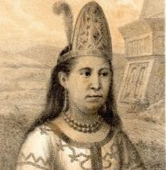
However, there were other non-tangible yet crucially important factors. The first was the spreading of some European diseases, particularly smallpox, that killed millions of Indians. The second was the fact the Aztec misunderstood the arrival of the Spanish troops with that of a vengeful god, and they were consequently very submissive. The third was that the Spaniards managed to make an alliance with people who resented the Aztecs. They did this with the aid of two interpreters: one was a Spanish monk who had been captive with the Mayans for 8 years and the other a Mayan girl, Malinche, who could also speak the Aztec’s Nahuatl in addition to her mother tongue.
Malinche had already been a slave under the Aztecs and was given to the Spaniards after a battle. It turned out the Spanish head of the expedition Hernán Cortés married her, and she gave birth to one of the first mestizos in history. She has then become the symbolic mother of Mexico, but also a symbol of betrayal.
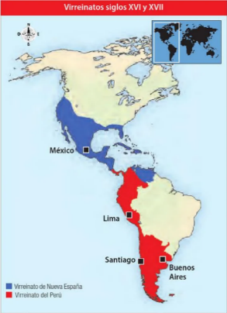
The Viceroyalty of New Spain: Racism and Sexism
The conquistador of Tenochtitlan Hernán Cortés, called the new land “New Spain”. This name extended to all the conquered American land until 1542, when roughly everything south of Costa Rica (except for the Venezuelan coastland) was made the Viceroyalty of Peru. The conquistadores saw all this land as a way to escape their own servitude by enslaving others, so their initial patronizing attitude towards the Indians turned into outright contempt as soon as they found some resistance to their enslavement plans. According to the Catholic moral, suffering was the best way to purify the soul, and the Indians were lazy sinners in need of the white man’s discipline.
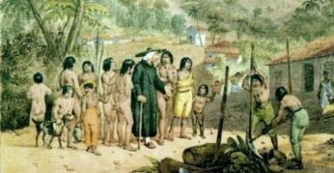
While the conquistadores were interested in the precious metals, the Church was much more interested in extending its own influence. Because the Church needed to admit Indians “had a soul” in order to have them baptized, the religious authorities had the king approve a law theoretically protecting Indians. But did the emerging global economic system have a soul? The Church and the market economy were supposed enemies, but it was only after the rise of Protestantism, that a new reformist religious order called “the Jesuits” managed to form self-sufficient Indians communities where the locals were treated as human beings and were also given and education despite the interest of big landowners. Unfortunately for these Indians, the Jesuits were banned from the empire in 1767, and they never were the same when they eventually got back.
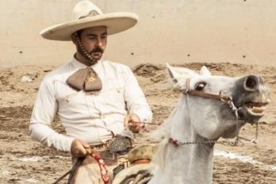
The fact initially all horses had to be imported caused that only wealthy Spaniards, or occasionally elite mestizos, could afford them. Predictably this made horses a symbol of racial status, so the horse owners ⎯ particularly mestizos ⎯ tried to mark their status with their showy rider clothing. Our stereotypical picture of Mexicans with traditional clothes and large sombreros come from that fact. Soon a cowboy-like culture under the name of charro developed in New Spain. The charros made some horse-riding stunt performances and drew large crowds to their competitions.
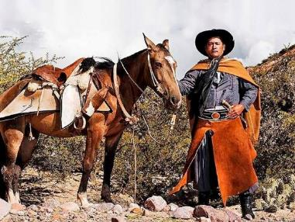
Also, mariachi music was born at this time, and men with charro-like clothing entertained the public. The fact the Texas cowboys’ clothes were not so showy might be due to the fact settlers did not mix with the Indians and thus had no need to differentiate themselves through clothing. As the Spanish empire extended, the South Cone developed its own rider culture under the name of gaucho during the 17th century. Horses were not such a privilege by then, so many gauchos got to flee low-paying ranch jobs to live in the wild with their horses. In time they would become a national symbol of individualistic freedom in Argentina, but they dressed like vagabonds since theirs was not a quest for status.
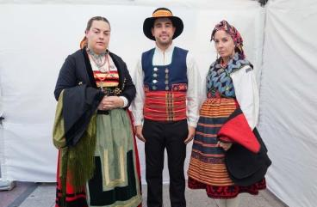
Interestingly, both Mexico and Argentina managed to develop its own folkloric outfits while Andean Indians were forced to dress like Spanish peasant by order of the king Charles III in the second half of the 18th century. The colorful Indian clothes, say, Peruvian Indians display today actually imitate the traditional dresses several southern Spanish regions use in their folklore nowadays.
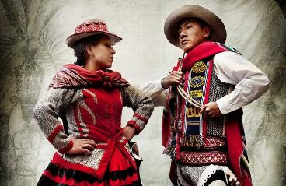
During the 16th century, New Spain managed to avoid the formal enslavement of Indians resorting to encomienda, a system in which slaves were “paid” with food, clothing, and regular lectures on Christianism. Indians could not refuse this deal even if they were much better off looking for their own food or felt uncomfortable in European clothes, so a blend of Christianism and local religions emerged in the Caribbean. Following the ideal of purification through suffering, the Church was not supposed to question why there was poverty or enslavement as the much-resented Jesuits or as the friar Bartolomé de las Casas did, but rather to provide relief to the needy, so they could better endure their exploitation.
Also, the Catholic Church of New Spain invented the piñata, taking some ideas from an old Chinese tradition that had traveled first with the 13th-14th-century sailor Marco Polo to Italy and then to Spain. Some signs suggest there might have been a related Aztec tradition the Catholic Church wanted to erase, but whatever the case piñata only took its final form when some friars started using it to teach Christianity to the Indians. They used a clay vessel filled with candy and beautifully decorated to symbolize the devil. That is why a traditional piñata had seven pointed tips, after the seven deadly sins, and people had to break it with a stick in order to get the prize.
Some traditional costumes in Spain (up) and in the Peruvian region of Cusco (down)
Nevertheless, the idea of piñata went beyond suggesting that people’s covered eyes symbolized blind faith, the stick symbolized god’s might, or the candy symbolized salvation. The devil piñata was portrayed as a cunning moving object with seductive skills. It was beautifully decorated because delicate, attractive things were considered sinful, and life was supposed to be a journey of suffering, submission, and self-denial. In this light, softness, persuasion skills, and everything traditionally attributed to women ⎯ even women themselves ⎯ were considered to be very dangerous, and men learned to react to this perceived threat with violence.
Despite some initiatives, the overall influence of the Catholic Church eventually led not only to perpetuate different forms of enslavement (even today), but also to wage a war as much against women as against femininity as a whole. Today, piñatas take multiple non-religious shapes and are widely used in children’s parties (particularly in birthday parties) in the Spanish-speaking countries and beyond. However, it is interesting to note a difference. While in Finland a pre-determined assortment of candy is packed into individual bags in order to ensure everybody has exactly the same amount, Latinos just throw all the candy in and have the children compete for it when the piñata breaks. When the lucky collectors share part of their spoils with the less fortunate, Christian charity is practiced.

The Inca Empire
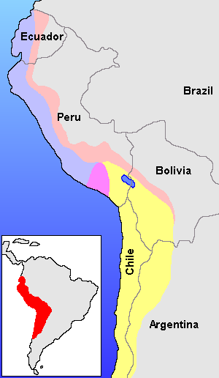
The lack of horses, wheels, or wagons limited the geographical spread of every civilization in the Americas except for the Incas. This empire stretched across the Andes mountains covering an area of about 2,5 million square kilometers. They managed to do this through both a comprehensive pathway network and a clever relay system in which a chain of messengers covered different segments of every route and had a number of designated shelters where they could rest and find some food. No evidence has been found the Incas had a written language, but they used bundles of colored ropes with knots called quipu for accounting and at least they were able to carry information within their borders.
The Inca Empire relied on a sort of “group feudalism”, where every ayllu (extended family), but not subjects individually, had the obligation of paying tribute to the emperor. Since they used no money, payments were made in worktime and were organized at the ayllu level. The everyday tasks within an ayllu were called ayni, and people were motivated to do it either by prestige or by the will to help their family. Larger projects such as pathway making, or house building required the cooperation of several ayllus though. This was called minka, and it has produced a strong cooperative culture among the Andean Indians much in the fashion of the Finnish talkoot. This cooperative work is currently called minga in Andean Spanish, but you should not use this word in Spain since it means “weenie” there.
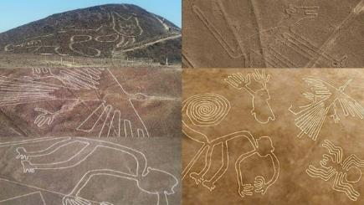
The Spaniards, though, were much more interested in the mita, the system under which every ayllu was obliged to send their adult males to work for the Inca a number of days a year. The conquistadores were lucky to find the Incas at the same time a civil war was being waged in it, so they seized the occasion to conquer the capital Cusco in 1533. As it happened to other words in the Quichua language, there has been some spelling-related fluctuations regarding s, c, and z. Nowadays the official name of Peru’s capital is Cusco, although many countries ⎯ especially Spain ⎯ hold on to the traditional spelling Cuzco. You might find similar fluctuations in words such as ceviche/seviche (the delicious Peruvian lime-marinated fish) or Nazca/Nasca (home to a famous set of geoglyphs).
The area of Nazca to the south of Lima is full of geoglyphs (drawings made on the surface of the Earth) that are best seen from the air. We do not know much about these drawings because they were made about a millennium before the arrival of Columbus, and the people who made them disappeared about five centuries before that same date. Anyway, the lines have stood the test of time remarkably well thanks to the fact this is one of the driest regions on Earth.
Anyway, the Incas were skilled goldsmith and weavers, although not many examples of their art have made it to this day. They were also pragmatic farmers who made stairway-shaped patches of land on the mountain hills in order to grow each vegetable at the appropriate temperature (the higher the colder), and they showed potatoes to the colonists, changing the basis of the different Western diets. However, the original Quichua word for this tuber, which is papa, was only adopted by the Latin-American Spanish. The Spaniards had previously learned about batata, which is Spanish for yam or sweet potato, in the Caribbean, so when they discovered potatoes they mixed them both. That is why this tuber is patata in Spain’s Spanish and potato in English.
The Spanish authorities enlarged the mita tribute considerably, making all Indian adult males to work intensively in the silver mines for ten months in a row roughly every six years. After the silver mine of Potosí was discovered in 1545, the mita replaced the encomienda. The encomienda had made possible to duck the ban on slavery by offering the Indians a compulsory deal of food, clothes, and Christianization in exchange of labor. Now the mita was a similar arrangement that took advantage of a pre-existing social organization in order to extract the local mineral resources.
Potosí killed around eight million Indians over three centuries. They died either in work-related accidents, diseases, and poisoning or afflicted by starvation and cold, but the Spaniards learnt that sucking coca leaves made people more resistant to hunger and fatigue, so these leaves stopped being a privilege of the Inca ruling class and were wildly distributed. Today, the habit of acullicar (chewing coca leaves) is very popular in the Andes, particularly among the Indians, and it is very useful against soroche (the altitude sickness). Coca is not a drug, but the US war on drugs has sometimes led to an attempt to eradicate the plant used to make cocaine with a considerable environmental damage.
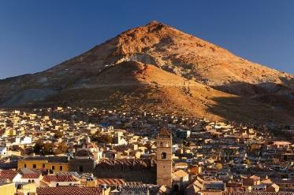
Current Peru has a wide-ranging gastronomy based on the Inca tradition as well as on the fact the country has three completely different ecosystems: the coastland, the mountains, and the rainforest. The country still has some important archeological remains such as the old city of Machu Picchu or many buildings with tightly stacked stones that are believed to imitate corn on a cob. At the beginning of the 20th century, a US explorer named Hiram Bingham popularized Machu Picchu and brought home some 50.000 objects he found there for “temporary” examination. However, Peru only got these objects back in 2018, making Machu Picchu a good example of the pillaging of works of art perpetrated by some rich countries.
Being a Hidalgo
The rise of the Spanish empire only caused economic crisis, depopulation, and authoritarianism in Spain. Amidst this general decline, the hidalgos, which were the lowest level of the Spanish nobility, were particularly terrified to become a part of the rabble. They were somehow similar to the Finnish talonpoika, but they had a fear-boosted fanatical contempt towards those below them. Since they were very proud people, the idiom herra ja hidalgo is still used in Finnish when someone acts like a lord, but they were no lords. Hidalgos actually feared very much being overtaken by others, so they were relatively active in reporting their economically successful Jewish and bourgeois neighbors to the Spanish inquisition.
The word hidalgo meant hijo de algo (something’s child). This meant they were supposed both to come from an old Christian family ⎯ meaning a family without any Muslim or Jewish parents or grandparents ⎯ and to own some land. These people developed a set of behavioral traits in order to mark their theoretical distinctiveness from the rabble. They carefully cultivated their own reputation with a display of pride, courage, and respectability. They especially avoided to be seen as needy and expressed a fanatical contempt for the weak, the landless, and the non-Christian. This had its effect for instance in the battlefields since the soldiers were too embarrassed to leave before when everybody was watching.
Today people do not behave like the old hidalgos, but bullfighters might be considered as fossilized hidalgos instead since they are supposed to show contempt for death and are expected to receive the public’s cheering with dignity and dispassion, as if they never needed it anyway. Nowadays most people deem the bullfighter’s style ridiculous, and maybe that is one of the reasons, along with a growing concern for animal well-being, why bullfighting has lost so much popularity in the last few years. However, we can still see some remnants of the old hidalgo attitude in other situations we might encounter every day.
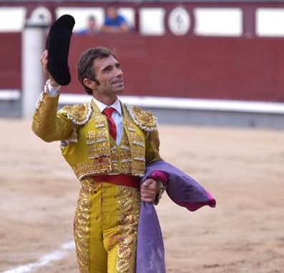
For instance, Spanish-speaking people say “thanks” instead of “please” when offered something. Saying “Yes, please” to a cookie would show too much need. In addition, Spanish speakers have a low threshold for asking for favors, but they often try not to sound in desperate need. Therefore, if we say no, they will most likely try to make clear there is no problem, and that they will most certainly find another way to solve it. And regarding the phone calls, you do not answer the phone by saying your own name because you do not introduce yourself when you are not asking for anything. Instead, if you do not know who is calling, you should want to say hello (diga in Spain, bueno in Mexico, and aló elsewhere), and let them who need something state their business.

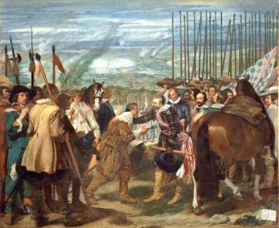
The Spanish Golden Age: Painting
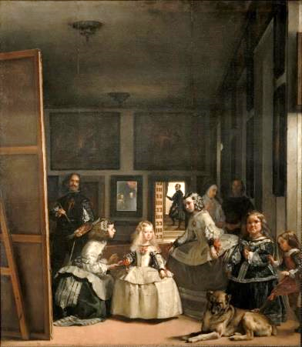
The Spanish arts and literature flourished during a time period called the Siglo de Oro (Golden Age). This time period started in 1492, when Columbus arrived at the Americas and the first grammar of the Spanish language was published, and ended in 1659 or 1681, depending on whether you place the end at the day of Spain’s military defeat against France or at the day of the death of the last great writer at the time. Paradoxically this happened at a time when Spain isolated itself culturally from other European countries and it also plunged into a series of severe economic crisis, so the term golden in no way refers to the American gold, which for that matter would actually be silver.
The most important painter at the time was Diego Velázquez, a baroque artist who became the master of light and space. Velázquez painted from nature, which was quite unusual at the time, and used paint strokes to compose a picture that only became real from a distance. He painted many portraits and religious images as painters had to do at the time, but he also got many other things for the king, which was an unusual honor.
In the Surrender of Breda (La rendición de Breda / Las lanzas de Breda, 1634 – 1635), Velázquez paints a defeated Dutch army on the left, and their leader handing over the key to the city of Breda to the Spanish general. The Dutchman is about to fall on his knees, but the general prevents him from doing so as a demonstration of magnanimity. This picture follows a complex, circular composition, which is typical in Velázquez, and it stands out that there is a blank piece o paper in bottom right corner. According to what we know, this painting was meant to be hung in a big room in front of a rival painter’s work. This other painter used to sign his pictures very visibly, so Velázquez tried to show a similar spiritual grandeur than that of the Spanish general by conveying the message that his art was so good that it spoke for itself and did not need to be signed. That’s how you show a true hidalgo attitude!
In Las Meninas (1656) Velázquez painted a number of ladies from the Spanish court as they were watching the royal couple that posed for the painter, who is also in the picture. The royal couple is reflected in the mirror on the backwall, so they stand right where we, as the audience, look at the picture, and they draw us into the scene. There are several light sources in the picture that are masterfully controlled to give a sense of reality. At the age of 60, Velázquez came back to this picture to paint the red cross of the Order of Santiago on his chest years after having finished it. Being accepted in this order had been a big deal, but in order to get in he had had to give evidence about two things:
- His parents and his grandparents were nobles: Velázquez got the king’s support to get out of a too thorough investigation since some doubts had been cast on one of his grandfathers, who was a Portuguese with a potential Jewish origin.
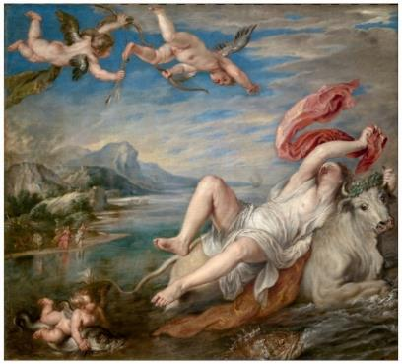
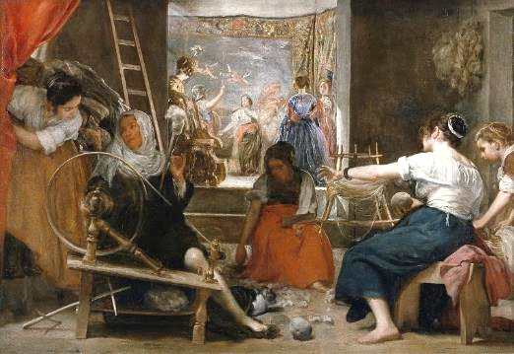
- He had never worked: work was considered shameful for the ruling class, so Velázquez brought before the panel of examinators some witnesses who testified he had never sold a picture because he was no brush worker; he was an artist. This helps us understand Velázquez’s obsession with reaching beyond the conventional artistic view of artisans and manual laborers.
Last, less known than Las Meninas but probably his chef d’oeuvre was Las hilanderas (The Spinners, 1657, on the left), a clever depiction of The Fable of Arachne. Arachne, which means “spider”, was a skilled weaver of tapestries in the Greek mythology. She was so arrogant that the goddess of wisdom and handicraft Athena went to visit her and tried to calm her down. Athena was not recognized because she was disguised as an old woman, and Arachne claimed to be the best weaver ever. Athena just had it. She took of her old woman’s clothes and challenged Arachne to a weaving contest. Eventually Arachne won, but the tapestries she had made for the competition depicted Athena’s father Zeus cheating on his wife with many different women. For this reason, Athena used her magic to turn Arachne into a spider so she could weave forever. The Greek word for spider is at the root of, for instance, arachnophobia in English or araña, which is the name of these animals in Spanish.
In the picture, a woman at the back calls our attention to a tapestry were Athena is turning Arachne into a spider. If we look closer, we will see the Athena and Arachne are not really in the tapestry, because their ghostly feet touch the ground. The tapestry behind it actually is a real oil canvas (see the second picture) named The Rape of Europa (1635) and painted by Peter Paul Rubens. In Ruben’s painting, the bull represents Zeus as he is kidnapping the woman, one of the scenes in Arachne’s tapestries. In the 17th century, it was very common painters copy one another in order to decorate different palaces of their lords, but by giving a new meaning to this painting of Europa, Velázquez surpassed his friend masterfully.
If we look at the foreground in Velázquez’s painting, we see a skilled young woman on the right and an old woman on the left, but we can guess she is not really that old because she has a bare young leg, so the same characters as in the fable of Arachne unfold before our eyes in real life. The expert use of light makes us look first to the skilled young woman, then to the “tapestry” in the back and finally to the old/young woman. And, in the middle of everything, there is a young girl picking the leftovers. She is right in the middle but still remains unnoticed. Velázquez broke completely the classical composition of paintings where the important characters were portrayed in the center of the picture and managed to make that spinning wheel really roll more than two hundred years before the impressionist painters started experimenting with light and movement in Paris.
For centuries, this mysterious painting was not understood until an investigator dug its original name (The fable of Arachne) out from and old list of works of art in 1948. Today, many of Velázquez’s works of art are in the Prado museum in Madrid. There you will also find the works of some other famous painters such as Peter Paul Rubens, Francisco de Goya, Doménikos Theotokópulos, Titian, Hieronymus Bosch, and Bartolomé Esteban Murillo, due to the fact the Spanish monarchy was the most important art collector of the 16th and 17th centuries. People starved or died in the imperial wars and Castille went continuously bankrupt, but the monarchs took good care to build some luxurious palaces and stuff them with outstanding works of art.

Literature in the Golden Age
The Golden Age marks the beginning of Spanish baroque writing. Poets vied with each other to uphold the respectability of either conceptismo or culteranismo, the two leading styles at the time. Conceptismo was about conveying the largest amount of meaning in the fewest possible words, and therefore made extensive use of double meanings, elision of unnecessary terms, and creativity in the word order, but culteranismo was the opposite. It expressed even the simplest idea in the most complex, wordy yet beautiful way possible, so it usually resorted to witty although somehow far-fetched metaphors. Although not limited to poetry, the most famous rivalry took place between the conceptist poet Francisco de Quevedo and his culteran poetic counterpart Luis de Góngora.
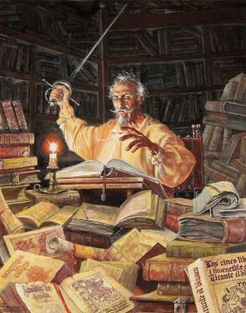
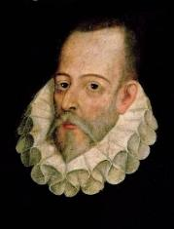
In general, books started to be widespread during the 15th and 16th centuries. In the villages, people gathered to listen to stories read by those who could, and these stories were often quite simple. In this context, The Ingenious Gentleman Don Quixote of La Mancha was published in 1605. The story was about a hidalgo who went crazy after reading many chivalric novels and decided to become a knight himself. Don Quixote (spelled Don Quijote in modern Spanish) convinces a redneck neighbor called Sancho to come with him as his squire, and both leap on to the world trying to defend gentlemanliness and justice in what actually was quite a backward society. The result was hilarious for readers at the time, and the novel was translated to many languages across Europe.
This is considered by many the first modern novel in history. First, because it openly challenges every chivalric novel that had been written before by turning them all into a parody. Second, because it is the first great novel where the narrator himself becomes a character in the story. And third because it offers several examples of literature within literature. At one point, for instance, the characters read a short novel that is included as one of the chapters, and in this short novel there are some characters who in turn author different poems! The book became such an enormous success across Europe that an inauthentic sequel was published in 1614.
The real author Miguel de Cervantes did not like at all the publishing of an unofficial sequel, so he published his own sequel in 1615, which had don Quixote do exactly the opposite things he supposedly did in the fake novel. In The Ingenious Gentleman Don Quixote of La Mancha, part II, don Quixote and Sancho leave again for more adventures, but they run into a noble family who know them by having read the first part (which is again an example of literature within literature). The nobles prepare all sorts of pranks and deceptions to make fools of them, which raises the question of who is actually a fool: our idealistic protagonists or an unjust world where those in power make a mockery of everything that is noble?
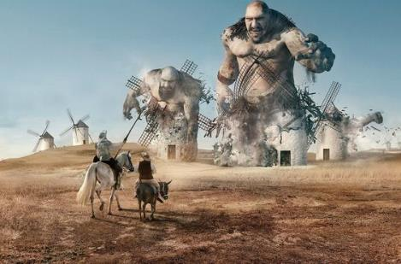
As the story goes on, the relationship between the protagonists evolves to a true friendship. The hardships of their journey slowly make don Quixote much more down-to-earth, just like Sancho, but Sancho in turn becomes more idealistic as he learns how to dream. In the end, don Quixote becomes so sensible we realize he never really was insane, for he was just and individual unable to accept the world as it is. He had clearly been defeated by a cruel world, but Sancho wants to carry on due to both his appreciation for don Quixote and a new-found idealism. Just like it happened with Velazquez’s The Spinners, most people did not understand this two-part novel completely for several centuries. It was thought to be merely a humoristic story until some 19th-century critics declared don Quixote the ultimate romantic character.
Don Quixote’s importance is so remarkable it has even permeated many languages. We call someone Don Quixotesque (quijotesco in Spanish) if they are foolishly idealistic. If someone imagines evils, we say they are fighting windmills, after a famous passage in which don Quixote fights a typical Castilian windmill he has taken for an evil giant, and after he clashes he is too much in denial to admit it was only a windmill after all. Another name for Spanish is la lengua de Cervantes (Cervantes’ language), and even the Spanish institution charged with teaching and certifying the Spanish language ―It has 87 venues around the world― is called Instituto Cervantes.
In 2002, this novel came first in a survey carried out by the Nobel Institute, in which 100 writers in 54 countries were asked to pick the best fiction work in history. But despite its continuous success, during the Golden Age the literacy rate in Spain was rather low and there was not such a thing as author’s rights, so Cervantes died quite poor. On the contrary the most successful genre was drama without a doubt. This is the time the character of Don Juan first appears in a drama play of uncertain origin. The character was an amoral playboy who hits on a nun, so nowadays don Juan is used as a synonym for “seducer.” Since in the play there is also a dead man who gets invited to a dinner, nowadays the term convidado de piedra (stone guest) refers to someone who has not had the chance to speak in a meeting.
Among the many playwriters Lope de Vega was by far the most successful. He wrote hundreds of plays, and his portrait was on a wall in many noble houses. Cervantes was jealous of him, but today the World Book Day is always celebrated on April 23rd since that is the day both Cervantes and Shakespeare died.

Corruption
Most Spanish-speaking countries are known to be highly corrupt by the European standards. However, the topic is too complex to give a straight answer to the question of how much of a problem corruption is. First, we could differentiate between three different types of corruption.

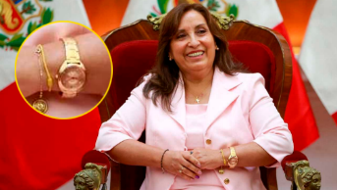
- At the State Level
Generally speaking, the less democratic a country the more corrupt it is. Democracy is preserved through the separation of powers and transparency, while dictatorships usually thrive on corruption and opacity (propaganda is used to mask that opacity) to secure the loyalty of people. And, considering that virtually all the Spanish-speaking countries have suffered at least a dictatorship or putsch in the last hundred years, it is no surprise some of the state structures are very corrupt in many cases.
Most Spanish-speaking countries are used to the corruption of politics. However, the corrupt politicians could never stay in power if it were not for the support they get from the same corrupt media they protect with their policies. In the picture, the undemocratic president of Peru Dina Boluarte, with one of the many expensive watches she has been wearing in 2024. She could have never afforded such watches with her salary.
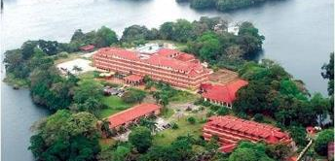
During the Cold War, the C.I.A. arranged several putsches in Latin America and trained thousands of Latin American policemen and members of the military in interrogation techniques in the premises of the unspeakable School of the Americas. Chile or Argentina are just the most famous cases of a long, long list of democratic governments overthrown with violence. However, the Argentinean Trial of the Juntas where the leaders of the last dictatorship were sentenced to different jail terms (from a few years to life imprisonment) in 1985 showed both the possibility to achieve justice and the potential of the judiciary to control the other branches of the state.
After the Trial of the Juntas, the Latin American judiciary started taking a more active role in politics, and some governments approved a set of harsh laws against corruption than in practice were used to prosecute the political opponents. Some famous cases are the imprisonment of the Brazilian president Lula da Silva under false accusations in 2018 or the charges against former Argentinean president Cristina Fernández de Kirchner, where the judge and the prosecutor played a football match in the villa of the defendant’s main political opponent in 2022.
The School of the Americas.
Over time, the judicial harassment of political opponents has attained a better coordination capacity with the media in a phenomenon called lawfare. The lawfare is the combination of the perversion of justice and propaganda. Its aim is not necessarily to reach a guilty verdict, but to provide the material for a slander campaign that will eventually lead to the reputational death of the victim. Cristina Fernández de Kirchner was subject to one of the most savage dehumanization campaigns in the Argentinean media until a man put a gun to her face in front of her house and shot twice in 2022. Luckily for her, the gun did not work though.
With all this in mind, it is probably no surprise to us people often vote for reputedly corrupt politicians, but the perversion of democracy has actually more to do with the role of the Latino countries in the global economy than it has to do with their culture. Sad as it sounds, it is in the best interest of both the industrialized nations and the big investment funds to sabotage any democratic development in the resource-rich countries, and the reputational murder of any political option that endangers these economic interests is therefore inevitable. We could go as far as to say that, in a world-wide market economy system, a wealth in natural resources usually correlates with high levels of oppression and corruption regardless the cultural background.
The former vice-president of Ecuador Jorge Glas has been doing prison time since 2017 under charges of embezzlement. The charges were based on an official report that was later invalidated by Ecuador’s supreme court. After some new questionable investigations and brief probation periods, Glas sought refuge in the Mexican embassy, but the Ecuadorian police broke illegally into the embassy and brought him to a high security prison, where he started a hunger strike. In spite of all this, it is not easy to find a news media where Ecuador is labelled an authoritarian state.

- At the Community Level
In the Catholic cultures people are supposed to help their own family and close friends. This might often mean securing a job to your children and some of your nephews if you are in a managing position or allowing someone to skip the line in some overcrowded public services such as the healthcare system. This kind of corruption does have to do with the culture, but it usually is only visible in small places where personal favors have a more important role in getting by. Naturally, the corruption at the state level is intertwined with this one.

- At the Everyday Life
In some places you might have to discreetly offer some money to a policeman or a civil servant in order to work things out. For instance, Mexico is well known for the role of mordidas just as much as Argentina is for its coimas, both being local Spanish words for soborno or bribe. However, despite the prevalence of this habit in many Latin American countries, it does definitely not apply to Spain. The reason is the hidalgo culture make most people too proud to accept a small amount of money. The Spanish people do not necessarily frown upon the idea of selling their dignity, but they want to think they are worth at least a figure followed by many ceros. For this reason, trying to get out of a traffic ticket with any reasonable bribe may cause you to face real trouble with an offended policeman. It is not about honesty but about pride.

Reformation and Capitalism: when the economy meets religion
At the beginning of the 16th century, the German priest Martin Luther led to a rebellion against the corruption of the Catholic Church and some of its dogmas. Many areas in Europe had already shown some signs of discontent over the sale of indulgencies that were being used to finance the building of the grandiose St. Peter’s Basilica in the Vatican, and the rising European bourgeoisie saw Luther’s teachings as an opportunity to escape the Catholic Church’s grip over business.
Depriving the Catholic Church of its monopoly on the interpretation of the word of God required people to learn reading, so they could interpret the Bible themselves under the guidance of a Lutheran priest. And the role of the Church was dimmed indeed, but this was compensated by the strengthening of God’s might since Lutheran’s salvation depended entirely on God’s unobjectionable will. Being forgiven by a priest was not important in the protestant denominations, and people could only hope to timidly further a bit God’s benevolence by their hard work or to have their success in life be a proof of God’s already decided support.
The new doctrines (Lutheranism, Calvinism, Anglicanism…) were very helpful to boost the development of capitalism in Europe, as they promoted the lending activity, hard work, and individualism. The common lands were being privatized in the Protestant countries as the feeding of a growing population offered great business opportunities, so people could no longer resort to the forest for food, clothing, and wood. Suddenly people were forced to earn a salary in order to buy all those things, and they crowded the cities in search of a job. The rising manufacturing sector got all the cheap labor it could ever dream of while the regular folk had to adapt to workdays of 16 hours.
In the modern world of the 16th and 17th century, most people lived worse than in the Middle Ages (exceptions being made for some war periods as well as the bubonic plague that took place in the 14th century) and definitely worse than the Indians in the pre-Columbian Americas. People barely made the money to survive, lived in unsanitary slums, and suffered frequent work accidents. The overcrowding of rooms led to a general increase in the birth rates, and many women were led to even lower paying jobs or directly to prostitution.
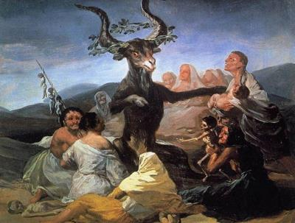
Many men did not want to face women’s and children’s competition in the labor market since they made the same work for even less money. Wage-earning men, children and elder people rather needed to be taken care of in the absence of a health care system or a policy of old-age or invalidity pensions, and women did all this for free. The rich people, for their part, were also happy to draw attention away from them, and the ideal of self-sacrificing, secluded woman was created. Women lost their monopoly on the assistance during childbirth, and wandering female healers who knew the secrets of contraception started looking suspicious as the Lutheran Church spread the rumor they were meeting the devil somewhere in the wild.
A witch-hunt unleashed in central Europe from the 15th to the 17th century. Nowadays, many people believe “witches” were burnt in the Middle Ages, but this historical phenomenon actually took place afterwards, during the rise of capitalism and particularly in the places where the new economic system was most developed. Although not all the witches were women, maybe 80 % of them were. The Witch-hunt targeted poor people as a whole, focusing a good deal on women, and particularly unmarried women who could taught the others the techniques of birth control. The new economic system needed an unrestricted supply of cheap labor, and women were essential in the reproduction of that work force.
Francisco de Goya painted Witches’ Sabbath (El aquelarre) in 1798.
The Protestant societies thus modernized on the shoulders of women, children, poor people, and also the Indigenous peoples of other continents. Men were given a privileged status to be sure, but they also became directly responsible to God without the all-pervasive supervision of a religious authority. And while this had a positive impact on the average reading skills of the population, it also caused that everybody’s opinion had to be considered. People became very aware about public opinion and focused even more on the belief that a success in earthly life was a sign of God’s future favorable judgement in the afterlife.
The Spanish hidalgo culture had thus made weakness or need shameful, but the fact that the moral issues were decided by an external authority (the Church or the ruling class) made the Spanish-speaking people less concerned with their neighbor’s opinions. After all, although everybody was required to behave proudly, showing too much concern for other people’s opinion could also be interpreted as a sign of weakness! The Protestants in turn felt more strongly the judging opinion of their neighbors, and it became for them very important to behave properly, be hard-working, and avoid seeming stupid. Many Finns feel that being shy is part of their nature. However, maybe we should rather speak of being aware of your reputation in an environment where everyone’s opinion counts.
The Protestant societies evolved to be individualistic then, and along with the above-mentioned awareness of the public opinion, the emphasis on individual responsibility also led to a remarkable degree of trust among the individuals. Nowadays people in the Nordic countries easily trust each other as long as everybody shares the same cultural background. This allows for a relaxed interaction between the individuals, but such interaction comes with an increased responsibility to behave “properly”. For instance, it seems cursing is more natural in hierarchical societies provided the interaction takes place among equals, but in Finland, cursing would be considered inappropriate in more situations and with a stricter threshold.

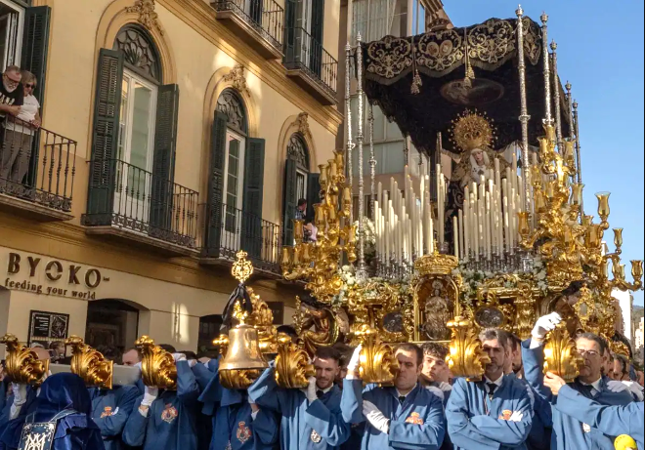
The Counter-Reformation
Predictably, the Catholic authorities reacted to the Reformation, on the one hand, by strengthening their control over the Southern European societies, and, on the other, by trying to correct some of the Church’s worst flaws. The control refers to such facts as standardizing the masses and making them compulsory, approving a list of censored books, or crushing any attempt to spread the Protestant ideas within its area of influence. Correcting the flaws in turn meant such things as forbidding the sale of indulgencies, improvising both the Church’s internal organization and the priests’ education, and the advertisement of a more spiritual, honest relation with the doctrine.
With the rise of a market economy, the protestant countries forced women to raise a larger working force. In the Catholic countries, the Church reacted by fostering the worship of the virgin Mary as an unattainable ideal for women or, in other words, as ideological weapon to keep women subdued.
In this context, the Jesuits were the most active advertisers of moral purity among the Catholics and consequently tried to protect the Indians against the landowners’ earthly interest until the Society of Jesus, as it was known, was banned from the Spanish empire in 1767. During the Counter-Reformation, the Catholic Church wanted to reassert its authority in contrast to what was happening in the Protestant countries, so it placed a great emphasis on the sacraments (there are seven in the Catholic Church compared to two in the Lutheran) as well as in its saints and martyrs. That is why often the Catholics do not pray directly to God, but to a saint who is thought to be well-placed near God and can therefore sneak in a few words in our favor whenever there is an appropriate moment.
This emphasis on saints and martyrs also led to an exaggerate importance of the role of Virgin Mary, to whom many prayers and requests are often addressed. The myth of Saint Mary as the purest human being ever was the Catholic answer to the Protestant ideal of self-denying, secluded woman, as both concepts were used to control women. In the case of Virgin Mary, it suited very well the idea favors are to be asked from women while the lords are to be left undisturbed in their comfortable position. Nowadays, you might find a good deal of Virgin Mary-based merchandising in the important Catholic worship centers, and also many Holy Week processions where Virgin Mary has a leading role.
It should be noted, though, witch-hunts were very rare in the Catholic areas. At the time, the poorer economic performance of Southern Europe softened the ongoing social changes to a large extent, so the Spanish authorities used the American silver to remain comfortably in the Middle Ages and made do with isolating the empire from the “dangerous” influence of Protestants, Muslims, and Jews. Spain still imported European manufactured products in exchange for silver and raw wool indeed, but it forbade the study trips to Europe and the import of books from any European country. It was a cultural “splendid isolation” that stood in sharp contrast with the Protestant policy of developing the population’s reading skills and caused both cultural areas to evolve along different lines in the subsequent centuries.
The Emphasis on Hierarchy
While the Protestants emphasized individual responsibility as shown in the assumption everybody should be able to understand the Bible for him/herself, the Catholic Church asserted the validity of hierarchy. Therefore, there are no elections in the Catholic Church, except for the fact the Pope is always elected among the cardinals, and holding elections on, say, a bishopric would seem as foolish as electing a God. The traditional Catholic education dictates the young must obey the elder, the employees must obey their employers, and women must obey men. This, however, only holds to some extent in the conservative Catholic areas.
This emphasis on hierarchy had different side effects:
- Lack of individual responsibility
The less you can participate in a decision-making process of a rule, the less you are likely to care about that rule.
- Catholics are way more likely than Lutherans to say the first thing that comes to mind.
- Catholics prefer being showy than to humbly worry about the socially accepted behavior. This applies for instance to dress codes, Christmas decorations, or even the volume of their voices.
- Lack of trust
The less you care about a rule, the less you can be trusted to follow it.
- Work and education: in Catholicism, work is necessarily unpleasant, but it purifies people’s souls. Catholics think it is just natural that people hope to duck work out of laziness, so they will usually expect some immediate authority to make sure things get done and also to promote some discipline. In this view, a good teacher would be the kind that inflexibly demands students to work, not the kind that motivates them to get voluntarily involved in the subject. Many people do not share this idea anymore, but the absence of a tradition of egalitarian participation can make the change especially difficult.
- Presencialismo: In some conservative workplaces, it is the obligation to be stuck behind your desk even if there is nothing to do. The goal of this system is not to be productive but to mark a hierarchy since you are not supposed to go home before the boss does. Obviously, it also helps the boss micromanage unreliable subordinates.
- Hotels and restaurants: In the Spanish-speaking countries, the receptionist of any hotel will require your passport in order to fill in your personal data, but in a Finnish hotel you are usually handed out a short form you are supposed to fill. Also, waiters place the cutlery on the table before their customers in the Spanish-speaking countries and may even use some pliers to hand them the bread, while in Finland the cutlery is already available on one side of the table.
- Herding instinct
A strong hierarchy prevents people from building collectively a common cultural background of their own. Instead, moral standards are usually set externally either by a superior moral authority or by a chain of command. That means people will not be interested, for instance, in what the socially acceptable amount of work is, but instead in how much their immediate boss is likely to expect from them. In the absence of a common background of their own, people are very dependent on their families and their close social circle.
- The Finnish exchange students usually mingle flexibly with many different groups of people while the Mediterranean and Latino students tend to faithfully seek the company of their own group. The possible language barriers can play a big role too. Then, whenever there is a holiday period, the Mediterranean students are usually more likely to fly back home than their North European counterparts are.
- You need to be a part of the same social circle with someone before you can get anything done. Catholics usually try to get as fast as they can to a common understanding with other individuals, or in other words to the common social circle where people actually matter. For this reason, they tend to be very talkative at first as they try to deem how close to “the circle” they should place the person they just met, while their Lutheran counterparts try to figure out what all the blathering is about and might even feel somehow embarrassed by the risk of stepping out of the socially accepted behavior they know.
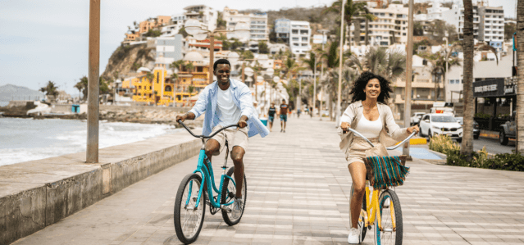
Culture Quiz

Answer the following questions on the basis of this document. Read the text carefully because you will also have to answer some bonus questions in class.
- If you can speak Spanish, what Iberian languages should be the easiest for you to understand? Why?
- What political penchant can you work out from a Spaniard who prefers the use of either español or castellano as opposed to someone who doesn’t care that much? Why?
- How is the term Reconquista ideologically charged?
- How was the birth of the Spanish state different from that of other European states?
- How have the sources of the Spanish Catholic Church’s power changed over time?
- Who are to be credited for the Spanish agricultural sector’s boom in the second half of the 20th century? Who are getting the profits?
- A friend offers to help you out with an exam, but the exam has already taken place. What would you say in Spanish?
- How did modern chess originate?
- Why has there been two royal dynasties in Spain after the Catholic Monarchs?
- You just happen to pass a course you thought you were bound to fail. How would you describe your passing in Spanish?
- Why are there to names for mayonnaise in Spain’s Spanish? Which of them do you think is preferred in Latin America?
- How has the meaning of liberal changed over time?
- Think of a situation where you could say Se te ve el plumero.
- Did poor people want a republic in Spain in the second half of the 19th century? How Monarchic were they?
- How important was Africa in the Spanish politics about a century ago? Why?
- How did the Bourbons managed to crawl their way back to power after Alfonso XIII’s exile? How did they consolidate their power?
- Why does most of the Spanish media support the monarchy?
- What are the two key differences between the current king Felipe VI and his predecessor Juan Carlos I?
- What is the main current threat to the Spanish monarchy?
- Why was Toledo an important city in medieval Spain?
- How are the churches different in northern and southern Spain? Why? What was the most modest aspect of the Muslim architecture?
- How was the Herrerian architecture style both a reflection of and justification on the social reality?
- What kind of relationship with the past was being advertised with the adoption of Neo-Mudéjar art?
- Why does Barcelona have Gothic district and numerous art-nouveau buildings?
- What does the size of a kitchen have to do with ideology?
- What factors encouraged the building of costly impressive buildings at the turn of the 21st century?
- Why did Spain specialize in pork meat and Argentina in beef?
- Where would you use papas fritas and where would you use patatas fritas for French fries? Why?
- Spanish speakers usually look either puzzled or pleasantly surprised if a Finnish guest thanks for a meal. In your view, what might tip the reaction one way or the other?
- According to a Spanish saying, “There are more bars in Antón Martín alone (a district in Madrid) than in all of Norway”. What attitudes can you infer from such a claim?
- How widespread are tapas in Spain?
- Which were major factors that helped prevent social unrest in the European colonial empires?
- How are a nation and a state different? Can you provide any example?
- How much are bullfighting and flamenco representative of the Spanish culture? Why?
- How did the Spanish elites manage to argue that both the dead people of past times and the unborn people of the future should have a bigger say defining Spain than their fellow nationals at the time?
- Why did the lower-class music styles become that important in Latin America as opposed to Spain? Can you provide some examples?
- Can you list the problems associated to extractivism? Can you think of any example?
- How were the borders of the Latin American countries decided? What factors intervened?
- Why are people living in the big Latin American cities resented in the countryside sometimes?
- Why have the Latin American countries not managed to get rid of the causes of their underdevelopment?
- Why did Spain not develop its own manufacturing capacity with the aid of the American silver?
- Why was usury considered a sin?
- How did the American silver affect the Spanish empire’s economy? Where and why were these consequences most visible?
- What was the linguistic policy like in the Spanish empire? Why?
- How representative are the Latinos we might run into while living in Europe? Why?
- Which factors did help the conquistadors to beat the Indian empires?
- Why did gauchos and charros dress so differently?
- How has the meaning of piñatas changed over time?
- Where is there a strong tradition of community work in Latin America? Why?
- What issues can be raised about the ban on the coca plant?
- Why do you think the Spanish painters did not paint from nature before Velázquez?
- Is The Ingenious Gentleman Don Quixote of La Mancha a comedy or a tragedy? Why?
- Where does the stereotype of “proud Spaniards” come from?
- In Los Serrano TV show, a man (Santiago Serrano) offers a policeman a 5-euro bill in order to avoid a traffic ticket, but the policeman laughs at him. This scene was mainly considered quite funny by the Spanish audience. Can you explain the cultural assumptions this scene was playing with?
- Why did people live worse, in general terms, in the Early Modern Era than in the Middle Ages?
- What was the drive behind the European witch hunts if not religious?
- Someone travels by metro without a ticket. How do you think this would be regarded in a Catholic society in opposition to a Lutheran society? Why?
- If a company has a closed-circuit television system for the surveillance of employees, are Lutheran and Catholic employees likely to take it the same way? Why?

There is something between 10.000 and 20.000 castles in Spain. https://www.lasexta.com/viajestic/curioso/mapa-espana-numero-castillos-que-existen-provincia_20221019634fcb8952d17f000180bf0f.html#:~:text=Se%20cree%20que%20en%20nuestro,%2C%20Catalu%C3%B1a%2C%20Arag%C3%B3n%20y%20Ja%C3%A9n.
https://www.fundeu.es/noticia/sudamerica-prefiere-el-termino-castellano-y-centroamerica-el-de-espanol-1047/
According to the Ipsos’ 2023 international survey, 23 % of Spaniards declare themselves practicing Christians, while 22 % believe in a higher power different than a god, and 32 % believe in neither god nor any higher spirit. https://www.ipsos.com/es-es/two-global-religious-divides-geographic-and-generational
According to Thomas Piketty, they gentry accounted for roughly 7 % of the population in Spain while the clergy accounted for some 4 %. See his book Capital and Ideology for more information.
Read Manuel Tuñón de Lara’s La España del siglo XIX and La España del siglo XX for a detailed account on how the Spanish ruling elite was formed in the last 200 years. For more recent developments, I would recommend Rubén Juste’s IBEX 35. Una historia herética del poder en España and La nueva clase dominante. Gestores, inversores y tecnólogos. Una historia del poder desde Colón y el Consejo de Indias hasta BlackRock y Amazon.
This is well documented in Antonio Maestre’s Franquismo S.A.
See the essay Extremadura saqueada for more on this: http://www.elrincondenaredo.org/Biblio-1978-Extremadura_saqueada.pdf.
Right now, CaixaBank and BlackStone are the main landlords in Spain, with some 41.000 rental properties combined all over the country. Other big players in the market are the American investment funds Cerberus, TPG capital, Ares management, LoneStar, and Goldman Sachs. https://www.idealista.com/news/inmobiliario/vivienda/2024/04/02/816386-caixabank-y-blackstone-son-los-mayores-caseros-de-espana-con-41-000-viviendas#:~:text=CaixaBank%20y%20Blackstone%20son%20los%20mayores%20caseros%20de%20Espa%C3%B1a%20con%2041.000%20viviendas%20alquiladas&text=CaixaBank%20y%20el%20fondo%20de,publicados%20este%20martes%20por%20Civio.
https://en.wikipedia.org/wiki/Common_Agricultural_Policy
https://www.vozpopuli.com/economia_y_finanzas/paradoja-millonaria-subvenciones-economia-sumergida_0_1332467131.html
https://www.nber.org/system/files/working_papers/w5398/w5398.pdf
A compound surname is made up of several words, and sometimes they are a combination of two hyphenated surnames. Nowadays a compound first surname can be found in less than 1 % of the Spanish population. https://www.genealogiahispana.com/apellidos/los-apellidos-compuestos-espanoles-origenes-clases-y-algunos-mitos/
In the Money Heist series, Berlin manipulates a tv-audience (in the first season, chapter 4) by saying his group is robbing the Royal Mint because they want to “leave something for their children” although most of the robbers do not actually have any children they would keep in touch with. Eventually this reasoning definitely strikes a chord in the Spanish audience.
See the chapter Land and Power in Spain for more information about the Spanish inquisition and its connection to land-based power.
https://www.ui1.es/blog-ui1/del-dicho-al-hecho-historico-de-donde-viene-la-expresion-salvarse-por-los-pelos
Despite the fact workers were starving at the time due to their little leverage over the employers.
See the chapter The Role of Urbanism in Class Conflict for some insight into the traces of these political events in the Spanish cities.
See his essay La España del siglo XIX (1808-1914).
There has only been one queen before the 19th century: Joanna of Castile (1479-1555), a daughter of the Catholic Monarchs of Spain who never held real power and was declared crazy and locked up in a palace five years after her coronation. Her mother Isabella I of Castile does not count since she shared power with Joanna’s father Ferdinand II of Aragon.
The Spaniards had to suffer the consequences of the very abuse they had tolerated in the African colonies, although to be fair colonialism was only supported by the Spanish elites, since they were the only ones not forced to send their children to fight in the colonial wars. The point of Europeans suffering in World War II the same terror they had inflicted on Africans is well described in Sven Lindqvist’s Exterminate all the Brutes. The book convincingly states that people tend to tolerate injustice on others if they hope to be spared themselves, but quite often they end up suffering the same consequences they did not bother to oppose when they had the chance.
Conservative businessmen and companies that were hoping to appropriate some strategic sectors of the Spanish economy. Some names are ITT, Shell, Texaco, Ford, General Motors, Studebaker, Dupont, or the Spanish banker Juan March. https://es.wikipedia.org/wiki/Guerra_civil_espa%C3%B1ola https://vscw.ca/es/node/104
https://www.youtube.com/watch?v=V5huzjdBJU4&ab_channel=Esparroqui
https://www.publico.es/politica/estudio-1970-muestra-20-espanoles.html
https://www.elnacional.cat/es/politica/golpe-estado-23f-rey-juan-carlos-sombras_584673_102.html
https://elpais.com/politica/2014/06/02/actualidad/1401704469_632570.html
https://www.20minutos.es/noticia/2452974/0/valoracion-rey/felipe-vi/mitad-espanoles/
https://www.elsaltodiario.com/encuesta-monarquia/39-por-ciento-votaria-republica-31-monarquia-referendum
If you watched the first season of Narcos, you maybe got a glimpse of its importance.
https://elpais.com/america-colombia/2022-08-08/polemica-por-la-decision-de-felipe-vi-de-no-levantarse-ante-la-espada-de-bolivar.html
See the chapter A Monarchy or a Republic? Rather a Dictatorship for more information on this.
The media usually claim “There’s not enough consensus for an amendment”, but at least a strong reason to prevent any modification is that the constitutional debate is seen as a real threat by the Spanish elites.
There is no proof the palace burnt by order of the king. However, we do know the king was mentally instable to a high degree and also disliked the palace, since it apparently was too humble for his Versailles taste. A mysterious fire burnt the palace down on Christmas Day 1734.
https://cordopolis.eldiario.es/cordoba-hoy/sociedad/mezquita-cordoba-fuera-bienes-inmatriculados-iglesia-abre-devolver_1_8683172.html
In these notes I use the word “American” as referring to the Americas.
Republicanism was a threat to the many interests vested in the Spanish state. If you check the date on the monuments you see next time you visit Spain (usually written in Roman numerals), you will notice most of them are symbols of imperial power that were erected right after the First Spanish Republic in 1873 – 1874.
Contrary to what happens in Finland, the Spanish Law of Land forces the municipalities to expropriate the land after it has been declared developable. This pushes up the price of land and makes the expropriation very expensive for the public purse. https://es.wikipedia.org/wiki/Ley_del_Suelo_de_Espa%C3%B1a
Ideology can often be traced through the language. For instance, a double bed is called a cama de matrimonio (marriage bed) in Spanish.
According to Credit Suisse, Spain has the highest density of elevators per inhabitant in the world. This is a consequence of the need to build tall buildings in order to make the inflated price of land profitable: https://research-doc.credit-suisse.com/docView?language=ENG&format=PDF&document_id=807337830&source_id=emcsplus&serialid=jcODwZh0skdq6x9yYrGbqUT0Ueqtn%2f0XDvHG5%2bjUSD0%3d
This is particularly well explained in Jorge Dioni López’s La España de las piscinas.
A car is a closed private compartment that prevents the driver from communicating with other individuals and turns every trip into a competitive race.
That’s Catalan for “Superblocks”.
https://aceites.top/productores-aceite-oliva/
https://cipotato.org/potato/potato-facts-and-figures/
Spain is the 5th top meat exporter world-wide, and it is heavily specialized in pork: https://www.20minutos.es/noticia/4936972/0/espana-nacion-jamon-es-el-quinto-exportador-mundial-de-carne-y-el-pais-que-mas-cerdo-vende-en-el-extranjero/
https://www.bbc.com/mundo/noticias-47119001. Other countries in the top four are the US, Australia, and New Zealand.
See the chapter Being a Hidalgo a few pages below to understand this.
France also switched to Germany’s time zone to please the nazis during World War II, but in this case the geographical difference is not as obvious as in Spain.
https://gdempresa.gesdocument.com/noticias/salario-bruto-medio-europa
See the chapter Housing and Ideology for more information on this.
See the chapter The role of urbanism in class conflict about this.
This is well explained in Benedict Anderson’s book Imagined Communities. A nation is nothing more than a shared account on the origins and the soul of a people. This is why the first forms of national sentiment and the first political parties were born around a newspaper. And, as George Orwell says in 1984, those who control the present, control the past and those who control de past control the future.
See the chapter Being a Hidalgo.
According to the Spanish Ministry of Culture, only 776.000 people attended a bullfight (this also includes some festivities with smaller bulls) in 2022, in spite of the fact many regional or local authorities give away free tickets, and roughly a quarter of the audience did not need to pay for the shows. According to the same statistics, the attendance figure exceeded three million in 2019. https://www.publico.es/sociedad/toros-respiracion-asistida-asistencia-hunde-pese-sosten-nuevos-gobiernos-ultraderecha.html
For instance, flamenco was meant to be listened to but never played by the lords.
These companies are Universal, Sony and Warner I’m drawing here on Jon E. Illescas’ books La dictadura del videoclip. Industria musical y sueños prefabricados and Educación tóxica. El imperio de las pantallas y la música dominante en niños y adolescentes.
I emphatically recommend you read David Graeber’s books if you want to know more about this topic. Namely Debt: The First 5000 Years and The Dawn of Everything: A New History of Humanity. Also, Bullshit Jobs: A Theory is highly recommended although not strictly related.
Another interesting book to look at about this topic is Propagandan historia, written by Silja Pitkänen and Ville-Juhani Sutinen.
The countries are Argentina, Chile, Colombia, Cuba, Mexico, the Dominican Republic, Uruguay, and the Philippines. https://es.wikipedia.org/wiki/Peso_(moneda)#:~:text=La%20unidad%20de%20peso%20era,una%20libra%20de%20oro%20fino.
The best approach to this topic is still in Marx’s and Engel’s Das Kapital. A few decades ago, this work was a compulsory read for the economics students in the former Helsinki School of Economics (nowadays a part of Aalto University).
This comes from Eduardo Galeano’s Open Veins of Latin America: Five Centuries of the Pillage of a Continent. This is probably the best book ever written to understand Latin America.
https://www.telesurtv.net/news/El-descubrimiento-de-America-o-el-inicio-del-mayor-genocidio-de-la-historia-20161011-0049.html. Also, David Graeber gives the same estimations in The Dawn of Everything: A New History of Humanity.
https://www.esglobal.org/esterilizaciones-forzadas-una-practica-aberrante-aun-vigente/
https://ourworldindata.org/most-densely-populated-countries#:~:text=Globally%20the%20average%20population%20density,%2C%20Hong%20Kong%2C%20and%20Gibraltar.
This report by Amnesty International is definitely telling. https://www.amnesty.org/es/wp-content/uploads/2021/07/amr460022014en.pdf
I’m drawing here on Howard Zinn’s A People’s History of the United States, a highly recommendable essay on the origins of the US wealth and its political evolution.
https://books.google.fi/books?id=b-DBTAYRYOMC&pg=PA47&lpg=PA47&dq=%22Apropiaci%C3%B3n+de+la+tierra+a+los+abor%C3%ADgenes+y+genocidios+en+el+R%C3%ADo+de+la+Plata%22,+Fernando+Del+Corro%27&source=bl&ots=HBie3b2QS7&sig=ACfU3U16I_wMITP9VflGVehTRXaxMr5yAg&hl=es&sa=X&ved=2ahUKEwj-p57Y5Mv8AhUuiYsKHUOHAHYQ6AF6BAgIEAM#v=onepage&q=%22Apropiaci%C3%B3n%20de%20la%20tierra%20a%20los%20abor%C3%ADgenes%20y%20genocidios%20en%20el%20R%C3%ADo%20de%20la%20Plata%22%2C%20Fernando%20Del%20Corro'&f=false
Note Uruguay or Argentina were de facto farther away from Spain than, say, Peru or Bolivia. This is because prior to the opening of the Buenos Aires harbor in 1778, all the South Cone goods had to go through Peru, Panama and Cuba before reaching Spain.
https://en.wikipedia.org/wiki/Protectionism_in_the_United_States
Read Eduardo Galeano for this.
See the previous chapter “The Americas Enter the Global Economy” to have a clear picture of the kind problems this generates.
Meaning putsches, dictatorships, social engineering, propaganda war, lawfare, intimidation and blackmail techniques used both by the rich countries and the big banks as well as by some supranational organizations such as the IMF or the World Bank.
This happened because the Ming dynasty’s stifling taxation led the desperate poor to dig for silver, and silver started being increasingly used as currency. See David Graeber’s The Dawn of Everything: A New History of Humanity for more.
According to Eduardo Galeano, Seville had 16.000 weaving looms when Filip II became king and only 400 when he died. By the year 1700, Spain’s population was half what it had been a bit over two centuries back.
Mostly Italian, Dutch, and Hanseatic at the time.
In these notes, I use the word “American” as referring to the Americas. From a Spanish-speaking point of view, the fact that one country could monopolize this adjective is hardly arguable.
https://es.wikipedia.org/wiki/Quiebras_de_la_Monarqu%C3%ADa_Hisp%C3%A1nica
https://www.publico.es/politica/andalucia-11-15-barrios-pobres-espana.html
https://www.unicef.es/prensa/unicef-presenta-el-atlas-sociolinguistico-de-pueblos-indigenas-en-america-latina#:~:text=En%20Am%C3%A9rica%20Latina%20hay%20522,en%20dos%20o%20m%C3%A1s%20pa%C3%ADses.
https://es.wikipedia.org/wiki/Conquista_del_Desierto
https://www.wilsoncenter.org/blog-post/slavery-brazil#:~:text=On%20May%2013%2C%201888%2C%20Brazilian,slavery%20in%20all%20its%20forms.
https://es.statista.com/estadisticas/581497/porcentaje-de-poblacion-perteneciente-a-los-diferentes-grupos-etnicos-mexico/
Jared Diamond studied this both in Guns, Germs, and Steel. and in Collapse: How Societies Choose to Fail or Succeed.
The theory of plough vs. hoe comes from the Danish economist Ester Boserup. You can find a detailed explanation in the following study: https://cep.lse.ac.uk/seminarpapers/07-12-12-NN.pdf. Also, this theory adds up to a wealth of interesting considerations about the gender roles in society in Caroline Criado Pérez’s The Invisible Woman.
In their first few letters to the Spanish monarchs, Christopher Columbus repeatedly projects an air of superiority towards the Indians based on the fact they were no Christians, they were always naked, and they had some weird habits such as that of eating some “disgusting things”.
It is said in the Bible Jesus expelled the merchants from the temple, and also that it is easier for a camel to go through the eye of a needle than for a rich man to enter the kingdom of God. However, the Catholic Church has historically transitioned from hostility to capital in the Middle Ages (hence their war on usury and Jewish moneylenders) to cooperation in both Modern Eras and full submission after the appointment of Pope John Paul II in 1978.
This friar and bishop published A Short Account of the Destruction of the Indies in 1552 a renowned detailed description on the Spanish atrocities in the Americas.
Remember charity is practiced from top to bottom while solidarity is practiced among equals. The Catholic Church has always defended the former and has a long history of lobbying policies devised to keep the poor both subdued and dependent as a means to ensure its own indispensability. This is very well explained in Ángel Munárriz’s Iglesia S.A.: Dinero y poder de la multinacional vaticana en España. Another telling example is what the Brazilian bishop’s Helder Camara one said in the second half of the 20th century: “When I give food to the poor, they call me saint. When I ask why they are poor, they call me a communist.” (More about this in a book called Dom Helder Camara: Essential Writings).
Some of these ancient pathways have become a touristic attraction under the name of Inca Trail.
Obviously all the gold and silver were molten and shipped to Spain.
No wonder why the Spaniards had trouble telling the difference between similar roots if we think that about 7.000 varieties of potato have been documented to this day. https://elpais.com/elpais/2020/01/16/buenavida/1579199833_108344.html
See the previous chapter about the Viceroyalty of New Spain for more information about the encomienda system.
The Open Veins of Latin America.
For instance, the use of mercury in the amalgamation of silver was extremely toxic.
https://www.lavanguardia.com/historiayvida/edad-moderna/20210712/7595509/hilanderas-velazquez-dimensiones-originales-museo-prado.html
https://www.clarin.com/sociedad/eligen-quijote-mejor-libro-tiempos_0_BkhexmSx0Fl.html
According to this study, something between a quarter and a third of the old Christians who did not work for the Church could read in the city of Ávila at the beginning of the 17th century. https://www.researchgate.net/publication/39212039_La_alfabetizacion_de_la_poblacion_urbana_castellana_en_el_siglo_de_oro/fulltext/57aa806708ae42ba52ac5f66/La-alfabetizacion-de-la-poblacion-urbana-castellana-en-el-siglo-de-oro.pdf
In some versions of the story, the dead man is a ghost. In others, he is either a skeleton or a grave’s stone statue. The idea of a dead guest is not unique to don Juan, and the dead man is not even in all the versions of the myth either. It was quite common to borrow whatever elements the author would like in another play since the concept of author’s rights did not exist. Actually, don Juan only became famous across Europe after Molière’s French version.
To be honest, Cervantes died on the 22nd but was buried the day after. And also, Shakespeare died actually on May the 3rd, but in the prevailing British calendar at the time it was April the 23rd. The fact is the Spanish authorities considered the proximity of both days was a good excuse to hold open-air book fairs under the mild sun of the Spanish spring. Hence the yearly celebration of the Spanish Book Day started in 1926, and UNESCO made it the World Book Day in 1989.
The School of the Americas was a training center for torturers that operated in Panama from 1946 to 2001, when the protests of human rights associations caused it to be renamed and moved to the state of Georgia in the U.S. Among its numerous graduates were the murderer of the much-remembered Chilean singer-song-writer Víctor Jara, Guatemala’s dictator José Ríos Montt, the organizer of the coup in the Dominican Republic Elías Wessin y Wessin, Panama’s dictator and drug trafficker Manuel Noriega, Bolivia’s dictator Hugo Bánzer, the leader of death squads in El Salvador Roberto D’Aubuisson, the organizer of a coup in Argentina Roberto Eduardo Viola, the member of the Argentinean junta and leader of the dirty war against political opponents Leopoldo Galtieri, the responsible of state terrorism, drug trafficking, influence peddling and forced sterilization of indigenous women in Peru Valdimiro Montesinos, the leader of Peruvian governmental death squads Santiago Martín Rivas, or Chilean torturer Manuel Contreras. https://numerof.org/escuela-de-las-americas-11-dictadores-entrenados-por-eua/#:~:text=Entre%20los%20graduados%20de%20la,Bosch)%3B%20el%20general%20Manuel
If you understand Finnish, you might be interested in a short series called Invisible Heroes. This show can be watched in Yle Areena and approaches the subject with a remarkable degree of respect. Also, a must-see Spanish-language documentary about this is La batalla de Chile (The Battle of Chile).
The film Argentina, 1985 manages outstandingly to convey the historical importance of this trial.
https://www.pagina12.com.ar/585615-la-filtracion-sobre-el-exjuez-sergio-moro-expuso-las-irregul
https://www.elperiodico.com/es/internacional/20220811/argentina-cristina-kirchner-politizacion-justicia-partido-futbol-juez-fiscal-macri-14259722
A very good account on this topic is in Noam Chomsky’s and Edward S. Herman’s Manufacturing consent: The Political Ecoomy of the Mass Media. For a Spanish-speaking point of view, check Pascual Serrano’s Desinformación.
About this, I would recommend a book called La guerra de los jueces: el proceso judicial como arma política, and written by the former judge of the Spanish Supreme Court José Antonio Martín Pallín.
See the previous chapter about “Being a Hidalgo”.
I am especially drawing here on Erich Fromm’s Escape from Freedom. Lutherans believed the good deeds and hard work could maybe make it a bit easier for God to decide saving someone, while Calvinists did not believe any human influence on God was possible and thought people could only hope to have their success in earthly life show how God had already decided to favor them.
Luther himself was against lending, but this was quickly overcome by the bourgeoisie’s influence on the new ideas. The Catholic authorities were very much against usury, since they coveted the same real estate properties moneylenders were holding as loan security, so the bourgeoisie had every reason to support a religious revolution that would benefit them.
In the case of Great Britain, this process is particularly well described in Karl Marx’s Das Kapital, volume 1.
https://en.wikipedia.org/wiki/Witch-hunt
This is superbly explained in Silvia Federici’s Caliban and the Witch.
This figure comes from a study carried out by Julian Goodare a few years ago, although he acknowledges the numbers might vary greatly from one country to another. Goodare published his conclusions in a book called The European Witch Hunt in 2016. https://books.google.fi/books?id=eM4mDAAAQBAJ&pg=PA268&redir_esc=y#v=onepage&q&f=false
I got this from Elisabeth Noelle-Neumann’s The Spiral of Silence. The author namely mentions how Tocqueville was impressed by the strict morality of North American Protestants during his trip in the U.S. In a land where everyone was the supreme ruler in their own private property (That property was not still as concentrated as it is today), your neighbor’s opinion was as good as that of any authority. And when you pile up a large amount of these neighboring opinions, you are bound to be under an enormous social pressure.
For an enlightening account on the conservative moral principles of work, please check George Lakoff’s Moral Politics.
In the series Això no és Suècia (Catalan for “This is not Sweden”), a couple of young parents from Barcelona are COMPLETELY lost in their pursuit of a better way to raise their kids. Personally, I did not like the series because of its nonsensical storylines, but the starting point of some lost parents who continuously resort to playing cartoons to their kids out of sheer desperation and have an insane fixation with their idealized, perfect, Swedish neighbor might be quite relatable for many Spaniards.
The customers want to be served and the waiters do not want the cutlery to disappear!

