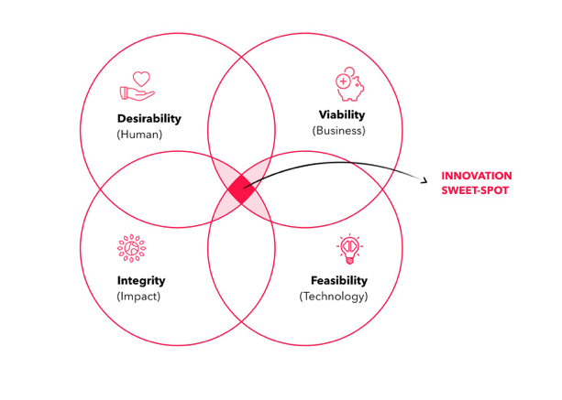

tu-e4060

design & innovation in context

fall 2023 (thursdays 09.00 – 11.30) @ aalto design factory

6 ects

your mentor dr peter kelly
connector @ aalto

my habitat tuas 2168 (maarintie 8)
my handles +358 41 503 4508 (mobile)
theideastudio (skype)
peter.kelly@aalto.fi

course objectives

By the end of this course, students will:

- Develop a deep appreciation for and exposure to design thinking principles

- Apply these principles to address “customer experience challenges”

- Develop an ability to craft persuasive and engaging messages

- Appreciate that entrepreneurship is a design infused discipline by its very nature

- Be confident and able to apply insights from this course to guide innovation in their own fields of interest

content

The learning objectives of the course:
- To develop your design and entrepreneurial acumen guided by Vision In Product (VIP) design framework and Effectuation theory
- To hone your sensemaking ability through observation, rigorous research, and discussion
- To identify relevant and meaningful starting point to guide new ”product” development
We are working from the premise that exploring future possibilities is more important than solving present day problems. Opportunity is “placed” in a future context that is constructed on the back of research insights, personal perspectives and conscious choices.
the design perspective
In the rush to innovate, too often our focus is short term in nature and based on superficial understanding of the underlying structure of the present domain where perceived problems lie. We need to deconstruct the present to design for the future.
We will rely on the Vision in Product (VIP) design framework developed at Delft University by Paul Hekkert and Matthijs van Dijk. Their work is part of a broader movement called speculative design. Phil Bagatas, formerly an Experience Design Partner at McKinsey considers speculative design as: “...a way to manifest possibilities, to prepare us for inconvenient challenges and facilitate a more desirable, responsible path in the future.”
The VIP process is displayed below and moves from bottom left to bottom right. Note that designing new products is the LAST not the FIRST stage of the process!
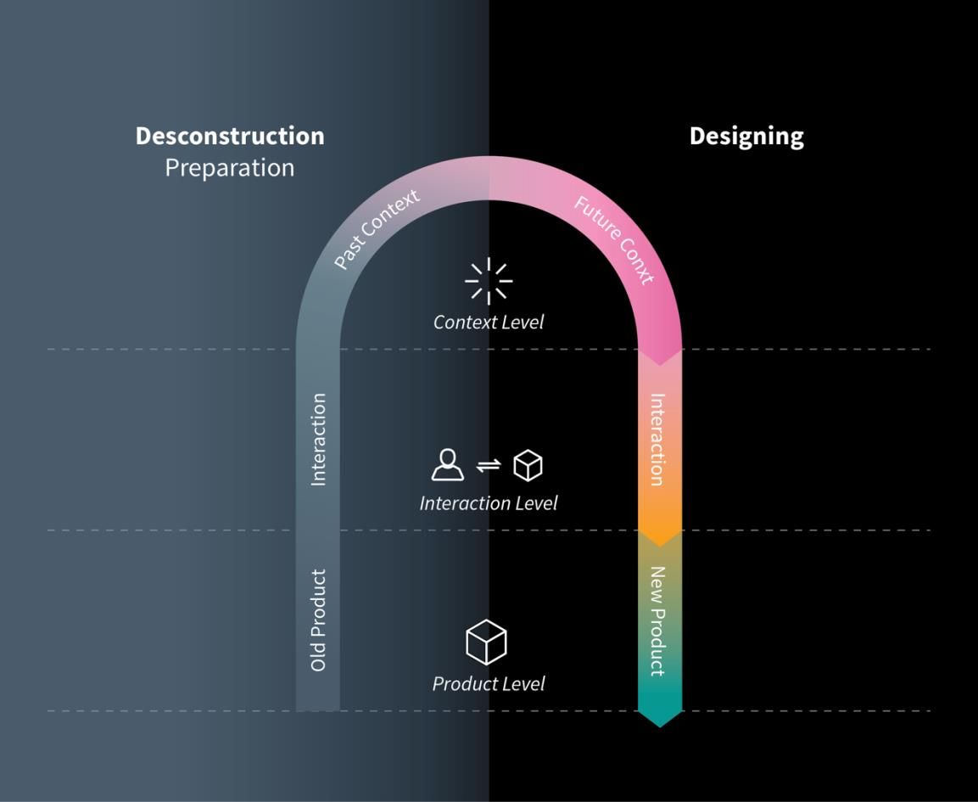
the innovation perspective
Taking the time to deconstruct a domain highlights some of the assumptions and driving forces that underpin existing products. On reflection, many of these existing products are well past their sell by date. VIP encourages you to identify relevant driving forces in a domain (called factors) and to speculate how these might play out in the future. In designing a future context, you imagine how people will interact and what they need in that world.
We know that successful entrepreneurs (and entrepreneurial individuals):
- Spot patterns where others see chaos
- Are grounded in a deep and empathetic understanding of the context within which customers operate
- Prototype potential solutions quickly and cheaply to garner feedback and guide future action
- Trust their instincts and intuition in knowing what customers want even if they are unable to articulate it, read Apple!
What we don’t appreciate nearly enough is the process they rely on to know opportunity when they see it and to act upon it. But if I had to speculate, look no farther than the work of Pierre Azoulay from MIT who looked at ALL the new businesses founded in the USA from 2007-2014. The average age of the founder of the top 1 in 1000 (,01%) growth ventures was 45 years. Ask yourself what does a 45-year old bring to the table? Deep networks for sure but an even deeper perspective on how a domain ticks, the driving forces at work, and perhaps experience bringing new products to life.
Once you have decided on what to do, that is when Effectuation theory kicks in. Saras Sarasvathy identified a set of decision-making principles that expert entrepreneurs use in situations of high uncertainty:
1) Action is initiated based on means available and not pre-set goals
2) Limits of investment both in terms of time and money are set up front
3) Opportunities are explored and developed in co-creation with outside parties
4) Surprise opens up new possibilities if you are open to reshape the opportunity
5) The future is shaped by the actions you take
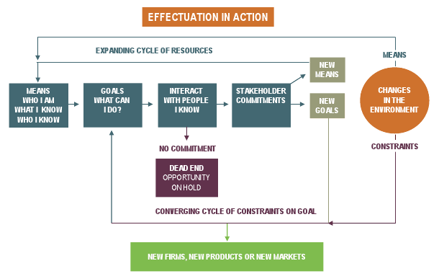

Using available means as a starting point, expert entrepreneurs create an artifact (idea), set limits on how much time/money to spend evaluating the opportunity potential, engage the outside world with an open mind to shape the opportunity with an aim to secure pre-commitments from some to take an opportunity forward. All the while, they are open to insights from surprises they encounter along the way demonstrating a knack for “turning lemons into lemonade”.

Expert entrepreneurs are the epitome of intentional learners continually honing their skills and abilities by treating every experience, conversation, meeting and moment as a learning opportunity. The fuel that drives their intentional learning is adopting a growth mindset that considers intelligence and capability as traits to be developed coupled with a determination to feed their innate curiosity.

Given the inherent uncertainties associated with how AI will develop and where it may take us, effectuation appears to be especially well suited for guiding decisions as we move forward. Individuals with an entrepreneurial mindset are not paralyzed by uncertainty but rather embrace it viewing it as opportunity not a threat.

deliverables & evaluation

Course deliverables involves both individual tasks (50%) and group project (50%)
Each participant will need to complete the following:

- Coffee Experience Challenge (20%) (Week 3):

As you may be aware, Starbucks has two outlets at Helsinki-Vantaa airport, a flagship store located at the iconic Aalto designed Academic Bookstore in central Helsinki, and a small store in Kamppi shopping centre. Starbucks went into partnership with Kesko Group (K Market) with ambitious plans to open more Starbucks adjacent to Citymarket. A small number of pilot stores were established but in late 2020 the partnership was put on hold, these pilots were closed down because “there was insufficient demand”. Experiments sometimes work and often times don’t – we expect that. But as yourself, why does a global coffee shop concept find it so difficult to gain hold in a coffee fueled country like Finland? Each participant is to put their creative hats on and propose some ideas that Starbucks should consider adopting.

For background, download a copy of “The Coffee Experience” where you will find a candid and critical email written by Howard Schultz, Chairman of the Board at Starbucks. I want each of you to prepare a succinct 1 page memo to Howard proposing what Starbucks should do to recapture the vision and inspiration that made the company one of the most successful IPOs in the 1990s and a $100+ billion market capitalization company today.

THE MEMO IS NOT A BRIEFING NOTE BUT IS PROVIDED AS A MASTERWORK IN THE ART OF CRITIQUING. IT WAS WRITTEN ON VALENTINE’S DAY – IN SHORT, ONE COULD INTERPRET IT AS “WE LOVE THE COMPANY” BUT “HAVE THE CUSTOMERS FALLEN OUT OF LOVE WITH US?”

In addition to the one page memo, I want each of you to prepare a presentation for Howard (5 minutes maximum). Append copies of your proposed slides to your memo. I WANT TO SEE HIGHLY VISUAL, IMAGINATIVE AND CAPTIVATING WORK.

- Coffee Experience Presentation/Critiques (10%):

On a voluntary, first come, first served basis, you will have an opportunity to take the “stage” and make a presentation to the class. A strict 5 minute time limit will be imposed and there will be an additional 5 minutes allocated for questions from the audience. PRESENTERS DO NOT NEED TO SUBMIT CRITIQUES

OR

If you do not present, you will be required to submit detailed and thoughtful critiques on any TWO (2) of the presentations. Howard probably spent several hours carefully considering his critique.

- Reflective Essay (20%)

Download a copy of the article “What Makes Entrepreneurs Entrepreneurial?” by Saras Sarasvathy from:

http://www.effectuation.org/sites/default/files/documents/what-makes-entrepreneurs-entrepreneurial-sarasvathy.pdf

Based on insights from reading through the substantial resources in the Design Reading Compendium that I have provided you on the course web, I want each of you to write a reflective piece to support the answer “because they embrace design thinking” to the question posed by Saras.

WORD LIMIT: 2000 (PDF)

The Future of the Department Store - Stockmann (Group Task 50%)

In our first session, I want you to visualize the concept of “department store”. The first image that comes to mind is probably a physical store. And you can probably think of a department store in the nearest city and/or anchor store in a familiar shopping mall to you.

In fact when you think about large cities, prominent department stores seem to be a fixture – Harrods in London, Galeries Lafayette in Paris, Saks and Bloomingdales in New York. As we are in Finland, you naturally think of Stockmann. I have been following this sector a long time. They have been around a long time – Stockmann was founded in 1862. And my sense is that in some respects the customer base is also established, read “old”!

For such a physical and tactile concept, department stores had to suddenly shutter their stores and transform their etail operations overnight when COVID19 and social distancing measures hit. But as you will discover, clothing etailers persistently face 40% return rates – especially for garments that don’t fit right, feel right, not the right colour, or for that matter don’t suit your tastes. Easy returns might be convenient for customers, they are an expensive drag for retailers.

Jeff Bezos discovered that Amazon was easy-peasy to buy books and other things when you know precisely what you want but no so good a place to browse the vast selection when you don’t know what you want or what you need (serendipity). Jeff speaks about the power of click-and-mortar plays and we will hear lots about the concept of omnichannel.

Many prominent department stores closed down during and after the pandemic because of lack of customers and for many, the inability to create a seamless experience between site and store. Stockmann has not been immune to this pressure. They have sold their physical real estate and leased it back. For store patrons like me, the company has been in pretty much a continual decline for more than a decade.

Unsurprisingly, the company announced they are exploring strategic options:
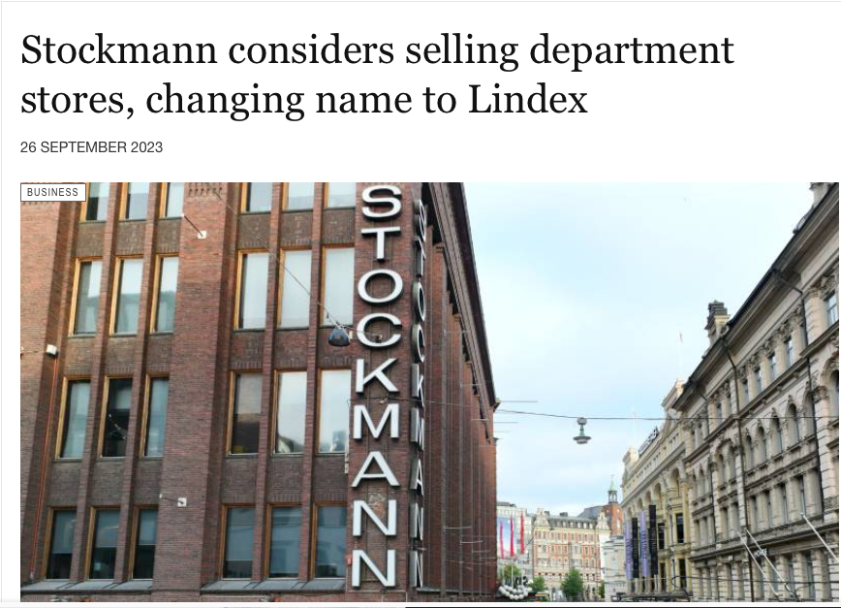

When I was in business school, one of the basic principles is that selling something implies that you have something of underlying value to sell. What is it precisely in the case of Stockmann?

Using VIP as your wireframe (look it up!), we will deconstruct the concept of department store. Why do department stores exist? What needs do they serve? What is it about their design that seems to repel younger generation consumers (like you!)? How do people shop?

I would like your group to take a look forward (not too far as we are talking about a public company) and propose a new experiment(s) for Stockmann to consider adopting that is both interesting to your group (you are younger consumers) and can be justified using the VIP wireframe structure we discuss in class. It should make business sense for Stockmann – they have shareholders to answer to after all. WHILE THE DEPARTMENT STORE RETAIL TRADE IS CHALLENGING, THEY HAVE A LOT OF PHYSICAL SPACE IN THEIR FLAGSHIP STORE TO PLAY WITH NEW CONCEPTS THAT ARE INTERESTING AND JUSTIFIABLE (WHERE VIP WIREFRAME HELPS). BUT REMEMBER WE KEEP VIP TERMINOLOGY HIDDEN – IT IS LIKE INTEL INSIDE.
Your group has complete freedom to interpret the brief any way you want. Once you immerse yourself in the current context, outdated design choices will jump out at you and lots of opportunities will be there to explore. I will help your team curate these choices.
YOU WILL BE WORKING ON THIS TASK IN GROUPS OF 7. AS IN OPPORTUNITY PROTOTYPING, I WILL BE JOINING EACH TEAM AS A MENTOR.

The Presentation

- Each team will be allocated private time with me “in camera” where I will provide you with detailed and thoughtful critique. This method proved to be the most valuable and impactful learning experience for course participants in previous years and addresses a very real need for students to develop the ability to create and deliver high impact messages.

- Final presentations will be in the form of Pecha Kucha – a highly visual story telling format that requires you to communicate messages in 20 second sound bites. Some examples and guidelines of this format can be found at: www.pechakucha.org.

- ABOVE ALL ELSE HAVE FUN WITH THIS AND DON’T CONSIDER IT A “TASK”!

