Welcome to your online resource MyLab Accounting which supports your textbook in this course. To make it easier your school has purchased access for all students. MyLab Accounting will offer you unlimited practice via a Study Plan that allows you to test yourself and practice with guided help me solve this support. You will find many videos, spreadsheets and animations in the multimedia library to improve your understanding. Your teacher will also deliver assignments directly in MyLab Accounting.
New Students:
- Use this direct course link https://mlm.pearson.com/enrollment/derichs77035
- Go to mlm.pearson.com and enter the CourseID: derichs67032
- Create a Log in Name using your university email
- Use the Access code shared by your instructor
- When you log in you will see your course.
If you have Pearson Account from another course:
- Please go to mlm.pearson.com
- Log in to your account with your previous username/password or use forgot password under the Sign In to reset your account.
- Use the Enroll in a Course Button
- Use the New Course ID derichs77035
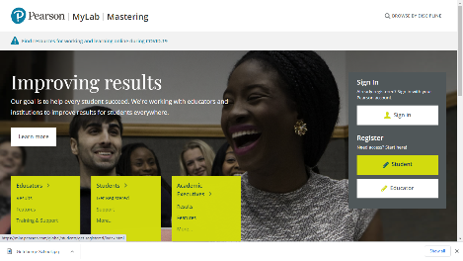

Any problems please reach out to our 24/7 support help
https://support.pearson.com/getsupport/s/contactsupport

