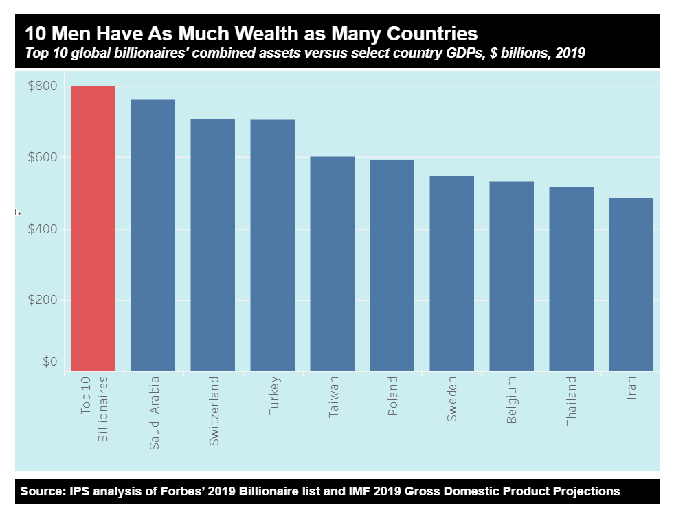
The Article:
https://www.theguardian.com/books/2016/apr/15/neoliberalism-ideology-problem-george-monbiot
Preguntas / Questions
Neoliberalism
– the ideology at the root of all our problems
- Define neoliberalism in a few words from the article’s perspective.

- Why equality is not desirable according to neoliberalism?

- How did neoliberalism become more extreme over the years?

- What specific policies were implemented under the Governments of Margaret Thatcher and Ronald Reagan according to the text?

- What authorities did force these measures upon many countries? What international instruments were additionally used to limit the power of sovereign political decisions?

- What strategy was used to enforce such measures within the countries?

- What is freedom under neoliberalism like according to the text?

- What has the economic performance of neoliberalism been like globally? What has it been like for the rich?

- What is the difference between rent and earned income?

- In what two ways has neoliberalism affected to the distribution of wealth?

- From the perspective of neoliberalism, our freedom is best exerted through our purchase decisions in a free market. What fundamental difference is there between a system based on purchase decisions vs. a system based on voting rights according to the text?

- What is the main paradox regarding neoliberalism’s laissez-faire state and freedom?

- How has the prevailing attitude towards the sources of wealth changed over the last century?

- Why has neoliberalism survived all its crisis? Why would the old recipes not work nowadays?

