Customer Experience Management

Course Overview
Gartner defines Customer Experience Management as: ‘’the discipline of understanding customers and deploying strategic plans that enable cross functional efforts and customer-centric culture to improve satisfaction, loyalty and advocacy’. (source: https://www.gartner.com/en/information-technology/glossary/customer-experience-management-cem)
Creating memorable customer experiences has become a management imperative in today’s hyper competitive global marketplace.
This course introduces and elaborates on the importance of Customer Experience Management for contemporary marketing theory and practice.

Course Objectives
The specific objectives and learning outcomes of this course will be:
- To understand the benefits of focusing on customer experience
- To become familiar with the building blocks and antecedents of customer experience
- To approach customer experience from multiple perspectives and points of view
- To introduce conceptual tools and techniques that can help create compelling customer experiences
- Capstone objective: To test/improve your ability to cohesively combine learning from multiple courses/sources

Learning Outcomes
On successful completion of this course, students will be able to:

- Argue for the need to focus on customer experience management
- Identify the drivers of outstanding customer experience
- Systematically diagnose and improve upon customer journeys and their outcomes

Teaching Methods and Materials
The teaching approach of the course builds on combining research-based knowledge with insights from practice. These are delivered through a combination of interactive lectures, case discussions and group work.
To fully benefit from the course, I encourage and expect you to complete all readings before coming to classes and do the assignment in time. Additionally, I encourage you to share your insights and personal experiences on the topics covered during class and be a good team player when working in groups. Your contribution to class interaction and learning activities is vital to everyone’s learning experience.

Course Readings
The course readings include 20 mandatory articles, and 6 optional/additional yet highly recommended readings.
All readings will be uploaded in MyCourses in folders labeled by Weeks.

Class Schedule

- 06.09 (12:15-14:00) - Classroom Session U7 PWC - U135a, Kandidatikeskus
- 08.09 (14:15-16:00) - Classroom Session U7 PWC - U135a, Kandidatikeskus
- 12.09 (13:15-15:00) - Classroom Session U9 - U271, Kandidatikeskus
- 14.09 (13:15-15:00) - Classroom Session U9 - U271, Kandidatikeskus
- 19.09 (13:15-15:00) - Classroom Session U9 - U271, Kandidatikeskus
- 21.09 (13:15-15:00) - Classroom Session U9 - U271, Kandidatikeskus
- 26.09 (13:15-15:00) - Classroom Session U9 - U271, Kandidatikeskus
- 28.09 (13:15-15:00) - Classroom Session U9 - U271, Kandidatikeskus
- 03.10 (13:15-15:00) - Classroom Session U9 - U271, Kandidatikeskus
- 05.10 (13:15-15:00) - Classroom Session U9 - U271, Kandidatikeskus
- 10.10 (13:15-15:00) - Classroom Session U9 - U271 Kandidatikeskus
- 12.10 (13:15-15:00) - Classroom Session U9 - U271, Kandidatikeskus

Weekly Plan
Week 1
Session 1 – Introduction to Customer Experience Management and Practicalities
Session 2 - Approaches and Building blocks of Customer Experience
Week 2
Session 1 – Action Session 1 - Touchpoints and Journeys
Session 2 - Touchpoints, Journeys and Narratives
Week 3
Session 1 – Innovation through Customer Experience Management
Session 2 - Action Session 2 – Personas, Profiles and Co-creation
Week 4
Session 1 – Metrics and Measurement – Revisiting the Firm
Session 2 - Aligning Brand Strategy, Research and Context
Week 5
Session 1 – Future of Customer Experience Management
Session 2 – Guest Lecure, TBD
Week 6
Session 1 – Final Presentations, Take-home exam introduction
Session 2 – Final Presentations and Wrap-up

Assessment and Grading

Components of Course Grade
- Literature-based assignments 20%
- Real-world assignments 20%
- Group Project 35%
- Take home exam 25%

Evaluation of Literature-based Assignments

You will be given a set of articles and a set of open-ended questions.

You have to answer the questions based on your understanding of the articles. Your answers should be clear and easy to follow.

Evaluation of Real-world Assignments
You will be given a set of tasks about real-world issues/challenges/successes
You have to collect data using the format provided to you for the task
You have to interpret your findings and report them in the given format

Evaluation of Group Project
It is your own responsibility to form a group of 4-6 students for the Group Project (e.g. by posting on MyCourses by 19.09.2023, 23:55)
Overall task:
- Please choose a well-known service brand (e.g. telecom, sports, music, hotel, restaurant, education, technology etc.)
- Identify a customer experience innovation that currently does not exist but that would work well and be aligned with this brand
- Argue why this particular experiential innovation will be relevant and impactful for the brand
Group Projects consists of three components:
- Project proposal (max.1 page long)
  - Submit a maximum of one-page long proposal which clearly indicates (1) a brand you chose (2) problem the brand is facing (3) customer experience innovation you suggest to mitigate the problem
  - 1-inch margins, Times New Roman 12, 1.15 spacing
  - Please note that you may always change the originally proposed brand and/or innovation throughout the project
- Presentation (15 min presentation, 5 minutes Q&A)
The 15-min presentation should summarize the various aspects of the task that your group worked upon. The goal of the presentation should be to convince the audience that your project should be implemented.
You can use the following guiding questions during your presentation:
  - What is the focal challenge this brand faces?
  - Why can this challenge be addressed with a customer experience innovation?
  - Why is your customer experience innovation particularly suited to address this problem?
  - What is the outcome you want to achieve with this experience innovation (e.g., Sales, Brand Image...)?
  - How can you be sure that your experience innovation will achieve this outcome?
  - Why should the company invest in your idea and not in competing projects?
The Group Presentation should:
- include supporting material, such as current managerial or trend studies (from Nielsen, Gfk, McKinsey, etc.) to illustrate upcoming business challenges
- include a short analysis of a current customer experience related problem by looking at consumer reviews or consumer forums (e.g., some text excerpt from reviews)
- emphasize the specific outcomes of your experience innovation and to provide reasoning why the experience innovation will reach the goal (e.g., innovation has been effective in another industry)
Do not forget to identify Customer Personas, sketch a CX journey and to utilize tools that are to be covered throughout the course
3. Management report (max. 10 pages, 1-inch margins, Times New Roman 12)
The Management report should be a short explanation of your presentation following the same questions as the presentation:
- Summarize the most critical information to one (1) executive summary page
- Justify your choices, i.e., develop a coherent line of argumentation
- Include grounded argumentation of your suggested CXM innovation and
- propose relevant CX measurements
- Explain the research processes for the reader (customer persona, journey
- mapping, ideation process, etc.)
- Utilize course literature and additional sources

Evaluation of Take-home Exam

The take-home exam will be a discussion of a real-world case guided by questions. The details of the take-home exam including the case/brand and questions will be introduced during the second-last lecture (10.10.2023).
You will be evaluated based on clear and logical use of methods and tools taught during the course to draw conclusions on the case.
The final examination for this course is a take-home exam, which is due three weeks after the end of the course.

Deadlines

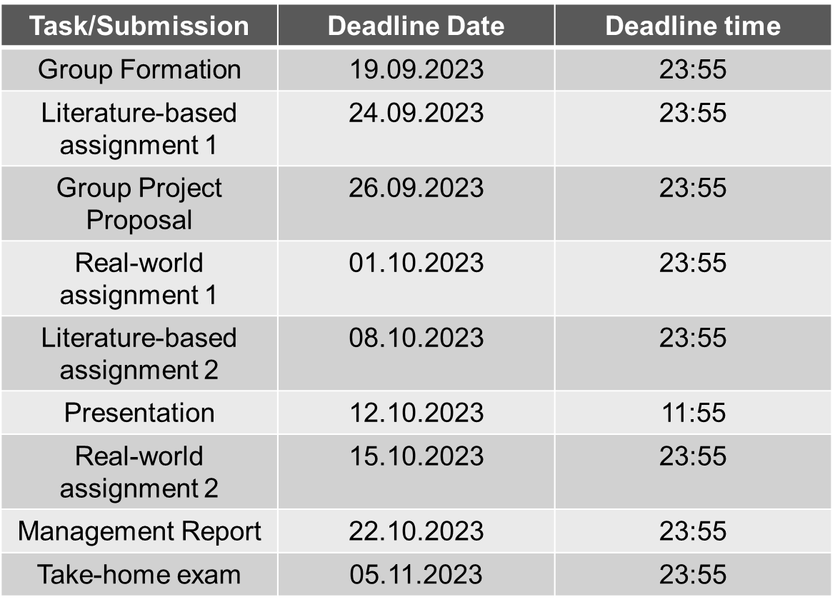

Assessment

Grading Scale
Grade | Points | Descriptor
5 | 90–100 | Excellent
4 | 80–89 | Very good
3 | 70–79 | Good
2 | 60–69 | Satisfactory
1 | 50–59 | Sufficient
0 | <50 | Fail

