Title of your paper
Firstname Lastname
Aalto University
School of xxx
Master’s/Doctoral programme on yyy

Abstract: This is the abstract of the paper explaining briefly the topic and motivation of the work, the modelling approach, main results and conclusions. (Typeset in the Abstract style of the template)

Introduction
This is template for the final paper on the MEC-E2010 Computational Fluid dynamics course. The different elements for the layout of the paper are provided in the following. The paper should have sections on introduction, modelling approach, case setup, results and discussion and conclusion.

Margins and paper layout
The paper size is A4 with 2cm margins on all sides (top, bottom, left, right). The layout is two column layout with 1cm separation between the columns.

Fonts
The font for all elements of the text is Times New Roman. The font size for the main body of text is 9pt (the Normal style in the template). The font size for the main headings is 9pt and these are type set in all caps (the Heading 1 style in the template)

Subheadings
The font for the subheadings is bold font in 9pt size (the Heading 2 style in the template). You should not use more than two levels of headings in your paper.

equations
Equations should be type set centered and numbered consecutively.
$A=πr^{2}$ (1)
The numbering should be flush to the right edge of the column. You can get this with the Equations style, which has a centered and right justified tab stops for the equation and the equation number respectively.
${\left(1+x\right)}^{n}=1+\frac{nx}{1!}+\frac{n\left(n-1\right)x^{2}}{2!}+…$ (2)

TABLES
Tables can be included as either one column or two column tables. Two column tables should be placed either at the top or bottom of the page. Tables should contain a caption located before the table, centred, typeset in the same font as the main text and numbered consecutively. The table should not have any borders, but there should be a horizontal line separating the column headings.
Table 1: Example of a table and table caption.
Column 1 | Column 2 | Column 3
Item 1 | Item 2 | Item 3
Item a | Item b | Item c
There should be one empty line after the table to separate it from the rest of the text.

figures
Figures can be included as either one column or two column figures. Two column figures should be placed either at the top or bottom of the page. Figures should contain a caption located below the figure, centred, typeset in the same font as the main text and numbered consecutively.
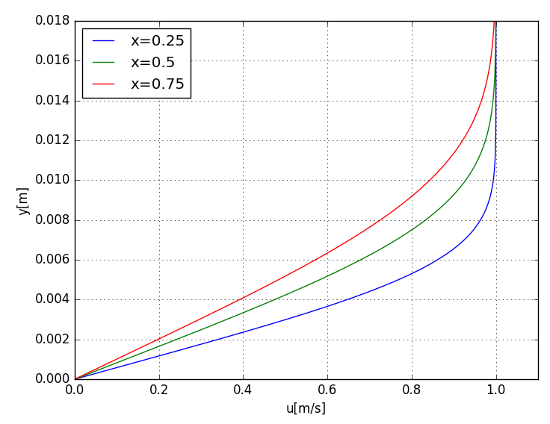
Figure 1: Example of a figure and a figure caption.
Pay attention to the size of the text in the figures. The text size should be such that it is easily legible. Avoid excessive margins around the figure and crop the figure accordingly if necessary.

references
The list of references is placed at the end of the paper with a main heading REFERENCES. The list should be organized in alphabetical order based on the name of the first author and items should be numbered consecutively. In the text you should cite the number in square brackets e.g. [1]. Examples of references are shown in the following.
- Hänninen, S., Mikkola, T., Matusiak, J., 2016, ” Development of vertical second harmonic wave loads of a large cruise ship in short and steep head waves”, Ocean Engineering.
- Tu, J., Yeoh, G.H., Liu, C., 2012, Computational Fluid Dynamics: A Practical Approach, Elsevier Science.

