Why Hotelling rule “fails” in Ex 2-3
In this report we will study why the Hotelling rule “fails” to maximize the net present value of a nonrenewable resource stock in Exercise 2-3. Note that some values are different here than in the most recent version of the exercise.
For simplicity, we assume zero cost for exploiting the resource. This means that, if the unit price of the resource is 100 EUR, the profit per unit for the proprietor is also 100 EUR. Unlike in the home exercise where the time resolution is one year, here the time resolution is one day.
We will compare the Hotelling rule strategy against a pricing strategy of constant percentual growth given by two strategy parameters:
- initial price
- annual price increase factor (factor 1.1 refers to annual percentual growth of 10%)

Interest rate zero
Let’s start with the simplest case, where the interest rate is 0%. This means that the value of 100 EUR earned one year from now is exactly the same as the value of 100 EUR earned right now.
Below is plotted the net present value of the resource as a function of strategy parameters. The optimal pricing strategy is 83±1 initial price and 0±1% annual increase.
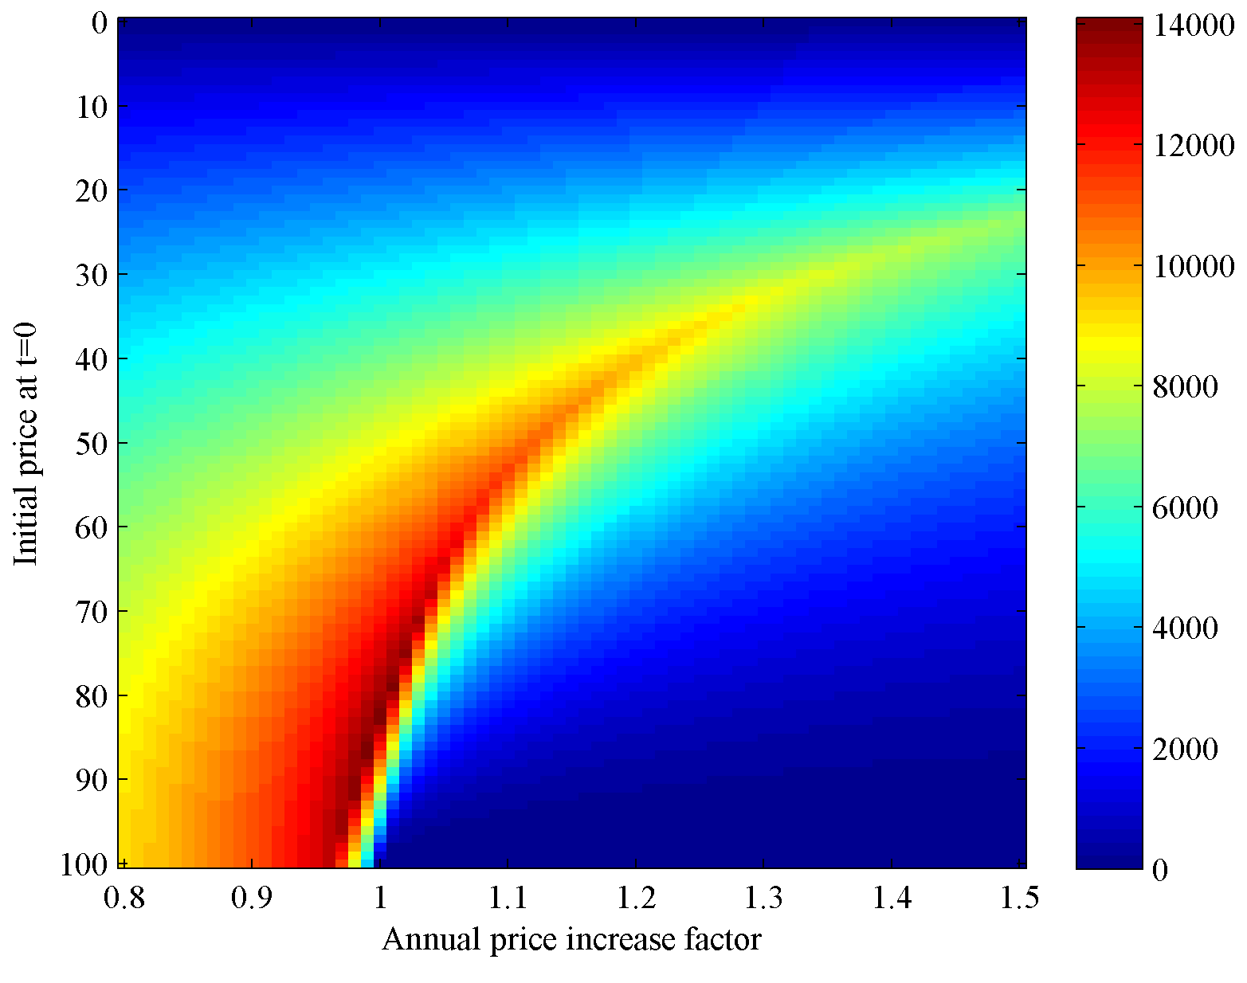
According to Hotelling rule, the annual increase should be 0%, equal to the interest rate. So far so good. What happens if the interest rate is nonzero?

Interest rate nonzero
Let’s increase the interest rate to 10%. This means that 100 EUR earned right now is 10% more valuable than 100 EUR earned one year from now.
Below is plotted the net present value of the resource again as a function of strategy parameters. The optimal pricing strategy is 71±1 initial price and 3±1% annual increase.
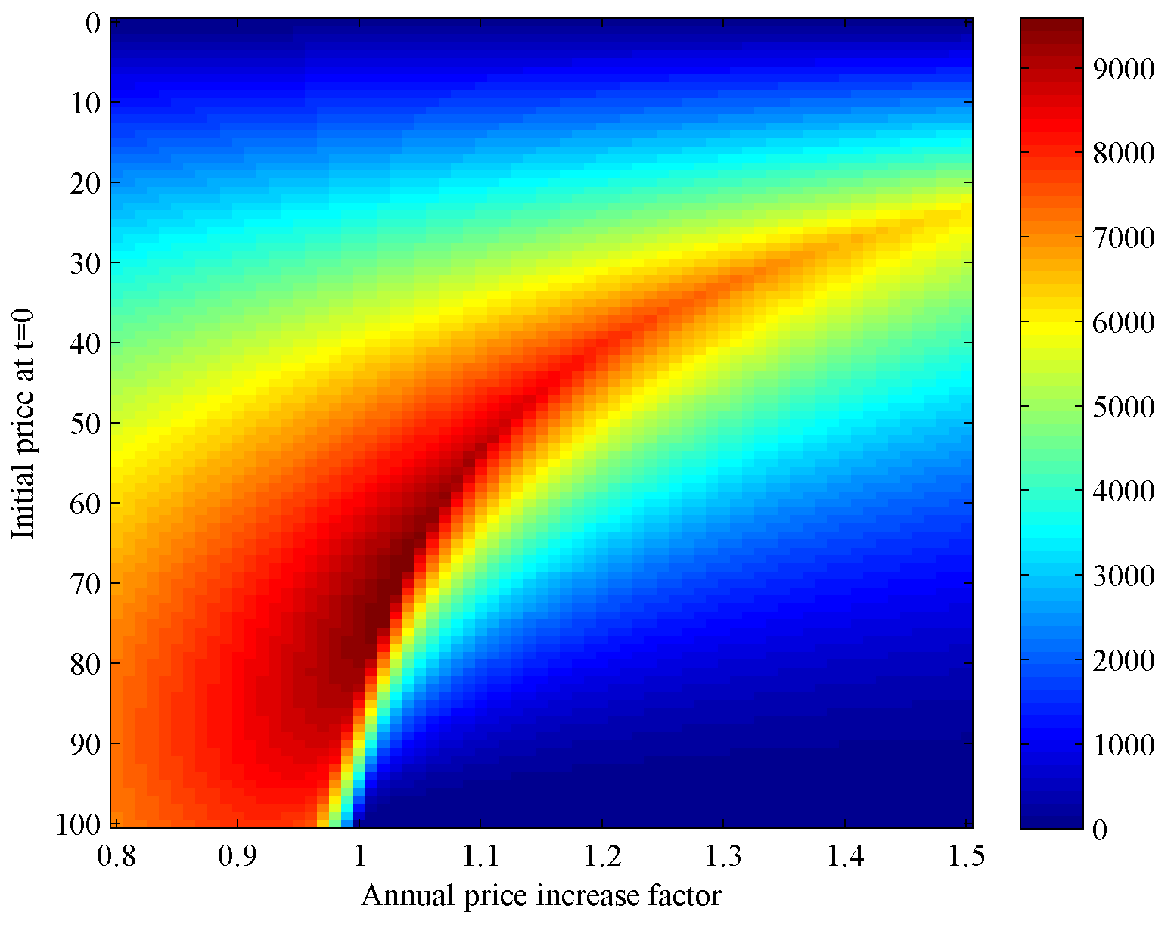
The optimal annual increase is 3±1%, while the interest rate is 10%. Why does Hotelling rule fail, or does it?

What went wrong
The demand function we are currently using is
$$Q_{t}=\max\left\{\frac{100-P_{t}}{365}, 0\right\}$$
We see that, when the $P_{t}=100$, the demand $Q_{t}$ is zero. This is the highest price the customers are willing to pay for our resource, let’s call it the choke price. However, due to the interest rate, 100 EUR today does not have the same value as 100 EUR one year from now. The present value of 100 EUR earned one year from now is ${100 EUR}/{\left(1+10\%\right)}≈90.91 EUR$. On the other hand, the amount of money earned one year from now that has the present value of 100 EUR is $100 EUR∙\left(1+10\%\right)= 110 EUR$.
Hypothesis: The demand function should incorporate the interest rate.
Let’s check the hypothesis by modifying the demand function.

Modification 1: Apply interest rate to choke price
Let’s see what happens with the following modification:
$$Q_{t}=\max\left\{\frac{100∙{\left( 1+d\right)}^{t}-P_{t}}{365}, 0\right\}$$
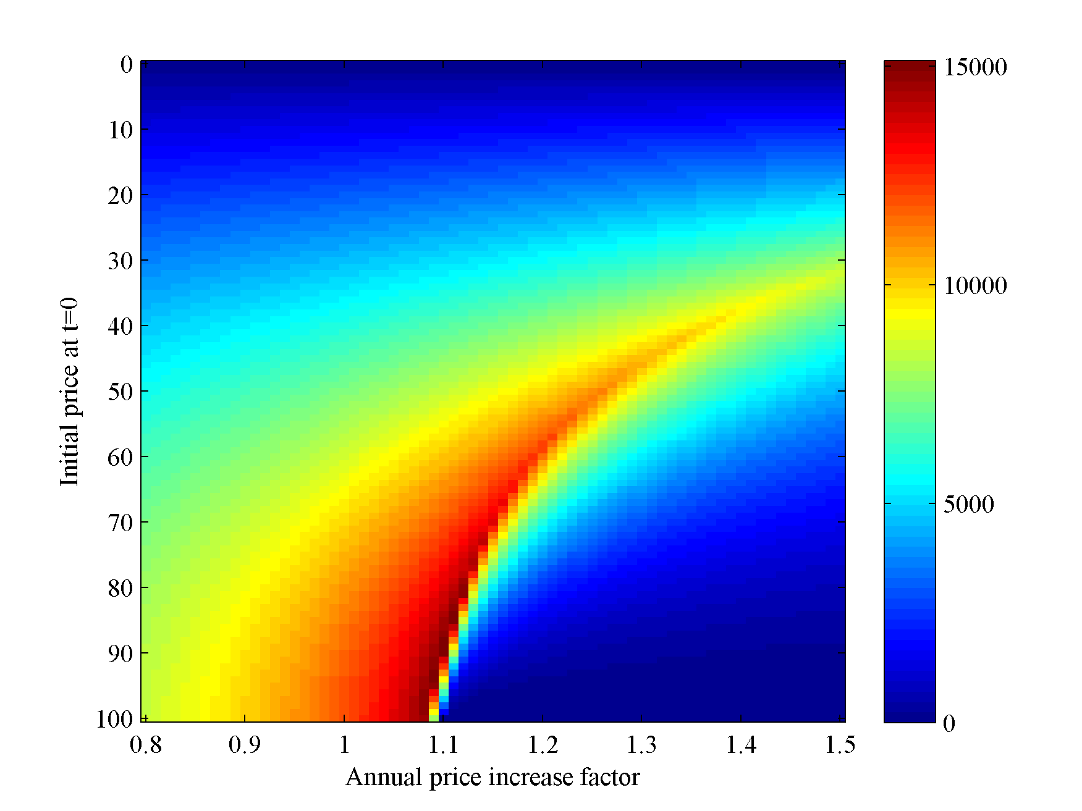
The optimal pricing strategy is 85±1 initial price and 11±1% annual increase. This agrees with the Hotelling rule.

Modification 2: Apply discounting to price
Let’s now modify the demand function by applying discounting to the price.
$$Q_{t}=\max\left\{\frac{100-\frac{P_{t}}{{\left(1+d\right)}^{t}}}{365}, 0\right\}$$
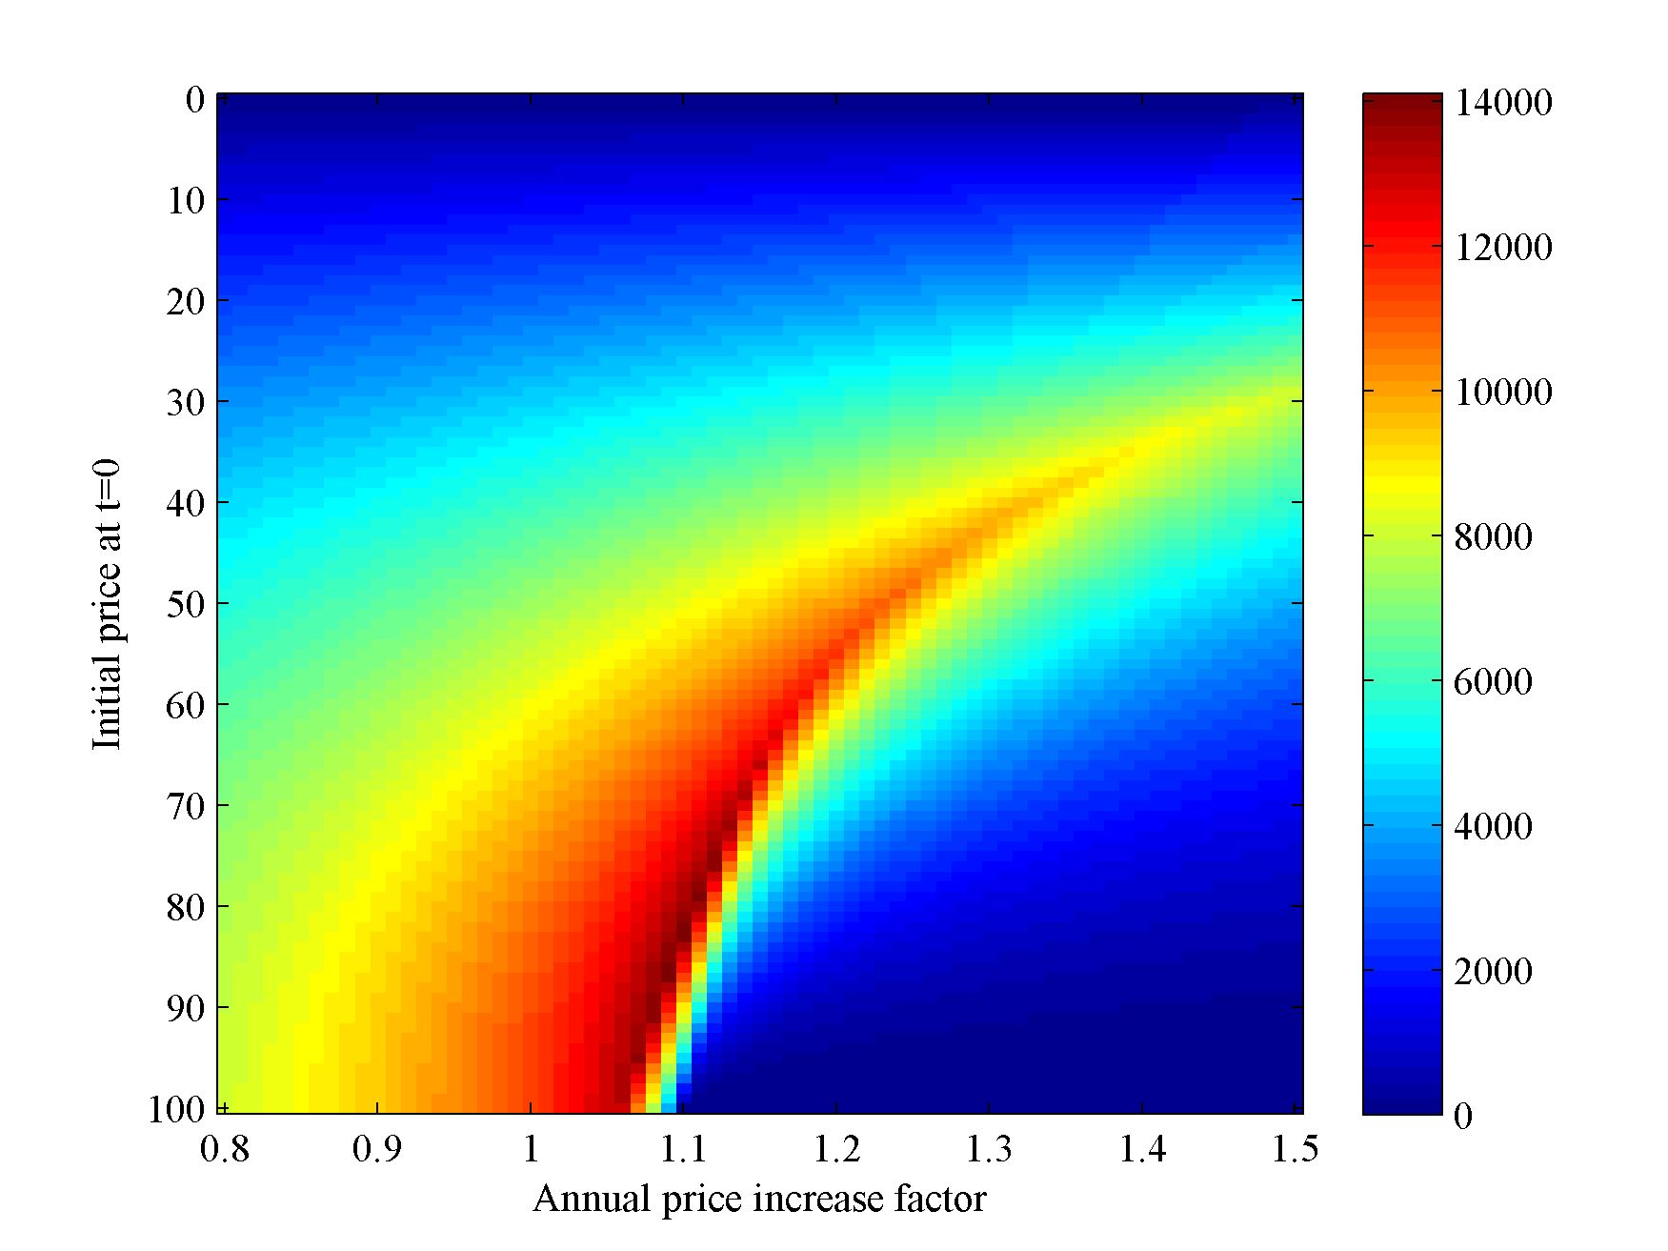
The optimal pricing strategy is 83±1 initial price and 10±1% annual increase. This also agrees with the Hotelling rule.

Modification 1+2: Apply both
Out of curiosity, let’s check what happens when both modifications are active.
$$Q_{t}=\max\left\{\frac{100∙{\left( 1+d\right)}^{t}-\frac{P_{t}}{{\left(1+d\right)}^{t}}}{365}, 0\right\}$$
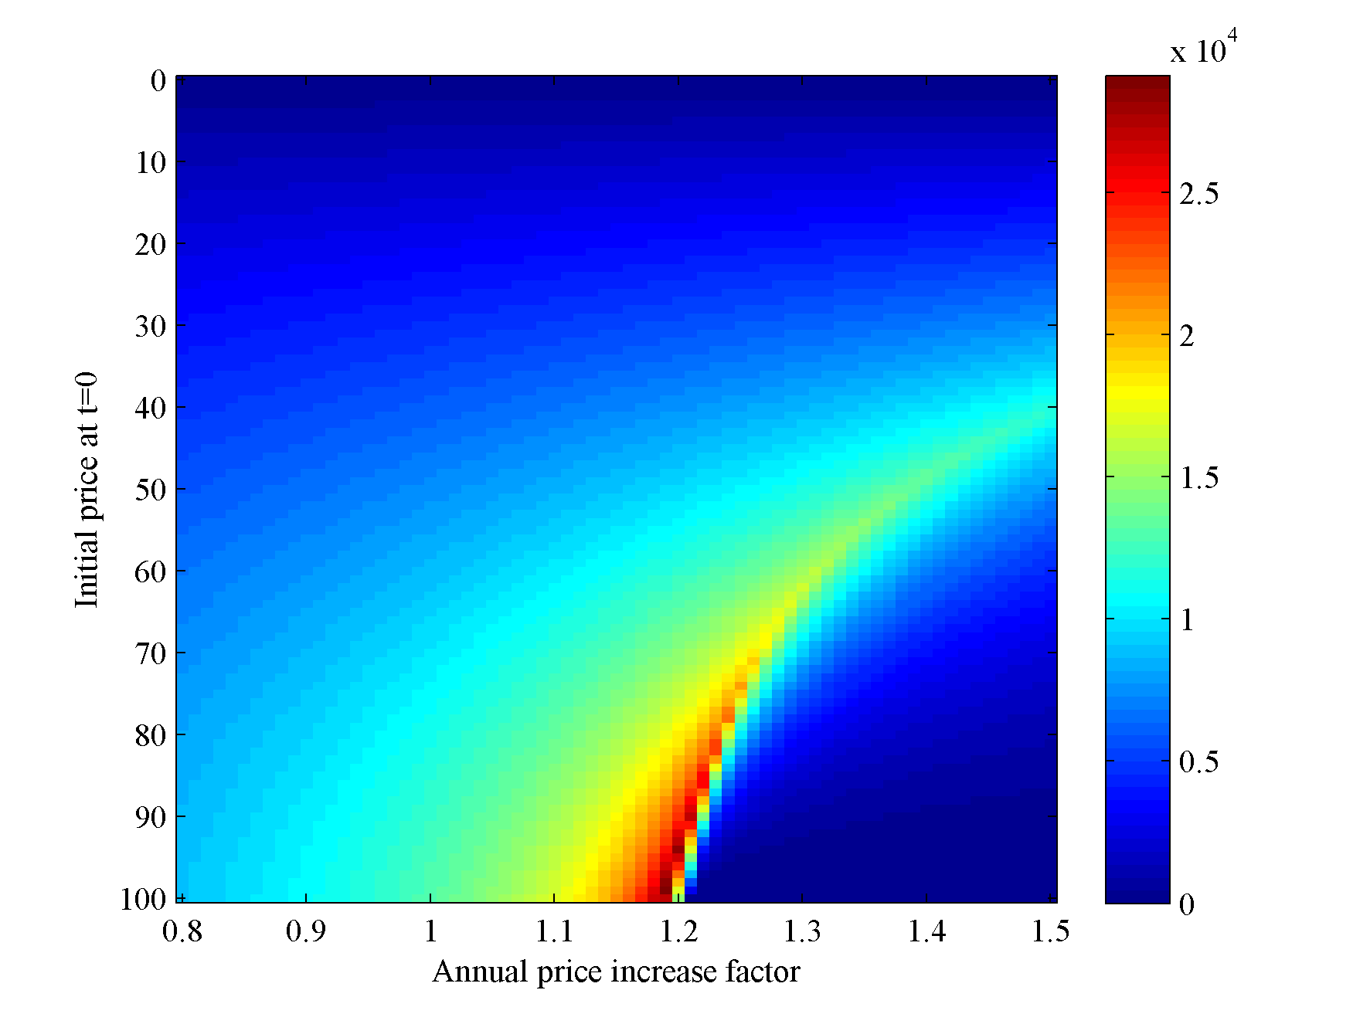
The optimal pricing strategy is 99±1 initial price and 19±1% annual increase. This is in conflict with the Hotelling rule.

Findings
Incorporating the interest rate to the demand function using either modification 1 or modification 2 makes the optimal pricing strategy agree with the one given by the Hotelling rule. However, both modifications should not be applied at the same time.

Conclusions
- The hypothesis is correct: the problem with the current demand function is that it does not incorporate the interest rate.
- Hotelling rule is not wrong. We are attempting to use the Hotelling rule outside its scope.

