URBAN CHALLENGE STUDIO 1: Urban Palimpsest - Discovering Vantaa
SITE DESCRIPTION
The project area of the Urban Challenge Studio 1 is located in the outskirts of the Helsinki Metropolitan Region (HMR) and approximately 15 km from the Helsinki City Centre.
The size of the area is 52 km² (4x13 km), consequently the project requires considerable work put into familiarizing yourselves with the surroundings. Getting acquainted and hopefully inspired by the area will help you in the planning process later in this semester. In order to get you started we created game-exercises to guide you in your first site-visits in the area. The aim of these two first weeks of Studio 1 is to get you familiar with the site and with one another since you will be working together during the next three months. These first exercises of semester long course are accompanied by instructions and inspiration from the Seppo gaming environment.
Note: If you have not yet arrived in Finland and therefore not able to visit the project area during the next two weeks, please find a comparable location from the surroundings of a big city you currently have access to and contact Michail Galanakis (michail.galanakis@aalto.fi) for additional info on the adjustments needed to complete these first three (3) exercises.
EXERCISES DURING SITE VISITS
In order to get a first impression of our large project area, each one of you is pre-assigned two (2) locations. Altogether on our area we have identified eight (8) locations of interest for the entire class to explore. Your aim of the site-visits will be to collect first-hand observations, which you will share, re-use, and reprocess in the class (via zoom). Any planning process is no more than what the participants bring to the table. Therefore, the most effective way to start the collection of raw data in by distributing and then softly nudging you on site via the Seppo gaming environment.
During your site-visits to the project area you will be collecting material for three (3) individual exercises. The sites you are visiting are not covering the entire area, but you have the possibility to revisit and collect additional information during the course. The deadline for the first introductory exercise (Ex. 1) is 17.09, while the deadline for the two other exercises (Ex. 2a & Ex. 2b) is 24.09. Take your time to get familiar with the new surroundings. We will go through all course related practicalities, course assessment criteria, and the overall Studio 1 working schedule, during our first joint teaching session on Friday, 18.09.
We expect that all exercises are conducted individually, but we encourage you to take the trip for the site-visits in small groups. Please, take precautions concerning COVID-19, even if the site-visits are outdoors. Ultimately, try to enjoy your first visit to our project area. You may use any mode of transport to access the locations (bicycles, public transport, private vehicles, or walking). Take with you a fully charged mobile devise, a recharger, and if handy a charged external battery, a notebook, pens, water, snacks, an umbrella, disinfectant, face masks, your good mood, etc.
Ex.1 ME, MYSELF AND I
PUT YOURSELF INTO RELATION WITH THE AREA AND MAKE A LANDSCAPE PORTRAIT OF YOURSELF. CHOOSE A TITLE FOR YOUR PORTRAIT AND WRITE A SHORT NARRATIVE
Topics: Knowledge - Synchronization - Awareness - Aesthetics - Composition - Duality - Integration - Memories - Feelings
Duration: ca. 20 min /// Format: Individual work /// Product: Landscape format photo to be uploaded on the student blog + max ½ A4 page narrative
How to: …ask a fellow student, or someone passing by to take an image of you… be precise with the setting of yourself in the surrounding… no selfie
Where: choose the place according to your personal reaction to this unknown area – it should be done during your one of your two Seppo exercise! …Replace the opening selfies of BOTH your Seppo trips with this “Me, Myself and I” exercise content. The image and narrative has to be added to Seppo latest by Thursday, 17.09.2020.
Presentation: during the Studio 1 class (zoom), Friday 18.09.2020, time t.b.a.
Ex.2a WALK THE SECTION
TELL A STORY OF YOUR PERSONAL READING OF THE SITE BY USING THE SECTION AS MEDIUM FOR COMMUNICATION! HIGHLIGHT THE HIDDEN LAYERS AND CONNECTIONS OF THE PLACE!
Topics: Scale - Dimension - Materials - Smell - Sound - Urban - Terrain Vague - Periphery - Landmarks – Geology
Duration: 30 min /// Format: Individual work /// Product: Collage of a section sketch with photos of material samples, descriptions of findings…including precise measures according to your own measurement system
How to: …collect the material on site, make sketches, take measures… arrange the material according to your interest/findings…produce the collage within the next two weeks
Where: Material collected during your Seppo exercise! THE AREA FOR EX. 2a, HAS TO BE DIFFERENT THAN THE ONE YOU CHOOSE FOR EX. 2b.
Presentation: during Studio I, Friday 25.09.2020, time t.b.a.
Ex.2b IT IS ALL ABOUT THE SOUND
OBSERVE THE SITE THROUGH THE MEDIUM OF SOUND AND HIGHLIGHT ONE OF THE LISTED TOPICS BELOW - OR COME UP WITH YOUR OWN TOPIC
Topics: Inhabitants - Infrastructure - Nature - Urban - Terrain Vague - Periphery – Materials
Duration: 30 min /// Format: Individual work /// Product: 30 sec sound clip and locate each sound on a map
How to: …use your phone to record the sound… put the location of your sound on a map and write down the sound source…back at home/school use a sound software to compose the sound-files to a 30 sec sound clip. The sound clip, as well as the map indicating your sound sources will be discussed during the presentation. For fun, add a title and a short description for your project.
Where: Material collected during your Seppo exercise! THE AREA MUST BE DIFFERENT THAN THE ONE YOU CHOOSE FOR EXERCISE 2a.
Presentation: during Studio I, Friday 25.09.2020, time t.b.a.
ASSIGNED VISIT AREAS
You are all distributed in eight locations for a small trip in the surroundings of a starting point. Each trip contains a number of subtasks that you need to complete in order to continue. Some tasks require searching additional information. If you feel that you get stuck, just enter something-anything so that seppo allows you to continue. Then later on you are welcome to correct your answers. The tasks must be opened in their actual locations, but once opened you are able to return and correct your answers while you are elsewhere. The sub tasks are not graded separately, but we will refer to them in order to get a better sense of how well the narratives unfolded.
The site-visit in any single area is estimated to take roughly half a day, but it might be wise to divide the workload in two days. All sites are easy to access by bicycle and on foot, but you can also access them by any other means of transport. Just make sure you are safe, so if you ride a bicycle, wear a helmet, and if you use public transport wear a face mask.
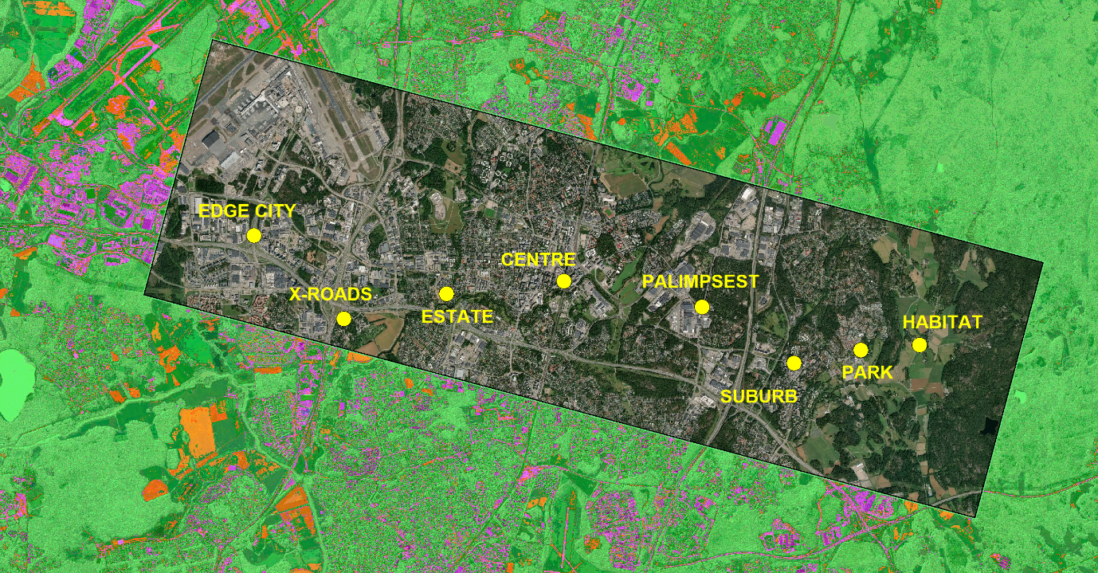
#1 HABITAT (Pin code: 71D25C) APPROXIMATE LOCATION: N 60.282382° E 25.139124°
Abdullayeva Yasmin, Anin Rahel Jossi, Matias Henrikki Vile, Mark Stomfai, Nella Elina Koivula, Hilja Léman,
Li Anna, Tina Cecilia Krause, Olli Elias Henrikki Erkkilä, Chong Xiao Ling, Amani Fard Faegheh
#2 PARK (Pin code: 287GF8) APPROX IMATE LOCATION: N 60.281766° E 25.123183°
Sara Rebecca Hurmerinta, Aino Emilia Vasankari, Moisander Anselmi, Zhang Huoying, Juuli Eveliina Koivumaa, Ulmanen Miisa, Sun Shenyu, Adam Saada, Tiia Maria Pirttimaa, Moona Tuulia Tikka, Kaija Kukka Laurila, Chen Yiqi
#3 SUBURBAN (Pin code: 58351D) APPROXIMATE LOCATION: N 60.279564° E 25.104955°
Emmi Anneli Kivistö, Vesa Jesper Edvard Tanner, Zhuang Huijia, Roslyn Palikhe, Emma Leen Ydiers, Maija Reetta Saali, Ella Elviira Paasilinna, Xu Meng, Quynh Lam Vo, Tukka Korpela
#4 PALIMPSEST (Pin code: 9D886C) APPROXIMATE LOCATION: N 60.289442° E 25.086385°
Li Anna, Tina Cecilia Krause, Olli Elias Henrikki Erkkilä, Chong Xiao Ling, Amani Fard Faegheh, Sara Rebecca Hurmerinta, Aino Emilia Vasankari, Moisander Anselmi, Zhang Huoying, Juuli Eveliina Koivumaa, Ulmanen Miisa
#5 CENTRE (Pin code: 534AA8) APPROXIMATE LOCATION: N 60.290961° E 25.042778°
Qiu Yanxia, Sanna Maria Rautio, Iina Mari Mäkilä, Ekka Michael, Turka Alje Louekari, Keeve Nuria, Tuulikki Hanna-Maria Peltomäki, Riccardo Costa, Tommi Petteri Toikkanen, Liisi Tiina Kaarina Matilainen
#6 ESTATE (Pin code: GF7CA2) APPROXIMATE LOCATION: N 60.289987° E 25.007908°
Sun Shenyu, Adam Saada, Tiia Maria Pirttimaa, Moona Tuulia Tikka, Kaija Kukka Laurila, Chen Yiqi, Emmi Anneli Kivistö, Vesa Jesper Edvard Tanner, Zhuang Huijia, Roslyn Palikhe, Emma Leen Ydiers
#7 X-ROADS (Pin code: 32A762) APPROXIMATE LOCATION: N 60.285788° E 24.983057°
Maija Reetta Saali, Ella Elviira Paasilinna, Xu Meng, Quynh Lam Vo, Tukka Korpela, Qiu Yanxia, Sanna Maria Rautio, Iina Mari Mäkilä, Ekka Michael, Turka Alje Louekari
#8 EDGE CITY (Pin code: 1D1F52) APPROXIMATE LOCATION: N 60.305569° E 24.959582°
Keeve Nuria, Tuulikki Hanna-Maria Peltomäki, Riccardo Costa, Tommi Petteri Toikkanen, Liisi Tiina Kaarina Matilainen, Abdullayeva Yasmin, Anin Rahel Jossi, Matias Henrikki Vile, Mark Stomfai, Nella Elina Koivula, Hilja Léman

ONLINE MAP RESOURCES FOR FURTHER EXPLORATION
https://kartta.vantaa.fi/?setlanguage=en
https://www.maanmittauslaitos.fi/en/e-services/old-printed-maps
https://www.maanmittauslaitos.fi/maastotiedonyllapito (In Finnish)
http://digi.narc.fi/digi/dosearch.ka?sartun=137171.KA
http://www.rky.fi/read/asp/r_kohde_list.aspx (In Finnish)
* the highlighted link is particularly important because it leads to a comprehensive archive of old and new maps and all the documents related to Vantaa including areas of interest for Studio 1. Therefore, it is advisable to explore this link and identify relevant maps before you start your site-visits.

