ELEC-E9210: EXAM (25 points) - 22.10.2020
(to be submitted before 10.30AM on MyCourses)

QUESTION 1: Optical Excitation in Organic Materials (3 points)

Indicate the main mechanism for optical excitation and the mechanisms for radiative decay, providing some key information (0.5 point/mechanism, 0.5 point/description)

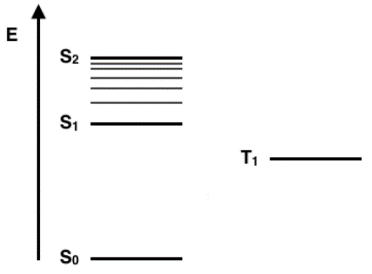

QUESTION 2: Organic Field Effect Transistors (8 points):

- Field-effect mobility of organic semiconductor depends on: (0.5 point/each, max 2 points)

- Two OFETs with the same structure (including substrate, organic materials and dielectric), differs only for electrode geometry (OFET1: L₁=25µm, W₁=1000µm and OFET2: L₂=50µm, W₂=5000µm). Which of the following applies?

- Saturation regime (1 points): □${ I}_{sat,1}> I_{sat,2}$
□ ${ I}_{sat,1}= I_{sat,2}$
□ ${ I}_{sat,1}< I_{sat,2}$

motivate your answer (1 points):

- Threshold Voltage (1 points): □ ${ V}_{th,1}> V_{th,2}$
□ ${ V}_{th,1}= V_{th,2}$
□ ${ V}_{th,1}< V_{th,2}$

motivate your answer (1 points):

- What is the difference between horizontal (classical) and vertical organic field-effect transistor? Briefly comments on properties and differences (2 points)

- QUESTION 3: OLED efficiency (2 points)
Consider the energy diagram below for 3L OLED devices. Anode, cathode and emissive layer are the same. Based only on energetics, which HTL/EML combination is expected to lead to a more efficient device? Briefly explain why? (0.5point/answer, 1.5points for explanation)

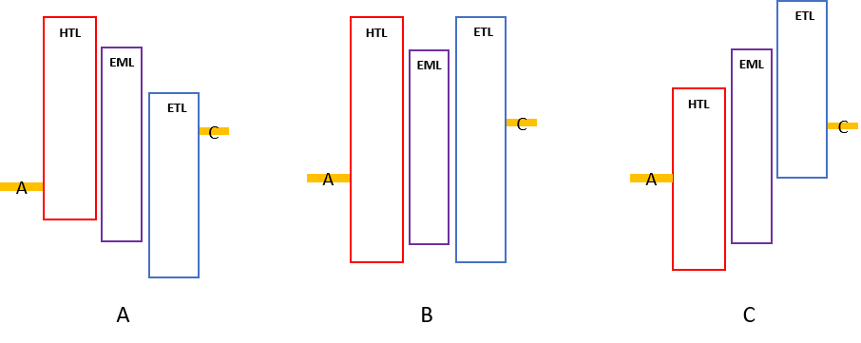

- QUESTION 4: Host-Guest system in emissive layer (5 points)

- Briefly explain the difference between charge transfer and energy transfer mechanism. Where does the exciton form? (2 points)

host | HOMO  (eV) | LUMO  (eV)
BCP | -6.5 | -2.8
m-CP | -5.7 | -2.3
Alq₃ | -5.9 | -3.1
guest | HOMO  (eV) | LUMO  (eV)
Ir(ppy)₃ | -5.6 | -3
Ir(piq)₂acac | -5.2 | -3.2
FIrpic | -5.8 | -2.9

- Based on materials HOMO-LUMO levels, for each host material determine a compatible guest(s). Briefly explain why (3 points)

COMBINATIONS
 | BCP | m-CP | Alq₃
Ir(ppy)₃
Ir(piq)₂acac
FIrpic

- QUESTION 5: Organic Light Emitting Devices: Diode vs. Transistor (3 points)

Briefly comments on the properties and differences between OLETs and OLEDs:

 | OLET | OLED
electrode(s)
what is the main charge transport mechanism
where is light emission located?

- QUESTION 6: Organic Photovoltaics (4 points):

- Describe the photovoltaic effect in terms of exciton dynamics (2 points)

- Briefly describe parameter/figure of merit of organic solar cell. Give a brief comment on why it is important in OPV (max 2 points)

