Cohesion

Quick grammar check

In Friday’s class, the students solved a rather complex problem.

Task 1

Version A |  | Version B
¹The application of science to the creation of useful devices to meet the needs of society is called mechanical engineering. ²The design, manufacture, operation and maintenance of a wide variety of machinery are the focus of a mechanical engineer’s work. ³Jet engines and minute instruments for use in medicine are amongst the products designed by mechanical engineers. ⁴Engineering drawings of the devices which are to be produced are created by mechanical engineers. ⁵Manual work was the normal means of creating drawings before the late 20th century, but computer-aided design (CAD) programs have been used to create drawings and designs since the use of computers became widespread. ⁶Three-dimensional models can be used directly for manufacturing the devices thanks to modern CAD programs. |  | ¹Mechanical engineering is the application of science to the creation of useful devices to meet the needs of society. ²Mechanical engineers focus on the design, manufacture, operation and maintenance of a wide variety of machinery. ³The products of their work range from jet engines to minute instruments for use in medicine. ⁴Mechanical engineers usually create engineering drawings of the devices which are to be produced. ⁵Before the late 20th century, drawings were usually made manually, but the widespread use of computers has now enabled the creation of drawings and designs using computer-aided design (CAD) programs. ⁶Modern CAD programs allow engineers to produce three-dimensional models, which can be used directly in the manufacture of the devices depicted.

1. Place “Familiar” before “New” information
http://sana.tkk.fi/awe > Cohesion > Information Ordering > The "Given-New" principle
- Constant Topic
^{FAMILIAR} | ^{NEW} | ¹Compressed hydrogen tanks are made from a strong but lightweight material such as carbon fiber. ²Currently, these systems carry about 5,000 pounds per square inch of hydrogen, but the goal is 10,000 psi to improve vehicle range. ³For safety purposes, the tank must have a burst strength at least twice the pressure of the fuel. ⁴Thus, the tanks must be made from materials that are either very heavy or very expensive. ⁵These tanks are also quite large, creating packaging problems in the vehicles.
¹…hydrogen tanks are made from…

²…these systems carry…

³…the tank must have…

⁴… the tanks must be made from….

⁵These tanks are also quite large…
- Step-wise Topic
.¹Solid organic waste is fed into a coarse shredder and cut into pieces. ²The shredded pieces are more finely ground into a paste before being mixed with manure and bio-sludge. ³The mixture is transported to a primary mixing tank where it is undergoes a homogenization process. ⁴The homogenized biomass is pumped into two pasteurization tanks, where it is held at 70 °C for one hour to produce a bacteria-free slurry. |  | ⁵The pasteurized slurry enters a digester where it undergoes methane fermentation at 38 °C for 20-24 days. ⁶The fermentation process yields methane at concentrations as high as 60-70%. ⁷This biogas is recovered and used for generating power at the power generation facility, and the digested slurry is returned to the farmers as organic fertilizer.

¹waste …shredder and cut into pieces.

²The shredded pieces … mixed with manure and bio-sludge.

³The mixture … a homogenization process.

⁴The homogenized biomass … pasteurization tanks...

⁵The pasteurized slurry …methane fermentation...

⁶The fermentation process yields…

- Hypertopic
^{FAMILIAR} | ^{NEW} | ¹Proton exchange membrane (PEM) fuel cells face several challenges. ²Platinum catalysts are expensive and also subject to CO poisoning from hydrocarbon fuels. ³For this reason, catalyst improvements, non-precious metal catalysts and other alternatives are currently under intensive investigation. ⁴New membranes more resistant to chemical impurities are also being developed. ⁵Alternative storage methods, such as metal hydrides and carbon nanostructures, may address hydrogen storage limitations that have prevented fuel cell cars from achieving a typical driving range (300-400 miles/tank). ⁶Cold starts from frozen internal water are improving, though the DOE’s goal of cold starts at -20°C in 30 seconds or less has yet to be achieved.
¹… PEM fuel cells face several challenges.

²Platinum catalysts are expensive and....
³For this reason, catalyst improvements…

⁴New membranes more resistant to…

⁵… storage methods, such as...

⁶Cold starts from frozen internal water

Task 2

- ¹Schematics for electronic circuits are prepared by designers using Electronic Design Automation (EDA) tools called schematic capture tools or schematic entry tools. ²These tools go beyond simple drawing of devices and connections. ³Usually, they are integrated into the whole IC design flow and linked to other tools for verification and simulation of the circuit under design.

- ¹Fender is the American term for that part of an automobile, motorcycle or other vehicle body that frames a wheel well (i.e., the fender underside). ²The primary purpose of a fender is to prevent mud, rocks, and other road debris from being thrown into the air by the rotating tire. ³Because they are rigid and can be damaged by contact with the road surface, fenders typically include flexible mud flaps close to the ground where ground contact may occur. ⁴In British English, the fender is called the wing, which may also refer to either the front or rear bumper.

- ¹A corrective lens is a lens worn in front of the eye to treat optical defects of the eye, such as myopia, hyperopia, astigmatism, and presbyopia. ²Corrective lenses can be divided into three types: glasses, contact lenses, and intraocular lenses. ³Glasses or "spectacles" are worn on the face a short distance in front of the eyes. ⁴Contact lenses are worn directly on the surface of the eye. ⁵Intraocular lenses are surgically implanted most commonly after cataract removal.

- ¹Simulation is a powerful tool for understanding the dynamics of complex systems. ²A simulation involves the development of a model to represent a real system and the experimental manipulation of that model to gain an understanding of how the real system might behave under various circumstances. ³Models may be purely physical, such as a wind tunnel, or logical, as represented in a computer program. ⁴Building computer models of complex systems has allowed decision makers to develop an understanding of the performance of the systems over time.

2. Place “Light” before “Heavy” Noun Phrases
http://sana.tkk.fi/awe > Cohesion > Information Ordering > The "light-before-heavy" principle

English prefers sentences that contain a short subject, come quickly to the verb and then continue as long as needed. However, what is most undesirable are sentences that are "top-heavy". In other words, you should avoid overloading your reader by placing heavy elements at the beginning of the sentence. Instead, English prefers "heavy-bottomed" sentences —those that place most of the information at the end of the sentence after the verb. Remember, English is a Subject-Verb-Object language!
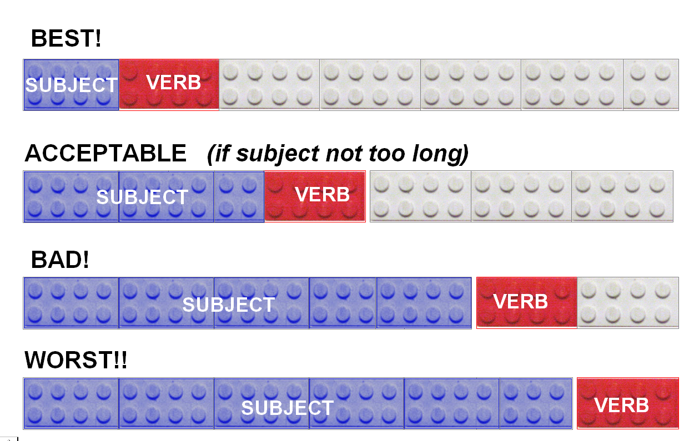
Ending clauses and sentences with a verb creates "top-heavy" sentences that seem badly imbalanced. Instead, good writers try to place the verb as soon as possible after the subject of the sentence. This can clearly be seen in the example below. There is such a strong need to avoid placing the verb at the end that native speakers feel compelled to place a noun phrase (e.g., The environmental effects of … warming) after the verb in order to create a sentence that feels more "balanced". There are numerous strategies that you can use as a writer to help balance your sentences. The next page lists some of the most common.
The effects of increasing atmospheric carbon dioxide and methane levels on the global warming were analyzed.

The effects of increasing atmospheric carbon dioxide and methane levels on the global warming are analyzed in this paper.
This paper analyzes the effects of increasing atmospheric carbon dioxide and methane levels on the global warming.

Strategies for Re-ordering Information
These are some strategies which may be useful if your sentences are top-heavy or end with a verb.
- Passive-Active Alternation
Engineers need good English language skills. [active]
Good language skills are needed by engineers. [passive]
- Equative Shift
One form of pollution that has received much attention IS air pollution.
Air pollution IS one form of pollution that has received much attention.
- Animate-Inanimate Shift
In this report, systems that use speech recognition are described.
Ø This report describes systems that use speech recognition.
- Personal-Impersonal Shift
In this report, systems that use speech recognition are described.
In this report, we describe systems that use speech recognition.
- Means-Purpose Shift
The humidity ratio was calculated (by) using Equation 8.

Equation 8 was used to calculate the humidity ratio.
- Introductory “It” (dummy subject)
Adding heat and raising the temperature of the gas would be necessary.
It would be necessary to heat and raise the temperature of the gas.
- Existential “There” (dummy subject)
A processor overhead associated with reconfiguration is available.
There is a processor overhead (that is) associated with reconfiguration.

- Resultative non-finite clause (so that ---> thus + -ing)
The laser light forms an EM field, so that the vibration of the atoms is slowed.
The laser light forms an EM field, thus slowing the vibration of the atoms.

- Purpose clause (so that ---> to infinitive)
The algorithm selectively clones a procedure, so that the code can be optimized.
The algorithm selectively clones a procedure to optimize the code.
- Split relative clause (that / which)
An algorithm that can facilitate fast image browsing is proposed.
An algorithm is proposed that can facilitate fast image browsing.
- Nominalization (verb ---> noun)
Health experts fear that technology addiction will increase. [increase = verb]
Health experts fear an increase in technology addiction. [increase = noun]

- When / before / after + -ing
Economical feasibility is an important factor when a PMR solution is selected.
Economical feasibility is an important factor when selecting a PMR solution.
- Reorder clauses
Various algorithms to generate testing automata have been developed.
Various algorithms have been developed to generate testing automata.
- Find a default subject (e.g., this thesis, this work, research)
Many gesture measuring devices for computer input have been devised.
Many researchers have devised gesture measuring devices for computer input.

