- A Doppler-radar based intrusion detection system (“a burglar alarm”) is measuring a single sinusoidal voltage that varies between –15 and +15 V. And the frequency is between 5 and 100 Hz. The measured waveform is displayed on a screen for supervision purposes.

Match the External Interface Requirements (EIR) for this particular input (see Section 5.1.2 of the textbook) with a coherent description. The answers might contain additional specifications to illustrate the necessary data for your requirements.

EIR

- Name of the item

- Description of purpose

- Source of input

- Valid range

- Accuracy

- Units of measure

- Timing

- Relationships to other inputs

- Relationship to outputs

- Data format

Description

The A/D-converted samples are 16-bit unsigned integers; –15.1 V = 0000 (hex), 0 V = 7FFF (hex), +15.1 V = FFFF (hex); 1 bit corresponds to 0.46 mV
Measures Doppler waveforms for supervision purposes
The measurement accuracy must be better than +/– 10 mV
The maximum voltage from the intrusion detector is +15 V and the minimum –15 V; to avoid saturation, the voltage range shall be –15.1 V … +15.1 V
The buffered Doppler output of a radar-based intrusion detector
None
The sampling period is 0.25 ms; its punctuality is better than +/– 0.01 ms
Volts
Measured samples shall be available as outputs for the screen_driver no more than 0.1 ms after each sampling moment
doppler_input

- Below, an image illustrates the life-cycle of real-time software. On the right side of the pyramid, you can find the approximate value of fixing an error in relative units, referenced to the first stage “Requirement time”.

Assume that your External Interface Requirements of problem A contained a critical and non-trivial error, and you noticed and corrected it during the Requirement Time stage. This took only one person hours of your team’s time.

Instead, in a different scenario, considering the error finding during the Acceptance Test, its fixing cost would be approximately 25 – 50 person hours according to the pyramid. Using your intuition, write a list of specific tasks in the table below of up to 11 actions that would require the team to make the corrections effective. Each specific task has a costs in person hour (ph), please estimate the approximate value in ph for each task and verify the total.

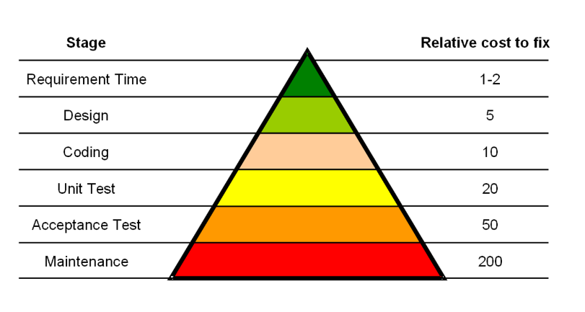

Q | Specific task | Person hour (ph)
1
2
3
4
5
6
7
8
9
10
11
12 | Total

