WAT-E2130 EXAM 2 Process control May 28, 2021
Student name:
Student number:

- Explain the following control configurations (4p):

  - Feedback control.
  - Feedforward control.
  - Cascade control.
Provide some practical examples of application in wastewater treatment plants, highlighting the pros and cons of each configuration.

- Consider a feedback control system set in manual mode and Figure 1 which provides the process reaction curve (upper plot) resulting from a step-function change in the manipulated variable (lower plot). Based on Figure 1, define and compute the parameters of process model in the form of $G\left(s\right)= \frac{Ke^{-αs}}{τs+1}$ .

What is the meaning of $K, α$ and $τ$? How can the model $G\left(s\right)$ be used for tuning a PID controller?
(6p).

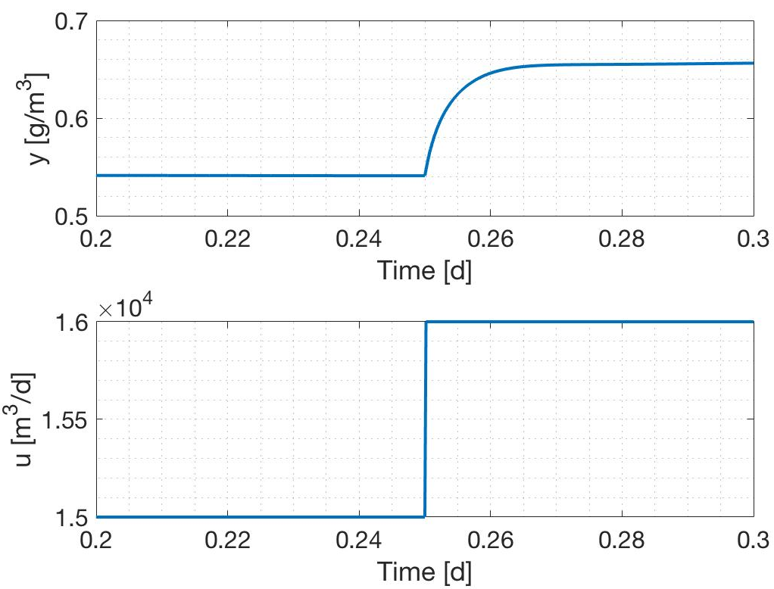
Figure 1. Process reaction curve for question 2.

- For controlling the plant schematically represented in Figure 2 you have the possibility of acquiring ONE suspended solid sensor. Answer to the following (6p.)
  - Given the available instrumentation, formulate and discuss a possible control configuration for the plant (that is, locate your sensor in the plant and a possible manipulated variable).
  - Define and justify reasonable values for the set-point of the controlled variable.
  - Discuss the how your control strategy could affect plant performances.
  - Suggest a commercial sensor to be acquired, their measuring principl es and highlight possible problems that you might encounter during their life time.
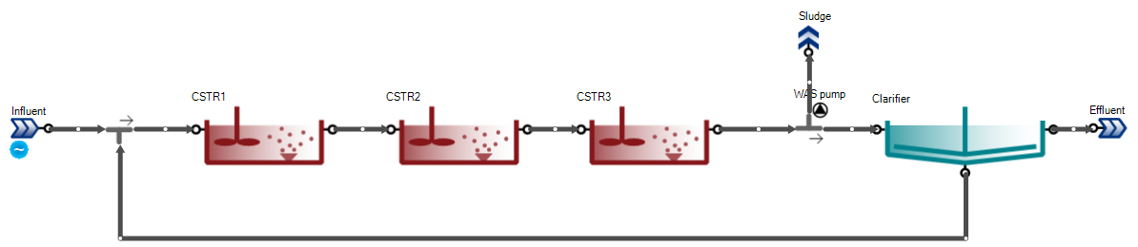
Figure 2. Plant layout for question 3.

- Figure 2 shows a cascade controller representation in SUMO where the dissolved oxygen setpoint controller targets the effluent ammonia concentration to a setpoint. Do the following (4p):
  - Represent the system as block diagram identifying the upper- and lower-level control loops, as well as the input/output to/from each block.
  - What benefit you expect from the cascade control configuration in Figure 2 with respect to a single dissolved oxygen controller in the plant?

