- AI automates repetitive learning and discovery through data. But AI is different from hardware-driven, robotic automation. Instead of automating manual tasks, AI performs frequent, high-volume, computerized tasks reliably and without fatigue. For this type of automation, human inquiry is still essential to set up the system and ask the right questions. Usually AI requires computational resources that might turn it too expensive for certain applications. AI as a service is an application paradigm that might bring the benefits from AI to simple computing devices (i.e. machine learning), which usually control and monitor certain low level hardware. In this paradigm, simple edge devices collect data, then through a network connection sends it for analysis to a remote powerful device and gets the specific answers about the data contents, as identification, recognition or just control commands.
Google cloud provides an easy example about how to use AI as a service, through an API (Application Programming Interface), in practice, you can request Google to identify what is the context of a picture, just to understand the idea of AI as a service.
Please, access the trial version of the Vision API from google AI & machine learning available at:

https://cloud.google.com/vision/docs/drag-and-drop

Test the API using the following picture. You can find the picture’s jpg file attached in the activity description. Remember to check the box telling you are not a robot.

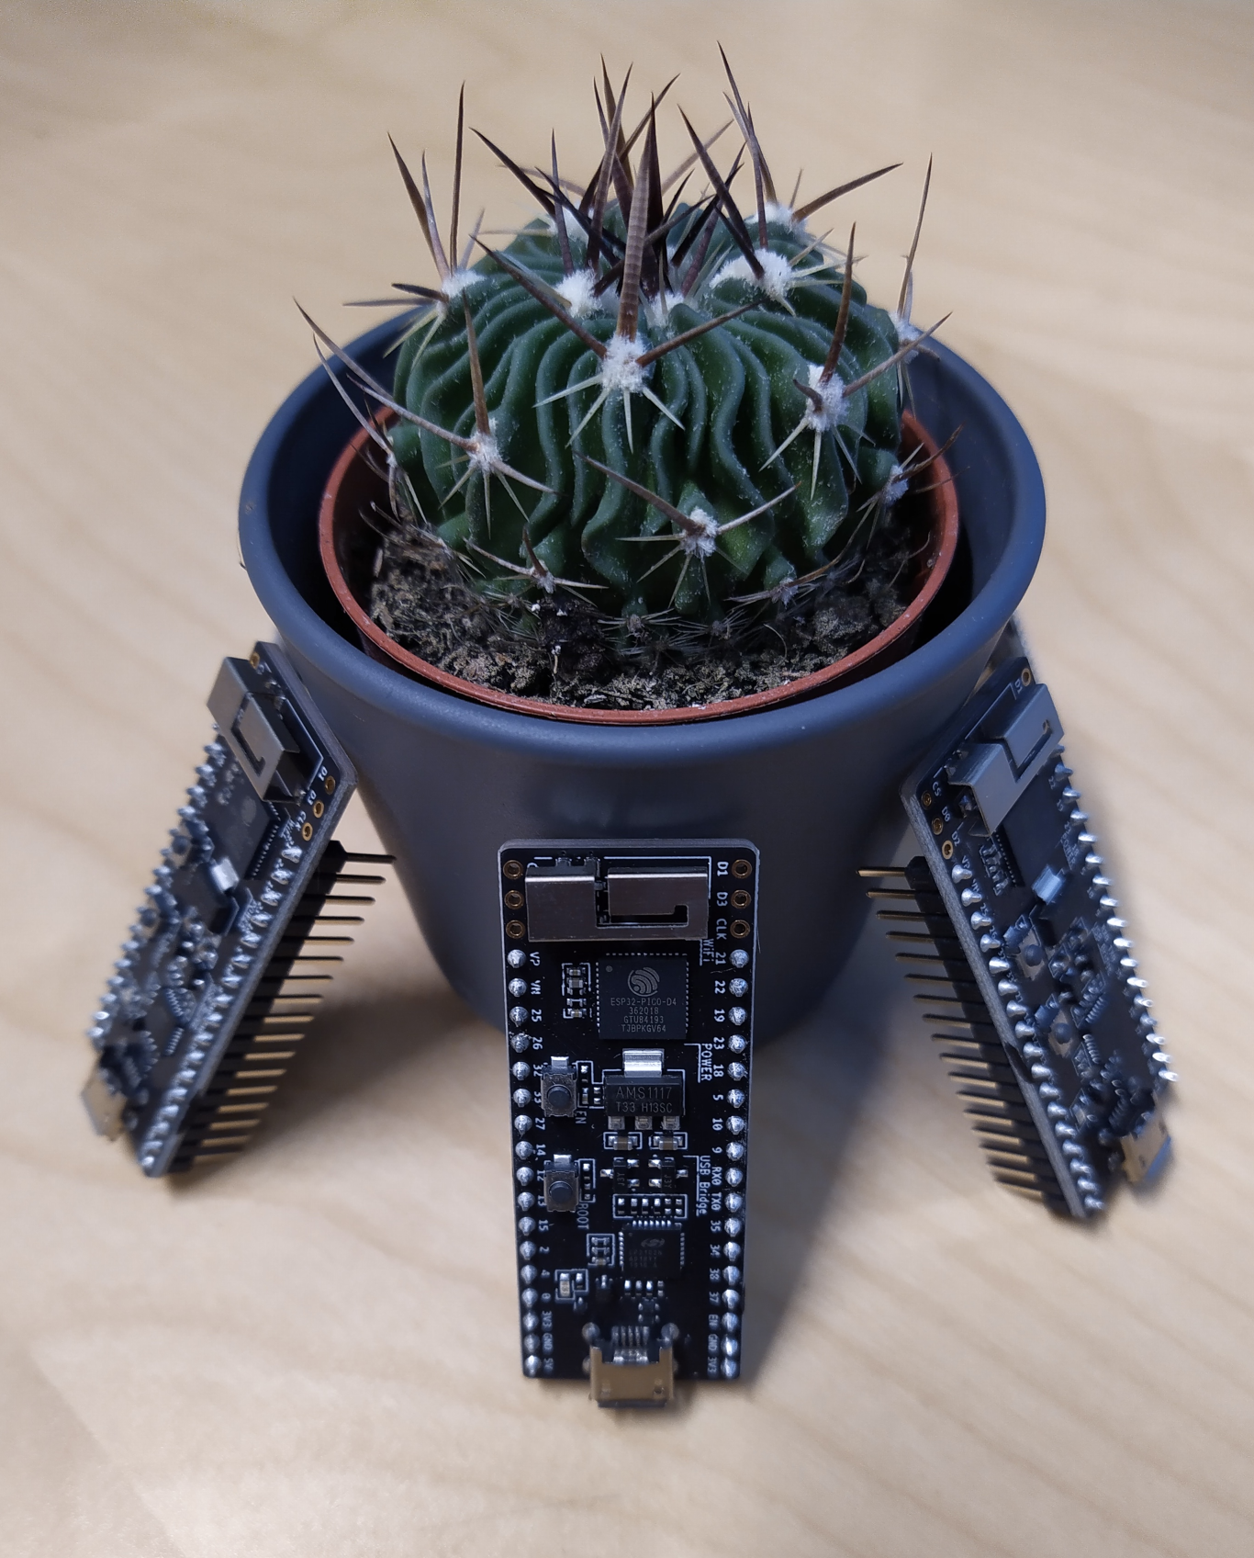
Please explore the labels produced by the API in JSON format (Show JSON option at the left lower corner of the picture). Check the Response text and find the "labelAnnotations" key, report (copy + paste) the JSON objects in the array for the labels on the following table. As an example, please find on the first label annotation the object for the label Plant.

Label Annotation (description) | JSON Object
Plant | {  "description": "Plant",  "mid": "/m/05s2s",  "score": 0.9552085,  "topicality": 0.9552085  }
Thorns, spines, and prickles
Automotive tire

- From the course material, Chapter 9 presents a forecast made of a selection of visions for the evolution and advancement of real-time systems. The material was published in 2011, but compiles ideas and references produced mainly in the 2000’s. The chapter introduction (pg 477-479) mentions certain aspects expected for 2020. Now in 2021 you are able to rate the prognoses and milestones from about 10 years ago. Please mark with a X if the prognose/milestone was correct or incorrect and provide a short explanation or evidence for your rate.

Prognose/milestone | Correct | Incorrect | Why?
“ Augmented reality will be much more mature and a familiar part of our lives. ”
“ Our interaction with machines will inevitably need to become more ‘ natural ’ through the dramatic increase in the use of indirect channels of communication — making machines sensitive to biometric data [and ges-tures] from which emotional and contextual information can be derived. ”
“ 10 Terabits of computer memory (roughly the equivalent of the memory space in a single human brain) will probably cost just $1000. ”
“ At the end of each day, I spend 20 minutes reviewing and annotating the downloads from my personal data chips that captured every conversation I had and every image I saw. ”
Distributed embedded control systems with multi - core processors and advanced networks available
Practical modeling methods from function specification to implementation.
Automatic verification methods for control software.
Collaboration among enterprises by model - based development methods

Adapted from https://www.sas.com/en_us/insights/analytics/what-is-artificial-intelligence.html

