Recording instructions for assignment C&C 1

This document includes instructions for making the video for assignment C&C 1 using either Zoom or Teams.

Zoom
Note: recording is only available in the Zoom Meetings app, not the browser version of Zoom. Recording is available for the meeting host, and the host can give the other meeting participants the permission to record (if allowed from the recording settings).

By default, meeting recordings are automatically saved to the computer of the person who was recording, after the meeting ends. The recordings will also be available at “Recordings” when you are logged in at aalto.zoom.us. You can also choose to save the recordings to the cloud and change other recording settings from “Settings” → “Recording” at aalto.zoom.us.

Making the recording:
- Start a Zoom meeting and launch it in the Zoom meetings app.
- When you are ready, start recording from the bottom toolbar:
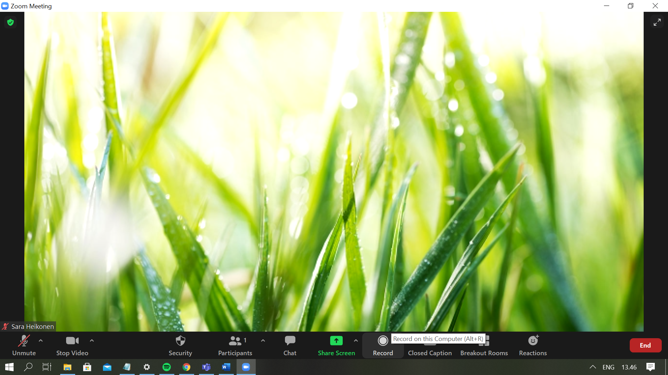

If you are screen sharing, the recording option can be found like this:
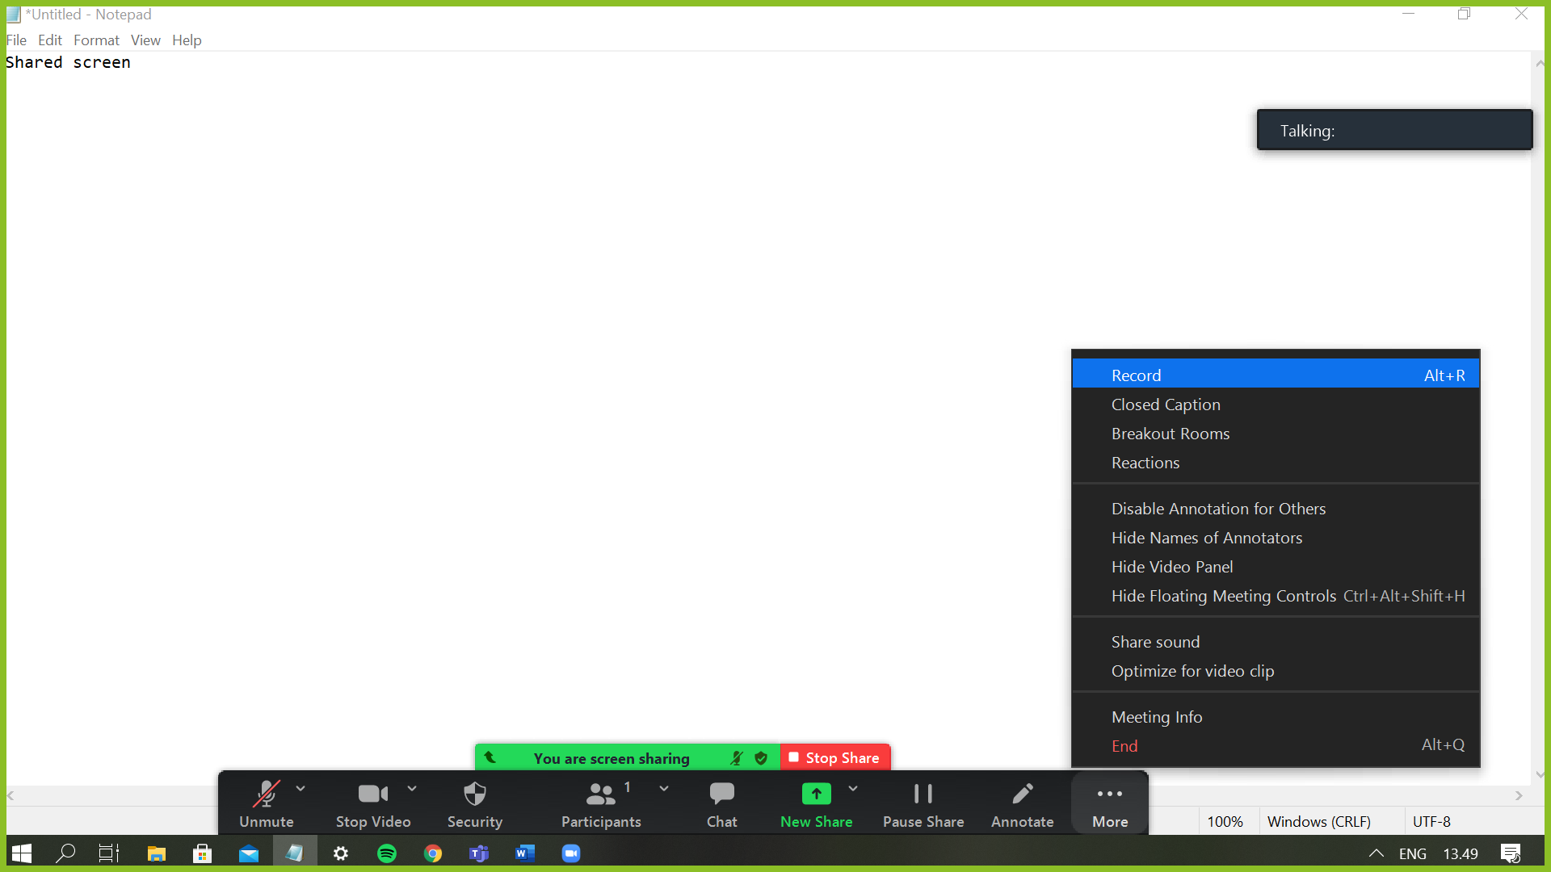

- You can pause, resume and stop recording from the same menu that you used when starting recording (the menus in the screen captures above, depending whether you are screen sharing or not).
- The recording is automatically saved to your computer or to the cloud after the meeting ends. There are two audio files and one video file (the .mp4 -file), and in this assignment we only need the video file.
- Open the video file and watch it to check that it works and there are no issues with the audio. If you still want to for example trim the video, use a video editing software of your choice.
- Submit the final mp4-file in MyCourses.

Teams
In Teams meetings, all participants can record by default. The recordings are automatically saved to SharePoint (channel meetings) or OneDrive (other meeting types) and can be shared further with a link.

Making the recording:
- Start a Teams meeting for example from your calendar in Teams.
- When you are ready, start recording from the toolbar at the top of the screen (regardless of whether you are screen sharing or not):
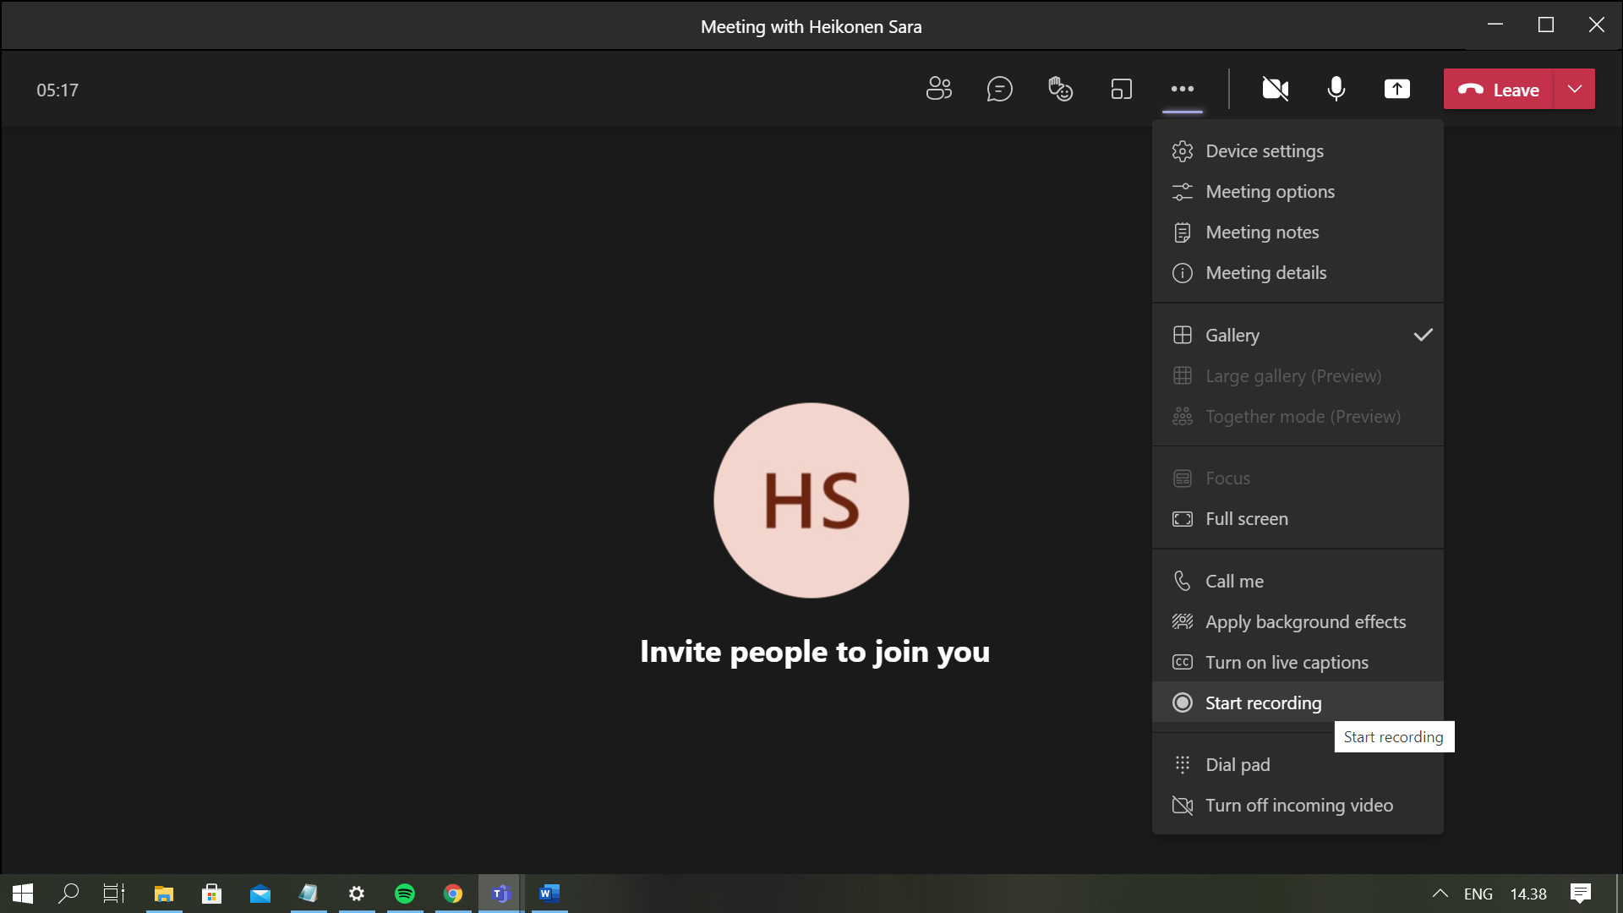

- You can stop the recording from the same menu that was used for starting recording.
- When recording is stopped, the recording is saved to SharePoint or OneDrive and it appears in the meeting chat or channel conversation as well.
- Click on the video to watch it and check that the audio etc. works. If everything is ok, you can get the share-link to the video from the video menu (three dots next to the video thumbnail, image below). The link is accepted as a submission for the assignment.
- You can also download the video (and make small edits to it) by opening it in Microsoft Stream (video menu, three dots next to the thumbnail), and submit the video file in MyCourses.

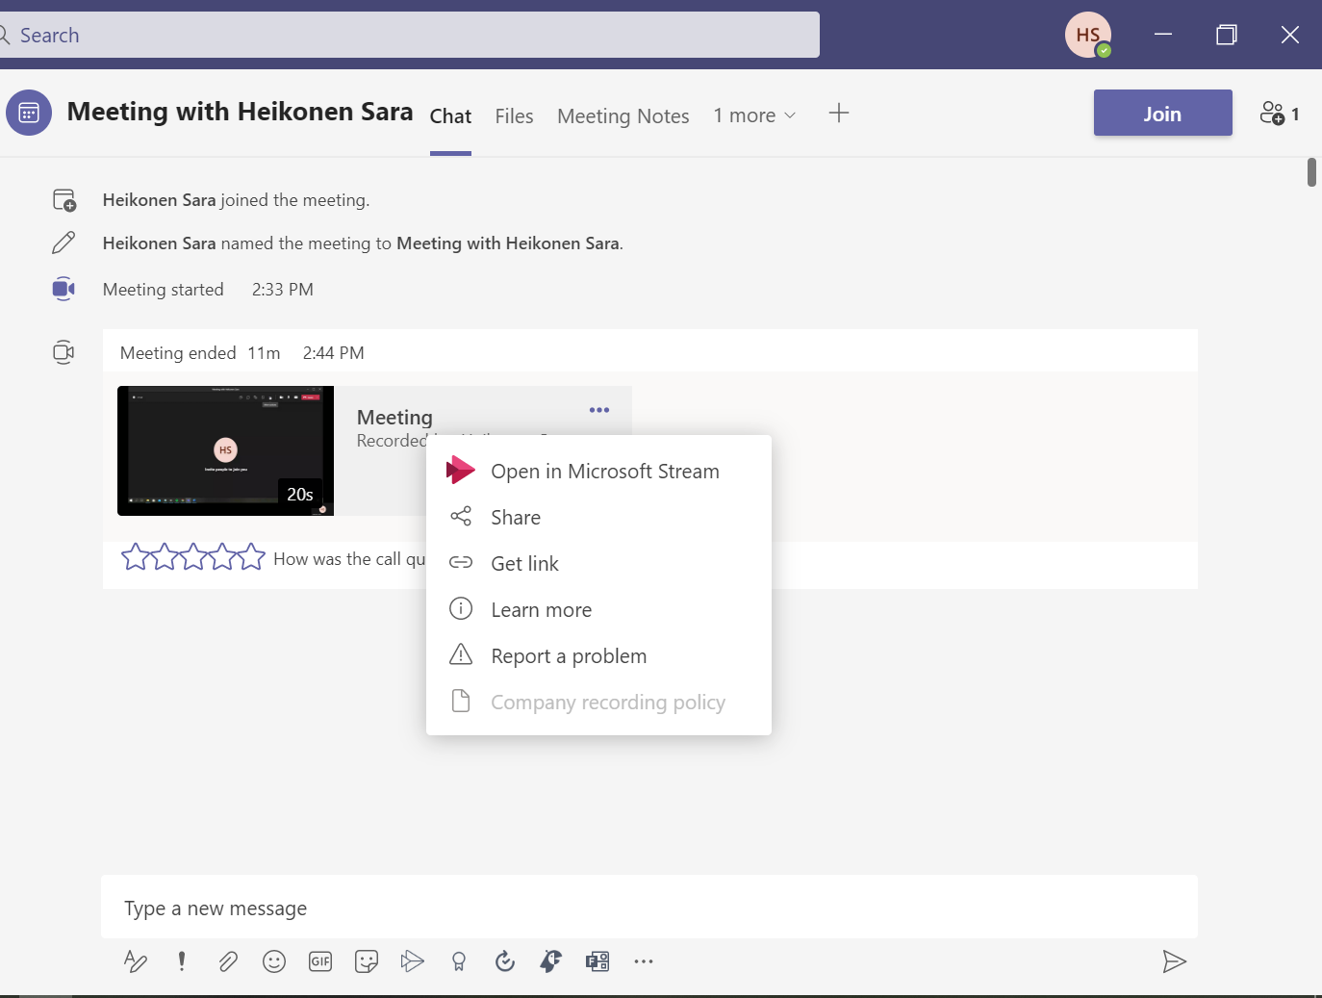

More information about recording Teams meetings here.

