Group-Assignment 4 (Bass model)

Marketing Analytics (Prof Kreuzbauer) 2021

Deadline: 31.5.2021, 13.00

Instructions

1. Apply the Bass-Model to E-bikes for a market of your choice (e.g. Finland, Europe, etc.)
2. Come up with a meaningful estimate for N(t), but note that surely not all bicycle owners will eventually change to e-bikes. Hence, you cannot use total number of bicycles as N(total). See Winston, page 434 for a possible method to estimate N(total).
3. Estimate p and q with past data (you can use the data from the graph below but you can also find other data)

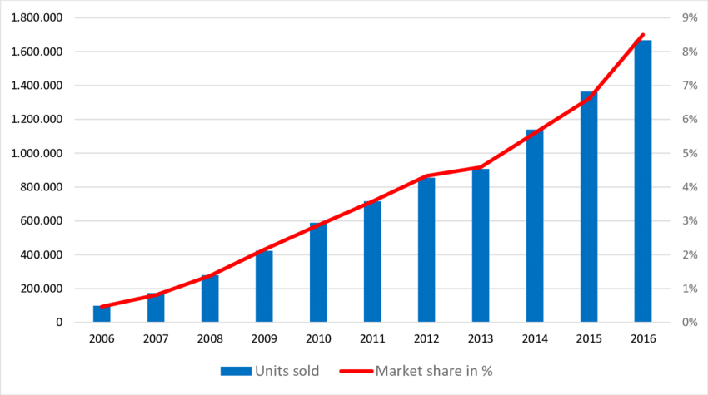

1. Compare your results with p and q from analogous products (the parameters for various products can be found through the internet)
2. Summarize your analysis in a max. 5-page report (12pt Arial, 1.5-line space, one additional cover-page must include full names from all group-members). Include relevant results from your analysis (data table, graphs) plus some notes to explain the rational and steps of your analysis.