Some Concepts of CA:

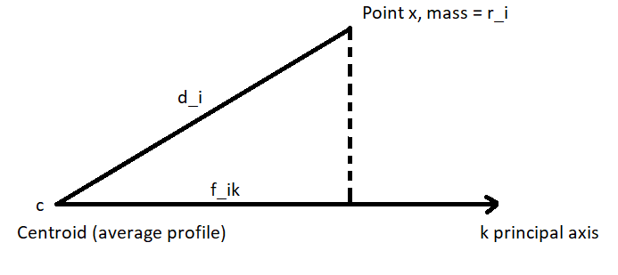
Total inertia of all points (Total variation) = $\sum_{i}{r_{i }}d_{i}^{2} = \sum_{i}{r_{i }} \sum_{k}{f_{ik}^{2}= \sum_{k}{λ_{k} } }$
Inertia is the weighted average of the squared χ2-distances between the row profiles and their average profile, where the weights are the row masses.
Inertia of point i = ${r_{i }d}_{i}^{2} = r_{i }\sum_{k}{f_{ik}^{2} }$
Inertia contribution of point i to k-axis= $r_{i }f_{ik}^{2}$
Contribution, ctr = $\frac{r_{i} f_{ik}^{2}}{λ_{k} }$
The contribution of the row along axis k.
Squared correlation, squared cosine, is $\frac{r_{i} f_{ik}^{2}}{r_{i} d_{i}^{2} }$ = $\frac{ f_{ik}^{2}}{ d_{i}^{2} }$
Squared correlation: the contribution of axis k to the corresponding inertia of point i.
Quality of representation: The sum of squared correlations for a point.

