COE-C2007 Themodynamics, 2022
Learning Exercise 3
The exercise is to be completed independently (do not copy paste from other students) and returned as a single pdf report with appropriate use of pictures and charts, as well as presentation of used equations in possible calculations. Name the uploaded pdf-file so that it tells the course, learning exercise number and your name, like Thermodynamics_LE3_Lastname.pdf
No single question/problem is compulsory, but a minimum of 50 % of points is required in order to pass the exercise. Include also your name and student number on the first page of the report. A proper length of an answer per question would be maximum 1 page. The time for answering this exercise is estimated not to exceed 8 hours, provided that you have attended lectures.
Return DL of LE3: Friday February 4, 2022, 23:55, in MyCourses.
- Steam enters an adiabatic turbine steadily at 7 MPa, 500°C, and 45 m/s and leaves at 100 kPa and 75 m/s. If the power output of the turbine is 5 MW and the isentropic efficiency is 77 percent, determine (a) the mass flow rate of steam through the turbine, (b) the temperature at the turbine exit, and (c) the rate of entropy generation during this process.? (20 Points)
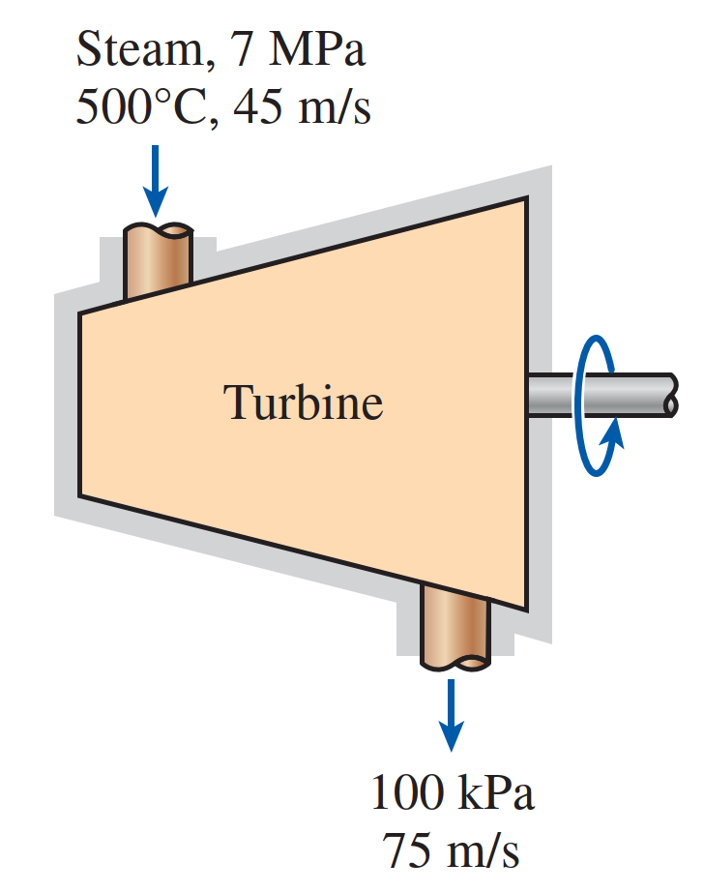
- A refrigerator with a coefficient of performance of 4 transfers heat from a cold region at –20°C to a hot region at 30°C. Calculate the total entropy change of the regions when 1 kJ of heat is transferred from the cold region. Is the second law satisfied? Will this refrigerator still satisfy the second law if its coefficient of performance is 6? (20 Points)
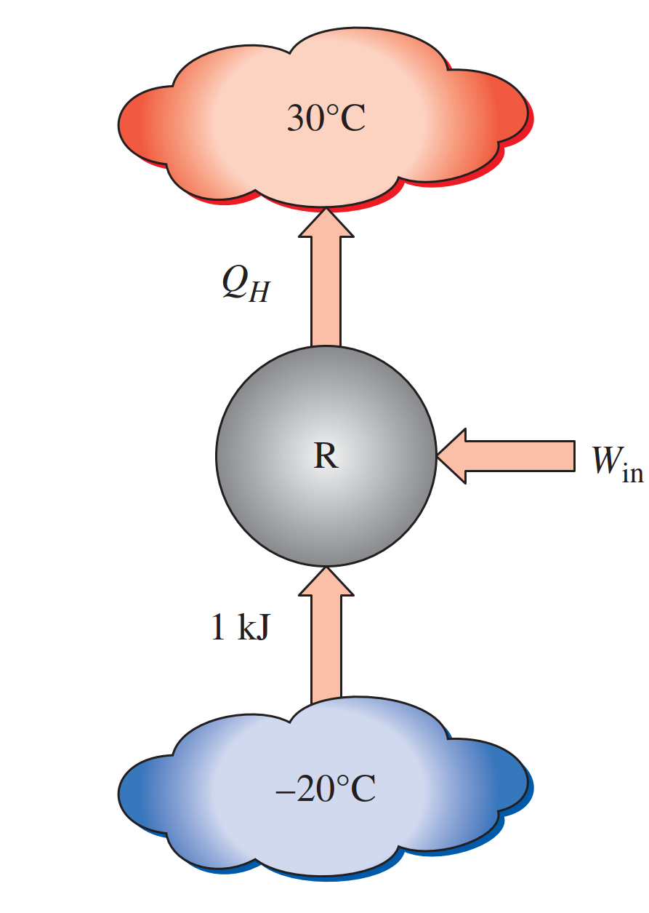
- One ton of liquid water at 80°C is brought into a well-insulated and well-sealed 4-m × 5-m × 7-m room initially at 22°C and 100 kPa. Assuming constant specific heats for both air and water at room temperature, determine (a) the final equilibrium temperature in the room and (b) the total entropy change during this process, in kJ/K. (20 Points)
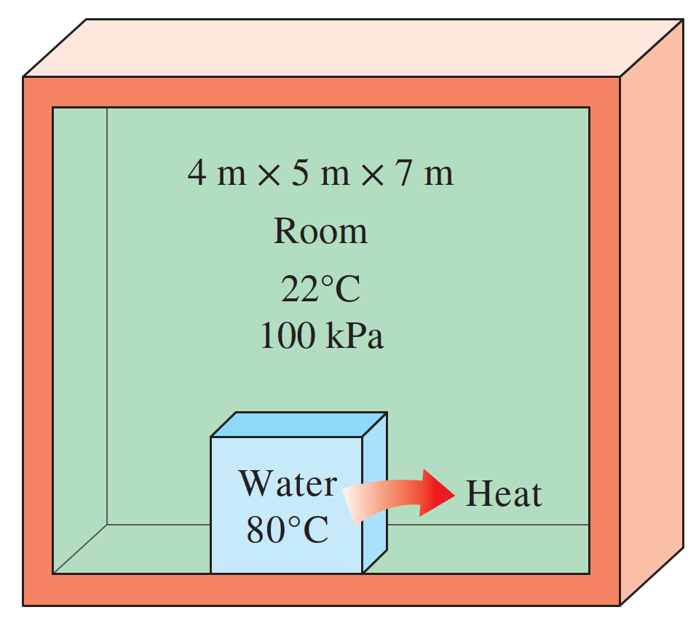
- The compression ratio of an ideal dual cycle is 14. Air is at 100 kPa and 300 K at the beginning of the compression process and at 2200 K at the end of the heat-addition process. Heat transfer to air takes place partly at constant volume and partly at constant pressure, and it amounts to 1520.4 kJ/kg. Assuming variable specific heats for air, determine (a) the fraction of heat transferred at constant volume and (b) the thermal efficiency of the cycle.
Comparing the thermal efficiency if varying the compression ratio from 12 to16 (12, 13, 14, 15, 16). (20 Points)

- A simple ideal Brayton cycle operates with air with minimum and maximum temperatures of 27°C and 727°C. It is designed so that the maximum cycle pressure is 2000 kPa and the minimum cycle pressure is 100 kPa. Determine the net work produced per unit mass of air each time this cycle is executed and the cycle’s thermal efficiency. Use constant specific heats at room temperature. (20 Points)
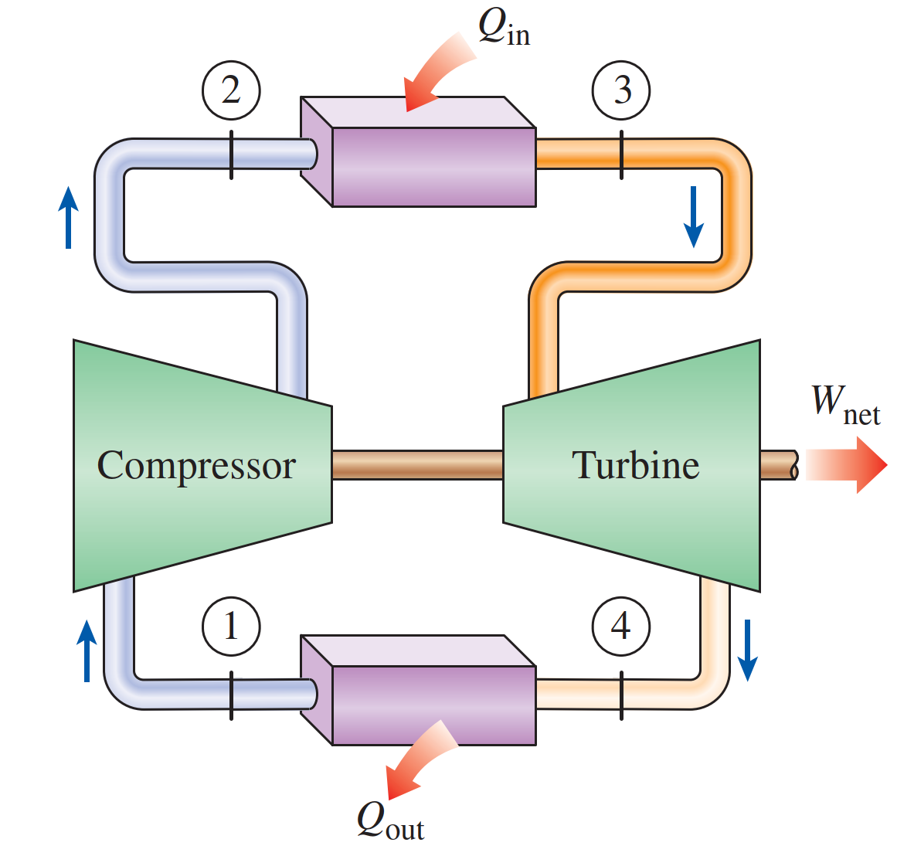
- Your free feedback on the third week and time spent on this learning exercise. (This does not affect the grading)

