Project 5
A Comparison Between 100 MW_{e} Wind Farm, Photovoltaic and Solar Dish Stirling Power Plants

Introduction
In recent years due to dwindling natural resources such as coal, crude oil and natural gas, renewable energy resources have been considered to supply the energy demand across the world. Renewable energy systems obtain their energy from renewable resources like wind, geothermal, sunlight, waves and tides. In Finland, both wind and biomass are attractive energy sources for producing electricity and heat. In contrast to other European countries, subsidies to use solar systems have not been implemented. The average daily solar radiation in Finland is nearly 900 kWh/m², and most of the radiation is found in the southern part of Finland. In this area, diffuse radiation is more than direct radiation (diffuse radiation is more effecting) [1]. Figure 1 shows a solar PV power plant in Finland.
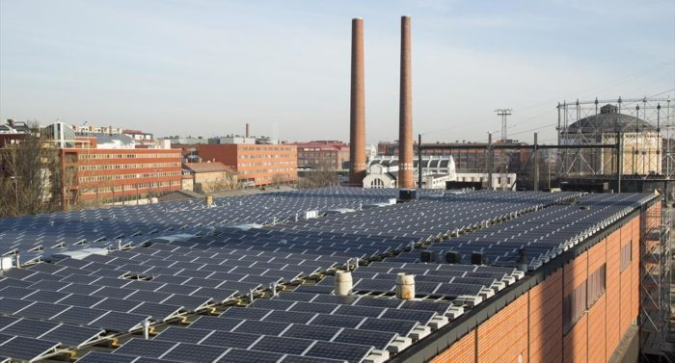
Figure 1 Solar PV system in Finland [2].
In Finland, wind power construction began later than in many other European countries. However, from 2012 to 2013, wind power construction has gained momentum and national construction and production statistics have been broken year after year. At the end of 2019, there were 754 installed wind turbine generators, with a combined capacity of 2284 MW. They generated 7 % of Finland’s electricity consumption in 2019. Figure 2 illustrates a wind power in Finland.
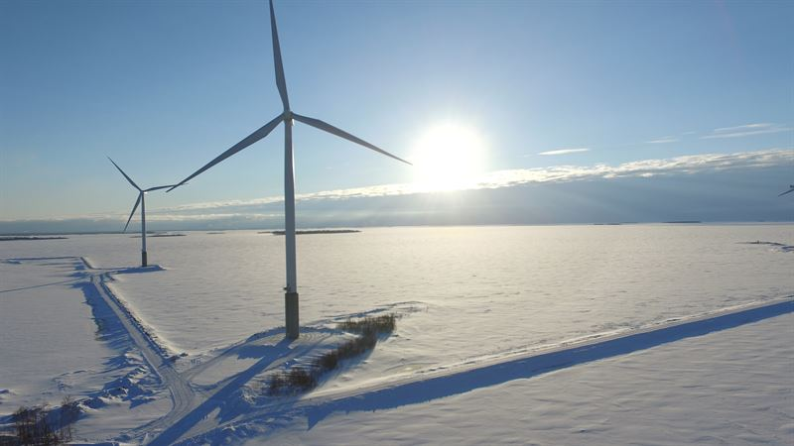
Figure 2 Wind power plant in Finland [3]
In addition to wind energy development, solar energy, also combined with external combustion engines, is strong candidate for transforming solar radiation into mechanical and electrical energy. The Stirling engine emerged in 1816 as an alternative to solve the serious accidents occurred with generation plants where was operated steam engines, for their ability to work with external combustion at low pressures. Among the main points that make the Stirling engine a viable alternative as a “clean” thermal engine are: low maintenance cost due to its mechanical simplicity; considerably high lifetime, close to 10 years; low levels of noise and pollutant emissions; ability to operate with the most diﬀerent types of heat source, including residual heat; high thermal eﬃciency at partial loads, around 30%; and the theoretical eﬃciency close to the Carnot eﬃciency due to its reversibilities. The real thermal performance of the Stirling engine cycle is lower than ideal eﬃciency due to the fact that problems such as heat transfer resistance, gas leaks and heat losses. A schematic of solar dish/Stirling presented in Figure 3.
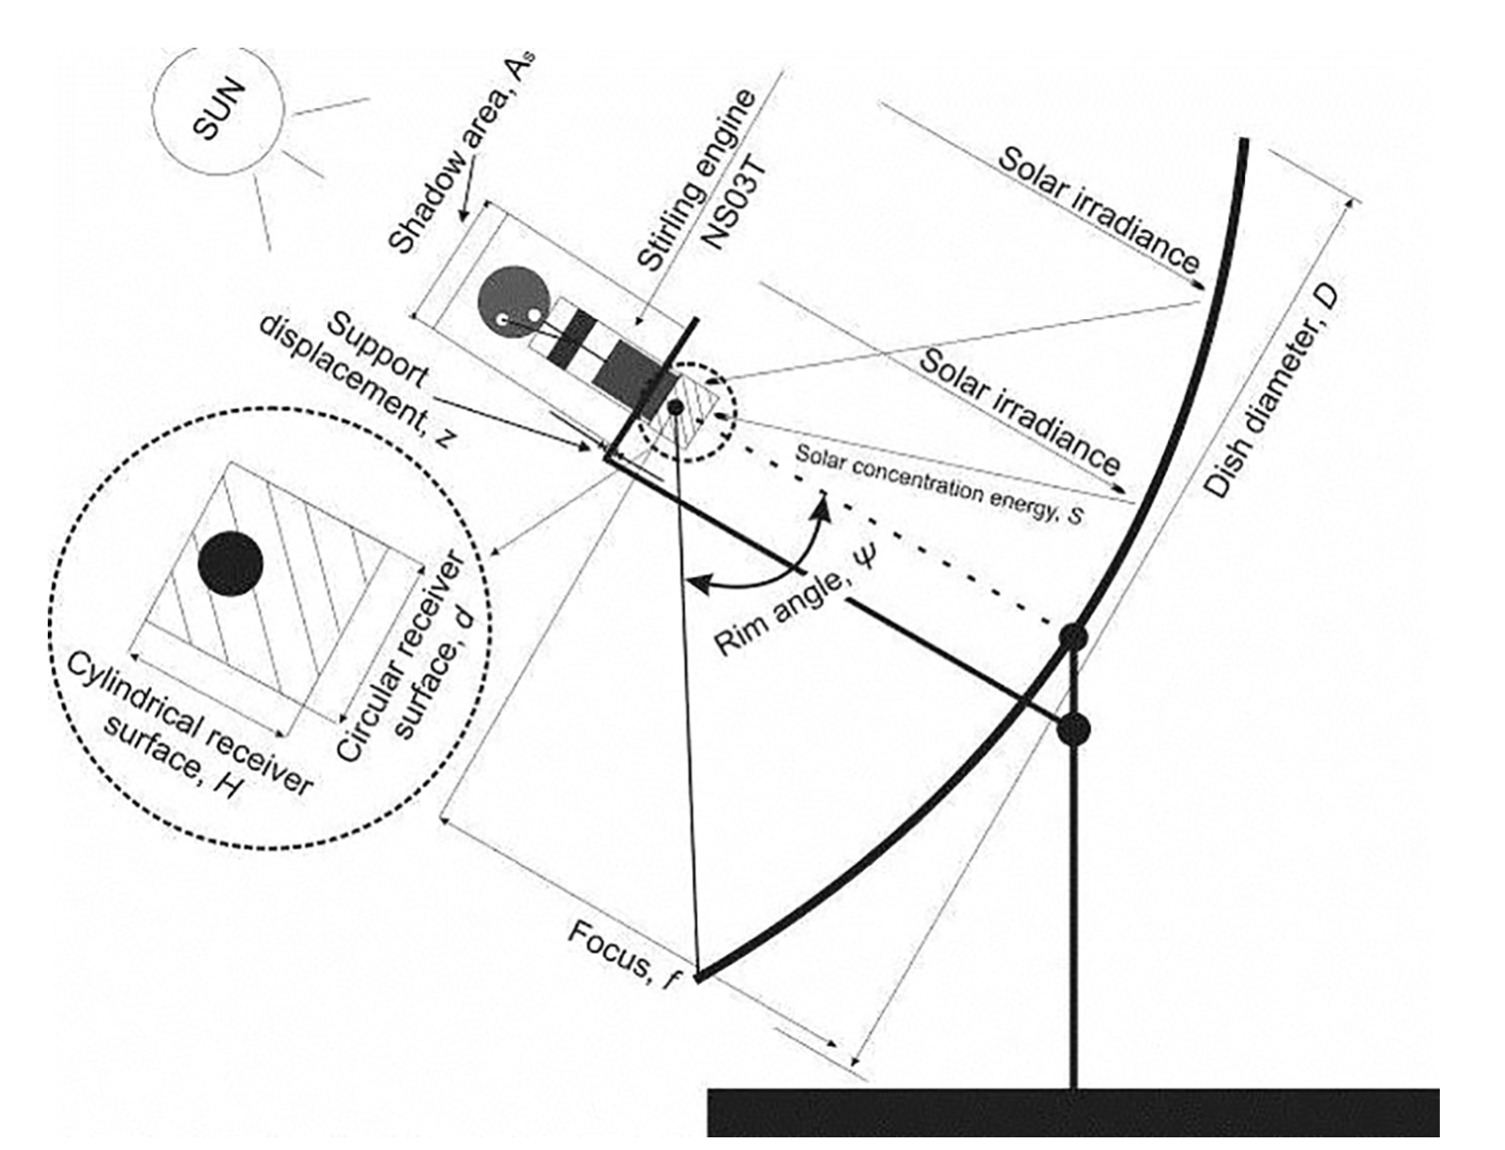
Figure 3 Solar dish/Stirling system.

Project Description
Case Study: Finland
Capacity of the power plants: 100 MW_{e}
Simulation Tools: SAM or Renewables ninja for PV and Wind

Project content
Project should be presented in the following form:
- Introduction (regarding energy source, technology and case study) (10 points)
- Case study (Plot: solar radiation, dry bulb temperature and wind speed for the case study region) (10 points)
- Material and methods (a short explanation about each power plant and simulation tool) (15 points)
- Results and discussion ((Summary of energy and economic analysis for each power plant (annual energy, capacity factor, LCOE (nominal), net capital cost)); Efficiency of each power plant (you can discuss the efficiency of each power plant in different sections such as receiver thermal efficiency, collector efficiency, engine efficiency, etc.); System power generated (profile or time series or heat map)) (30 points)
- Conclusions (compare the power plants and discuss the results) (15 points)
Presentation (20 points)
References
[1] E. Pihlakivi, “POTENTIAL OF SOLAR ENERGY IN FINLAND-Research for Solar Leap,” 2015.
[2] “Finland reaches for the solar switch - thisisFINLAND.” [Online]. Available: https://finland.fi/business-innovation/finland-reaches-for-the-solar-switch/. [Accessed: 19-Feb-2021].
[3] “Significant amounts of market-based wind power will be built in Finland.” [Online]. Available: https://www.wartsila.com/media/news/18-06-2018-significant-amounts-of-market-based-wind-power-will-be-built-in-finland-2211563. [Accessed: 19-Feb-2021].

