Project 7
Designing 100 Mw_{t} Thermal Plant for District Heating Network in Finland (A Comparison Between Heat Pump, Heat Only Boiler and Geothermal Heat)

Introduction
Finland has undertaken a very ambitious climate target of carbon neutrality by the year 2035 [1]. The electricity system is already very low-carbon (average CO₂ emission factor 88 gCO₂/kWh in 2019), but in District Heating (DH), 47% are still fossil fuels and peat [2], [3]. One promising solution for decarbonization of district heating network is electrification of the network. This work commonly is done by heat pumps that work based on compression cycles. There are tendencies to mitigate high-grade energy consumption (such as vapor compression cycles) in energy applications and researchers are working to develop innovative alternatives to increase system efficiency. Figure 1 shows a basic vapor-compression cycle, scenario 1.
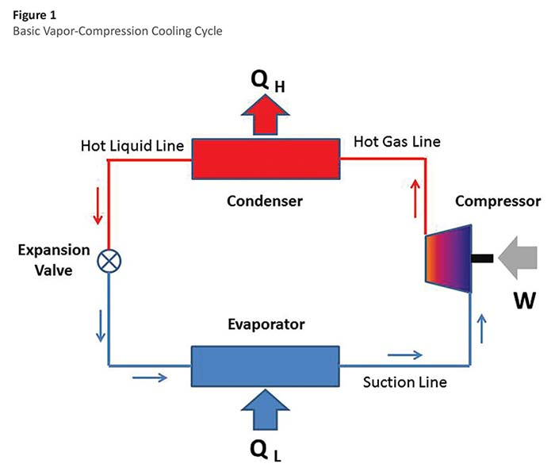
Figure 1 Basic vapor-compression cycle.
Geothermal energy is not used in Finland for electricity production and there are no direct applications of geothermal energy either. This situation is due to the Precambrian geology with thick crust and lithosphere resulting in low geothermal gradient values. Vantaan Energia, one of Finland’s largest city energy companies will start work on a geothermal heating plant in Vantaa Varisto. The renewable heat generated at the plant is directed to the Vantaa district heating network and sold to geothermal customers. Vantaa is a municipality in the greater Helsinki area, the capital of Finland.
Heat only boiler (HOB) is also known as the conventional boiler which is investigated as a technology for heat production. Figure 2 shows a schematic of HOB (scenario 2) and geothermal heat (scenario 3).
Figure 2

Project Description
Case Study: Finland
Capacity of the System: 100 MWe
Simulation tool: EES, Python, Matlab, SAM

Project content
Project should be presented in the following form:
- Introduction (regarding energy source, technology and case study) (10 points)
- Case study (potential of geothermal in Finland, heat pump in Finland) (10 points)
- Material and methods (a short explanation about each heat production technology and simulation tool) (15 points)
- Results and discussion ((Summary of energy and economic analysis for each heat production plant (annual energy, capacity factor, LCOE (nominal), net capital cost)) (30 points)
- Conclusions (compare the heat plants and discuss the results) (15 points)
Presentation (20 points)
References
[1] “The Ministry of the Environment > Government’s climate polic.” [Online]. Available: https://www.ym.fi/en-US/The_environment/Climate_and_air/CarbonNeutral_Finland_2035. [Accessed: 14-Apr-2020].
[2] “Energiavuosi 2019 Sähkö,” 2020. [Online]. Available: https://energia.fi/files/4360/Sahkovuosi_2019_mediakuvat.pdf. [Accessed: 14-Apr-2020].
[3] “Energy Year 2019 District Heating,” Finnish Energy. [Online]. Available: https://energia.fi/files/4517/Energy_Year_2019_DistrictHeating_MEDIA.pdf. [Accessed: 14-Apr-2020].

