TASK CAD D FOR THE STUDENTS WHO HAD PARTICIPATED BEFORE IN THE COURSE
the task is divided in 2 tasks:

Task A Flat
Do the model of the flat, attached is the cad file, so please do all the model of the flat, with only windows, doors, and materials on walls, please upload the archicad file

Task B House

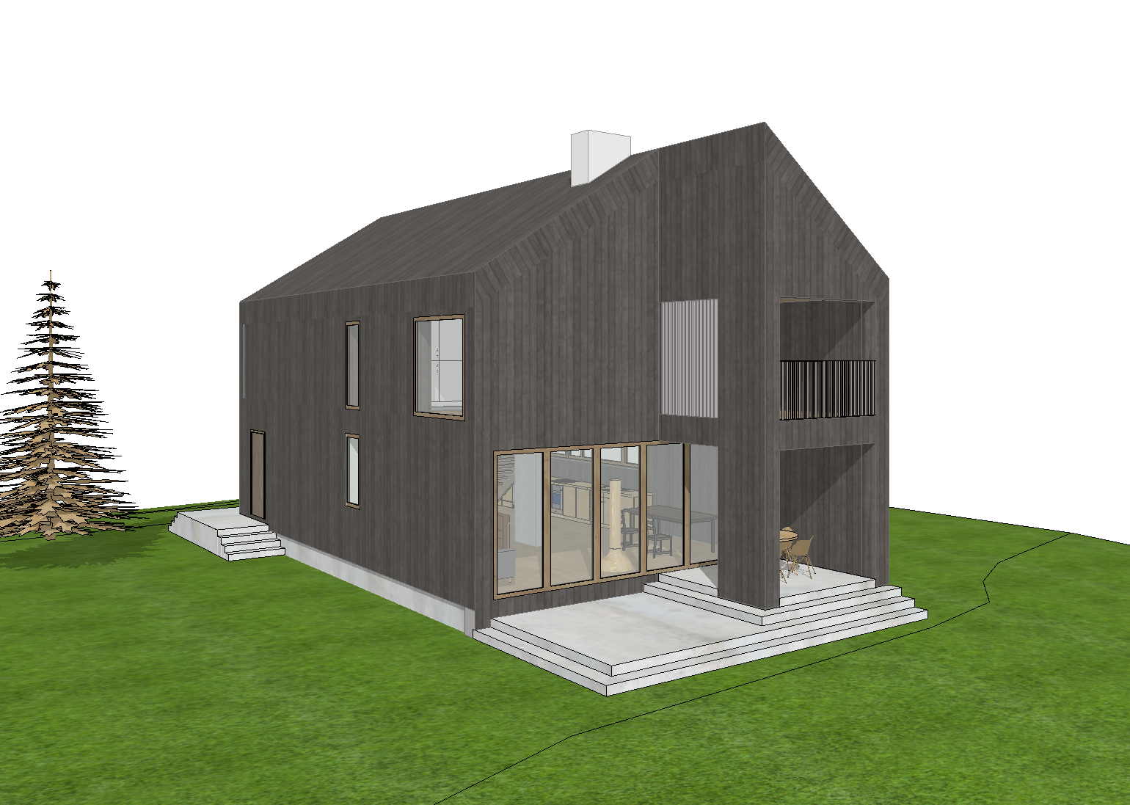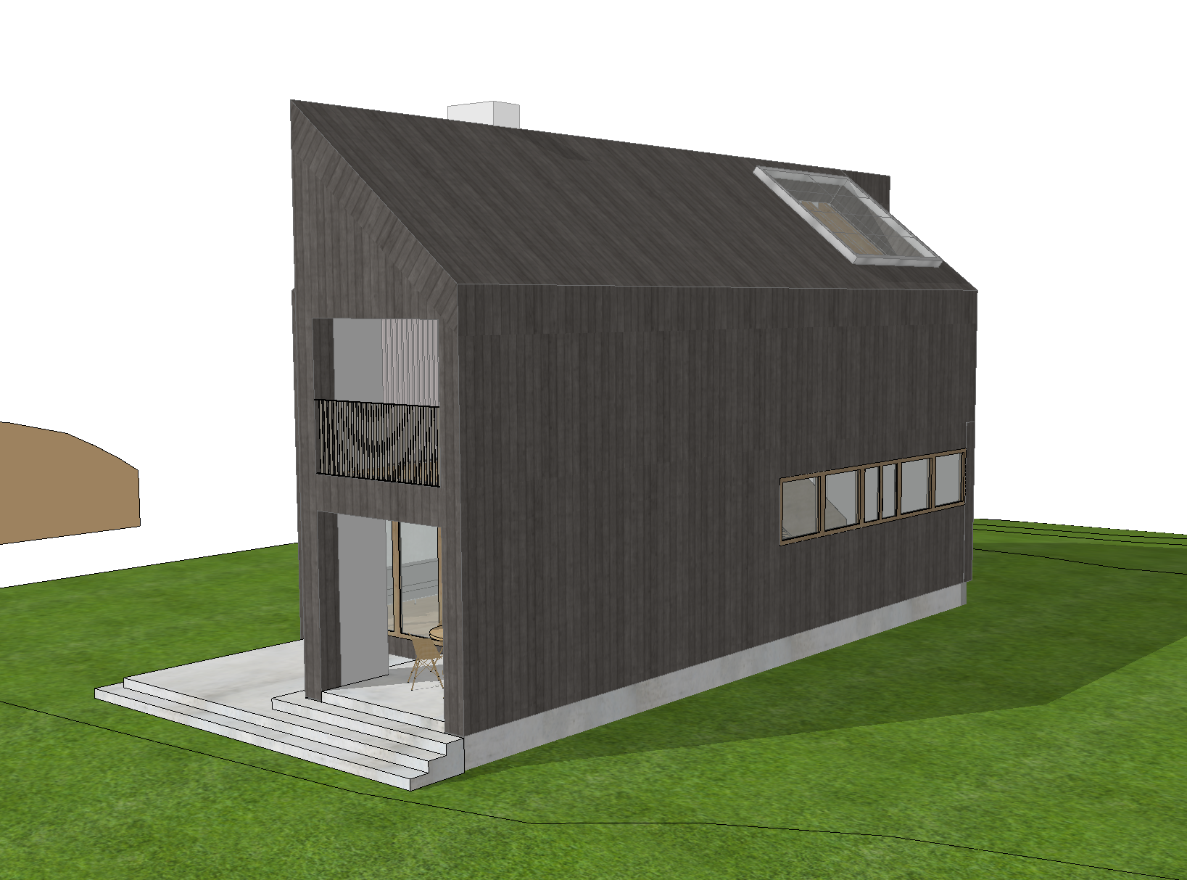

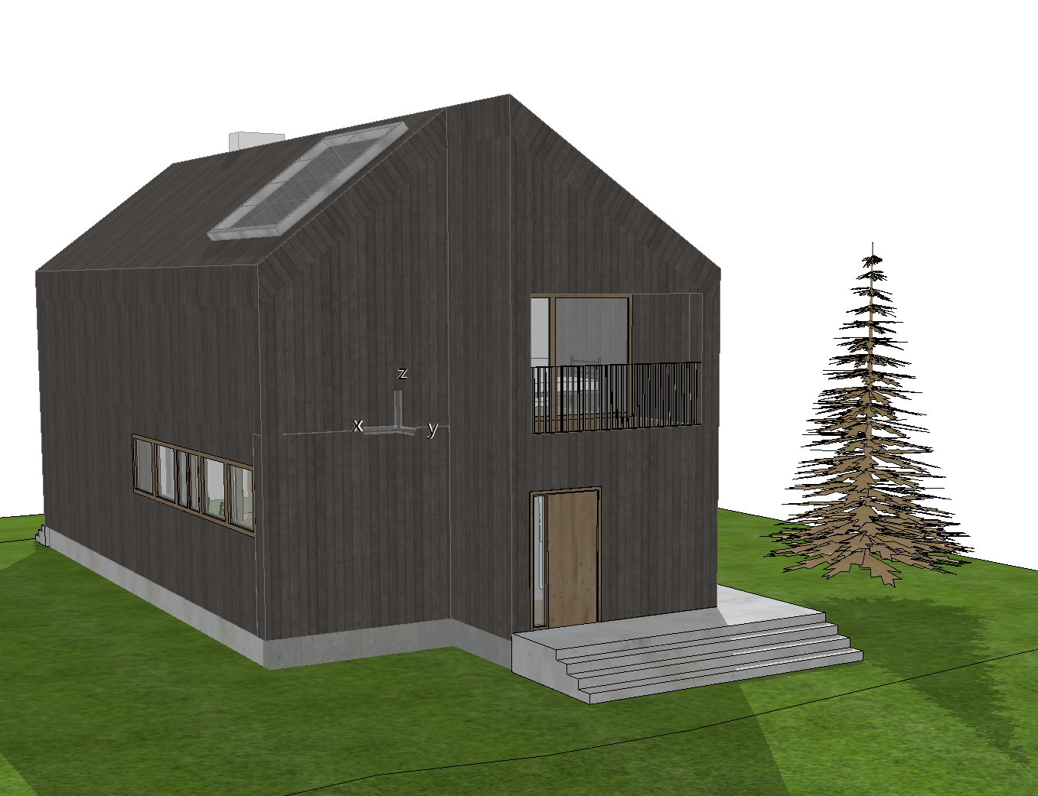

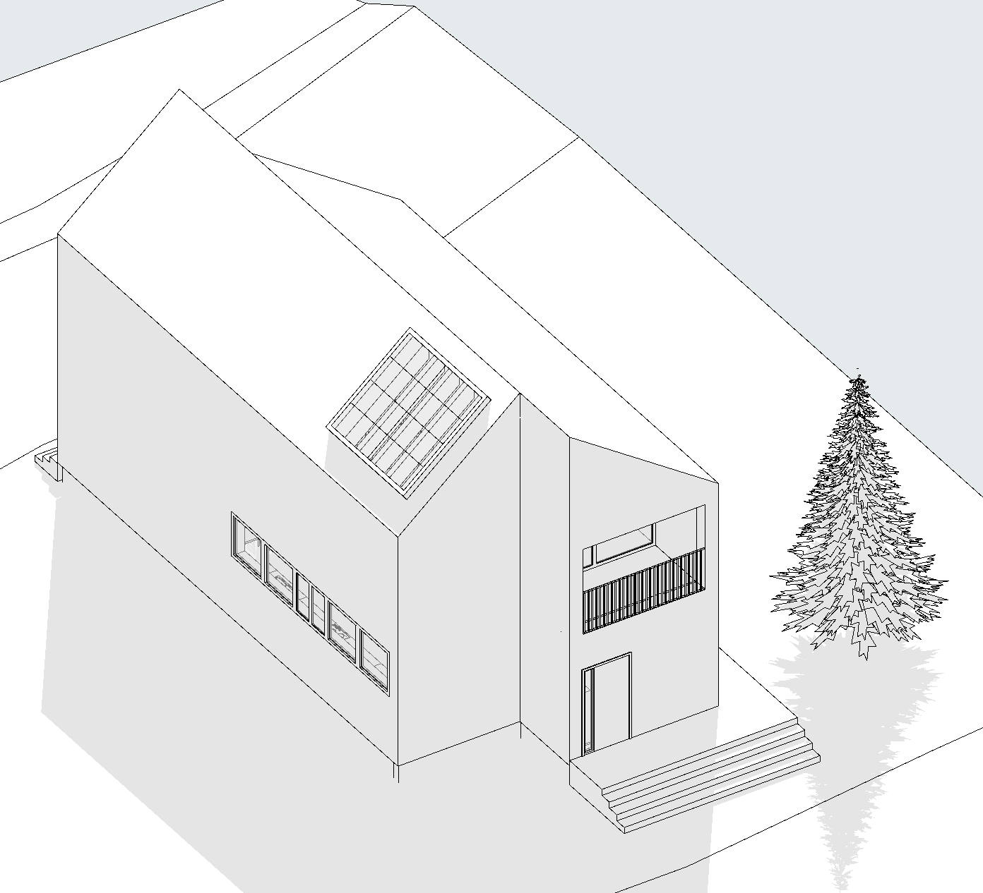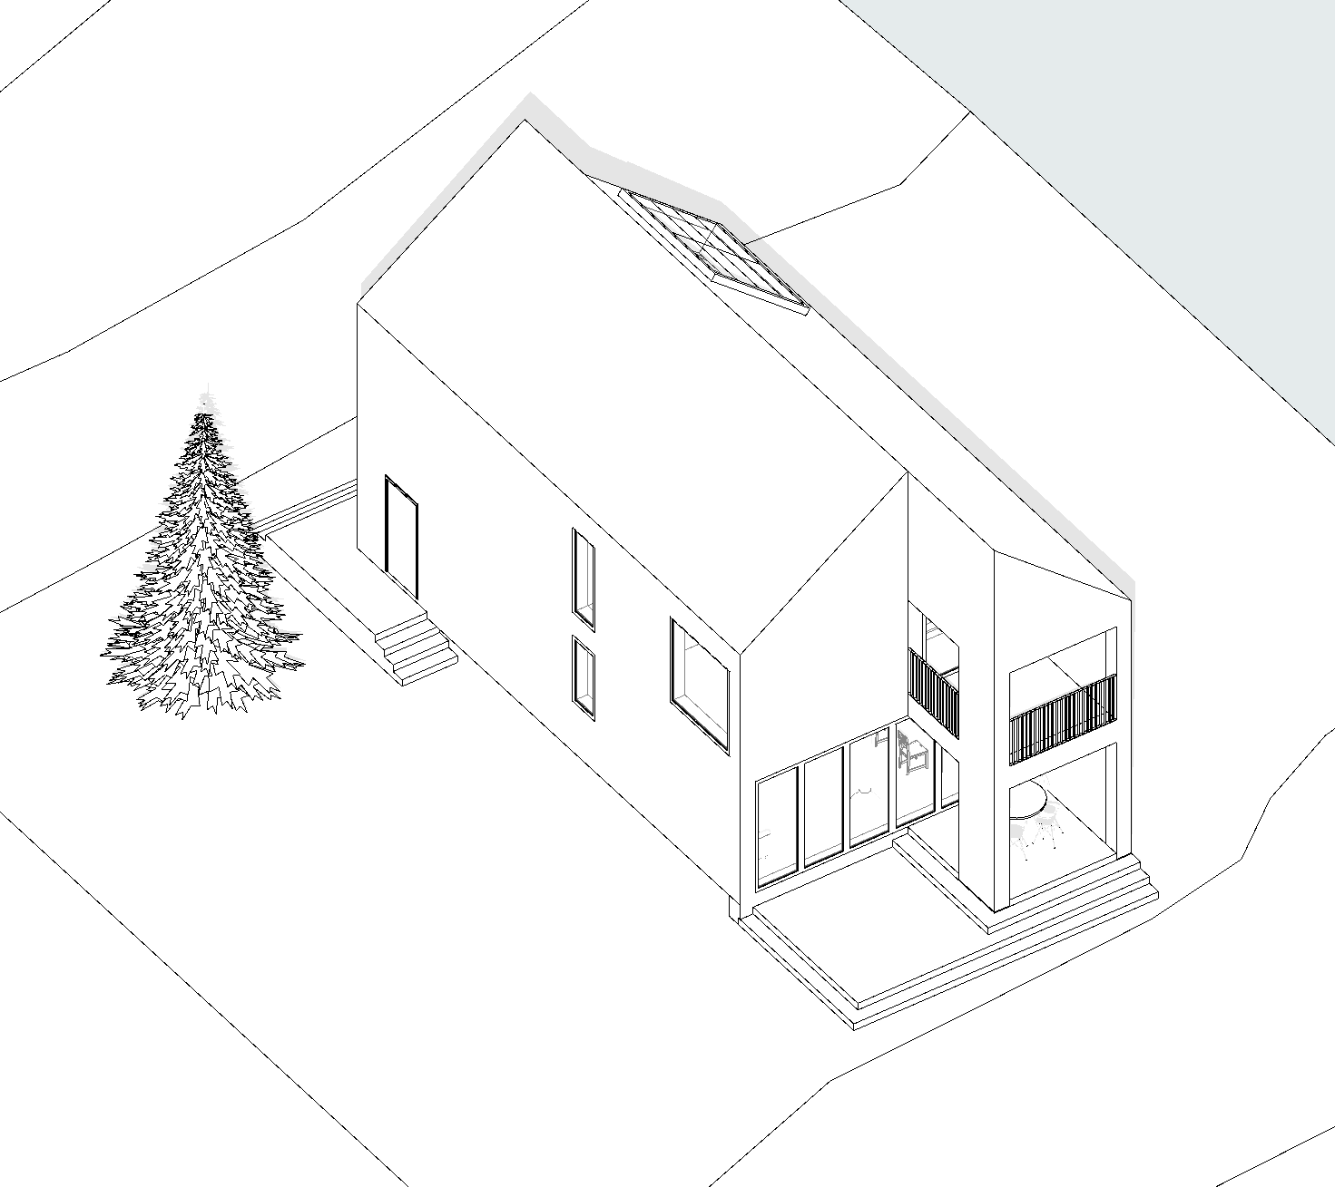
please do a pdf document, A3 landscape with the following documents:
- 1Krs. floor plan
- 2Krs. floor plan
- Sections (2)
- North Facade, East Facade
- South Facade, West Facade
- Axonometric view
- Perspective (Outside)
- Perspective (inside)
- Render (inside)

all the A3 pages have to be in one pdf
each page have to have:
Name of student, student number, and content of the page (floor plan, section etc..)
please deliver by the 3th of June please
thank you very much

Best regards

Marco Rodriguez

