Geographie Arbeitsblatt work sheet 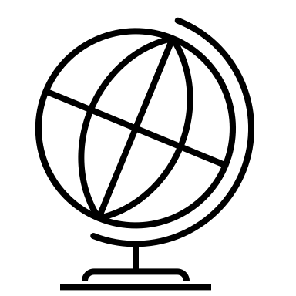
- Flüsse rivers
Der Rhein
Special background music: Beatles: River Rhine
https://www.youtube.com/watch?v=h5CIbOlCmlE

- Check the beginning and the end of the river Rhine (der Rhein) on a map.
Find the German names and place of the cities mentioned in the video (Link in MC).
What are the most important and biggest cities at the river Rhine?

2. Write down at least three of its tributaries (sivujoki = der Nebenfluss).
a)
b)
c)

3. Have a look at the rivers Elbe, Main, Weser and Donau.
Write down three major cities at each of these rivers.
Elbe:
Main:
Weser:
Donau:

- Gebirge mountains
Die Alpen
- What is the highest mountain of the Alps called? Altitude?

- What are the names of the highest mountains of the German-speaking countries?
Look them up on a map.
Deutschland:
Österreich:
Schweiz:
- Where would you like to go (and to do what) in the Alps?

- Look up the word “Alptraum” in a dictionary

- Seen lakes
- Open a map and look out for at least 5 lakes in the German speaking countries.
Fill in their names and location here (like in the example)
1 | Wörthersee | Österreich, Kärnten
2
3
4
5
6

- Try out some of these geographical online Quizzes:
https://online.seterra.com/de/

Upload your completed work sheet to MC > Assignments

Homework for next week:
Choose one geographical topic and prepare a short presentation
Topics might be:
Mittelgebirge
https://de.wikipedia.org/wiki/Liste_der_Mittelgebirge_in_Deutschland
Choose one and find information about it
(Location, altitude, towns, attractions, specifics)
die Alpen
die Schweizer Alpenseen (the lakes in the Swiss Alps)
die Nordsee
das Wattenmeer (Mudflats or mud flats, also known as tidal flats)
die Nordsee-Inseln (islands)
die Ostsee Baltic Sea
die Ostseeinseln (islands)
der Bodensee Lake Constance

! Share your choice in the forum to avoid that too many choose the same topic.

