Deutschland

16 Bundesländer

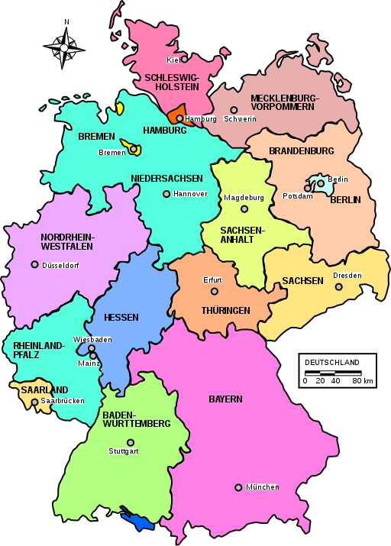

More: https://en.wikipedia.org/wiki/States_of_Germany

Bevölkerungsdichte - Population density

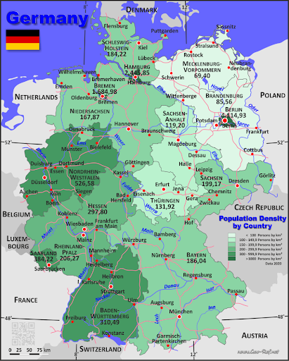

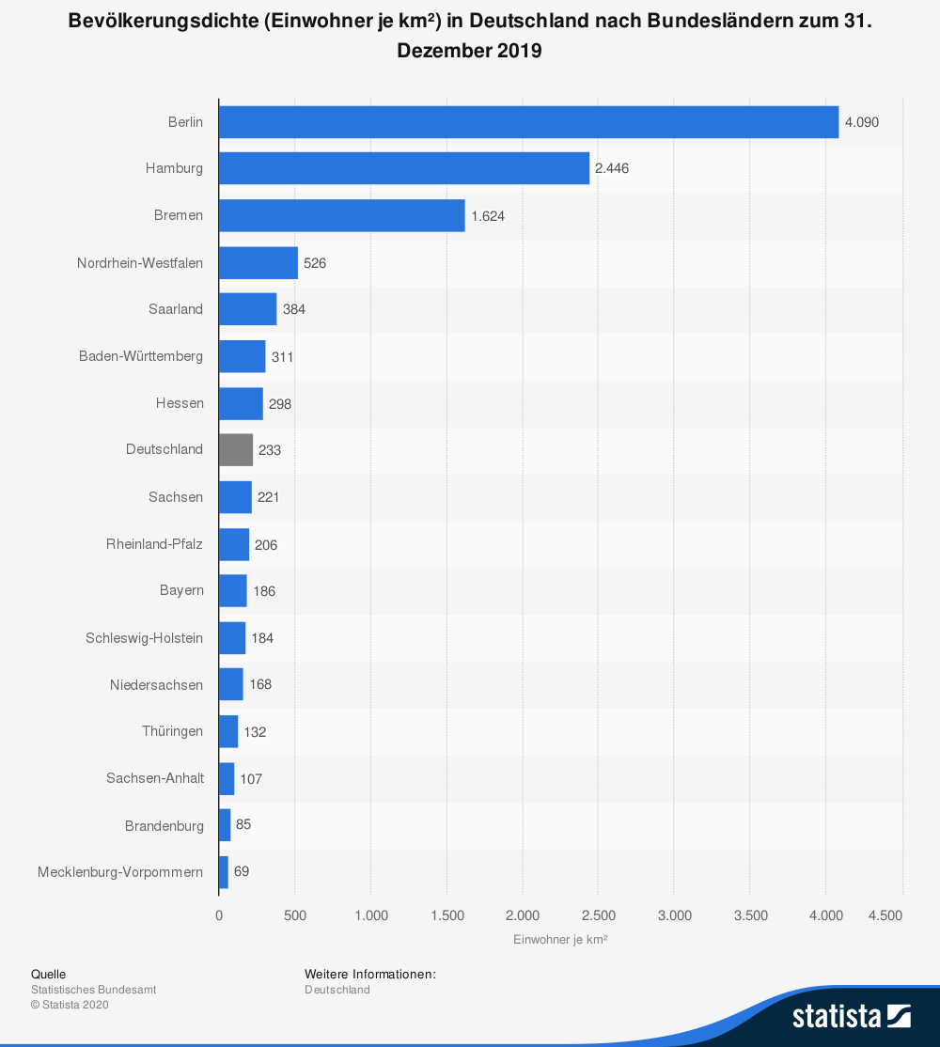

Größte Städte:
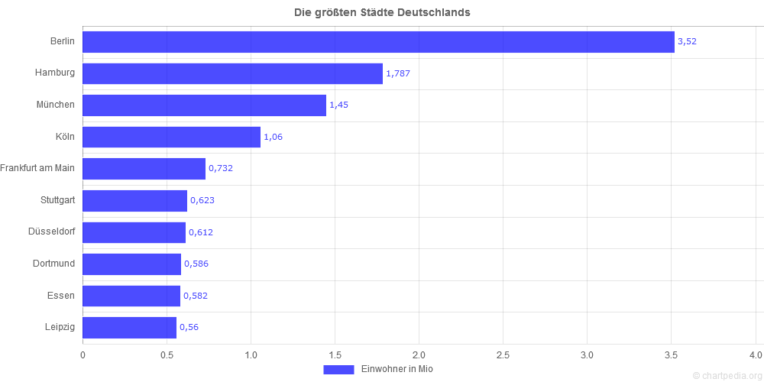

Bundesländer-Quiz: https://online.seterra.com/de

Religionszugehörigkeit

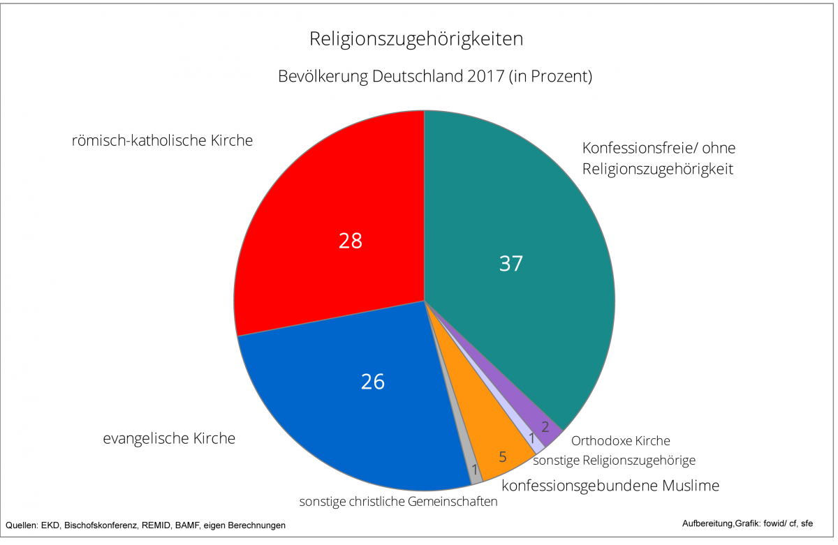

Bundesländer:
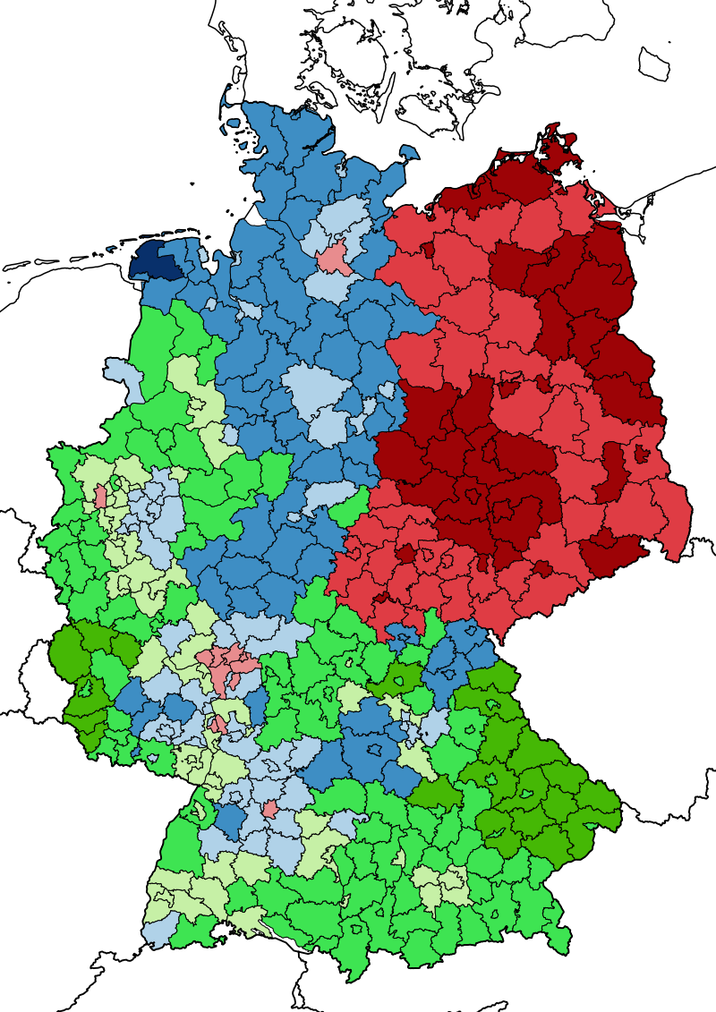

Predominant confessions in Germany as revealed by the 2011 Census using the self-identification question. Blue: Protestant plurality Green: Catholic plurality Red: Non-religious / unaffiliated plurality Darker shades indicate a majority between 50 and 75% while the darkest shades indicate an absolute majority with more than 75%.

*

Politik
Bundestag
„Reichstag“
The Reichstag building with the famous glass dome is one of the most frequently visited sights in Berlin. It is seat of the German parliament, the Bundestag.

More: Video (DW): https://www.youtube.com/watch?v=yZ866HxCyHo
https://www.berlin.de/en/attractions-and-sights/3560965-3104052-reichstag.en.html

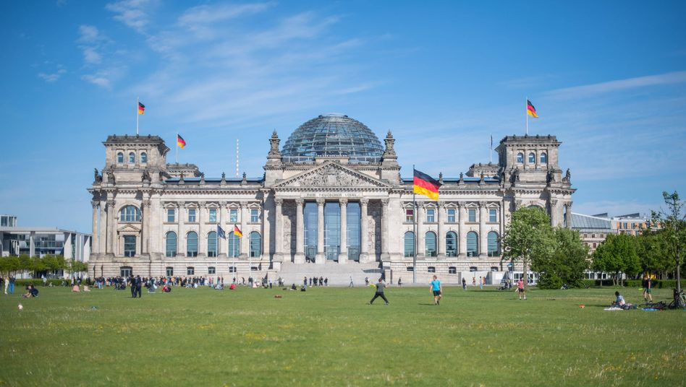

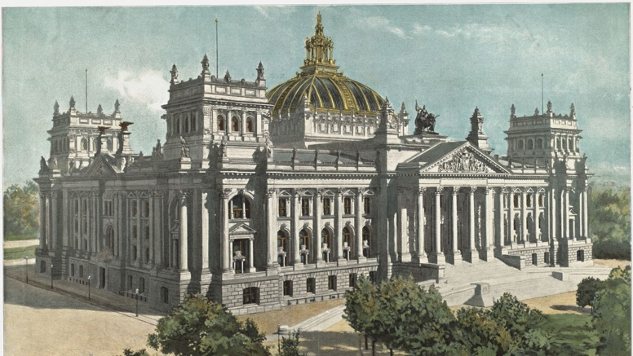 | 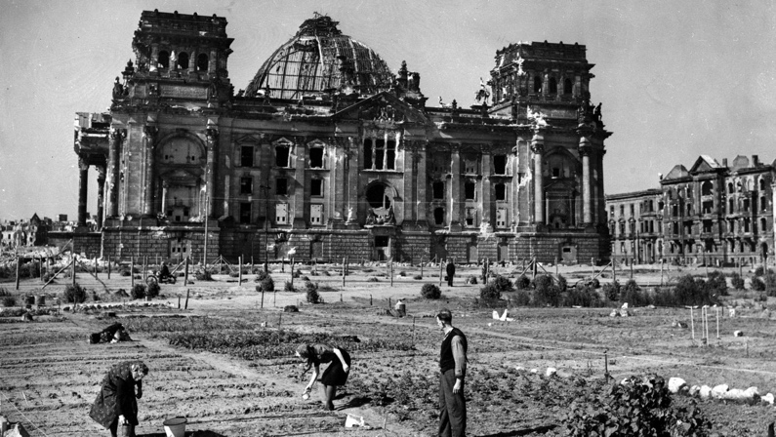
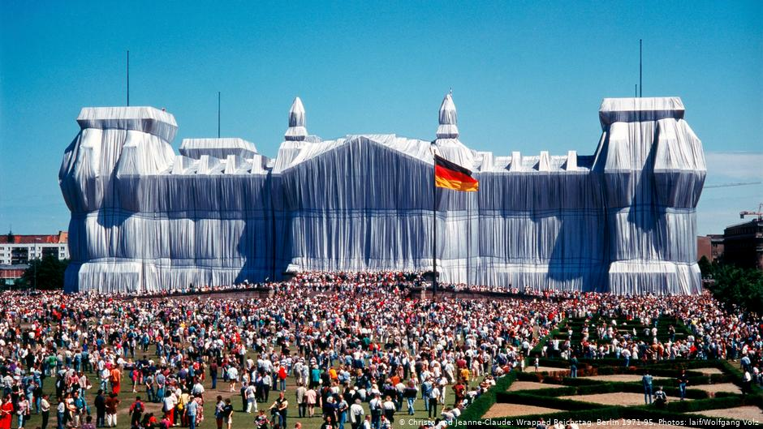 | 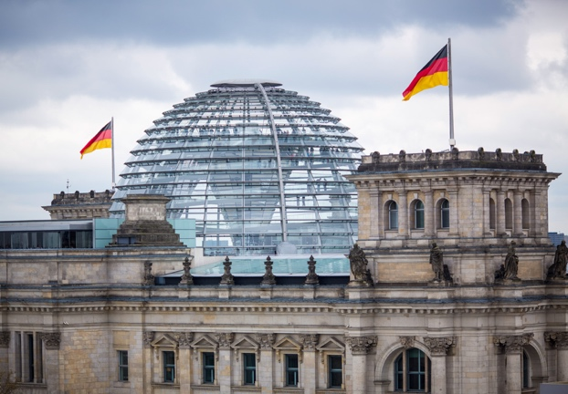

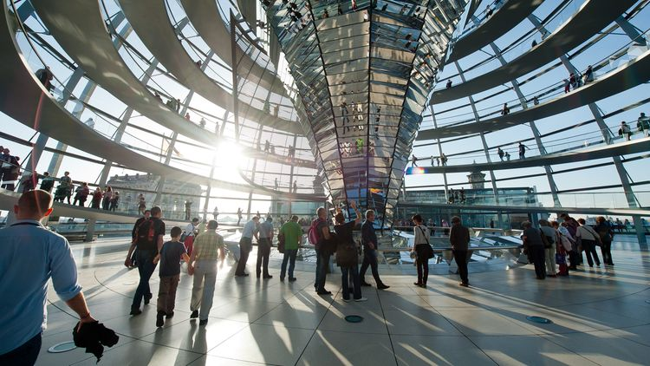

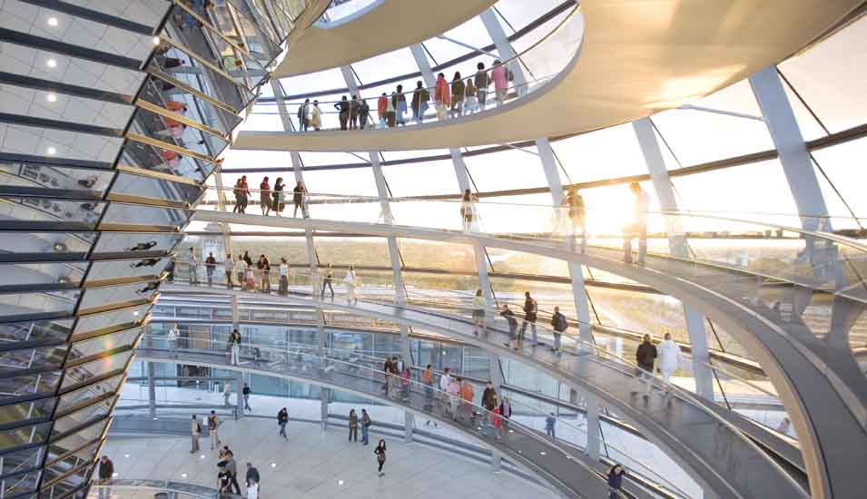

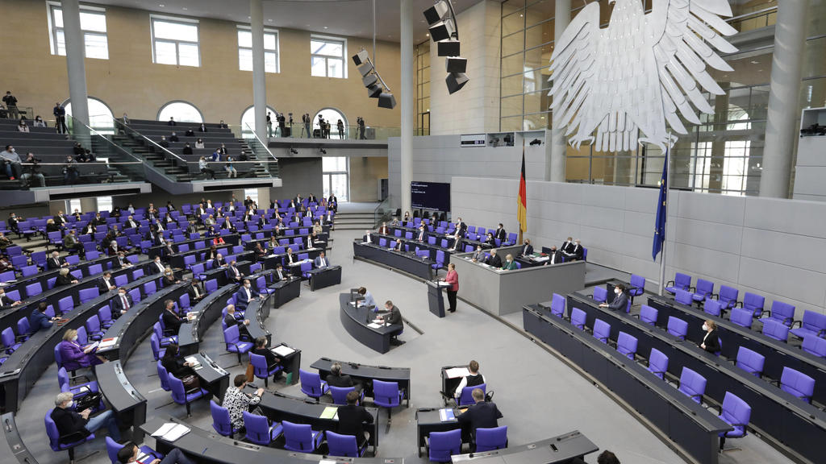

Sitzverteilung des 20. Deutschen Bundestages
Bundestagswahlen September 2021

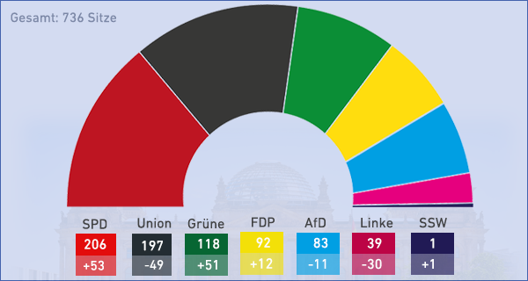

Bundesregierung
Ampel-Koalition: SPD + Grüne + FDP

 | Bundeskanzler/in | Außenminister/in | Wirtschaftsminister/in | Finanzminister/in
Name
Partei

https://www.bundesregierung.de/breg-de/bundesregierung/bundeskanzleramt/bundeskabinett

Bundesländer
Regierungsparteien, Koalitionen (2018):

*
Nationalhymne:

"Das Lied der Deutschen" ("The Song of the Germans"), or part of it, has been the national anthem of Germany since 1922. In East Germany, the national anthem was "Auferstanden aus Ruinen" ("Risen from Ruins") between 1949 and 1990.

After World War II and the fall of Nazi Germany, only the third stanza has been used as the national anthem. That stanza's incipit "Einigkeit und Recht und Freiheit" ("Unity and Justice and Freedom") is considered the unofficial national motto of Germany, and is inscribed on modern German Army belt buckles and the rims of some German coins.

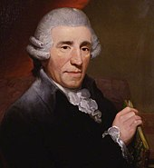

The music is the hymn "Gott erhalte Franz den Kaiser", written in 1797 by the Austrian composer Joseph Haydn as an anthem for the birthday of Francis II, Emperor of the Holy Roman Empire and later of Austria. In 1841, the German linguist and poet August Heinrich Hoffmann von Fallersleben wrote the lyrics of "Das Lied der Deutschen" as a new text for that music, counterposing the national unification of Germany to the eulogy of a monarch, lyrics that were considered revolutionary at the time. Along with the flag of Germany, which first appeared in its essentially "modern" form in 1778, it was one of the symbols of the March Revolution of 1848.

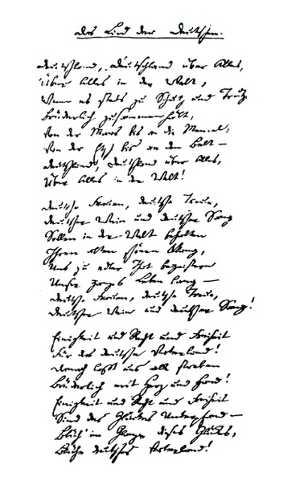 | Einigkeit und Recht und Freiheit  Für das deutsche Vaterland!  Danach lasst uns alle streben  Brüderlich mit Herz und Hand!  Einigkeit und Recht und Freiheit  Sind des Glückes Unterpfand –  Blüh' im Glanze dieses Glückes,  Blühe, deutsches Vaterland!  Blüh' im Glanze dieses Glückes,  Blühe, deutsches Vaterland! | Unity and justice and freedom  For the German fatherland!  Towards these let us all strive  Brotherly with heart and hand!  Unity and justice and freedom  Are the safeguards of fortune;  Flourish in the radiance of this fortune,  Flourish, German fatherland!  Flourish in the radiance of this fortune,  Flourish, German fatherland!

In order to endorse its republican and liberal tradition, the song was chosen as the national anthem of Germany in 1922, during the Weimar Republic. West Germany adopted the "Deutschlandlied" as its official national anthem in 1952 for similar reasons, with only the third stanza sung on official occasions. Upon German reunification in 1990, only the third stanza was confirmed as the national anthem.

https://www.youtube.com/watch?v=mBmCcSz6HWw

Wohnen
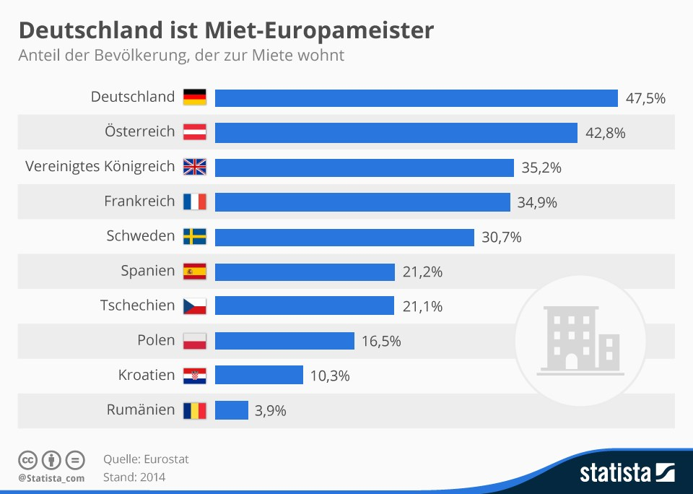

Preise für Wohnimmobilien in den deutschsprachigen Ländern:
https://www.cash-online.de/immobilien/2017/deutschland-schweiz-oesterreich-wo-wohnen-am-meisten-kostet/398805

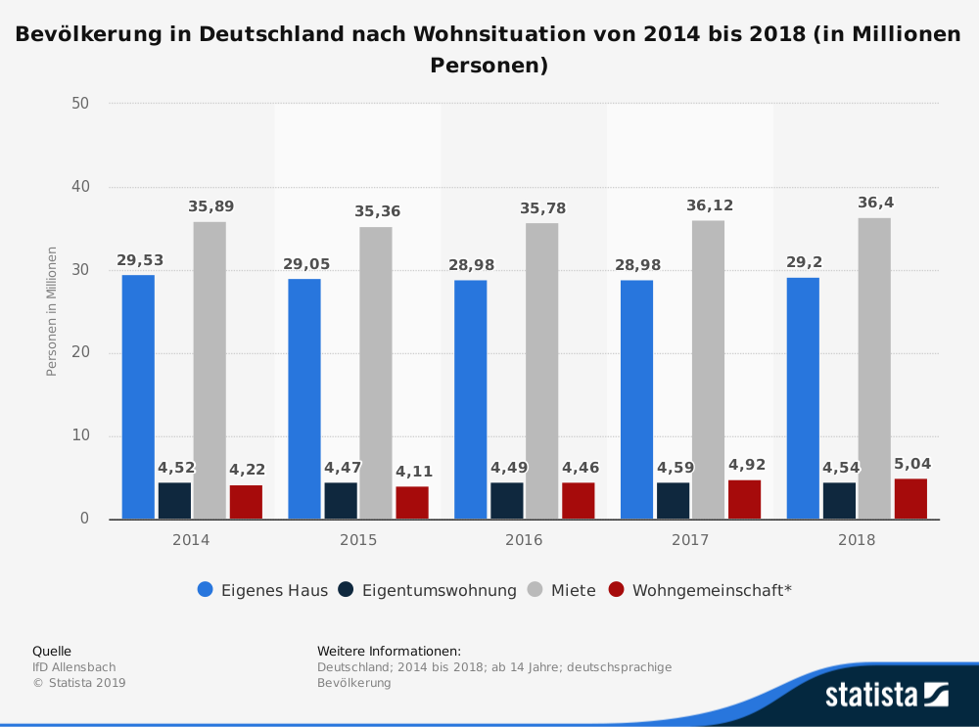

Bildung
Schulsystem
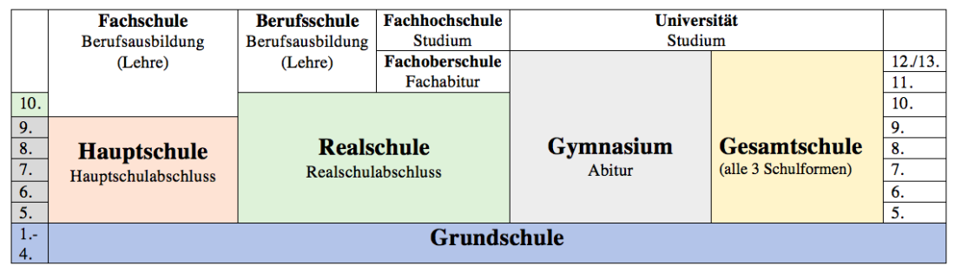

Noten grades: 1 sehr gut
2 gut
3 befriedigend
4 ausreichend
5 mangelhaft
6 ungenügend

Studieren in Deutschland
Sommersemester: April – Juli
Wintersemester: Oktober – Februar
Semesterferien

DW Euromax: https://www.youtube.com/watch?v=TaMWIQ-8KE8

Universitäten
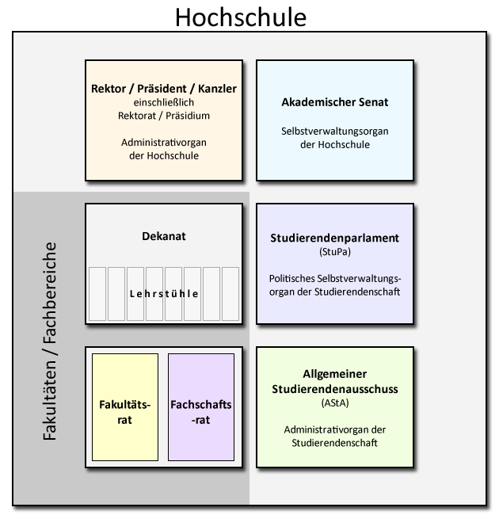

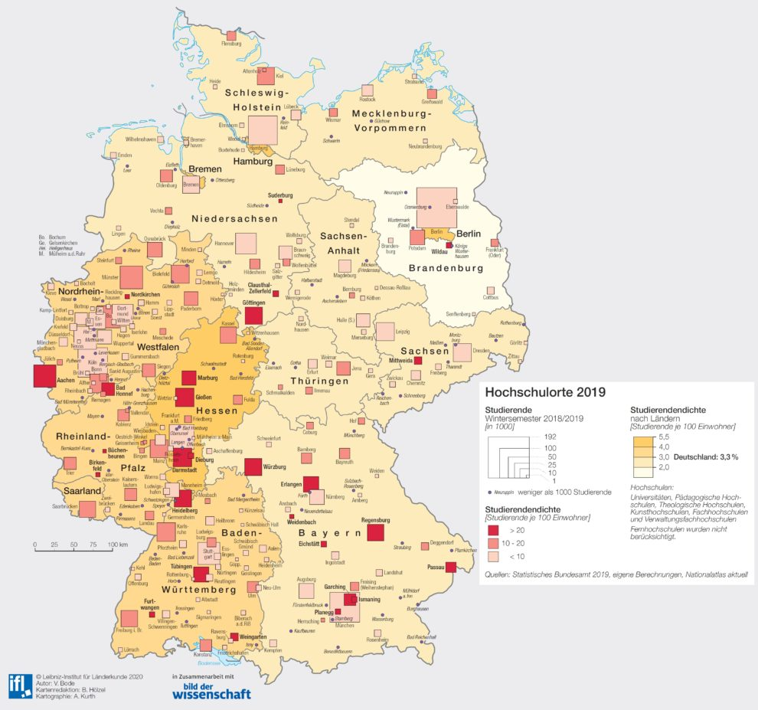

https://www.study-in-germany.de/en/
https://www.deutschland.de/de/studieren-in-deutschland
https://www.deutschland.de/en/topic/knowledge/higher-education-and-research

ASTA
The General Students' Committee (German: Allgemeiner Studierendenausschuss) or AStA, is the acting executive board and the external representing agency of the (constituted) student body at universities in most German states. It is therefore considered the student government and student representative organization. The AStA fulfils a similar function as the Students' Union at a British university.

AStA committees are usually elected by the student parliament and consist of one or more chairpersons as well as a set of consultants from different fields of study. Sometimes AStA includes so called Autonome Referate (Autonomous consultants) representing minorities which are elected by the members of their peer groups (not by student parliament).

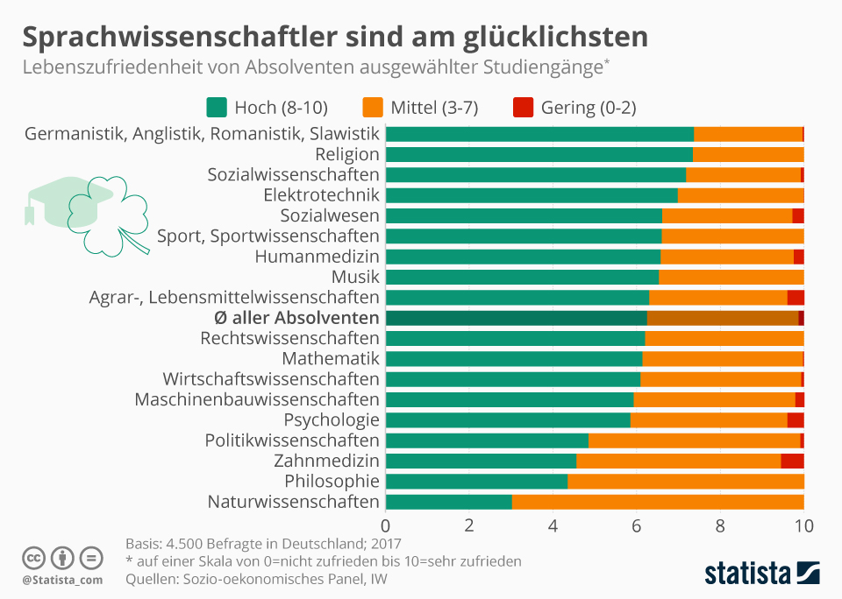
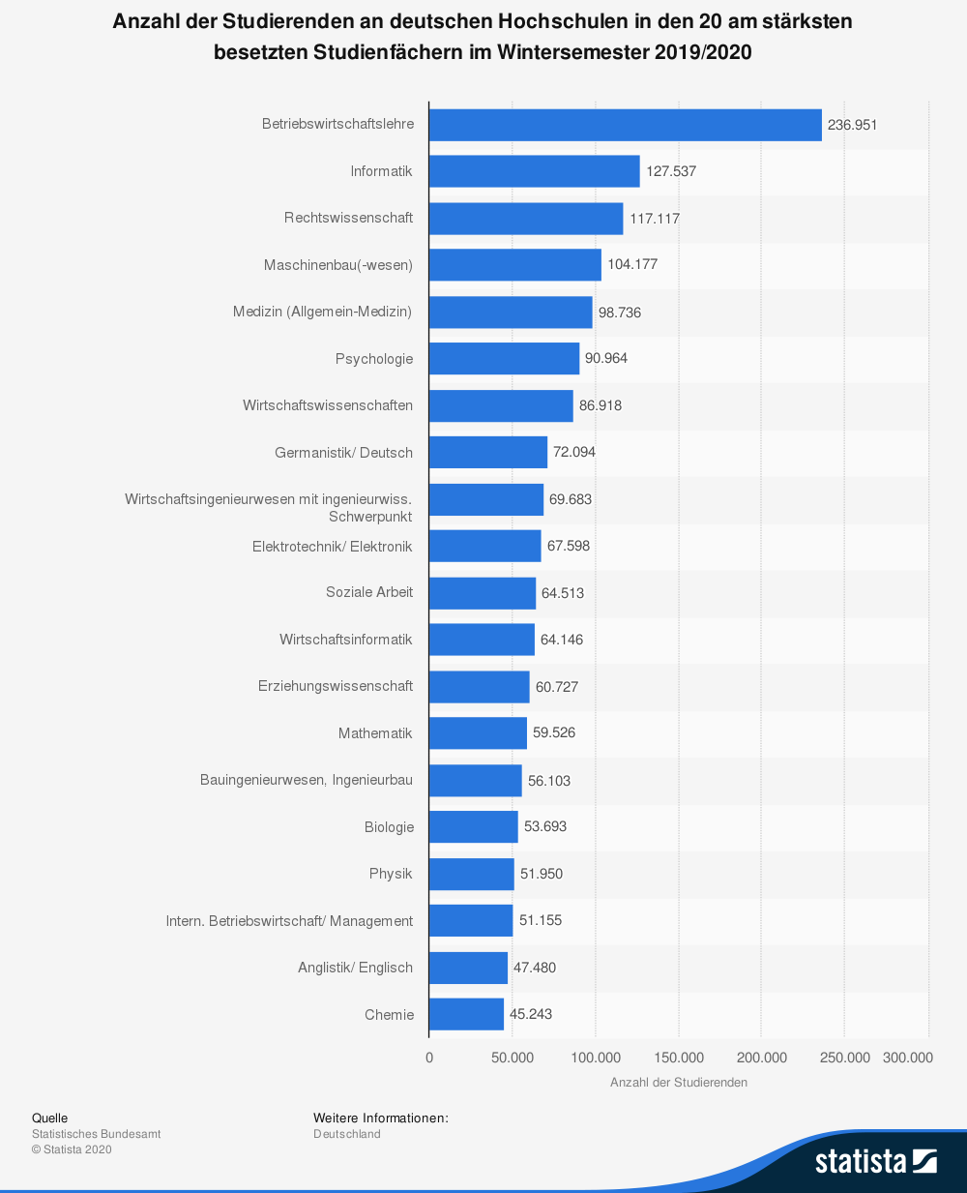

*
Deutsch-finnische Beziehungen > PPP

