Reactor Design

Lin Li

This lecture begins with a brief overview of design as an important part of engineering education, and then focuses on using fundamental concepts and models in kinetics and transport phenomena to understand, analyze, and make decisions related to reactor design and scale up. As an example of using reaction engineering concept to address real world problems, it will also discuss key challenges for energy transition.

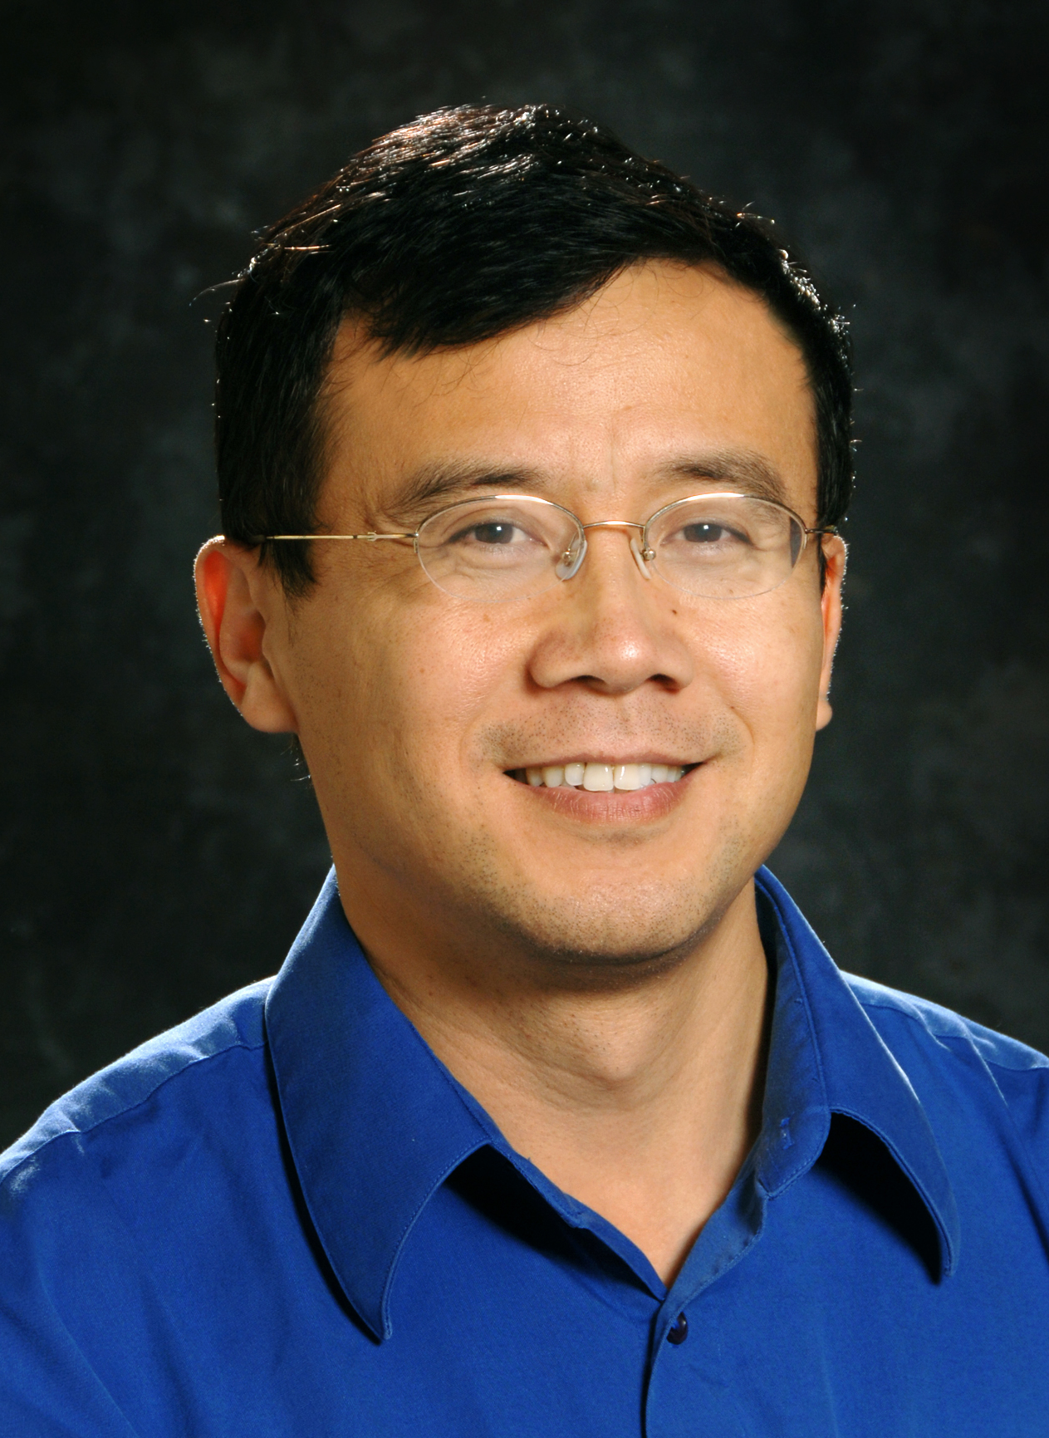
Lin Li is a Consulting Research Engineer at Chevron Technical Center (Richmond, CA), where he manages and conducts strategic research and technology development projects. He received BS, MS and Ph. D. degree in Chemical Engineering from Tianjin University (Tianjin, Chin) in 1983, 1986 and 1989, respectively, and then worked 9 years at Tsinghua University (Beijing, China), with growing responsibilities in teaching, research and administration. He moved to the US in 1998, and after research experiences at Princeton University and UC Berkeley he started his industrial career by joining UOP (Des Plaines, IL) in 2001. He has published 2 books, 50 journal papers and 25 filed patents. He is a certified 6-Sigma Black Belt. He is a AIChE Fellow. Since 2019 he serves as ABET Program Evaluator (PEV, Chemical Engineering). He is also a longtime leader of Chinese-American Chemical Society (CACS) and currently serves as Board Member of CACS.

