Title of your master’s thesis (in title case)

(remove paragraph breaks here as needed to accommodate the length of your thesis title so that everything fits on one page)

Master’s Thesis
Anton Frantsev
Aalto University School of Business

2017

Author Anton Frantsev
Title of thesis Title of your master’s thesis (in all caps)
Degree Master of Science in Economics and Business Administration
Degree programme Study programme name
Thesis advisor(s) Advisors
Year of approval 2017 | Number of pages 14 | Language English
Abstract
Georgia Regular, 11pt/14pt. Each subsequent paragraph has an indentation of 5mm.
Lorem ipsum dolor sit amet, consectetuer adipiscing elit. Sed posuere interdum sem. Quisque ligula eros ullamcorper quis, lacinia quis facilisis sed sapien. Mauris varius diam vitae arcu. Sed arcu lectus auctor vitae, consectetuer et venenatis eget velit. Sed augue orci, lacinia eu tincidunt et eleifend nec lacus. Donec ultricies nisl ut felis, suspendisse potenti. Lorem ipsum ligula ut hendrerit mollis, ipsum erat vehicula risus, eu suscipit sem libero nec erat. Aliquam erat volutpat. Sed congue augue vitae neque. Nulla consectetuer porttitor pede. Fusce purus morbi tortor magna condimentum vel, placerat id blandit sit amet tortor.
Sisennetty kappale, sisennys 5mm. Mauris sed libero. Suspendisse facilisis nulla in lacinia laoreet, lorem velit accumsan velit vel mattis libero nisl et sem. Proin interdum maecenas massa turpis sagittis in, non lobortis vitae massa. Quisque purus lectus, posuere eget imperdiet nec id arcu. Vestibulum elit pede dictum eu, viverra non tincidunt eu ligula.
Mauris sed libero. Suspndisse facilisis nulla in lacinia laoreet, lorem velit accumsan velit vel mattis libero nisl et sem. Proin interdum maecenas massa turpis sagittis in, interdum non lobortis vitae massa. Quisque purus lectus, posuere eget imperdiet nec sodales id arcu. Vestibulum elit pede dictum eu, viverra non tincidunt eu ligula.

Keywords keyword, keyword, keyword

Tekijä Anton Frantsev
Työn nimi Title of your master’s thesis (in title case)
Tutkinto Tutkinto
Koulutusohjelma Koulutusohjelma
Työn ohjaaja(t) Ohjaajat
Hyväksymisvuosi 2017 | Sivumäärä 14 | Kieli Kieli
Tiivistelmä
Georgia Regular, 11pt/14pt. Each subsequent paragraph has an indentation of 5mm.
Lorem ipsum dolor sit amet, consectetuer adipiscing elit. Sed posuere interdum sem. Quisque ligula eros ullamcorper quis, lacinia quis facilisis sed sapien. Mauris varius diam vitae arcu. Sed arcu lectus auctor vitae, consectetuer et venenatis eget velit. Sed augue orci, lacinia eu tincidunt et eleifend nec lacus. Donec ultricies nisl ut felis, suspendisse potenti. Lorem ipsum ligula ut hendrerit mollis, ipsum erat vehicula risus, eu suscipit sem libero nec erat. Aliquam erat volutpat. Sed congue augue vitae neque. Nulla consectetuer porttitor pede. Fusce purus morbi tortor magna condimentum vel, placerat id blandit sit amet tortor.
Sisennetty kappale, sisennys 5mm. Mauris sed libero. Suspendisse facilisis nulla in lacinia laoreet, lorem velit accumsan velit vel mattis libero nisl et sem. Proin interdum maecenas massa turpis sagittis in, non lobortis vitae massa. Quisque purus lectus, posuere eget imperdiet nec id arcu. Vestibulum elit pede dictum eu, viverra non tincidunt eu ligula.
Mauris sed libero. Suspndisse facilisis nulla in lacinia laoreet, lorem velit accumsan velit vel mattis libero nisl et sem. Proin interdum maecenas massa turpis sagittis in, interdum non lobortis vitae massa. Quisque purus lectus, posuere eget imperdiet nec sodales id arcu. Vestibulum elit pede dictum eu, viverra non tincidunt eu ligula.

Avainsanat avainsana, avainsana, avainsana

Acknowledgements
This section is optional and can be removed if not wanted.

Table of Contents
Acknowledgements iii
1 Introduction 1
2 Tables Are Your Friend 2
2.1 Thinking With Tables 2
2.2 Such Tables. So Streamlined. Many Captions. Much Wow. 2
2.2.1 Captioning Tables 3
2.2.2 Inserting Numbered Equations 3
3 Conclusions 4
References 5
Books and reports 5
Articles 5
A separate part of a collection, handbook, or conference proceedings 5
Interviews 5
Internet-references 5
Appendix A: Appendix Title 6

List of Tables
Table 1: Summary Statistics for the Variable by Location 2
Table 2: Post-hoc Tests for the RevPAR Variable by Cluster 3

List of Figures
Figure 1. Distribution of the variable by location. 2
Figure 2. Thesis writing process. 4

Introduction
Please READ CAREFULLY the instructions in these example sections: The body text goes into this section. Therefore, don't insert any extra section breaks here; use only page breaks as needed. Also note that the first paragraph of body text in every section starts without indentation. It has its own Style that can be found from the Quick Style menu in the ribbon that’s called First Paragraph.
The next paragraphs after the first paragraph in a section should be indented by 1 cm, just like this one. You can find this illustrated throughout the template. The style corresponding to the subsequent paragraphs of body text like this one is called Body Paragraph. By default, the paragraphs following the first will automatically be of this style.
There are other predefined document styles which you can find from the Quick Style menu, so you don’t need to create your own styles. You should use no more than 3 levels of headings. It is also recommended to start each “major” section of your thesis (those that begin with integer numbers and are denoted by the style Heading 1) on a new page. Use a page break for this purpose, not a section break.
In general, try to refrain from section breaks unless absolutely necessary. Use sections breaks at your own risk of breaking the number and automation of this template.

Tables Are Your Friend

Such Tables. So Streamlined. Many Captions. Much Wow.
All pictures and tables need captions. The easiest way to keep a caption together with the object it belongs to is to create a 2 × 1 table and insert the object and caption into the cells. This is the approach used in this template and in the examples above and below. This does mean sometimes having a table within a table (omg, table-ception!), but it makes everything much nicer.
The numbering of the captions is automatic and sequential. You don’t need to adjust the numbers yourself, but if you see numbers out of order, you need to “update” the document by switching to Draft view and then back. The text of the caption is in Caption style. This allows MS Word to generate a list of tables and/or figures automatically. It does this only if the caption text is in this style. You can find the Caption style in the Quick Style menu.

Thinking With Tables

Captioning Tables
Below are examples of a table and figure. Note how the table caption is above the table, while the figure caption is below the table.
To make life easier, it is strongly recommended that you copy the below example table or figure wherever you need to insert a new one into your thesis, and then simply replace the content in the cell and the title of the caption, being mindful to change only the title and not the “Figure 1.” or “Table 1:” labels.
The style and format of your own tables doesn't need to be like the one in the examples, and you can use whatever color scheme and style that you think fits your thesis best. However, all tables and figures are placed into a paragraph of Normal style, so if you have weird wrapping or breaking issues, see if you need to change the style to Normal.
Table 1: Summary Statistics for the Variable by Location
Location | N | Mean | Std. Deviation | Std. Error | 95% Confidence Interval |  | Minimum | Maximum
 |  |  |  |  | Lower Bound | Upper Bound
Airport | 366 | 84.49560 | 30.305793 | 1.584109 | 81.380483 | 87.610735 | 20.2255 | 131.8702
City Center | 6216 | 74.17497 | 40.539810 | .5141931 | 73.166975 | 75.182967 | .0000 | 428.1100
Biz Park | 347 | 71.74901 | 33.656533 | 1.806777 | 68.195368 | 75.302666 | 2627435 | 185.1481
Suburb | 730 | 57.86440 | 31.885857 | 1.180148 | 55.547514 | 60.181305 | .0000 | 120.9666
Total | 7659 | 73.00364 | 39.431973 | .4505702 | 72.120407 | 73.886889 | .0000 | 428.1100

Captioning Figures
When it comes to figures, it is possible to add sub-plots to figures if you want to show off two or more charts. This is easily achievable by making a 1 × N table with equal cells and distributing them equally, then filling the cells with the appropriate contents. To make nice sub-captions for each plot, just insert an extra row in the table and place the sub-captions into the cells under the images, but above the main figure caption, as shown in Figure 1 in the example below. The table below is a 3 × 2 table with the last row’s cells merged to accommodate the caption. The numbering of the sub-captions is not automatic.
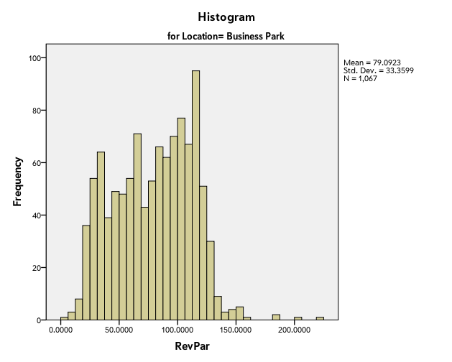 | 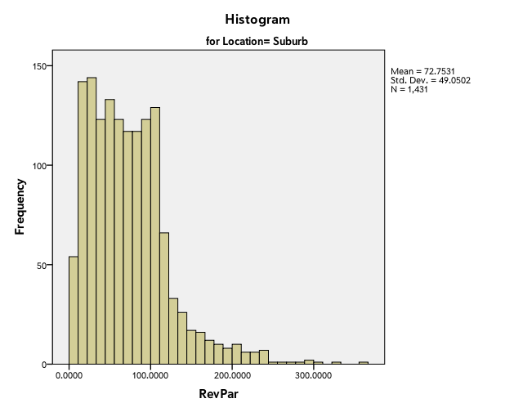
a) One distribution | b) Another distribution
Figure 1. Distribution of the variable by location.
Here’s another example table to illustrate that numbering is automatic and sequential.
Table 2: Post-hoc Tests for the RevPAR Variable by Cluster
(I) Cluster | (J) Cluster | Mean Difference (I-J) | Std. Error | Sig. | 95% Confidence Interval
Number | Number |  |  |  | Lower Bound | Upper Bound
1 | 2 | -111.3117347* | 1.3804259 | .000 | -114.954600 | -107.668869
 | 3 | -24.6599086* | .9813590 | .000 | -27.249659 | -22.070158
 | 4 | -51.4134906* | .6871433 | .000 | -53.226823 | -49.600158
2 | 1 | 111.3117347* | 1.3804259 | .000 | 107.668869 | 114.954600
 | 3 | 86.6518261* | 1.5136690 | .000 | 82.657339 | 90.646313
 | 4 | 59.8982440* | 1.3417505 | .000 | 56.357440 | 63.439048
3 | 1 | 24.6599086* | .9813590 | .000 | 22.070158 | 27.249659
 | 2 | -86.6518261* | 1.5136690 | .000 | -90.646313 | -82.657339
 | 4 | -26.7535821* | .9261664 | .000 | -29.197683 | -24.309482
* The mean difference is significant at the 0.05 level.

Inserting Numbered Equations
If you need to insert an equation into your thesis, it’s best to have a numbered equation so that it can be referred to easily later on. For that it’s also best to use a table. In the example below, the equation is in the middle of a 1 × 3 table, and the right cell contains a counter.
If you need to have a series of equations in your thesis, copy and paste this example equation elsewhere in the document, and the number will automatically update; all you need to do is change the equation in the middle cell.
$$P\left(q_{L},q_{F}\right)=α-β\left(q_{L}+q_{F}\right).$$

Conclusions
This template has been created out of frustration during my own master’s studies from the terrible automatic formatting applied by Word. The frustration, which is summarized in the figure below, was so great that I went a step further and wrote my thesis in LaTeX.
This template is my gift to you. It should work nicely 95% of the time. If you do encounter problems, please contact its creator via email. The address may be found on the seminar webpage. Since the formatting of the thesis has largely been taken care of for you, you can now focus mostly on the content.
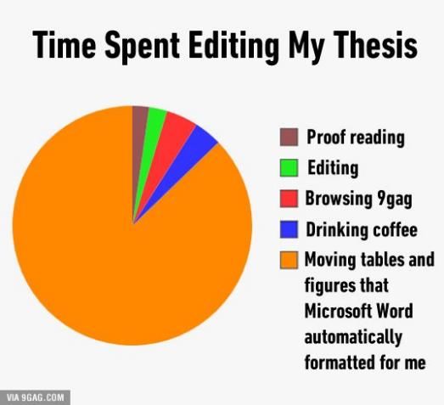
Figure 2. Thesis writing process.
This is the last section of body text, and it is followed by a page break before the bibliography and appendices begin.

References
You are encouraged to use either MLA or APA style for making references. Use the Reference style from the Quick Styles menu to format the entries. Note that the following are examples, and all references are to be listed in alphabetical order regardless of type.
The references section is followed by a page break (already included) before the start of the appendices.

Books and reports
Author(s) name, printing year, title of the book, publisher, printing location, and number of pages:
Koskinen, A., Kivistö, T., Lankinen, M., Sakki, J. & Vepsäläinen, A. (1995) Ostotoiminta yrityksen kehittämisessä, Weilin & Göös, Espoo, 333 s.

Articles
Author(s), year of print, title of the article, name of the journal, volume and number of the journal, time (e.g. Summer, Fall), and page numbers:
Laine, J. & Vepsäläinen, A. (1994) "Economies of Speed in Sea Transportation", Journal of Physical Distribution and Logistics Management, Vol. 24, No. 8, pp. 33-41.

A separate part of a collection, handbook, or conference proceedings
Author(s), year of print, title of the article/chapter/paper, ”in” author(s) name, printing year, title of the collection, publisher, location, and page numbers:
Iyer, A. V. (1999) "Modeling the Impact of Information on Inventories", in Tayur, S., Ganeshan, R. & Magazine, M. (eds.) Quantitative Models for Supply Chain Management, Kluwer, USA, pp. 337-358.

Interviews
Name of the interviewee, job, company, place and time
Raivio Riku, Director, Company XYZ, Espoo, 12.10.2001.

Internet-references
Posti (1999). Online. Available at: www.posti.fi, [15.2.2000].

Appendix A: Appendix Title
Appendices are also automatically numbered. Just copy and paste the above heading and change the title of the appendix, if you’re planning to employ more than one.
Table A1: Excerpt of Replication Data
Number | 1 | 2 | 3 | 4 | 5 | … | 17 | 18 | 19 | 20 | 21
Location | 2 | 2 | 2 | 2 | 2 | … | 2 | 2 | 4 | 2 | 3
Cluster | 4 | 1 | 1 | 1 | 3 | … | 4 | 4 | 4 | 1 | 4
Chain | 1 | 1 | 5 | 1 | 5 | … | 1 | 2 | 3 | 5 | 5
Value | 86,02 | 37,91 | 42,45 | 41,10 | 90,87 | … | 80,85 | 121,07 | 88,72 | 28,82 | 100,15
1 | 143,90 | 53,20 | 56,92 | 105,71 | 135,51 | … | 132,36 | 114,93 | 118,66 | 47,10 | 92,01
2 | 100,89 | 90,79 | 88,23 | 24,86 | 37,75 | … | 89,29 | 98,83 | 37,21 | 85,54 | 103,52
3 | 89,88 | 56,34 | 61,16 | 100,30 | 45,76 | … | 54,66 | 142,49 | 34,69 | 57,16 | 17,88
4 | 60,91 | 150,48 | 12,10 | 83,82 | 100,58 | … | 48,68 | 32,37 | 73,99 | 91,15 | 48,95
5 | 63,74 | 45,56 | 10,45 | 27,69 | 45,41 | … | 19,83 | 67,77 | 236,01 | 130,55 | 115,95
… | … | … | … | … | … | … | … | … | … | … | …
195 | 49,76 | 77,73 | 75,61 | 60,39 | 84,11 | … | 72,34 | 14,06 | 46,76 | 30,81 | 16,99
196 | 98,85 | 111,86 | 106,98 | 103,40 | 90,37 | … | 86,45 | 84,86 | 38,45 | 60,63 | 122,25
197 | 100,19 | 31,50 | 96,62 | 76,56 | 153,76 | … | 127,94 | 85,28 | 78,76 | 59,86 | 37,99
198 | 77,59 | 115,59 | 51,97 | 79,68 | 174,06 | … | 23,04 | 26,71 | 33,75 | 76,70 | 90,26
199 | 115,57 | 29,61 | 56,97 | 105,58 | 94,92 | … | 45,56 | 32,28 | 120,25 | 53,30 | 31,81
200 | 163,43 | 30,02 | 69,79 | 61,51 | 70,03 | … | 85,56 | 6,76 | 110,60 | 125,70 | 32,31

Tables and figures in the appendices have a slightly different numbering style. Nevertheless, it is also automatic, so the same rules apply as before: make sure you change only the name of the table or figure and leave the prefix ending with "A#:" untouched.
Table A2: Excerpt of Operations Data
Summary Statistics
Number | 1 | 2 | 3 | 4 | 5 | … | 17 | 18 | 19 | 20 | 21
Mean | 76,79 | 72,02 | 74,73 | 78,58 | 82,51 | … | 73,45 | 72,10 | 75,14 | 76,03 | 72,73
St.Dev. | 38,12 | 37,14 | 36,25 | 39,29 | 48,69 | … | 38,83 | 38,99 | 40,41 | 42,30 | 38,31
Min | -5,48 | 0,62 | -22,58 | 1,70 | -12,38 | … | 14,33 | -5,32 | -15,33 | 2,68 | -12,17
Max | 269,42 | 215,20 | 175,89 | 247,25 | 289,31 | … | 220,42 | 237,42 | 265,75 | 239,70 | 248,40
Number | 1 | 2 | 3 | 4 | 5 | … | 17 | 18 | 19 | 20 | 21
Value | 86,02 | 37,91 | 42,45 | 41,10 | 90,87 | … | 80,85 | 121,07 | 88,72 | 28,82 | 100,15
Day
1 | 86,31 | 18,17 | 35,50 | 47,04 | 111,14 | … | 137,73 | 156,01 | 102,84 | -8,61 | 145,34
2 | 34,96 | 61,68 | 23,47 | -29,15 | 89,11 | … | 58,99 | 133,06 | 57,06 | 75,41 | 121,04
3 | 71,09 | 59,63 | 19,94 | -23,54 | 23,99 | … | 69,59 | 191,92 | 63,27 | 41,77 | 133,61
4 | 145,93 | 51,00 | 113,32 | 2,07 | 107,17 | … | 60,25 | 98,57 | 61,27 | -42,67 | 52,54
5 | 90,59 | 65,11 | 110,87 | 51,44 | 63,39 | … | 106,09 | 102,04 | 31,42 | -28,40 | 85,82
… | … | … | … | … | … | … | … | … | … | … | …
296 | 124,89 | -27,23 | 6,16 | 72,81 | 75,15 | … | 8,57 | 112,62 | 22,30 | 30,60 | 149,48
297 | 92,14 | 55,97 | -7,50 | 55,95 | 105,97 | … | 52,85 | 125,62 | 131,35 | -16,57 | 89,80
298 | 81,19 | 58,96 | -7,38 | 8,44 | 190,98 | … | 80,18 | 184,86 | 73,71 | -23,39 | 66,67
299 | 29,50 | 5,69 | 83,97 | 87,83 | 161,35 | … | 94,72 | 116,59 | 103,19 | 26,94 | 33,83
300 | 64,08 | 17,13 | 63,69 | 34,62 | 68,24 | … | 104,67 | 78,14 | 120,06 | 56,79 | 94,67

