Projekti / Kurssi - Project / Course | Standardiloimi - Standard warp  White wool warp  Kudottujen kankaiden suunnittelu Tekstiilimallisto  Advanced Woven Fabrics | 7
Sidos - Weave structure | 20 shafts CAD Loom
Loimen pituus - Warp length | 24 m (5/2022)
Loimen tiheys - Warp density | 12 ends / lankaa / cm
Loimen lankaluku - Yarn count | 496 ends - lankaa
Kaiteen/Pirran numero - Reed | 60:2
Loimilangan materiaali - Warp material | 100 % WO  Pure new wool, white  Nm 40/2
Kudelankojen materiaali - Weft materials
Kuteen tiheys - Weft density | kudetta / picks / cm
Kaideleveys - Width in reed | 41,3 cm
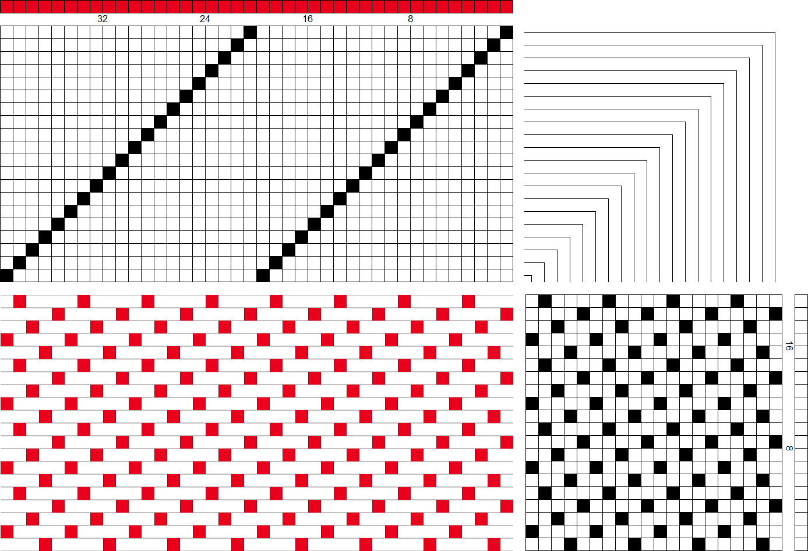 | The comments:  With this warp you can weave any design with 20 shafts.  Remember to use all 20 shafts in the weaving file (even if pattern repeat is smaller you need to multiply it to 20 shafts)  Note also! Change loom setting to 24 shafts (Weave Options EW24W AND The shaft nearest to the weaver)

