PowerPoint Task
- Open a blank PowerPoint file. Create a title slide with the following information ‘Bachelor's Thesis’ and name [insert your name].
- Create a contents slide with Abstract, Introduction, Literature Review, Methodology, Analysis and Conclusion written into separate shapes.
- Add slides with corresponding titles. Using hyperlinks, link up contents shapes with the added slides.
- Insert animation of your choice in relation to the methodology slide.
- Insert the picture below into a content with caption slide. Select a design of your choice. Title the slide as BA Thesis and in the main body of the slide type ‘A guide to successful thesis’. Insert a fly in animation for the latter text only.

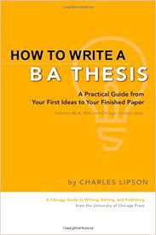

- Save the edited document as PowerPoint_Pretest_ lastname where “lastname” is replaced by your own last name. Submit by uploading to MyCourses.

