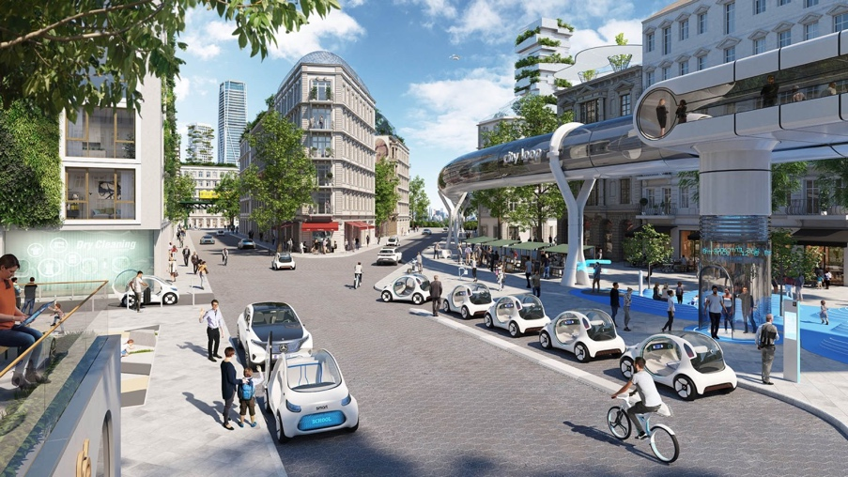
’
URBAN MOBILITY IN 2030
Design Factory – 1 December 2022

Each team is allocated 5 minutes MAX presentation time 3 minutes Q&A

WE WILL START AT 14.00 PROMPTLY GIVEN THE NUMBER OF TEAMS

ACT 1 14.00 Slot #1
14.08 Slot #2
14.16 Slot #3

INTERMISSION 14.24

ACT 2 14.30 Slot #4
14.38 Slot #5
14.44 Slot #6

INTERMISSION 14.52

ACT 3 15.00 Slot #7
15.08 Slot #8
15.16 Slot #9

INTERMISSION 15.24

ACT 4 15.30 Slot #10
15.38 Slot #11
15.46 Slot #12

FINAL CURTAIN 15.54

