Principles of Economics

Session 1: In-class Activity
PPF Part 1
Tom lives alone on an island and has some resources, namely land to either grow wheat (bread) or raise sheep (cloth).
Possibility | Bread (loaves) | Cloth(Yards)
a | 20 | 0
b | 18 | 1
c | 15 | 2
d | 11 | 3
e | 6 | 4
f | 0 | 5

a) On a separate sheet of paper (that you don’t need to turn in) graph the above PPF.
b) On your graph, find one point that is unattainable and label it point U.
c) On your graph, find one point that is attainable, but inefficient and label it point I.
d) On your graph, find one point that is efficient and label it point E.
e) Let's say you are originally at "possibility a", making 0 yards of cloth and 20 loaves of bread. What would be the opportunity cost of making one yard of cloth? _______
Starting at "possibility b", what would be the opp. cost of making one more (from 1 to 2) yards of cloth?_______
What would be the opp. cost of making one more cloth if you were already making 2 cloth?________
What would be the opp. cost of making one more cloth if you were already making 3 cloth?________
What would be the opp. cost of making one more cloth if you were already making 4 cloth?________
f) If you were currently making 0 bread, what would be the opportunity cost of making 6 bread? ______
Within the 0 to 6 range for bread production, what is the approx. o.c. of producing 1 loaf of bread?____
g) Are the opp. costs depicted in this example constant, increasing, or decreasing? Try to explain why.

PPF Part 2: Robinson and Friday
ROBINSON FRIDAY
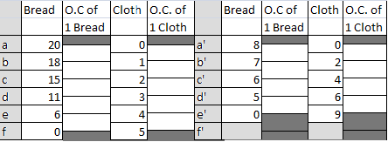
a) Fill in the empty boxes.
b) Who has the absolute advantage in cloth production? Explain.

c) Who has the comparative advantage in bread production? Explain.

d) Who had the comparative advantage in cloth production? Explain.

e) Does either have the absolute advantage in both good?

g) If Robinson initially has bundle d and Friday had bundle b’ before trading, what are the total quantities of each good produced?

h) If they each specialize, how much of each good in total will be produced?

i) Is it possible that they could both be made better off by specializing and trading? If so, give an example of a mutually beneficial allocation.

