[IDEAS](https://www.theatlantic.com/ideas/)

How Crypto Disappeared Into Thin Air

When a currency’s value is based on belief alone, it’s liable to evaporate.

By [James Surowiecki](https://www.theatlantic.com/author/james-surowiecki/)

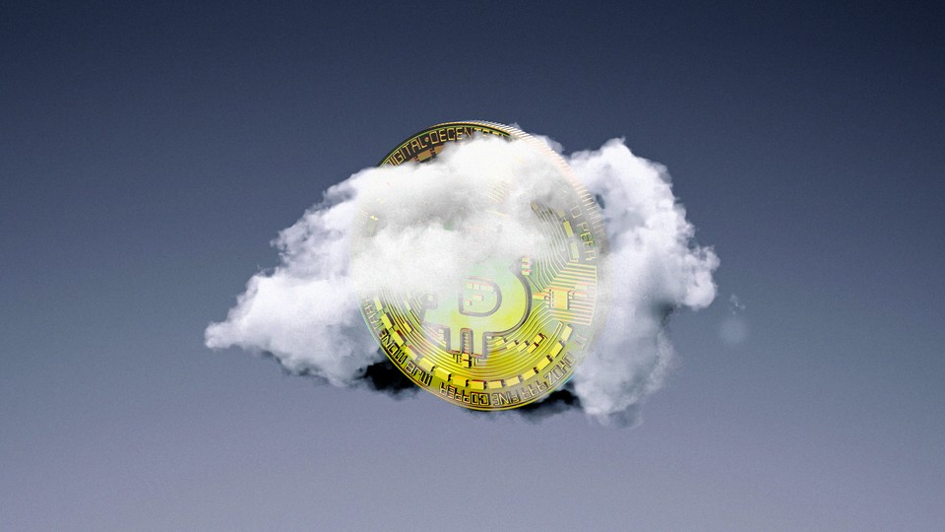

The Atlantic; Getty

MAY 20, 2022

SHARE

Carnage in the cryptocurrency market is nothing new. Over the past decade, even as the value of cryptocurrencies like bitcoin and ether has risen sharply, crashes have been a regular feature of the market. (There’s a reason HODL—“Hold on for dear life”—is a mantra among crypto believers.) But even by crypto standards, the destruction of value over the past six months—and in particular, over the [past few weeks](https://www.theatlantic.com/technology/archive/2022/05/bitcoin-cryptocurrency-crash-risk-misfortune/629909/)—has been staggering.

Since November, something like $1.5 trillion in cryptocurrency value [has been erased](https://www.forbes.com/sites/billybambrough/2022/01/22/like-the-1929-crash-new-crypto-winter-warning-as-sell-off-wipes-15-trillion-from-the-combined-bitcoin-ethereum-solana-bnb-cardano-and-xrp-price/). Bitcoin and Ethereum, the market’s bellwethers, [are both down](https://www.nytimes.com/2022/05/12/technology/cryptocurrencies-crash-bitcoin.html)about 60 percent from their peaks. And most strikingly, the so-called stablecoin Terra and its sister token, Luna, which together were [valued at](https://fortune.com/2022/05/18/who-is-do-kwon-luna-ust-crypto-founder-rise-and-fall/)about $60 billion six weeks ago, imploded in a matter of days and are now essentially worthless.

This huge sell-off of course raises a natural question: What happened? You can certainly point to potential culprits. [Inflation](https://www.theatlantic.com/ideas/archive/2022/04/us-economy-inflation-unemployment-housing/629717/) and interest rates [are rising](https://www.theatlantic.com/newsletters/archive/2022/05/worrying-signs-economy-inflation-crypto/629848/)—though cryptocurrencies were supposed to be hedges against inflation, and indifferent to what’s happening in the “fiat” financial world. Stocks are being sold off—though one of crypto’s big selling points was that it was supposed to be uncorrelated with other assets. But really, there’s a much simpler explanation: People’s faith in crypto wavered. And faith, not fundamentals, is what most of crypto’s value depends on.

Crypto, after all, is different from assets like farmland, or stocks, or even real estate. When investors are trying to figure out how much to pay for those kinds of assets, they’re interested, at least in theory, in their intrinsic value. If you’re going to buy farmland, you want to know how much money you’ll get from the crops you can grow on that land. If you’re going to buy an apartment building, you want to know how much rent you’ll be able to get from your tenants over the next 30 years (or whatever your time horizon is). And if you’re buying stock in a company, you want to know how much cash it’ll generate in the future, together with the value of whatever assets it currently owns.

Now, calculations of intrinsic value are always estimates, and are also always inaccurate, because there’s no way to perfectly predict the future. But the crucial idea is that assets have value that’s independent of what other people will pay for them. If you owned all of Apple right now, you’d get at least $100 billion in profit—that’s real cash that would go into your bank account—in the first year. And assuming you let Tim Cook just do his thing, you could count on getting that, and probably more, every year for the foreseeable future. So that provides a baseline for how much Apple is worth.

Crypto valuations, though, are generally founded on a different principle: Intrinsic value doesn’t matter. The value of an asset is not dependent on its use value in the real world, or its ability to generate cash in the future. Instead, the value of an asset depends on what people think it’s worth. This is a kind of postmodern vision: There is no “real” value, only narratives of value we collectively construct and choose to believe in, or not. As the crypto and NFT (non-fungible token) investor Nick Tomaino [put it last fall](https://decrypt.co/81610/early-nft-opensea-investor-nick-tomaino-belief-equals-value), “If the collective group of people on the internet believes something has value, it has value. We are in a world where belief equals value.”

There are, of course, other markets in which value depends on belief, including, most obviously, gold, fine art, and collectibles. But gold has a millennia-long history of people choosing to accept it as money; and fine art is wrapped up with ideas of rarity and the aura of an original work. What’s striking about the crypto market is that it has used this same logic to conjure more than $1 trillion of value out of thin air (or, more accurately, out of code) in less than a decade.

The purest examples of this phenomenon are memecoins, the most famous of which is Dogecoin. Dogecoin [was created](https://www.cnn.com/2021/04/17/investing/what-is-dogecoin/index.html) back in 2013, literally as a joke. It has no real-world use value; no one needs Dogecoin to buy or sell anything. It’s not even scarce because, unlike bitcoin, which has a finite supply of coins that will ever be available and becomes harder to produce as time goes by, Dogecoins are really easy to “mine.” Yet, at its peak in April 2021, Dogecoin was “worth” a supposed $50 billion, and even today, after its value has dropped almost 90 percent, it’s still worth about $11 billion. Why? The answer might be as dumb as the fact that Elon Musk mentioned Dogecoin [in a tweet](https://twitter.com/elonmusk/status/1357241340313141249?lang=en), calling it “the people’s crypto,” and got everyone excited about it.

Or take Terra and Luna. They’re little more than three years old, and until 2021, they were worth less than $1 billion combined. Then, in the space of a year or so, they were suddenly valued at $60 billion. From August 2021 to March of this year alone, their combined value more than tripled. At that point, Terra and Luna seemed like the next big things in crypto. Do Kwon, Terra’s founder, started getting talked about as a visionary. Luna holders were calling themselves Lunatics. Terra paid nearly $40 million to put its name all over the Washington Nationals’ stadium.

This wasn’t because anything important about Terra as an asset had changed. People didn’t start using its coins in great numbers to buy stuff. Terra’s underlying businesses didn’t dramatically improve. Mostly, what changed is that in March 2021, Terra [launched](https://www.bloomberg.com/news/articles/2022-03-23/terra-s-promise-of-20-defi-return-raises-sustainability-concern) an app called Anchor, which began offering 20 percent interest on deposits, which got people to buy Terra in order to then deposit it and get the 20 percent. That hooked lots of new investors, and in the months that followed people started to buy into the company’s narrative that it had solved one of the most complicated questions in crypto: how to create coins that would be stable enough to use as currency without having a mountain of financial reserves to back their value up. (Terra, more than a few pundits opined, had found the “holy grail” of cryptocurrency.) So even though some warned that the way Terra was set up meant that it was eventually going to face the equivalent of a run on the bank (which is, in fact, how it collapsed), crypto holders collectively decided that Terra and Luna were really valuable, and so they were. Until a few weeks ago, when all of a sudden they weren’t.

It’s that “all of a sudden” that makes investing in crypto such a vertiginous experience. In a world where belief determines value, you can never be sure you’re on firm ground. There are cryptocurrencies—ether, most obviously—that have real use value in the blockchain world. And arguably, bitcoin, apart from its usefulness in buying drugs and other illicit items, has retained value long enough that its status as “digital gold” is not under serious threat. But even these two currencies can see their values oscillate wildly based on little more than investor fickleness.

In that sense, crypto can be said to incarnate Karl Marx and Friedrich Engels’s description of capitalism’s effect on social relations: “All that is solid melts into air.” It’s no surprise, then, that crypto holders are always exhorting one another to believe in order to buck up their collective confidence, and that they identify themselves as HODLers and give their Twitter photos laser eyes. When crypto’s value is the product of investors’ collective will, then it’s essential to try to keep that will intact.

That’s why the most interesting question about this crypto crash is not really why it happened, but whether it will provoke a true crisis of confidence. The market has rebounded many times from crashes in the past, and it will not be shocking to see it do so again. Belief, after all, can return as quickly as it departs. But the most recent crypto boom was driven by investors new to this market: ordinary retail investors, as well as institutional investors, most of whom have no philosophical or ideological commitment to crypto, and no desire to HODL when things are falling apart.

Even for the true believers, the obliteration of Terra and Luna was a powerful reminder that investing in most cryptocurrencies is the financial equivalent of Wile E. Coyote running on air—it works great until people decide to look down. And once they do, it’s a really long way to fall.

[James Surowiecki](https://www.theatlantic.com/author/james-surowiecki/) is the author of [*The Wisdom of Crowds*](https://bookshop.org/a/12476/9780385721707) and blogs at [Medium](https://surowiecki.medium.com/).