CHEM-E6145 Unit Operations in Mineral Processing
HSC-SIM: Assignment 3 3.03.2023
Kinetic flotation circuit model
Name:
Student number:
The purpose of this assignment is to find out how different process design and operation parameters affect flotation process.
Parameters that will be tested are:
- Air flow rate to the cells
- Froth thickness in the cells
- Amount of the cells
- Ore feed rate
Process description:
The Flotation feed is Cu-Mo ore from hydrocyclone, which is floated selectively to produce Mo concentrate.
The Flotation circuit consists of one Conditioner tank followed by Flotation bank with three cells. The flotation cell tails will be treated in a separate process (not included in the Assignment).
Feed:
- Dry solids feed rate is 450 t/h
  - Feed solids percentage is 35%
- Minerals in the Cu-Mo ore (stoichiometric)
  - Molybdenite (MoS₂): 7.3 % of the feed
  - Chalcopyrite (CuFeS₂): 42.8 % of the feed
  - The rest of the feed is quartz (SiO₂)
- 5 particle size classes:
- 0-20 µm, 20-37 µm, 37-74 µm, 74-120 µm, 120-270 µm
- Size distribution
- Rosin-Rammler passing size P80: 78 µm
  - The mineral composition of the particles stays the same through size classes
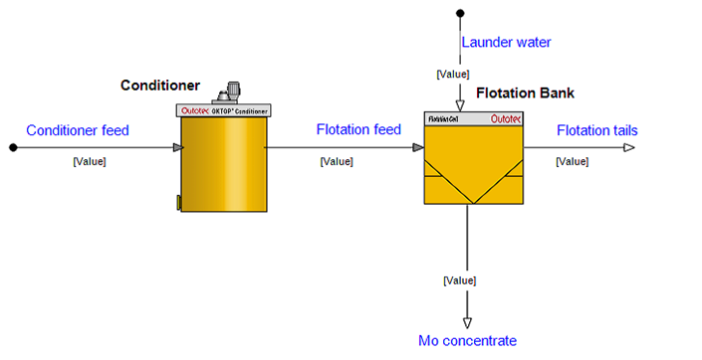

Conditioner
Model Parameters
  - Use the Three component flotation model equation.
  - Parameters of the three-component Flotation model based on continuous plant sampling data
Flotation rate constants
Mass proportion of fast, slow and non floating particles.
Molybdenite:

Size, µm | Fast | Slow | Non | Fast kin. | Slow kin.
0-20 | 0.6 | 0.3 | 0.1 | 0.245 | 0.0245
20-37 | 0.6 | 0.3 | 0.1 | 0.2695 | 0.02695
37-74 | 0.6 | 0.3 | 0.1 | 0.24255 | 0.024255
74-120 | 0.6 | 0.3 | 0.1 | 0.218295 | 0.0218295
120-270 | 0.6 | 0.3 | 0.1 | 0.1964655 | 0.01964655

Chalcopyrite:
Size, µm | Fast | Slow | Non | Fast kin. | Slow kin.
0-20 | 0.4 | 0.4 | 0.2 | 0.155 | 0.0155
20-37 | 0.4 | 0.4 | 0.2 | 0.1705 | 0.01705
37-74 | 0.4 | 0.4 | 0.2 | 0.15345 | 0.015345
74-120 | 0.4 | 0.4 | 0.2 | 0.138105 | 0.0138105
120-270 | 0.4 | 0.4 | 0.2 | 0.1242945 | 0.01242945

Quartz:
Size, µm | Fast | Slow | Non | Fast kin. | Slow kin.
0-20 | 0.1 | 0.2 | 0.7 | 0.04 | 0.004
20-37 | 0.1 | 0.2 | 0.7 | 0.044 | 0.0044
37-74 | 0.1 | 0.2 | 0.7 | 0.0396 | 0.00396
74-120 | 0.1 | 0.2 | 0.7 | 0.03564 | 0.003564
120-270 | 0.1 | 0.2 | 0.7 | 0.032076 | 0.0032076

Flotation Bank Model Parameters
Flotation Bank
- Number of cells in row: 3
- One Flotation Cell unit model can do calculations for a bank of cells
Residence Time
- Flotation Equation: Continuous
- Kinetic parameters from continuous plant sampling data
- Residence time calculation: Feed Volumetric
- Feed rate of each cell is used for calculation of its residence time
Cell Dimensions:
- Use the initial values
Gas Hold-Up:
- Use the initial values
Froth Volume:
- Froth Volume Calculation: Based on Froth Thickness
  - Used for Cell Effective volume calculation
- Froth thickness: 250 mm
Froth Recovery:
- Froth Recovery: Function of Froth Depth
  - Method to calculate froth recovery
Entrainment:
- Use the initial settings
Air Flow:
- Air Flow rate: 8 m³/min
Water Recovery:
- Water Recovery: Concentrate Target
- Concentrate Solids: 25 %
- Target with launder water: on
Sb Scaling:
- Enable “Sb in Use” and set the Nominal Sb to 30
- Sb = The bubble surface area
- to obtain mineral floatabilities from kinetic rate factors
Dynamic Parameters, Carry Rate, Warnings, Valve Selection:
- Use the initial settings
In the flowsheet
- Add a launder water stream to the flotation cell
- Set the water flow rate to 2 t/h per cell.

Effect of flotation air rate
- Simulate the Flotation circuit by using different air flow rate and Fill the following table for the concentrate:
Air Flow rate (m³/min) | Total solids (t/h) | Mo grade (wt-%) | Mo recovery (rec-%) | Cu grade (wt-%) | Cu recovery (rec-%)
8
12
16
20

What changes did you notice in the results?

Why did these changes take place?

Effect of froth thickness
- Set the air flow rate to 18 m³/min
- Simulate the Flotation circuit by using different Froth thickness and Fill the following table for the concentrate:
Froth thickness (mm) | Total solids (t/h) | Mo grade (wt-%) | Mo recovery (rec-%) | Cu grade (wt-%) | Cu recovery (rec-%)
50
150
250
350

What changes did you notice in the results?

Why did these changes take place?

Compare the effect of Froth thickness on Mo- and Cu-grade. Are there any differences between them ? If so, what is the reason for this ?

Number of flotation cells:
- Set the froth thickness to 250 mm
- Simulate the Flotation circuit by using different amount of Cells and Fill the following table for the concentrate:
- Remember to adjust the water flow rate accordingly (2t/h per cell).
Cells in Row | Total solids (t/h) | Mo grade (wt-%) | Mo recovery (rec-%) | Cu grade (wt-%) | Cu recovery (rec-%)
2
3
4

What changes did you notice in the results?

Why did these changes take place?

Effect of ore feed rate
Increase the ore feed rate from 450 t/h to 500 t/h by keeping the feed solids percentage of 35%.
How does this affect Mo-grade and Mo-recovery compared to previous case (froth thickness 250 mm, 4 Cells in row)?

What is the reason for this?

- When you have completed the tasks, upload the Simulation file as a zip-file and Results as a word-file to your own Dropbox (Assignment 3) latest on Thursday March 10th at 16:00.

