WAT-E2130 EXAM 2 -- Process control June 02, 2023

Answer the following questions.

1. (4p) Explain the following control configurations:
   1. Open-loop control.
   2. Feedback control.
   3. Feedforward control.

Provide some practical examples of application in wastewater treatment plants, highlighting the pros and cons of each configuration.

1. (6p) One popular tuning method for PID controller is based on the process reaction curve given in Figure 1. Answer to the following:
2. Explain how the curve is obtained in practice, the information it provides and how it can be used for the tuning of the controller.
3. Explain the meaning of “PID controller”, the pros and pros, and cons of the P, I and D terms in the controlled variable response compared to an open-loop strategy.



Figure 1. Process reaction curve for question 2.

1. (6p) For controlling the plant schematically represented in Figure 2 you have the possibility of acquiring ONE dissolved oxygen sensor and ONE suspended solid sensor, answer the following:
   1. Given this instrumentation, formulate and discuss a control configuration for the plant.
   2. Locate your sensors and identify the manipulated variables.
   3. Define and justify reasonable values for the set-points of the controlled variables.
   4. Discuss the effects that you expect your control strategy could bring to the plant performances.

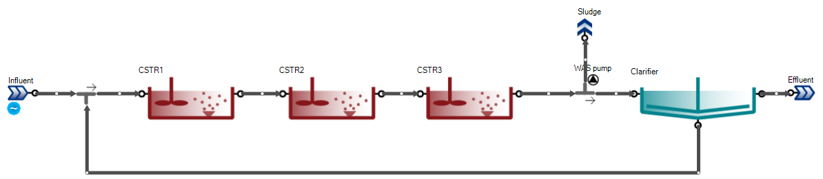

Figure 2. Plant layout for question 3.

1. (4p) Figure 2 shows a cascade controller representation in SUMO where the dissolved oxygen setpoint controller targets of matching the effluent ammonia concentration to a setpoint. Do the following:
   1. Represent the system as block diagram identifying the outer and inner loops, as well as the input/output to/from each block.
   2. What benefit you expect from the cascade control configuration in Figure 2 with respect a single dissolved oxygen controller in the plant?

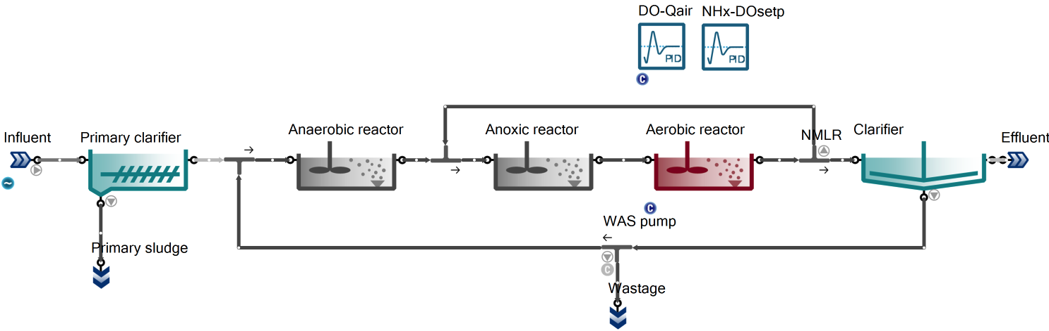

Figure 2. Plant layout for question 4.