WAT-E2130 MID-TERM EXAM 1 Version 2 Process modelling

7.6.2023

Answer the following questions:

1. Explain the following terms:
2. Composition variable (1p)
3. Monod’s saturation function (1p)
4. There’s something wrong with the following modelling projects. Find 4 errors in the table and figures below. (4p).

Table 1. Influent water quality for a wastewater treatment plant.

|  |  |  |
| --- | --- | --- |
| Compound | Concentration | Unit |
| Suspended solids | 280 | mg/l |
| BOD7 | 180 | mg/l |
| CODCr | 160 | mg/l |
| Ntot | 46 | mg/l |
| NH4-N | 49 | mg/l |
| NOX-N | 2 | mg/l |
| Ptot | 8 | mg/l |
| PO4-P | 5 | mg/l |
| Temperature | 13 | °C |

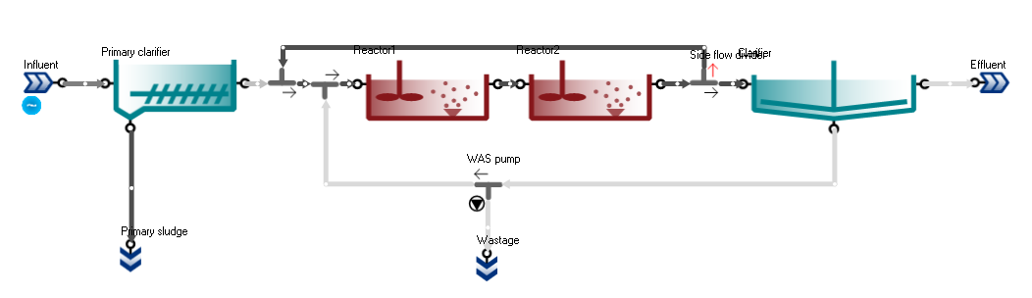

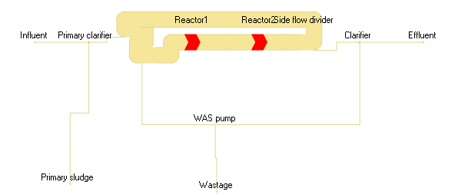

Figure 1. Process model elements and flows of a process (upper picture) and a sankey chart of the flow rate in the process.

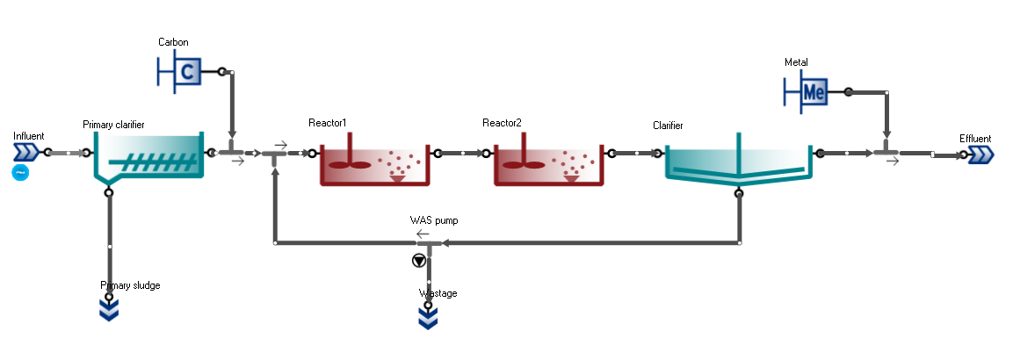

Figure 2. Process model elements and flows of a process.

2. Observe the ASM1 Gujer matrix below. Answer the following questions. (4p.)

a) How many processes are taken into account in this model?

b) How does the state variable 1 (Inert soluble organic matter) affect the anoxic growth of heterotrophic bacteria?

c) Explain the stoichiometric relationship between the state variable 5 and the decay of heterotrophs.

d) What happens to the aerobic reaction rate of the heterotrophs if the readily biodegradable organic matter concentration (Ss) approaches to zero?

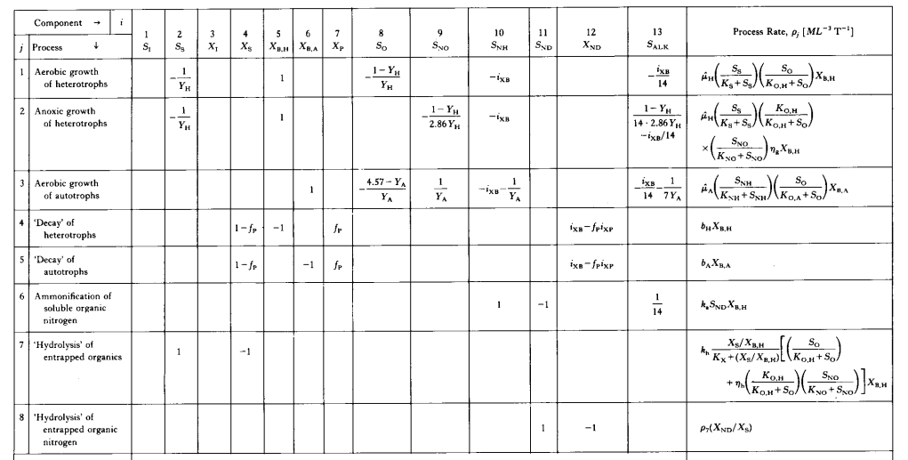

1. A modelling project has different steps, namely project definition, data collection and reconciliation, model set-up, calibration and validation and simulation. Explain what calibration in this context is and what is the difference between calibration and validation. Could a model be used without calibration? If yes, give some examples of model applications. (6p).
2. Modelling can be used to study different aspects in a wastewater treatment plant. Project definition impacts the model set-up and the boundaries of the modelled system. Imagine that you are doing a modelling project for the treatment plant presented in the picture below using an ASM based full plant model such as Sumo1.



What kind of system boundaries (which elements to include in the modelled system) and what kind of models would you select for the following tasks:

1. Energy optimization of the wastewater treatment plant
2. Study the effect of different carbon courses in the biological denitrifying filters.
3. Study the effect of different dissolved oxygen concentrations in aerated zones on nitrogen removal performance and energy consumption
4. Study the effect of changing the existing coarse screens to fine screens.

(4p).